Welcome to Bonnypark Early Learning and Childcare Centre

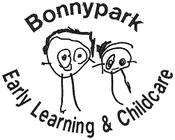

Parent/Carer’s Brochure
2026-2027

Bonnypark Early Learning & Childcare Centre
Wellpark Terrace
Bonnybridge
FK4 1LR
Telephone: 01324 503162
Email: bonnyparkelcc@education.falkirk.sch.uk


Welcome to Bonnypark ELC Centre

I would like to start by saying a huge welcome to Bonnypark ELC Centre – we are delighted to have your child attend our nursery.
We believe in supporting our children and families through high quality learning experiences and developing our partnership work with parents/carers. It is important for us to build positive relationships with you and your child and support each child’s individual development. We aspire to making your child’s transition and experience at nursery as smooth and nurturing as possible.
Your child will be allocated a keyworker, who will carry out the induction process and tailor the transition period to nursery at a suitable pace for you and your child. The keyworker will keep you up to date on your child’s progress through sharing their learning, daily conversations and written reports.
Please see our vision, values and aims for our setting overleaf. Our practice is underpinned by :
- Our nurturing approaches and practice
- Our strong value on our relationship with you and your child
- Our value on providing high quality learning for your child
- Our value on ensuring our nursery is an inclusive environment for all children
If you have any queries, please ask 😊
Kind Regards
Chelsey McClurg
Head of Centre

Transitions at Bonnypark ELC Centre
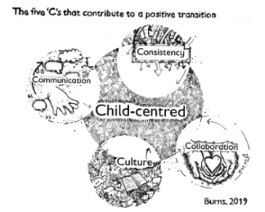
Here at Bonnypark, we aim to provide a smooth, flexible and personalised transition for all our children. Please find below some helpful information that will support our approach to transition and settling into ELC life.
It is important to us, that we get to know you and your child as well as we can. Home visits and settling in visits really help us to do this. Please share as much information as possible with us, in order for us to find out what is important to your child and you, as a family.

Frequently asked questions…
‘How long will my child take to settle?’
This is unique to every child. During their settling visits we will ensure you child experiences a variety of different aspects of the ELC day (e.g. snack, lunch, outdoor play). We will keep you informed as to how your child is getting on and we will increase the duration of the visits according to how settled and comfortable they are.
‘Who can I speak to about my child?’
Your child will be allocated a keyworker, they will be responsible for planning transition visits and documenting your child’s play and learning. However, all staff are available at drop off and collection and you are welcome to talk to anyone.
‘What if my child is upset?’
We understand that it can be difficult for children to separate from their parent/carer, however we are here to support both of you during this time. If your child is crying, it is ok for you to leave them, they will be comforted by a member of the team and we will share photos with you via ‘See-Saw’ to reassure you, once they have settled.
‘Do I need a uniform and what do I need to bring for my child?’
There is no compulsory dress code for ELC, however we ask parents/carers to dress their children in older clothes (as they will get messy), and provide a bag with spare nappies/changes of clothes.
You can purchase a Bonnypark embroidered jumper, from ‘Border Embroideries’ in Falkirk and they stock these from age three and up.
‘Does my child need to be toilet trained?’
We support toilet learning at all stages. The playrooms are equipped with facilities for toileting and nappy changing throughout the day. When you are ready to transition your child from nappy to pants, we are here to support you with this – please just let us know.

Feedback

We value your feedback, please let us know your thoughts regarding your transition/home visit.

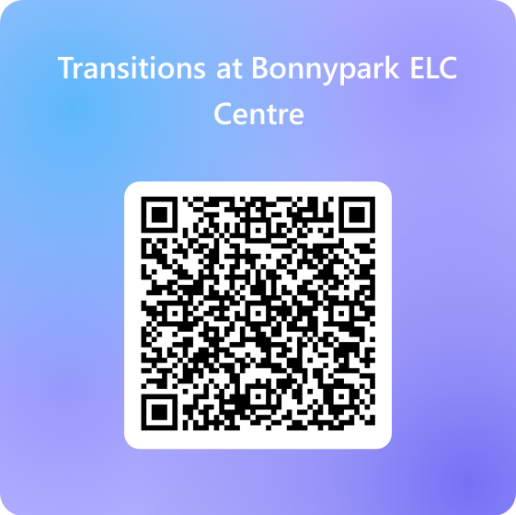
Please scan the QR code to access the short questionnaire.

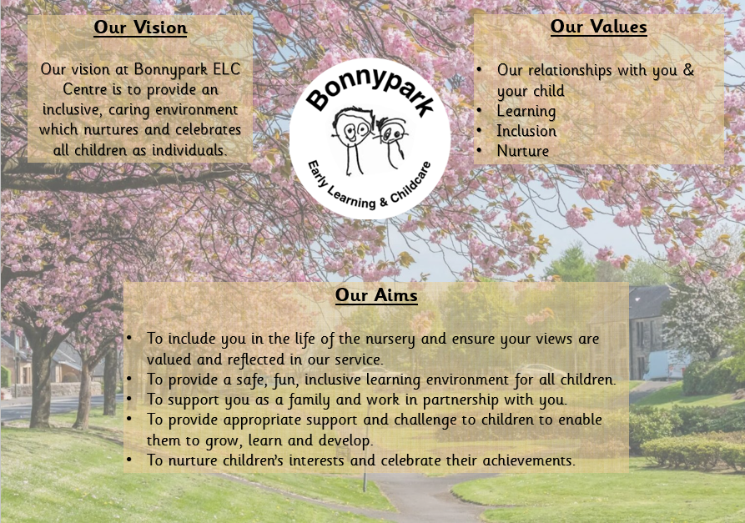
Est April 2024

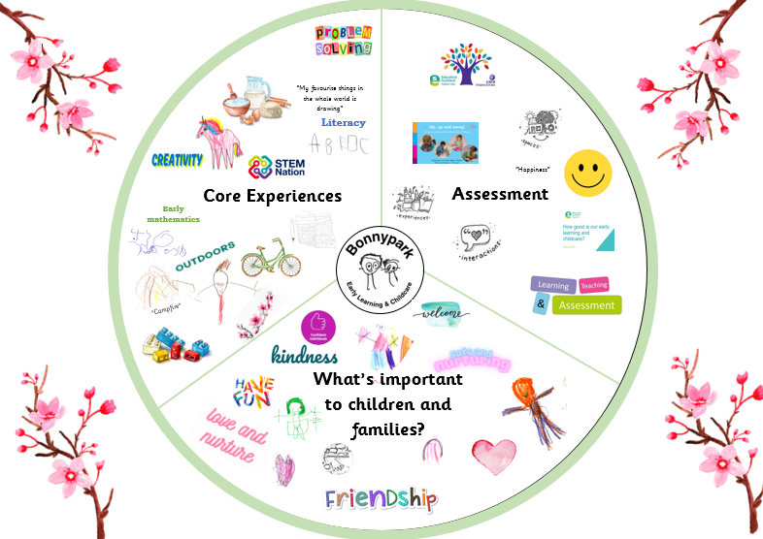
What is a curriculum rationale?
Our curriculum rationale is our approach at Bonnypark ELC to learning, teaching and assessment for our children. Our rationale is written in consultation with our children, families, team of practitioners and our stakeholders.

Our Rationale:
Our play based pedagogy and approach to learning offers children a balance of child led and adult initiated experiences to help support and nurture their interest and in learning.
Children’s interests and stages of development are planned for with appropriate differentiation and challenge to support all children. We believe children learn best when they are motivated by real life experiences and with practitioners who scaffold their interests and challenges their thinking.

Est June 2025

Opening Hours
Bonnypark ELC Centre is registered with the Care Inspectorate to provide care for children from 6 weeks to 5 years and we can have 98 at any one time. At present we only cater for children aged 2-5 years old
We operate a service for our children and families from 8am – 6pm on a full-time or term time basis and only close for public holidays and over the Christmas holidays.
Please see below our options for hours for your child:-
Term Time Options
Option 1 – Monday to Friday 9.00 – 15.00
Option 2 – Monday to Friday 9.00 – 12.00
Option 3 – Monday to Friday 12.00 – 15.00
Option 4 – Any three days 8.00 – 18.00
Full Year Options
Option 1 – Monday to Friday 9.00 – 13.45
Option 2 – Any three days 9.00 – 17.00

If you have indicated on your initial enrolment form you wish to purchase additional hours onto your child’s 3-5 room place then these hours are priced at £5.60 an hour.
If you have any queries around your child hours/days please speak to Chelsey, Head of Centre, or Lucy, Principal Early Years Officer, who will advise you on this.

Our 2 year old spaces are for eligible children, and we operate a paid place service for families wishing to purchase care for their 2 year old.

Staff to Child Ratio:- We maintain a strict child:adult ratio in line with Care Inspectorate requirements :-
1 member of staff for every 5 2-3 year olds
1 member of staff for every 8 3-5 year olds

Our Staff Team
We have a very large and skilled staff team in Bonnypark that work across both playrooms and support all children in our shared garden space outdoors. We as a staff team pride ourselves in using our skills and expertise to support you, your child and your family.
Let’s Meet the Team
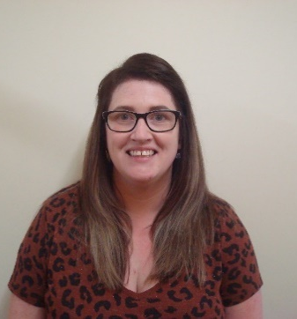 | 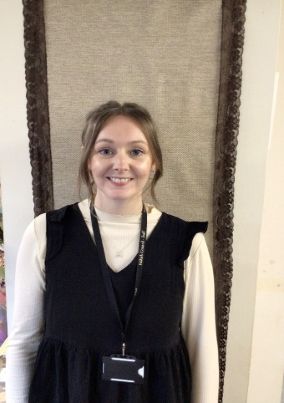
Chelsey McClurg  Head of Centre  Monday – Friday  Full Year | Lucy Mason  Principal Early Years Officer  Monday – Friday  Full Year

 |  |  | 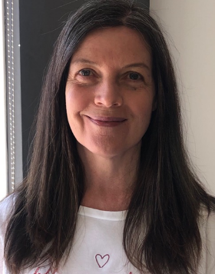
Danielle Murphy  Senior Early Years Officer  Monday – Friday  Full Year | Leona Masterson  Senior Early Years Officer  Monday – Wednesday  Full Year | Fiona Morris  Early Years Officer  Monday–Wednesday  Term Time  Senior EarlyYears Officer | Julie Murray  Clerical Assistant  Monday – Friday  Full Year
 | 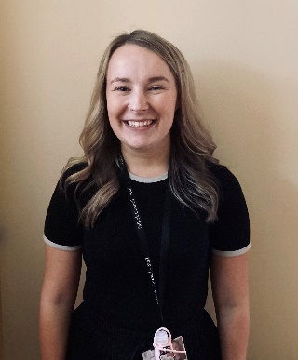 |  | 
Saskia Marshall  Early Years Officer  Monday – Wednesday  Term Time | Lisa Quigley  Early Years Officer  Monday – Friday  Term Time | Rebecca McGregor  Early Years Officer  Monday – Friday  Term Time | Abby Thomson  Early Years Officer  Monday – Friday  Term Time
 |  |  | 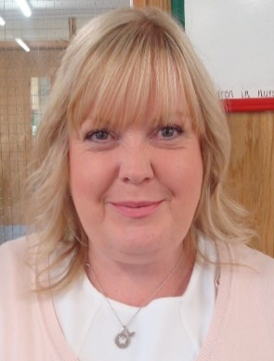
Laura Snaddon  Early Years Officer  Monday – Friday  Term Time | Claire Kenny  Early Years Officer  Monday – Friday  Term Time | Joe Easton  Early Years Officer  Monday – Friday  Full Year | Lesley Redpath  Early Years Officer  Monday – Friday  Term Time
 |  |  | 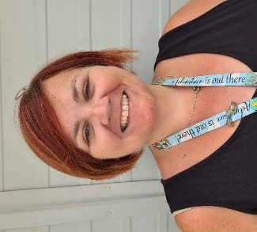
Sarah Archibald  Monday – Wednesday  Term Time | Bethany Noble  Monday – Friday  Full year | Nicola Deans  Early Years Officer  Monday – Friday  Full Year | Lynne Morrison – Love  Early Years Officer  Monday – Friday  Term Time
 | 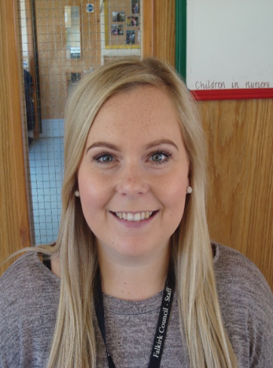 |  | 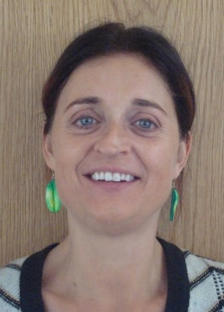
Caitlin Gibb  Early Years Officer  Thursday – Friday  Term Time | Lauren Spalding  Early Years Officer  Thursday – Friday  Term Time | Yvonne Wright  Early Years Officer  Thursday – Friday  Term Time | Lorna Brown  Early Years Officer  Thursday – Friday  Term Time
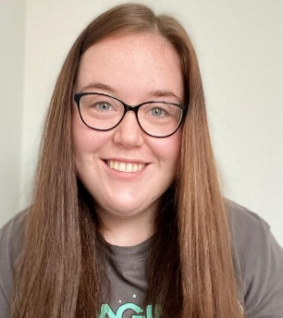 | 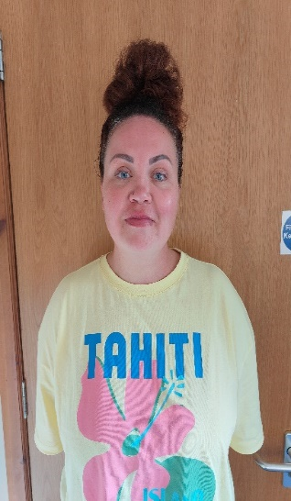 |  | 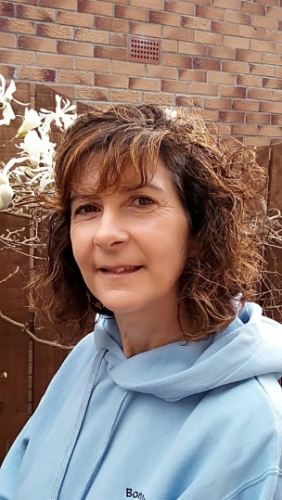
Chanice Rodgers  Early Years Officer  Monday – Wednesday Term time | Rebecca Rowland  Early Years Officer  Monday – Friday  Term Time | Adele Crombie  Early Years Officer  Monday – Friday  Full Year | Angie Cade EarlyLearningAssistant  Monday – Friday  Ful Year
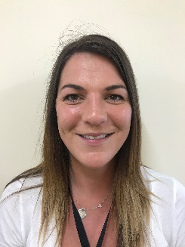 |  |  | 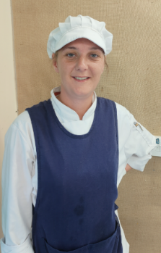
Louise Orr  EarlyLearningAssistant  Monday – Friday  Term Time | Lorraine Crombie  Support for Learning Assistant | Sharlene Kerr EarlyLearningAssistant  Monday – Friday  Term Time | Jennifer Stewart  Catering Assistant  Monday – Friday  Full Year

Communication is KEY!

It is very important to use to strive for excellence in our communication with you as your child’s parent/carer.
You and your child will be welcomed daily on the door by staff who will help settle them into play. Staff are always available if you have any queries.
We issue our monthly newsletters by email with important dates, nursery news and information on children’s learning so please look out for these. We also send out regular texts and have notices all around our entrance ways to ensure we keep you informed of key events.
We document individual children’s learning in their own personal folder, which they have daily access to. You will receive this home twice a year with an evaluative statement of your child’s progress. However, if you have any concerns about your child’s progress in nursery, we are more than happy to meet and discuss this with you and any other agencies such as health visitors.


Online Learning Journals

At Bonnypark ELCC, we use the Online Learning Journal App to document and record your child’s learning and development.
As part of your child’s induction and settling in process, we will create them with a online profile. You will get an email to create log in details in order to access your child’s profile, once this has been set up.
What to expect…
All Educators are responsible for ensuring your child has two detailed observations per month published within their individual learning journal profile. These rich observations will provide you with information on your child’s knowledge, skills and developments.
You will be able to access these at your own leisure. In addition, your child will have regular stories which will provide you with fun snap shots throughout their time at Bonnypark. You will receive at least one learning story per month.
We love for our families to get involved within their child’s Online Learning Journal and would encourage you to comment on any of their observations or stories. Additionally, you will be able to add your own stories through Parental Contributions – sharing any photos from home.

If you need any help accessing your child’s online Learning Journal, please speak to a member of the team.

Our Family Centred Approaches


As part of our ongoing family learning work we hold fortnighlty “Bonnybakers” sessions. We invite our families to come along to take part in some cooking and baking experiences alongside your child
The aim of these sessions are to spend some quality time with your child in the nursery enviroment while we have fun baking and cooking!
We follow a Froebelian approach to cooking which means children will all have their own utensils and ingredients which promotes their independence and provides them with a sense of ownership over what they have made!

At Bonnypark we have a passion for stories, songs and rhymes and know how important this is for children’s development.
Fortnightly Bookbug sessions which are run by our qualified leaders for parents/carers (or grandparents) to attend with their child within the nursery to enjoy.
At these sessions we will :-
- Sharing stories helps your little one's development, language and social skills.
- Spending a few minutes reading together every day helps to build bonds and develop relationships.
- It can have a positive effect on emotional wellbeing for both babies and families.

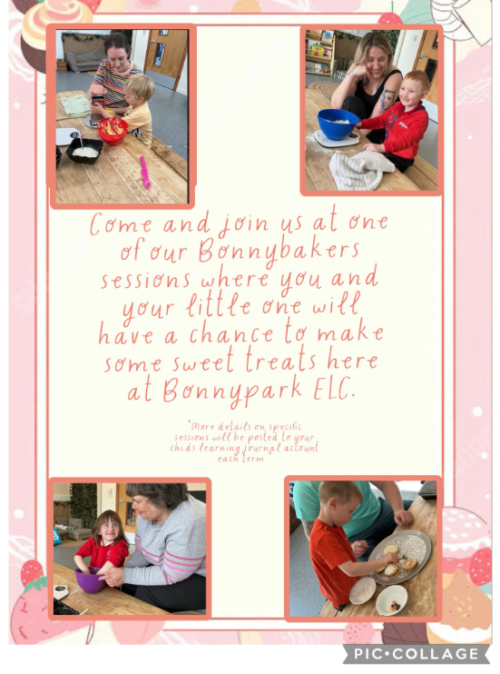
Core Curriculum Experiences
To enhance children’s knowledge through skill based learning, our core learning experiences are as follows –
- Marvellous Mealtimes - This is Falkirk’s approach to holistic snack and mealtime experiences across both playrooms in the nursery. It ensures all children can enjoy unhurried snack and mealtimes in a relaxed atmosphere. Children will have the opportunity to access a variety of fresh fruit and vegetables, nutritious snack and meals and fresh water and milk on a daily basis. Children have free flow access to lunch in a home-like environment and will have access to real life crockery, cutlery and resources during snack and lunch times. Children are also involved in preparing snack and lunch and enjoy being involved in lots of baking/cooking experiences.
Watch out for our Bonny Bakers classes where you are invited into nursery to bake with your child!

- Woodwork – Children in the 3-5 room are given daily opportunities to experience woodwork activities. They are empowered to use real tools on a one-to-one basis with a skilled practitioner. Engaging in woodwork experiences supports creative thinking, maths skills, scientific investigation, physical development and coordination, developing language and vocabulary, as well as building self-esteem and confidence.

Within the 2-3 room we offer a ‘pre wookwork experiences’ through the use of fine motor experiences to build on their hand strength and hand/eye co-ordination.

- Art and creation stations – In both playrooms we offer children creative experiences are daily with free flow access to paint, pens, pencils, glue, collage materials and junk modelling, for example.
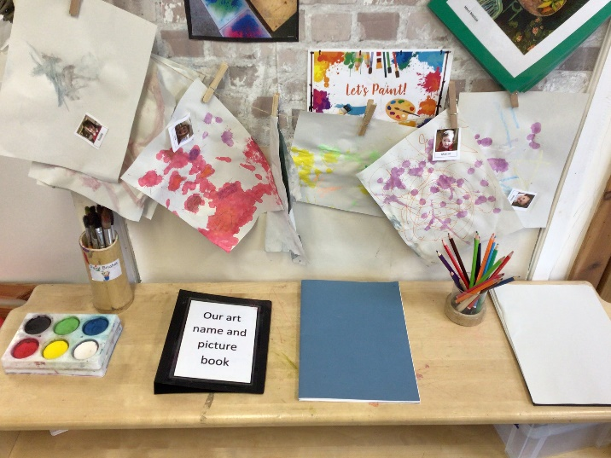

- Malleable Experiences – In both playrooms we offer daily opportunities for children to engage with sand, water, clay and playdough.

- Home corner – We incorporate authentic resources into our home corner, to create rich and engaging experiences for all children that promotes cultural diversity, equality, exploration, imagination and a deeper connection of the world around them.
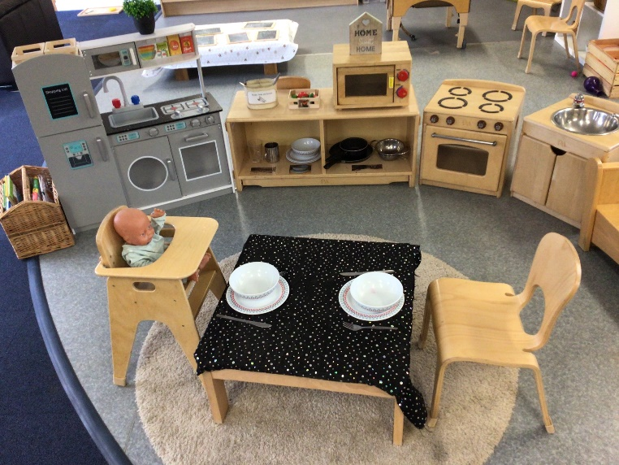

- Block play / construction – Children will have daily access to our block play and construction areas. These areas help to develop children’s abstract, logical and symbolic thinking. It also aids the development of mathematical concepts, such as sorting, matching, measurement, shapes, patterns for example.
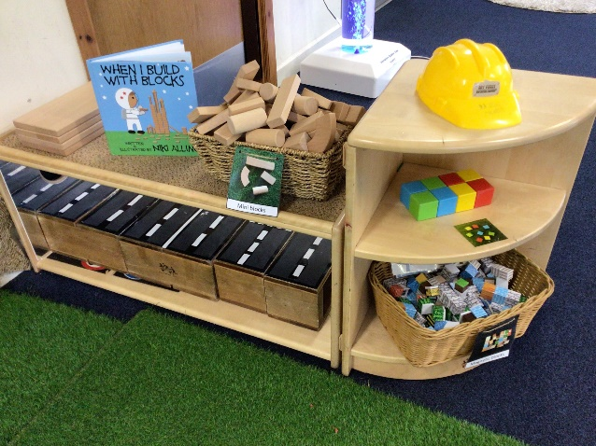
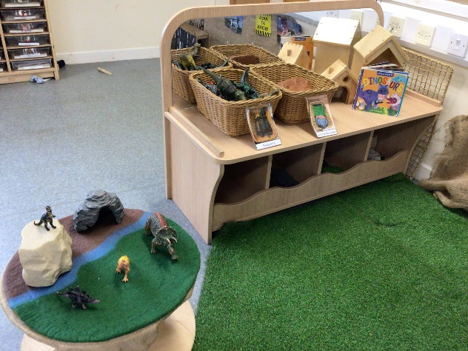

- Stories, songs & rhymes – Children have the opportunity to explore a wide variety of books (fiction & non-fiction) within every area of the nursery. They are also encouraged to join in with singing and rhymes throughout the day. Practitioners understand the importance of sharing stories, songs and rhymes with children as it helps to develop warm and affectionate relationships.

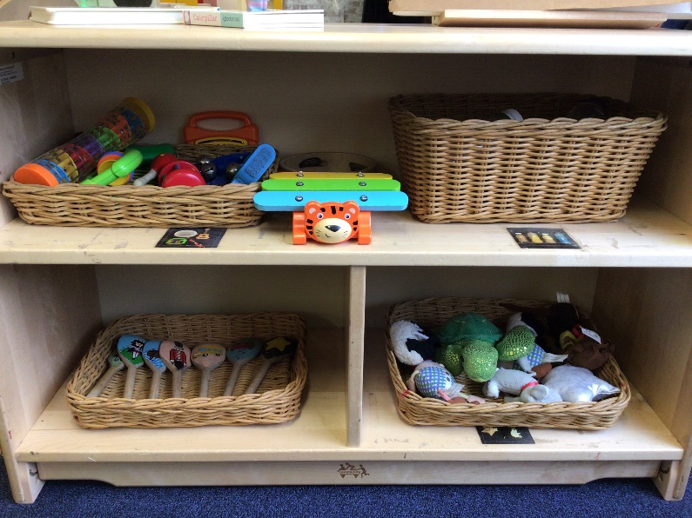

- Problem solving areas– Children have daily access to a range of problem solving experiences, such as jigsaws, puzzles and games.

- Fire building – We currently have 5 practitioners who are qualified in fire building. This experience is regularly offered to children, is carried out within the school grounds and is fully risk assessed. Children learn about fire safety and are supported by the practitioners to cook on the fire.

- Outdoor play – Our outdoor area is a shared play space for all 2-5year old children. The children have access to the outdoors from 9.15 and this space is then accessible all day and in all weathers and allows free flow access to our garden for all children

- Use of ICT – Children have daily access to our interactive smartboard (in the 3-5 room). This can be used for a variety of literacy and mathematical game. Children also have supervised access to staff iPads to further their knowledge.

- STEM (Science, Technology, Engineering, Mathematics) – children will have the opportunity to experience STEM activities throughout their day in ELC


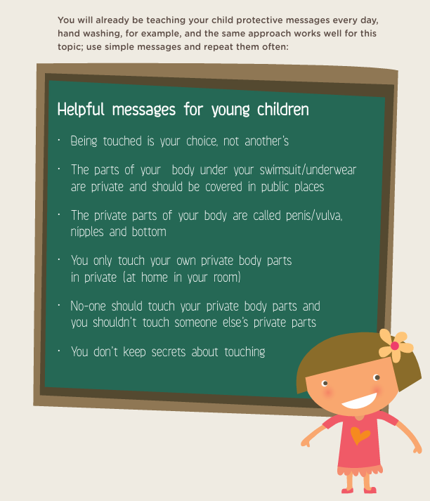

Positive Protective Messages
Further information can be found:
https://www.rightdecisions.scot.nhs.uk/media/zurmulrz/my_body_ggc_web.pdf

Please Scan QR code (2-3year old families)

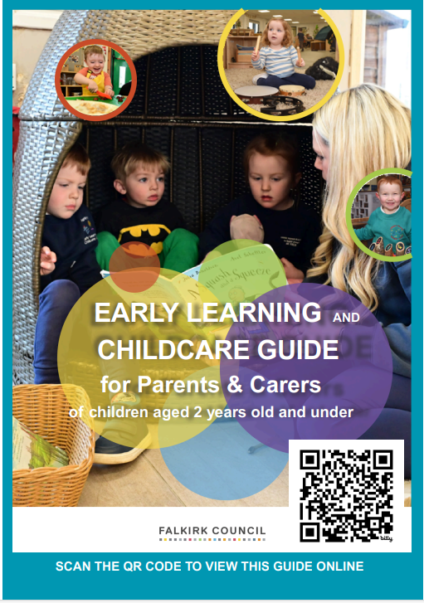
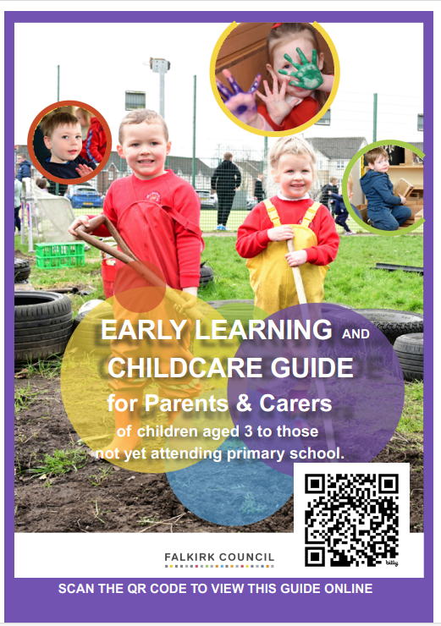
Please Scan QR code (3-5 families)

Clothing

Children love to explore and participate in messy activites during their time at nursery so please dress your child with this in mind.

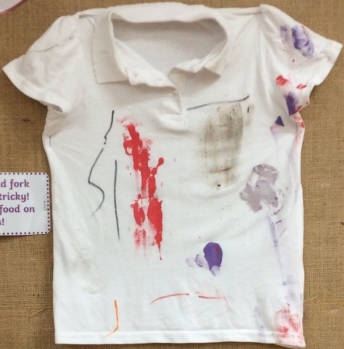
I sometimes get pen & paint on my clothes. This is because I am developing creative skills & exploring different ways of making art!
I’m sorry that I got messy today but it helps to show what I have been learning!
This splodge is part of my lunch, I am still learning to use utensils correctly when I eat.

Exploring in the water tray is giving me lots of maths & scientific skills, such as pouring, filling & emptying. Sometimes my clothes may get wet.
Playing outside is so important. I run & jump & get lots of fresh air, developing my gross motor skills. Sometimes I might get grass or mud on my clothes.
Our sand pit & mud kitchen are so much fun. I use all my senses which is so important for my development. It also helps me use my imagination & practise playing with my friends.

Your child’s wellies, wetsuit/outdoor clothing and sun hats can be left on their peg. You are also welcome to bring a bag with additional clothing/nappies that be left on your child’s peg.
For all 3-5 children nursery branded polo shorts and jumpers can be purchased online or in store at Border Embrodieries. Can we please ask that all your child’s belongings are labelled with their name.

Absence
We do have an exclusion policy for children who have sickness and/or diarrhoea. We ask that children must be kept at home for 48 hours after their last symptoms occurred.
If for any reason your child is absent from the nursery, please telephone to let us know why your child is not attending. If you could possibly do this before 9.30am so we do not order a lunch for them.
We deep clean the nursery several times a day, as well as having nightly cleaners, however, if there is an outbreak of sickness, chickenpox, diarrhoea etc we are extra vigilant and thorough with our cleaning to minimise more cases occurring.

Safety
We are always particularly careful when it comes to the safety of the children in our care. Children must be dropped off and collected from nursery by a responsible adult (someone over the age of 16), who is known to the child and staff. We require children to be signed in at drop off time and signed out once they have been collected.
If someone different is collecting your child, please contact the nursery on 01324 503162 to advise us. If you do not call and someone else comes for your child, they will not be allowed to collect them until we have confirmation from parent/carer.

Complaints Procedure
If you are unhappy about any part of the service we provide at Bonnypark ELC Centre please:-
- speak to one of the staff team immediately or speak to Chelsey McClurg, Head of Centre or Lucy Mason, Principal Early Years Officer
At Bonnypark we pride ourselves on our dedication to our children and families so please do not hesitate to approach us about anything you are unsure about.

Please see poster from Care Inspectorate

