Adam Lee Strength & Condition Beginners Program

Dynamic Warm Up: Squats, Heel Flicks ( heel to bottom) Hamstring Kicks, Back slaps & alternate arm swings 10 reps x 3 sets
Session 1 |  | Dates |  | Only move onto next session when technique has improved and reps and sets are achieved
 |  |  |  | Session 1 |  |  | Session 2 |  |  | Session 3 |  |  | Session 4
Exercise | Diagrams |  | Comments | Load reps sets |  |  | L | R | S | L | R | S | L | R | S
Back Squat | 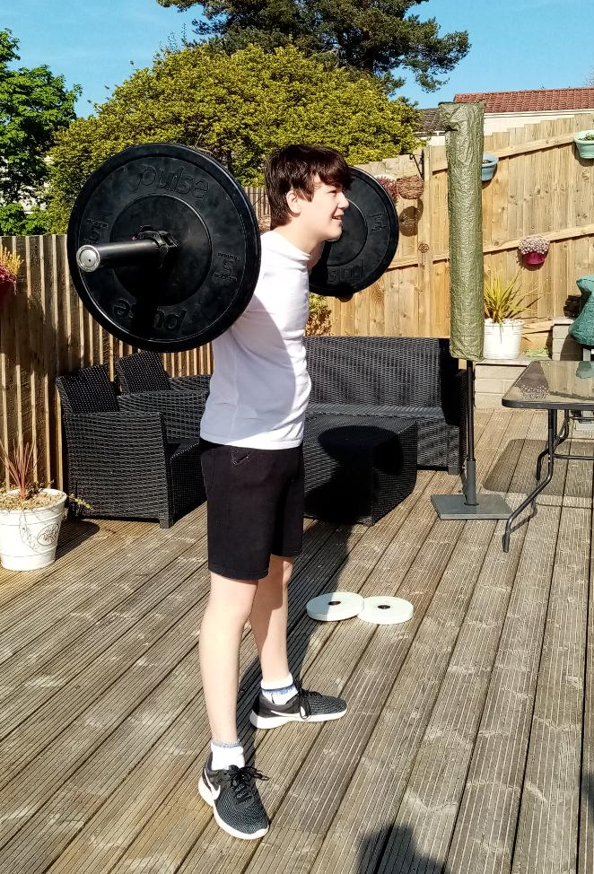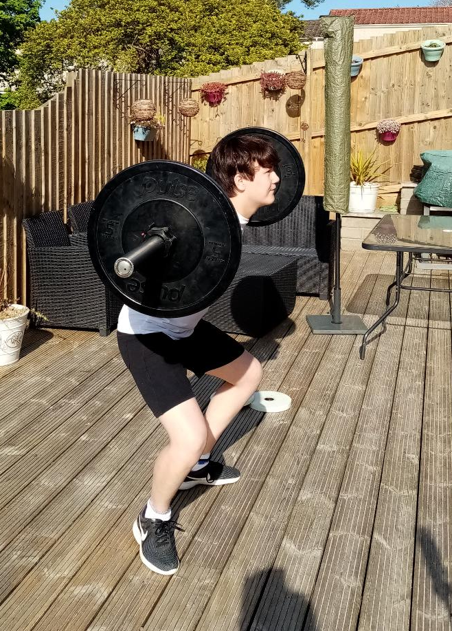 |  | Still working on technique need to work on depth | 25kg | 5 | 3 | 25kg | 8 | 3 | 25kg | 10 | 3 | 35kg | 5 | 3
Front Squat | 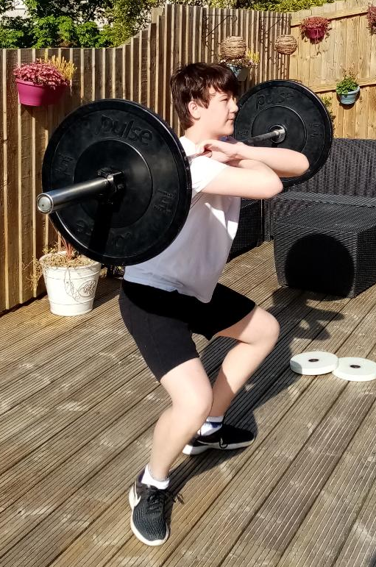  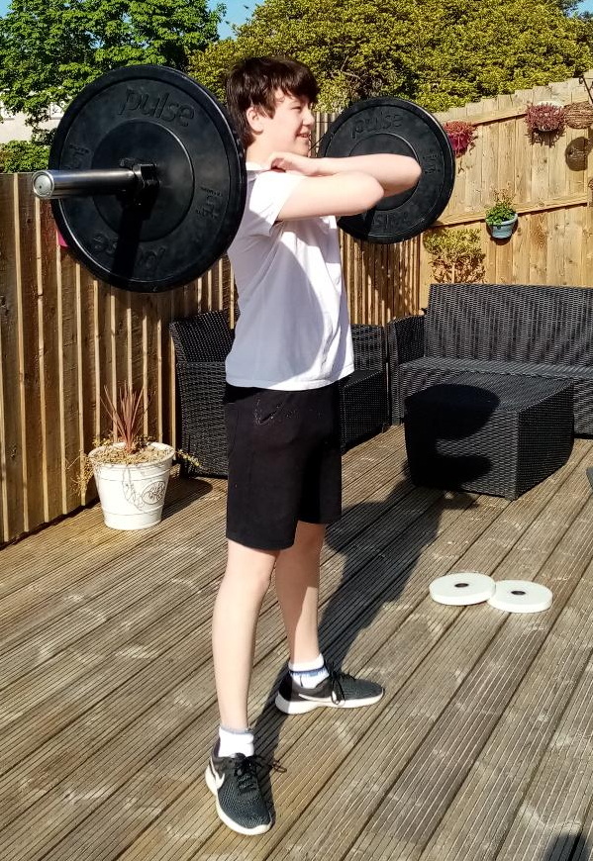 |  | Need to work on hand hold and depth, using shoulder hold for the now | 25kg | 3 | 3 | 25kg | 6 | 3 | 25kg | 8 | 3 | 25kg | 10 | 3
Hanging Clean Pull | 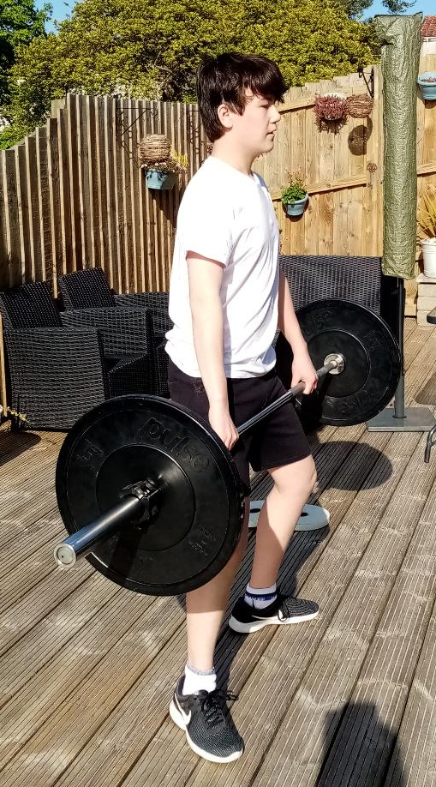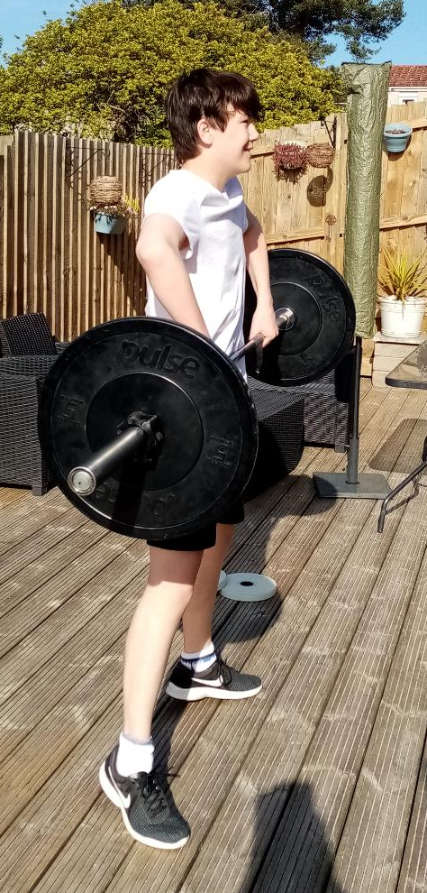 |  | Need to work on Strength | 25kg | 5 | 3 | 25kg | 8 | 3 | 25kg | 10 | 3 | 35kg | 5 | 3
Hanging High Pull | 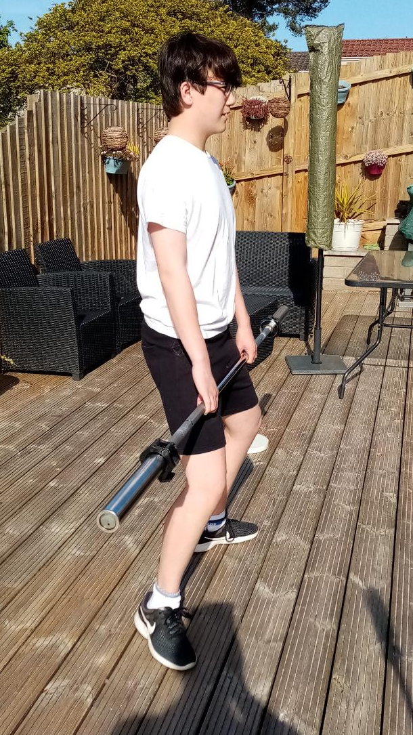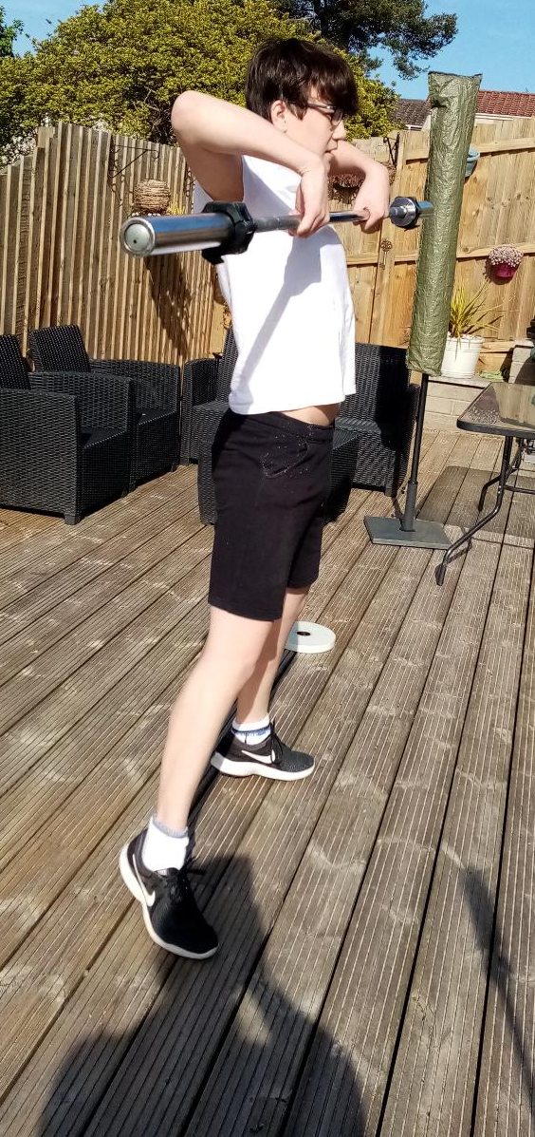 |  | Need to work on upper strength | 15kg | 5 | 3 | 15kg | 8 | 3 | 15kg | 10 | 3 | 25kg | 5 | 3
Push Press | 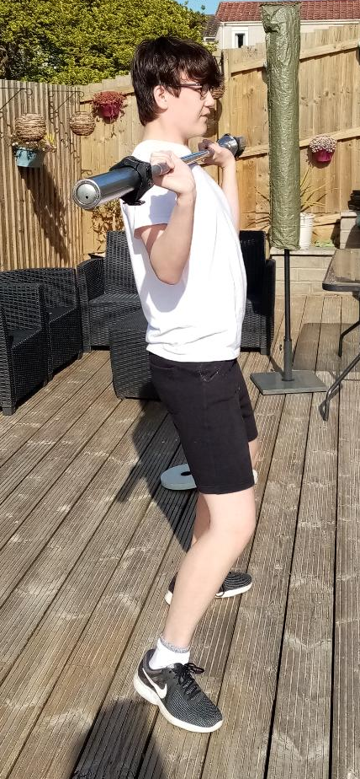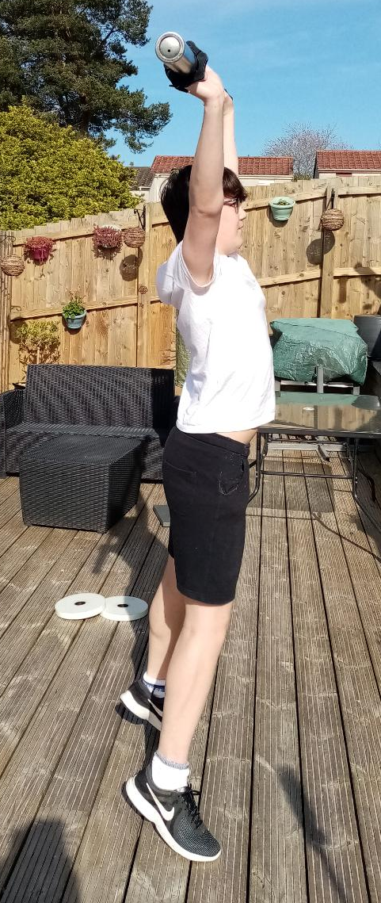 |  | Need to work on co-ordination, balance and core strength | 15kg | 3 | 3 | 15kg | 6 | 3 | 15kg | 8 | 4 | 15kg | 10 | 3
Cool Down: static stretching 5-10mins

