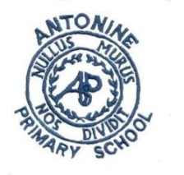
Antonine Primary School
Pupil Learning Conversations Group
Focus of the walk
- Numeracy and Maths learning
- Number strategies and practical tools
- Numeracy Displays
- Pupil work and discussion
Numeracy – Maths focus  What have you learned in maths so far?  What is the focus this term?  Number/Maths topics  What is the theme? | What do you see?  Walls, pupil response, teacher input, corridors, effective working classrooms, resources, interactions. | What do you hear?  What is everyone doing?
Numeracy Wall
Helpful supports
Evidence of pupil work

How is this used in lessons?

Pupil Discussions

What do you do for maths in class?
What have you learned so far?
What are your next steps in maths?
What do you think about maths?
How can maths be improved?
What would help you in Maths/what would you like to change?

Evidence

Pupil work
Display
Posters
Weekly Planning

Feedback:

