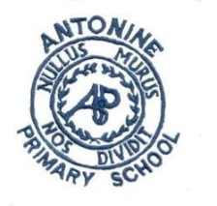
Antonine Primary School
Pupil Learning Conversations Group
Focus of the walk
- Literacy focus
- Pace and Challenge within spelling & grammar
- Literacy Displays
- Talk 4 Writing experiences
- Pupil work and discussion
Literacy focus  What have you learned in literacy so far?  What is the focus this term?  What is the theme? Talk 4 Writing genre | What do you see?  Walls, pupil response, teacher input, corridors, effective working classrooms, resources, interactions. | What do you hear?  What is everyone doing?
Literacy Wall
Helpful supports
Evidence of pupil work

How is this used in lessons?

Pupil Discussions

What do you do for literacy in class?
What have you learned so far?
What are your next steps in literacy?
What do you think about literacy?
How can literacy be improved?
What would help you in Literacy/what would you like to change?

Evidence

Pupil work
Display
Posters
Weekly Planning

Feedback:

