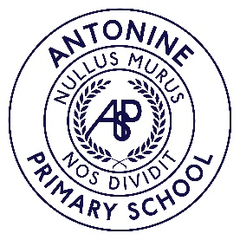**Antonine Primary School**

Dream, Believe, Achieve

What a Good Lesson Looks Like.....

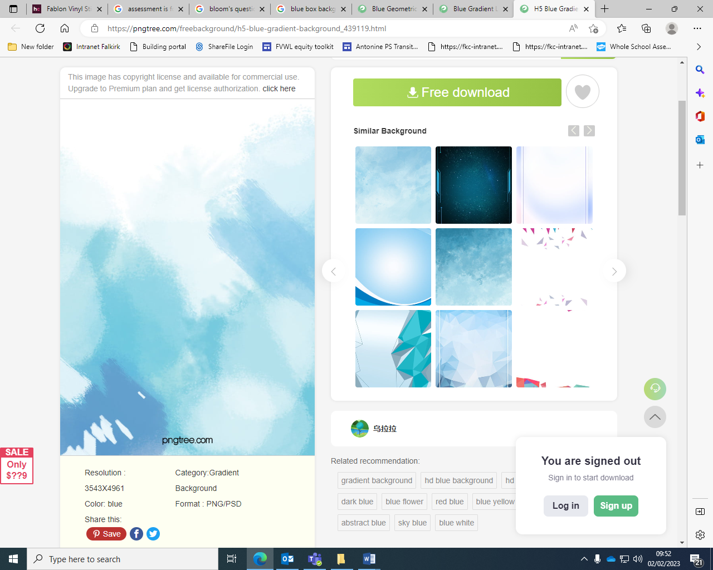

|  |  |  |
| --- | --- | --- |
| **Planning**   * Is responsive, progressive and has depth * Learning and Success criteria co-created * Pupil voice evident – personalization * Cross curricular links evidenced * Using the pathways, experiences and outcomes to develop next steps * Totality/Breadth of the curriculum * Differentiation built in * Opportunities for moderation | **Meeting Learner’s Needs**   * High expectations and aspirations for all * Differentiation, pace and challenge * Pupil voice * Sharing and evaluating next steps – pace and challenge * Appropriately resourced * Using SFLA support effectively * Learning styles considered * Homefiles/Jotter expectations * Self-reflection | **Learning Experiences**   * Based on GIRFEC principles and linked to RRS * Engaging & active * Play based * Collaborative * Outdoor * Digital approaches * stack of five books stack of five books / cartoon vector and illustration, black and white, hand drawn, sketch style, isolated on white background. black and white book stock illustrationsChild led * Highly engaging * Real life learning |
| **Assessment & Attainment**   * Summative and formative assessment used * Track & monitor regularly * Use of data * Pressure points * Benchmarks * Formative and summative assessment * On-going and responsive * Variety of assessment approaches * AiFL strategies used in lessons | **Skills Development**   * Learner journeys * Developing the Young Workforce * Skills for life, learning and work * Pupil leadership opportunities * Bundling approaches | **Visible Learning**   * Child led displays * Engaged, on task pupils * Variety of teaching resources * Independent learners * Self/peer evaluation * Effective feedback * Confidence in their ability and next steps * Restorative conversations/positive behavior support |

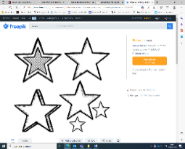

Enabling our learners to become...

Successful Learners Effective Contributors Confident Individuals Responsible Citizens