Falkirk Learning to Achieve Moderation Support Programme Session 2

We are looking forward to re-connecting at Session 2 of the Falkirk Learning to Achieve Moderation Support Programme. Over the course of the remaining 5 sessions we will be working in Trios. An online space has been set up for each Trio in the PLC Notebook of our Glow Teams Site.

The following planning and learner evidence has been supplied by a practitioner for us to use during session 2 as we familiarise ourselves with the digital approach to moderation and participate in a guided moderation task. The same planning and learner evidence is located in the session 2 section of each Trio in the PLC Notebook and we will spend time reviewing this live during session 2.

Please spend 30 minutes to familiarise yourself with the following moderation material and prompt questions on the comment sheet prior to attending Session 2. We will complete the moderation comment sheet during session 2 in groups so there is no need to do this beforehand. There are also short video clips hyperlinked which help to explain the task for each stage of the moderation cycle.

Moderation Material

Planning Learning, Teaching and Assessment

Choose the focus area / organiser(s) and a stimulus appropriate to your context.
First Level Literacy IDL Scotland Topic
- Literacy & English
- Social Studies

Stimulus – context and prior learning
Learners have been visiting the school and local library to explore a range of fiction and non-fiction texts. They have experience of reading non-fiction texts and have discussed key features of fiction and non-fiction texts. Learners are continuing to develop their reading skills in class (skimming/scanning/summarising). They have taken part in group discussions about what makes Scotland unique and why it is popular around the world.

Learners have experience of accessing the internet for research and using key words to search for information. They have explored some key features of persuasive language in writing and how information can be presented to persuade the reader.

Identify the relevant Experiences and Outcomes.

Reading
Finding and using information
Using what I know about the features of different types of texts, I can find, select, sort and use information for a specific purpose.
LIT 1-14a
I am learning to make notes under given headings and use them to understand information, explore ideas and problems and create new texts.
LIT 1-15a
Understanding, analysing and evaluating
To show my understanding across different areas of learning, I can identify and consider the purpose and main ideas of a text.
LIT 1-16a
Writing
Enjoyment and choice
I enjoy creating texts of my choice and I regularly select subject, purpose, format and resources to suit the needs of my audience.
LIT 1-20a
Social Studies
People, place and environment
I can describe and recreate the characteristics of my local environment by exploring the features of the landscape.

State learning intentions (which reflect standards within the Experiences and Outcomes).
- To be able to make notes and sort information into different categories/subheadings
- To be able to use reading tools (skim and scan for specific information)
- To be able to summarise key information from sources
- To be able to write using persuasive language
- To create an information piece about a country of my choice using previous notes
- To be able to choose the best way to present my work (leaflet/poster/PPT)

State success criteria (clear, relevant and measurable).

- I have created subheadings of the information I want to find out about (culture, language, traditions, history, famous people etc.)
- I have used several sources of information
- I have selected the information I need for my subheadings
- I have used my own words to explain information in each subheading
- I have used words in the present tense
- I have used words that engage the reader
- I have included the key features of information text (title, subheadings, pictures, key information, colourful)

Upload planning for learning, teaching and assessment (include details of ongoing or periodic assessments) which allows the learner to demonstrate progress, breadth, challenge and application.

Assessment Activity
- Read and select information about Scotland from a range of non-fiction sources (texts, online, videos) and note relevant and factual information. Provide a summary of the information to explain why Scotland is a good place to visit.
- Produce a poster/information sheet using previous notes about a country of their choice (unfamiliar text/information).

Learner Evidence

Please upload (anonymised) evidence of the learners work, including any feedback given to the learner.

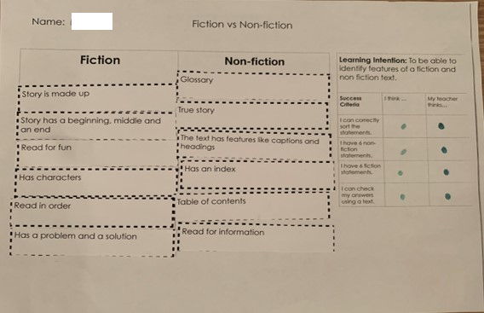

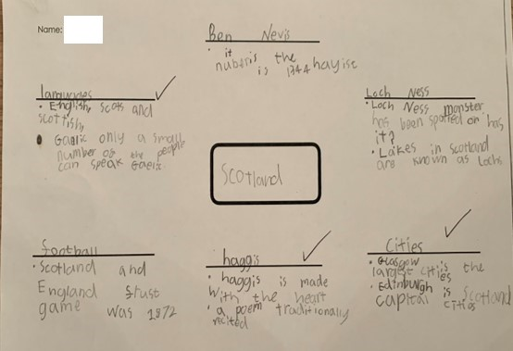

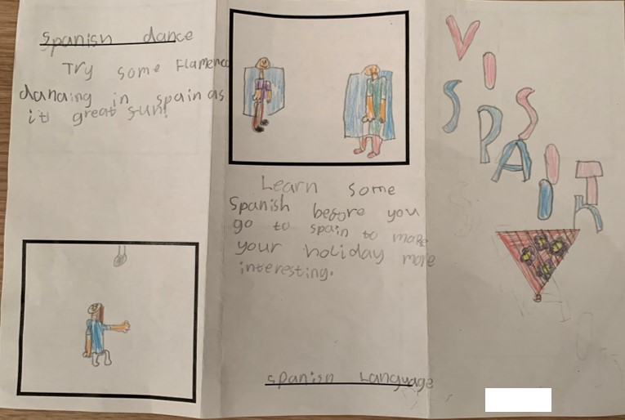
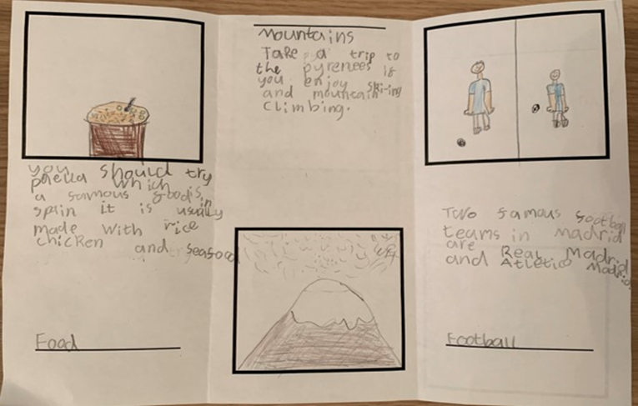

Please provide an evaluative statement including comments on strengths and areas for improvement for this learner.
Strengths: The learner was able to demonstrate an understanding of the features of different types of texts. They were able to use taught reading skills to find, sort and summarise key information from various sources. The learner was able to apply reading skills across the curriculum.

Next steps: The learner needs to continue to develop their understanding of persuasive language and how to engage the reader through the presentation of their information text. This will continue to be developed through further experience of persuasive writing.

Moderation Comment Sheet

Please review all of the above information and consider the following prompt questions for each stage of the moderation process. Enter your comments in the table below and state NA for any sections where planning or evidence is not available. A few of the headings have hyperlinks to short video clips which provide an explanation of the task for certain stages of the moderation cycle.

Prompts | Group comments:
Four Contexts for Learning
Did the task come from one of the 4 contexts for learning?
- Ethos and life of the school
- Curricular areas
- Interdisciplinary learning
- Opportunities for personal achievement
Experiences and Outcomes
Do the E&Os link concepts appropriately?
Are they taken from a range of organisers?
What is the main curricular area focus?
Does the task focus on another curricular area/s?
Learning Intentions and Success Criteria
Learning intentions
Do these reflect the expected standards within the Es and Os and Benchmarks?
Success Criteria
Are they clear, relevant and measurable definitions of success?
Learning, Teaching & Assessment
Is there a range of learning experiences?
How did this assessment allow the learner to demonstrate progress, breadth, challenge and or application? Is it at the appropriate level?
Does the task enable the teacher to gather information against the set criteria?
To what extent does the task promote higher order thinking skills?
Analysing
Applying
Creating
Understanding
Remembering
Evaluating
Evidence
Is there a range of appropriate evidence which demonstrates breadth, challenge and application?
Evaluate
Does the teacher’s evaluation of learning reflect the standards within the Es and Os and benchmarks?
Feedback & Next Steps
Feedback
Is the feedback appropriate to the SC?
Would it be helpful to learners?
Next Steps
Are the next steps appropriate?
Do they relate directly to success criteria and consider progress, breadth, challenge and application?
Reporting
Are the reporting comments appropriate?
Are they in plain English?
General comments
Please enter any general comments you would like to share here.

