Introduction 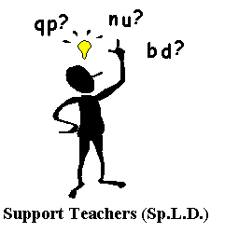

The Support Teachers (Sp.L.D.) have devised a systematic programme for the daily reinforcement of phonic patterns, to be used in conjunction with the Phonic Code Cracker programme.

INSTRUCTIONS

- A word wall has been created for each different phonic pattern.
- The word wall is to be used on a daily basis, with a tick recorded in each box by class teacher/S.L.A./parent, for each correct response.
- Only 1 tick per box per day is to be recorded.
- When box has 3 consecutive ticks, it is assumed that pupil can read the pattern.
- Pupil can colour box in or put on a sticker.
- Pupil cannot move on to next word wall until all boxes have 3 ticks.
- Appropriate pages from PCC, which will reinforce each pattern, are indicated.
- A page of nonwords or mixed up patterns has been included in each level for further practice.
- The programme can be downloaded from the Support Teachers (Sp.L.D.) glow group.

