Activity Sheet 1
Robert Burns Timeline
Can you add any more details/pictures to the timeline.
Born in Alloway in Ayrshire on the 25th of January 1759  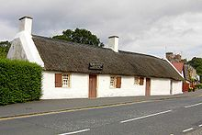 | Wrote his first song ‘O Once I Lov’d a Bonie Lass in 1774 | His father died in 1784 | He met Jean Armour in 1785 and wrote ‘To a mouse’.
In 1788 he wrote ‘Auld Lang Syne’. | In 1790 he wrote ‘Tam O’Shanter’ 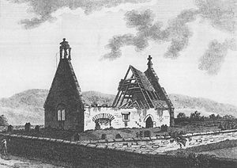 | In 1791 he wrote ‘Ae fond Kiss. | In 1796 he died in Dumfries aged 37.  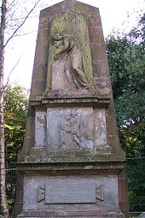

Activity Sheet 2
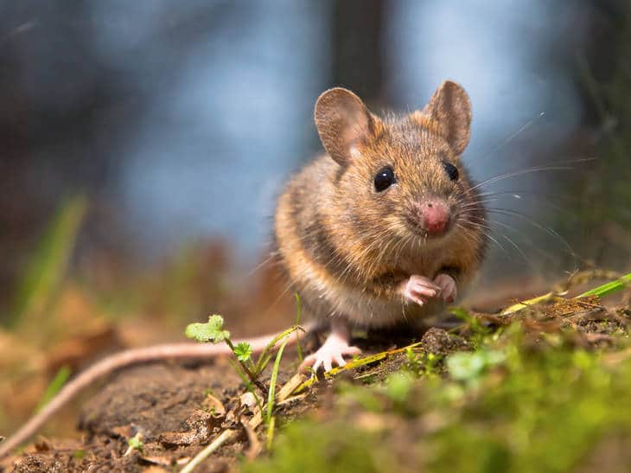
This Photo by Unknown Author is licensed under CC BY-SA
To a Mouse by Robert Burns- First verse

Wee, sleekit ,cowrin , tim’rous beastie
O, what a panic’s in thy breastie!
Thou need na start awa sae hasty,
Wi’ bickering brattle!
I wad be laith to rin an’ chase thee ,
Wi murd’ring prattle!

Translation
Small, crafty, timorous little beast,
Oh what a panic is in your little breast!
You need not start away so hasty,
With argumentative chatter!
I would be loath to run and chase you,
With murdering plough-staff.

Robert Burns wrote a poem all about a mouse. Can you write a poem about a pet or an animal which you like.

Activity Sheet 3
Charles Rennie MacIntosh was a famous Scottish artist. He was very famous all over the world for his beautiful designs.
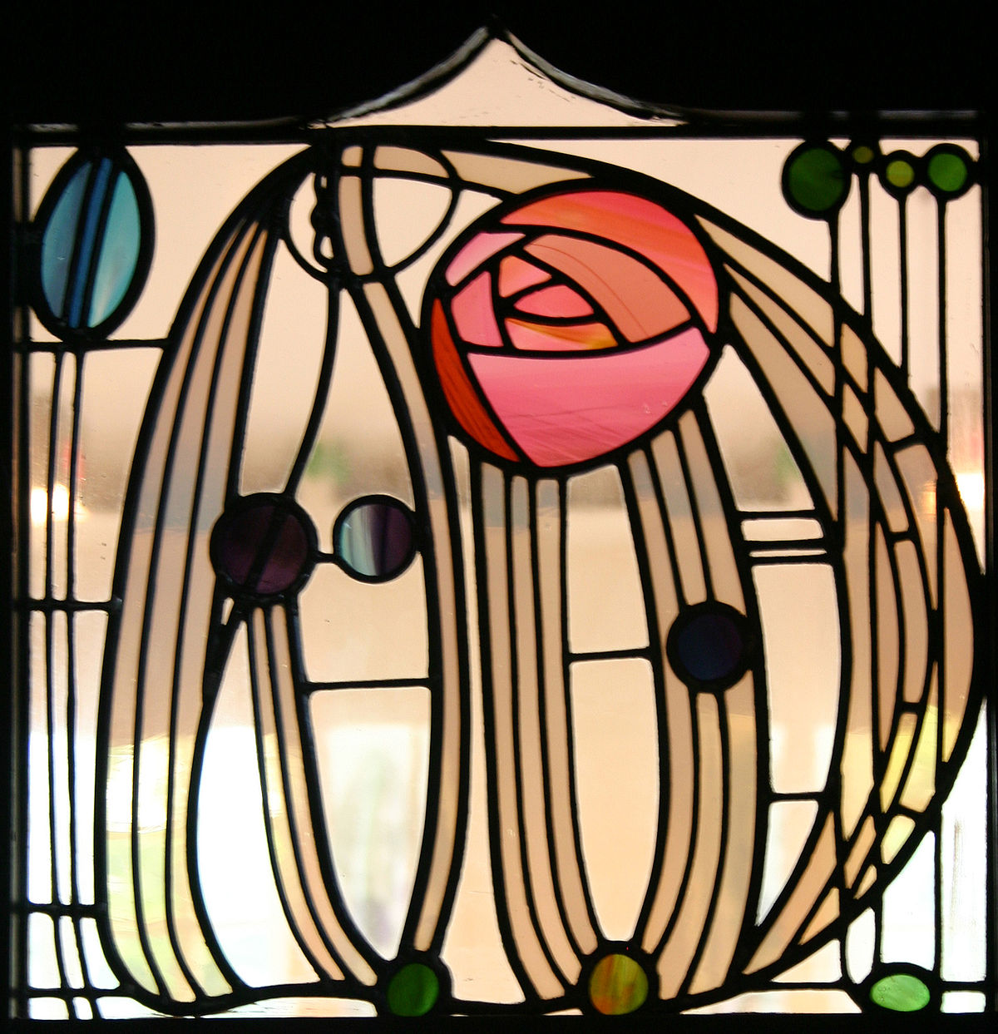

Can you make a picture using Charles Rennie Mackintosh’s designs.

Activity Sheet 4
Here are some famous Scots. Can you find out what they were famous for?
Alexander Fleming | 1881-1955 | Doctor
Andy Murray | 1987- | Sportsman
Denis Law | 1940- | Sportsman
James Watt | 1736-1819 | Scientist/ Engineer
John Logie Baird | 1888-1946 | Inventor
Robert Burns | 1759-1796 | Poet

Activity Sheet 5a
Scots Words - Match the Scots word with its meaning.

auld cold wet day

bairn beautiful

ben old

braw fine

bonnie afraid

dreich mountain

drookit child

feart soaking wet

Activity Sheet 5 b
Read this well-known Scottish nursery rhyme
Wee Willie Winkie

Wee Willie Winkie
Running thru’ the toon
Up the stair, doon the stair in his nichtgoon
Rapping at the windae, crying at the lock,
Are all the bairnies in their beds,
It’s past eight o’clock

Can you find the meaning of the Scottish words in the rhyme

Scots Word | What you think it means | What it does mean

Activity Sheet 6
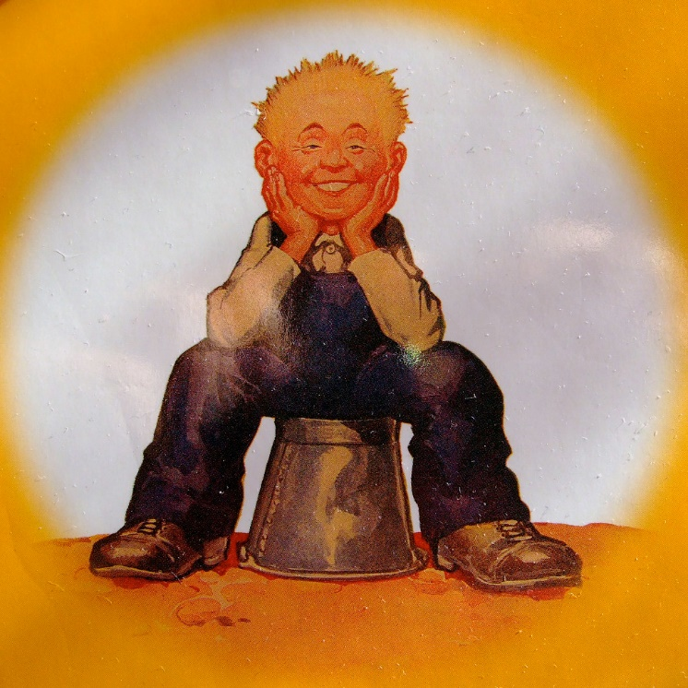
Oor Wullie is a famous Scottish cartoon character who is always getting into mischief with his friends.
Can you make up a cartoon about your adventures with your friends.
Activity Sheet 7
Scots Songs
We learn many Scots songs as children. This is one of them.

Oh ye Cannae Shove yer Granny Aff a Bus

Oh, ye cannae shove your granny aff a bus
Oh, ye cannae shove yer granny aff a bus
Ye cannae shove yer granny, fer she’s yer mammy’s mammy
Oh ye cannae shove yer granny aff a bus.

If you are not sure of the tune you could ask your parents, teacher or even your granny to sing it to you.
Can you write another verse about why you shouldn’t shove your granny off the bus?

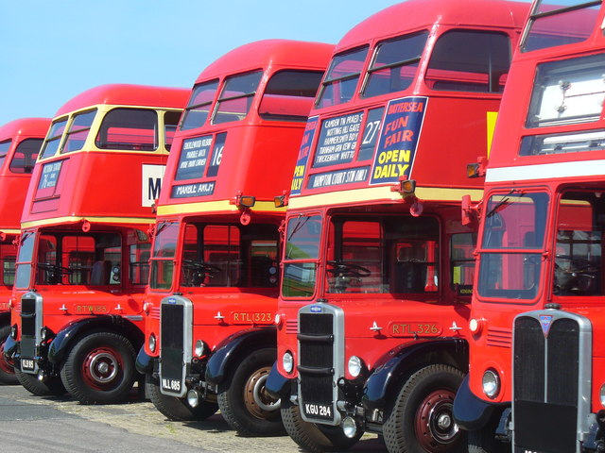

Activity Sheet 8
We have many animals which live in Scotland . Here are just a few of them

Adder | Snake - Reptile | Lives in woodland | Eats small mammals,and birds.
Badger | Mammal | Lives in burrows | Eats worms, birds eggs, fruit and bubs
Brown Hare | Mammal | Lives in grassland and woodland | Eats plants and tree bark
Common frog | Amphibian | Lives in ponds, woodlands, gardens and hedges. | Eats insects like snails, slugs and worms.
Bat - Common Pipstrelle | Mammal | They are nocturnal and live in roof spaces in houses. | Eat flying insects
Grey Seal | Mammal | Live in the sea, on rocks and on the seashore | Eat fish
Otter | Mammal | Live in burrows near water | Eat amphibeans , birds and fish.
Pine Marten | Mammal | Live in woodlands in holes in tress or old birds nests. | Eat berries, birds, insects and small mammals.
Red Deer | Mammal | Live on mountains, moorlands and grasslands | Eat grass and plants

Can you make up a factfile for your favourite animal?

Activity Sheet 9
Castles - There are many different parts to a castle.

The Keep- Main building for living in.
The Moat- A ditch filled with water around the castle to keep invaders out.
The Drawbridge- It fitted over the Moat to let the King and Queen into the castle.
The Portcullis- A gate which could be lowered to stop people crossing the drawbridge getting into the castle.
The Tower- Used for guards to watch for people coming and sometimes these were used for keeping prisoners.
Arrow Loops- Narrow slits cut into the stone towers to allow archers to fire on their enemies.
Battlements-Blocks on top of the castle walls to protect guards from incoming arrows but lets them see over the land.
Use your imagination to design your own castle and try to label all the different parts.
