Examples of Travel Diaries

[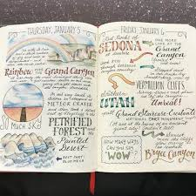](https://www.google.co.uk/url?sa=i&url=https%3A%2F%2Ftravelwithmeraki.com%2Ftravel-bullet-journal%2F&psig=AOvVaw3Q9FPrXQ1vpMj0yZRBHkhk&ust=1589645217826000&source=images&cd=vfe&ved=0CAIQjRxqFwoTCOjopYmgtukCFQAAAAAdAAAAABAD)

[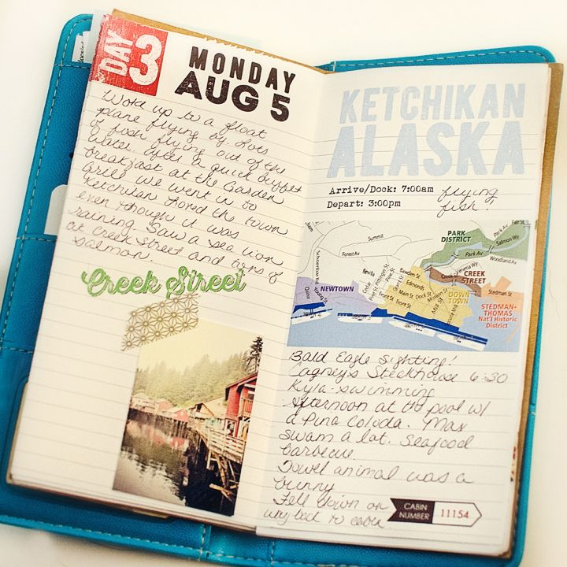](https://www.google.co.uk/url?sa=i&url=https%3A%2F%2Fathletesabroad.wordpress.com%2F2014%2F01%2F01%2Fthe-art-of-keeping-a-travel-journal%2F&psig=AOvVaw3Q9FPrXQ1vpMj0yZRBHkhk&ust=1589645217826000&source=images&cd=vfe&ved=0CAIQjRxqFwoTCOjopYmgtukCFQAAAAAdAAAAABAb)