OUR DREAM HOLIDAY FAMILY LEARNING PACK – Digital Version

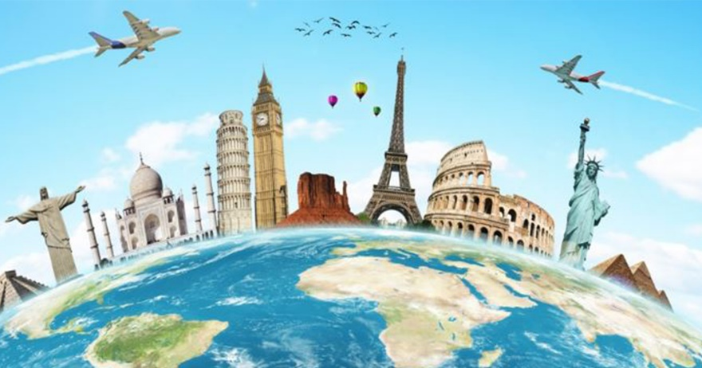
This booklet will help you learn from your pretend
tour of 3 cities.

Open up to follow the Our Dream Holiday Plan
and task sheets
We hope you enjoy learning with your family

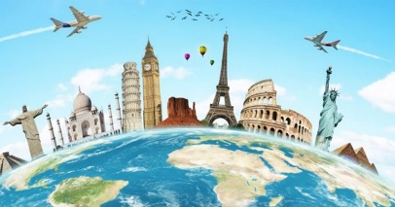

Our Dream Holiday Plan
THIS BOOKLET COMBINES A WHOLE PLAN OR PATHWAY OF LEARNING WITH TASK AND ACTIVIY SHEETS (see the little ovals plan pathway on the next page). IT IS DESIGNED TO BE USED EITHER BY INDIVIDUAL CHILDREN OR BY FAMILY GROUPS LEARNING TOGETHER.
ALTHOUGH NONE OF US CAN TAKE A REAL HOLIDAY RIGHT NOW, WE CAN USE OUR IMAGINATION TO PLAN A DREAM. HOLIDAY WHICH DEVELOPS OUR LITERACY SKILLS – reading, writing, talking and listening plus:
- Planning and putting ideas and events into order
- Communicating and working as part of a team
- Finding information for specific purposes (research skills)
- Making informed decisions
- Responding to other peoples’ ideas and feelings
- Practising other languages
- Reading and understanding a variety of different kinds of text
- Writing, typing or creating texts for a various real-life purposes
The diagram below show you other skills across the curriculum which this booklet will help your child develop
Other languages – practise & improve your second or even third languages
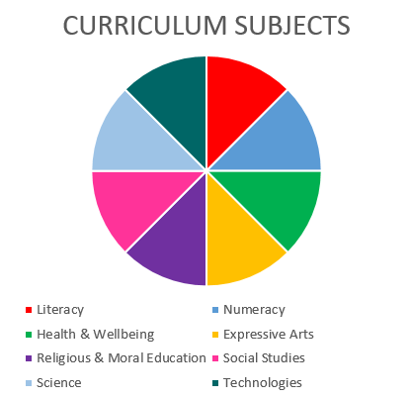
Lots of literacy – talking, listening, reading and writing

Social Studies – people, places, culture, events & traditions
Expressive Arts – Art, Drama, Music, Dance
Numeracy – adding, subtracting & budgeting

Our Dream Holiday Plan Pathway
Start here & follow the arrows. Use the files in the pack to do each task

We think a holiday is – type or write your answer in the box below

Use this space to draw or write about your favourite family holiday or day out.

Use this page to write down what you know or can find out about how the coronavirus is affecting the lives and the holidays of people all over the world?

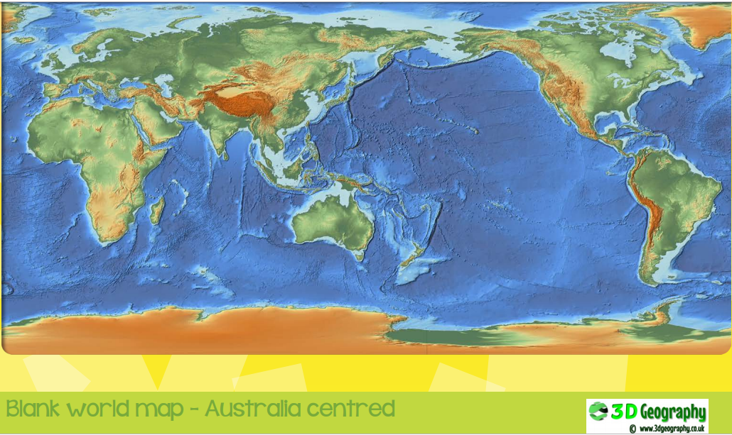

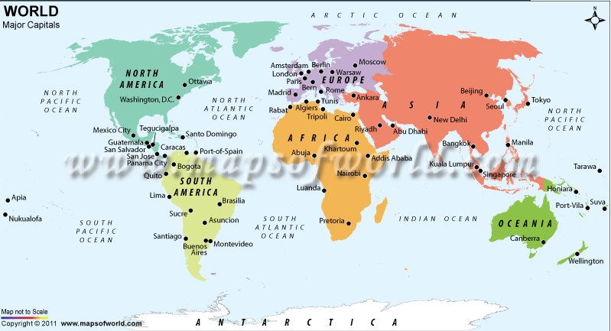
Map from https://www.mapsofworld.com/world-major-capital.htm
Your family have won a (pretend) dream holiday! Which 3 cities in the world could you go to?
Talk with your family about the cities you know write these as a list – can you say which countries they are in?
City we know about | The country these are in

Let’s get planning

What do we know about cities of the world?
- Read the city brochure or open the city file links from the blog to find out more about some of the cities of the world . Use the space below to take notes about the ones you are interested in.
- Use the space below to write your explanation of which 3 cities your family want to go to. Remember to give reasons for your choices
Cities we want to visit | Our reasons

- Find out more about your cities using books or the internet if you want to.

Transport – How will your family travel to each city?
Method of transport | Advantages? | Disadvantages?
Car
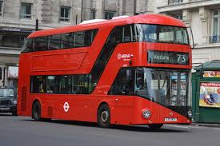
Bus
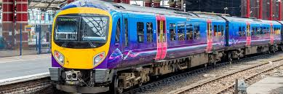
Train
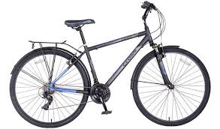
Bicycle
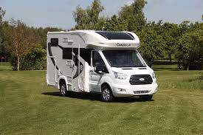
Motorhome

Method of transport | Advantages? | Disadvantages?
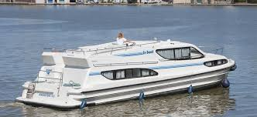
Boat
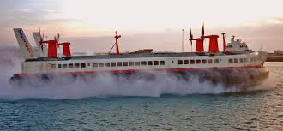
Hovercraft
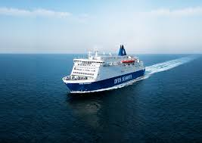
Ferry
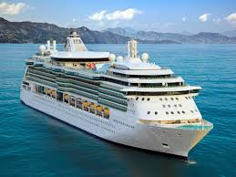
Cruise Ship
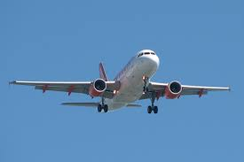
Aeroplane

Our family will travel from home to our first city by

We will then travel from our first city to our second city by
Draw a little picture of you travelling if you like
To get from our second city to our third city we will
and then to get home we will travel by
We are looking forward to travelling by
most of all because

Browse through these types of holiday accommodation and think about which suits your family best?
Type of accommodation | What we like? | What we dislike?
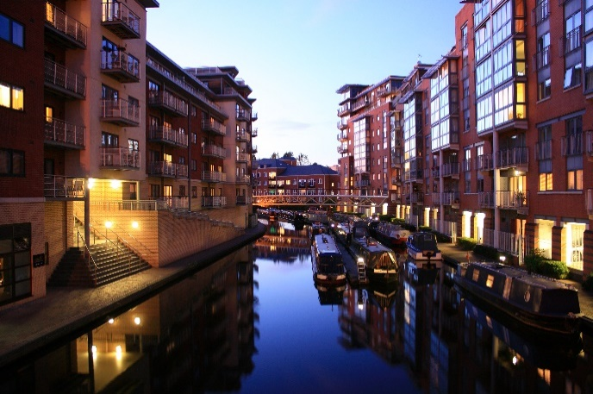
Self- Catering accommodation
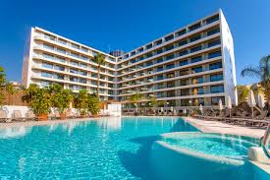
Hotel

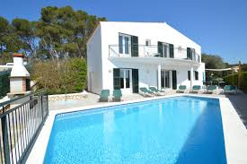
Villa

Type of accommodation | What we like? | What we dislike?
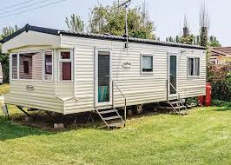
Caravan
Motorhome
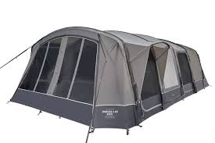
Tent
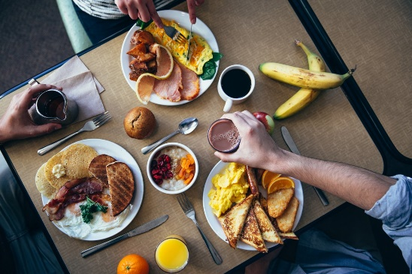
Bed and Breakfast

What are your decisions about accommodation? Where would your family like to stay in each city?
City | Type of accommodation | Reasons for choosing

Planning what your family wants to do in each city
Now that you have decided which cities to visit, how to travel and where to stay, take another look at the fact files and begin to plan what you want to do. Use the space below to take notes or draw a little diagram or picture of your plans.

Oh No – How much will this cost?
- Use the information on the next page to find out how much things cost in pounds Sterling.
- Use the budget planner on the page after that to estimate how much your holiday could cost
The good news is that your family has an imaginary £12000 to spend !!! Will that be enough?

Holiday Price List – use this to help you estimate costs and create a budget for your trip
Purchase | Cost per person
Visit to museum | £5
Visit to cathedral | £7
1 visit to theme park | £8
Theme Park Pass [unlimited visit] | £25
I bus trip | £2
Bus Pass [unlimited travel ] | £10
Boat Trip | £12
Lunch in a cafe | £3
Lunch in a hotel | £5
Dinner in a hotel | £10
Can of Juice | £2
Bottle of water | £3
Small souvenir | £6
Large Souvenir | £8
Bike hire | £9
Segway trip | £11
Guided walk | £7
Entry to swimming pool | £4
Entry to botanical gardens | £8
Entry to zoo | £10
Hire a sunbed | £5
Hire a beach towel | £3
Small Ice cream | £1
Large Ice cream | £3
Hotel room 1 night | £100
Hotel room 1 week | £650
Caravan 1 night | £25
Caravan 1 week | £125
Tent Hire per week | £60
Self- catering accommodation per week | £500

YOUR DREAM HOLIDAY BUDGET PLANNER AND TRACKER –Use this sheet to estimate your costs BEFORE you go and track your spending WHEN YOU ARE ON HOLIDAY
OUR HOLIDAY ITINERARY | HOW MUCH WILL THIS COST  Use the cost sheet to add in your costs below | OUR BUDGET TOTAL –Subtract (take away) your estimated costs from your  £12 000 budget | When your holiday begins, use this column to keep track of your running total –what you spend and how much you have left
Preparing for our holiday

Getting from home to our first city

Transport
Food
Accommodation
Other expenses
Our first city is

Travelling in and around the city
Food
Accommodation
Entertainment – tickets to shows, admission fees, etc.
Other
Getting from city 1 to our next city

Transport
Food
Accommodation
Other expenses
Our second city is

Travelling in and around the city
Food
Accommodation
Entertainment – tickets to shows, admission fees, etc.
Other expenses

Getting from city 2 to our next city

Transport
Food
Accommodation
Other expenses
Our third city is

Travelling in and around the city
Food
Accommodation
Entertainment – tickets to shows, admission fees, etc.
Other expenses
Travelling home

Transport
Food
Accommodation
Other expenses
Write your estimated costs in the next box across

Write how much of your money you think you might have left at the end of your holiday in the next box across

If you use the end column (yellow) to write down how much you have left each day of your holiday then you should end up with a total of what you have left at the end. Is this the same as your estimate or was your actual spending more or less than your estimate?

Your Holiday Itinerary
Now that you have worked out your costs, you can create your holiday itinerary. There is an example of a holiday itinerary below. It shows what the people on holiday plan to do each day – where they will go, how they will get there, etc. This family have even noted special costs or things they need to remember to help them see all that they want to see.
Use the blank version on the page after to create your own family holiday itinerary.
There is a blank page too in case you want to create a different layout.

Holiday Itinerary – Example to help you
Day | Travel/what to see | Info
1 | Fly Edinburgh Airport to London Heathrow  Fly London Heathrow to Rome (Fiumicino)  Leonardo Express train to Termini Station, Rome  Smart Hotel, Piazza Indipendenza
2 | The Colosseum  Roman Forum and Palatine Hill | Pre book tickets and additional gladiator tour  Free with Colosseum ticket
3 | Museo Nazionale Romano  Trevi fountain  Pantheon | Pre book tickets  Free  Free

4 | Vatican City walk  Castel Sant’Angelo  Piazza Navona | Look for viaduct on walk  Pre book tickets  Free
5 | Day trip to Ostia Antica  (Take metro line B and change at Piramide) | Pre book tickets
6 | Leonardo Express train from Termini Station to Rome (Fiumicino) Airport  Fly Rome to Paris (Charles de Gaulle)  Train (RER B) to Gare du Nord  Hotel Mercure, Paris Gare du Nord La Fayette | Pre book 3 day Paris Museum pass
7 | Eiffel Tower  Big Bus, hop on, hop off Tour  Place de la Concorde  Champs-Elysees  Arc de Triomphe | Walk around  Free with museum pass  Free  Free  Free with museum pass
8 | Louvre  Sacre-Coeur and walk around Montmarte | Free with museum pass  Free
9 | Versailles  Take RER C from Paris to Versailles | Free with museum pass
10 | Day trip to Disneyland Paris from centre of Paris with transfers | Book through Francetourisme.fr

11 | Train (RER B) to Charles de Gaulle Airport  Fly Rome to Barcelona (El Prat) Airport  Aerobus to Barcelona centre (Placa de Catalunya)  Hotel Casa Volver, La Rambla, 129, 08002 | Just off Placa de Catalunya
12 | Casa Batllo  Casa Amatller and Casa Mila  Las Ramblas  The Gothic Quarter | Pre book tickets  View from outside and buy chocolate!  Free  Free
13 | La Sagrada Familia  Park Guell | Both sites free with Barcelona City Pass- pre book
14 | Camp Nou  (travel by Metro L3 Green) | Pre book tickets
15 | Aerobus from Placa de Catalunya to Barcelona Airport (El Prat)  Fly Barcelona to Edinburgh Airport

Holiday Itinerary – use this sheet to create your own trip to 3 cities
Day | Travel/what to see or do | Info
1
2
3
4

5
6
7
8
9
10

11
12
13
14
15

Blank page for different itinerary layout if you prefer.

Let’s get going!

Make a list of things you have to do to get ready for your holiday.
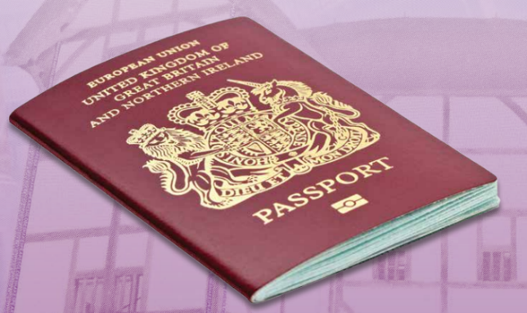 | This is the cover of a British Passport  (it will change soon because Britain has left the European Union)
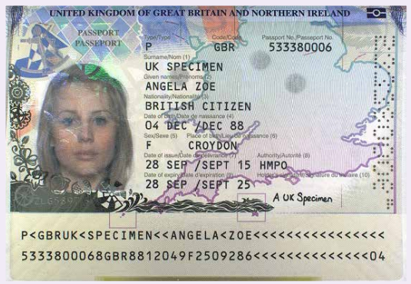 | This is the page where the person’s details are
These photos come from an Her Majesty’s Passport Office:
https://assets.publishing.service.gov.uk/government/uploads/system/uploads/attachment_data/file/473495/HMPO_magazine.pdf

Do you need to make a passport? (have a look at a real one if someone in your family has one, or use the template on the next page to create your own)

Passport Template
Draw/colour the box below to create the back cover
Draw/colour the box below to create the front cover

Draw/colour the box above to create a page for the inside front cover – your picture goes here
Draw/colour the box above to create a page for the inside back cover – your details go here

Talk to your family about anything else you need to prepare and make a list below. Maybe you want to do some drama to pretend you are buying a lovely new holiday outfit? Maybe you want to arrange a pretend taxi to the airport?
List of preparations for our dream holiday

When you are all packed and ready use the best safe space you can find to act out your pretend journey to your first city – you might want to move chairs so they look like an aeroplane, or dress up and use props.
Enjoy the journey!

City 1 Tasks
Start your holiday diary or scrapbook –you can use the format below – draw/insert a photo in one section and write/type in the other OR create your own
Your first diary entry should be about your journey, your accommodation and your first impressions of city 1

Look at your itinerary to see what you had planned to do in this city. Have fun pretending to do these things.
To help you say what you enjoyed, use the fact file to read about your city or look at books or the internet to find out more. Then add type or write down what you discover or learn from your research.
City 1 – what we enjoyed | What I learned from my research about this city
City 2 – what we enjoyed | What I learned from my research about this city

The language of city 1 – what do you know about this language?
- Have a conversation with your family to see whether you can use this language to communicate?

- What can you say and what could you ask for in this language?

- Practise saying the words and phrases you know, then use the grid on the next page to learn some more words and phrases.

- Have fun practising those too.

- Pretend you are enjoying your holiday in city 1 – which words and phrases will you need. Write these in the space below if you want to or maybe you will draw a comic strip with speech bubbles showing what you did and what you said?

Five Languages Vocabulary Table
English | German | French | Italian | Spanish
Hello | Hallo | Bonjour | Ciao | Hola
How are you? | Wie geht’s? | Ça va ? | Come stai? | ¿Cómo estás?
Goodbye  Cheerio | Auf Wiedersehen | Au revoir | Arrivederci | Adiós
please | bitte | s’il vous plaît | per favour | por favor
thank you | danke Schön | merci | grazie | gracias
Yes/No | Ja/Nein | Oui/Non | Si/No | Sí/No
I would like … | Ich möchte … | Je voudrais … | Vorrei … | Me gustaría …
Can I have … | Kann ich …. haben | Puis-je avoir | Posso avere | Puedo tener
an ice cream | ein Eis | une glace | un gelato | un helado
an orange juice | einen Orangensaft | un jus d’orange | un succo d’arancia | un zumo de naranja
a glass of water  a bottle of water | ein Glas Wasser  eine Flasche Wasser | un verre d’eau  une bouteille d’eau | un bicchiere d’acqua  una bottiglia d’acqua | un vaso de agua  una botella de agua
A cup of tea  A tea | eine Tasse Tee  einen Tee | une tasse de thé un thé | una tazza di tè  un tè | una taza de té  un té
A cup of coffee  A coffee | eine Tasse Kaffee/einen Kaffee | une tasse de café  un café | una tazza di caffè  un caffè | una taza de café  un café
chips | Pommes Frites | des frites | patatine fritte | unas patatas fritas
a cake | einen Kuchen | un gâteau | una torta | un pastel
a biscuit | einen Keks | un biscuit | un biscotto | una galleta
chocolate | die Schokolade | du chocolat | il cioccolato | el chocolate
toilet | die Toilette | la toilette | la toilette | el baño
What is …? | Was ist das? | Qu’est-ce que c’est ? | Cosa è ... | ¿Qué es?
Where is …? | Wo ist | Où est… ? | Dov’è ...? | ¿Dónde está …?
When is…? | Wann ist …? | Quand est … ? | Quando è …? | ¿Cuándo es…?
restaurant | das Restaurant | le restaurant | il ristorante | el restaurante
swimming pool | das Schwimmbad | la piscine | la piscina | la piscina

What is the food like in your first city?
Use the boxes below to draw or describe what you will eat for each meal and where will you eat it.
Meal | Where we will eat it
Breakfast
Lunch
Dinner

Maybe your family can eat some of the same food in real life too today?

City 1 to City 2!

Use the postcard template below to tell a friend or relative about your pretend holiday in city 1. You don’t have much space so will have to choose your words carefully

Use the blank box to draw the picture for the front of the postcard. What part of city 1 will you show?

Practise your drama skills by asking your family to act out the journey from city 1 to city 2. You might want to write a little script to structure the drama. Use the box to type/write your script or to plan your drama.
Type or write a sentence in the space below explaining how your drama worked out. What worked well, and what would you improve?

- Look at your itinerary for city 2.
- Choose the attraction you find most interesting
- Plan a new drama showing how the visit to this attraction goes. You can use what you learned from your other drama task to help make this scene even better.
- Use the space below for your script/plan OR
- You might prefer to write the story of your visit OR
- You might prefer to draw the story of your visit

Use the box below to type/write about or draw what you find out about special celebrations or festivals in your city.

What is the food like in your second city?
Use the boxes below to draw or describe what you will eat for each meal and where will you eat it.
Meal | Where we will eat it
Breakfast
Lunch
Dinner
Maybe your family can eat some of the same food in real life too today?

- Use this page to draw your experiences and adventures in city 2.
- Draw pretend “photos” showing where you went and what you did in city 2.
- Add speech bubbles showing you using the language of city 2.
- Go back to the language grid on page 70 and practise saying the phrases you will need in city 2.

City 2 to City 3!

Write another holiday diary entry about your holiday so far.

Write about or draw pictures of the special places and things in your third city – use the box below.
Use the grid on page 46 to practise the language spoken in this city. You might want to play at buying things in the shops, or asking for things in cafes.
My favourite word in this language is
I like this word because
Draw a picture in the box with a speech bubble which shows where you would use this word.

A souvenir is a little thing people collect or buy when they visit a place. It is usually a small, inexpensive gift for their closest friends or family to give them a feel for what the place was like. People buy souvenirs for themselves too - something special to remind them of their visit when they get home.
Do you have souvenirs in your house which other people gave you or your family? Spend some time looking at these and finding out about the memories they bring back to the people who bought them if you can. What do the souvenirs tell you about the places which were visited and the people who live there?
Use the table below or a sheet of paper to plan your souvenir buying – think about then add:
- What souvenirs do you want to gather or buy now that your pretend holiday is almost over?
- Who will you get souvenirs for?
- How much can you afford to spend – have you been filling in your budget tracker? If not, go back and do it now – I wonder how much you have actually spent?
Type or write it here - £
- Now write down how much of your £12000 is left
Type or write it here - £

Who will you buy a souvenir for? | How much can you spend? | What you’d like to buy that person?

What is the food like in your third city?
Use the boxes below to draw or describe what you will eat for each meal and where will you eat it.
Meal | Where we will eat it
Breakfast
Lunch
Dinner

Use the postcard template below to tell a friend or relative about your favourite part of this dream holiday.

Use the blank box to draw the picture for the front of the postcard. What part of your dream holiday will you show?

Imagine that you are on your way home now. What will you type/write on the last page of your holiday diary? Can you summarise the highlights of your holiday?

Enjoy acting out your journey back home – we hope you enjoyed your pretend dream holiday to three wonderful cities.

Your final task is to think about and show what you learned from this storyline
Tick or draw in the boxes of the table below to show how you feel you have progressed with each skill.
The skills you have developed or learned | How you feel you got on with these skills
How to have fun together as a family
How to take control of your own learning
Reading and understanding different texts
Finding information using different texts
Writing interesting and creative texts of your own
Communicating information clearly
Communicating ideas and information creatively (through your playing, drawing, drama, etc.)
Reading, listening to and saying words and phrases from other languages
Planning how to order and organise events
Making and using a budget to track spending
Learning about cities of the world – write in the space opposite, or tell a family member one short, favourite fact about each of your cities – you could make up a quiz for each other if you like? | - ?  - ?  - ?
Use this space to write or share what you liked best about this family learning storyline
(You can Tweet us using the #LiteracyAtHome hashtag if you want to)

THE END

