OUR DREAM HOLIDAY
FAMILY LEARNING PACK
BROCHURE OF CITIES
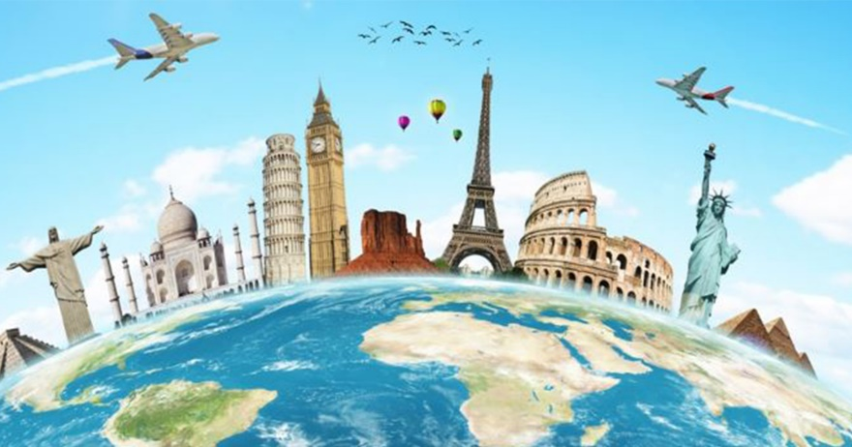

Browse this booklet to help you
learn about cities of the world.

Open up for a spot of city research …

Barcelona in Spain
https://school.eb.co.uk/levels/intermediate/article/Barcelona/273106 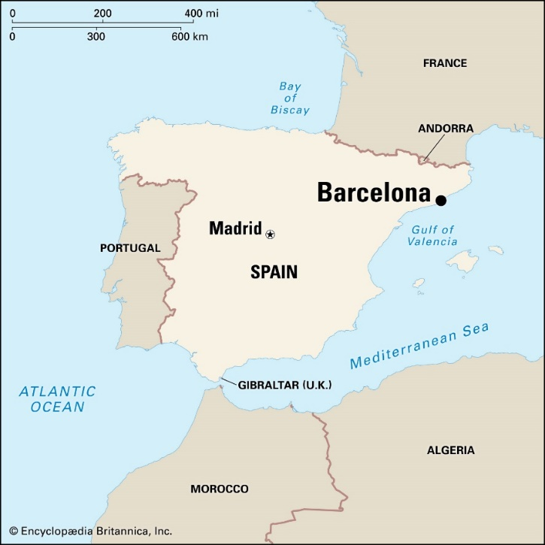
Barcelona is Spain’s greatest seaport and across the Mediterranean Sea toward the islands of Majorca and Sardinia. It is in the heart of a region called Catalonia and is set between scenic mountains and the Mediterranean Sea.
The average annual temperature is 61 °F (16 °C); January is the coldest month, averaging 49 °F (9 °C), and August is the hottest, at 76 °F (24 °C).
Public transport includes buses, subways, railways and cable cars.
The city is a major cultural centre with a remarkable history. Many famous architects and artists studied in Barcelona and their art and buildings can be seen around the city, for example the Casa Batlló, Casa Milá and Güell Park. There are super museums to visit like the National Art Museum of Catalonia, the Maritime Museum and the Waxworks Museum.
The most popular street in the town is La Rambla, a tree-lined pedestrian mall, stretching from the city centre to the harbour. It is full of life and you can see artists and acrobats, you will find many restaurants and cafes, as well as a large public market and shops.
On the waterfront there is a beach, marina and places to eat and there is a zoo in Ciutadella Park.

Places to visit-Barcelona
- Basilica de la Sagrada Familia
Church built by Gaudi which has 18 spindly towers.
- Barri Gòtic (Gothic Quarter)
Visited by Christopher Columbus, this area has been occupied for the past 2000 years. A good place to sit in the fresh air and eat lunch.
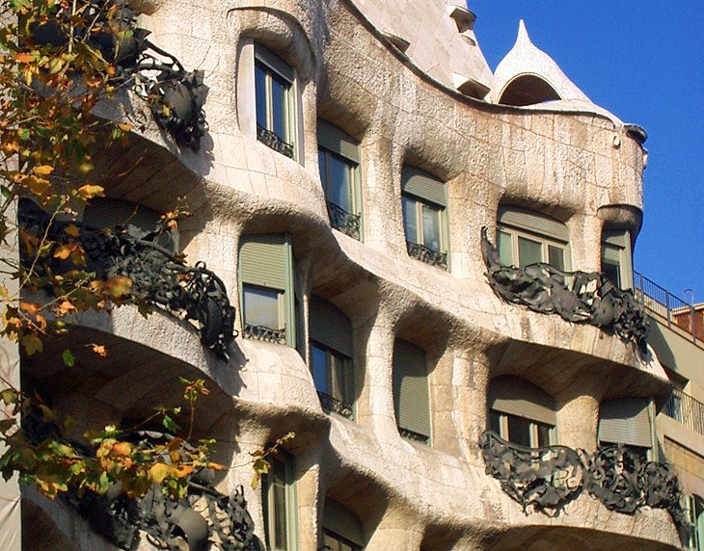
- Casa Mila
This building was built between 1906 and 1912 by Gaudi. The front of the building is all curved. You can walk around the roof to look at mosaics on the chimneys.

- La Rambla
Is in the old part of the town. It is a wide tree lined street and is a great place to visit the shops and eat lunch in one of the cafes or restaurants.
- Palace of Catalan Music
Built between 1905 and 1908 as a concert hall for the choral society Orfeó Català. The inside and outside of the building are both decorated to celebrate the music which is played here.
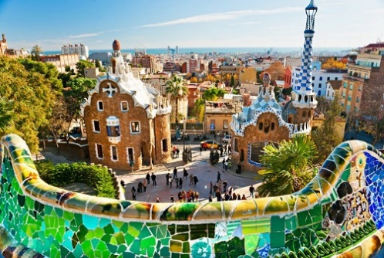
- Parc Guell
This large park has lots of things to see like viaducts and grottoes. They are all decorated in bright colours and it is a great place to get a view over the city.

- Casa Battlo
This beautiful building is famous for the way it looks . It has lots of colourful tiles on the outside and has lots of strange shapes around the windows which look like plants and caves.
- Camp Nou
This is the home of the FC Barcelona, the 99,354-seat stadium is the largest in Europe and second largest in the world. You can see a game here or take a tour and visit the museum. Camp Nou was one of the venues for the 1992 Summer Olympics in Barcelona.
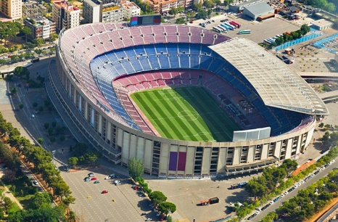
- The Magic Fountain
One of the favorite things to do in Barcelona at night is to watch the Magic Fountain. It was built in 1929. It has light and water shows set to music.
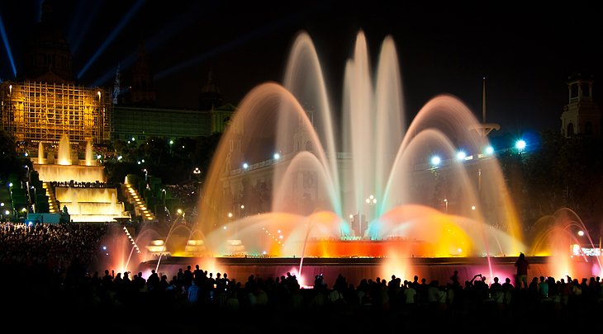
- Art Museum
This part of the city is known for its beautiful natural park with great views and superb museums including the National Art Museum of Catalonia.

Munich, Germany
https://school.eb.co.uk/levels/intermediate/article/Munich/275981 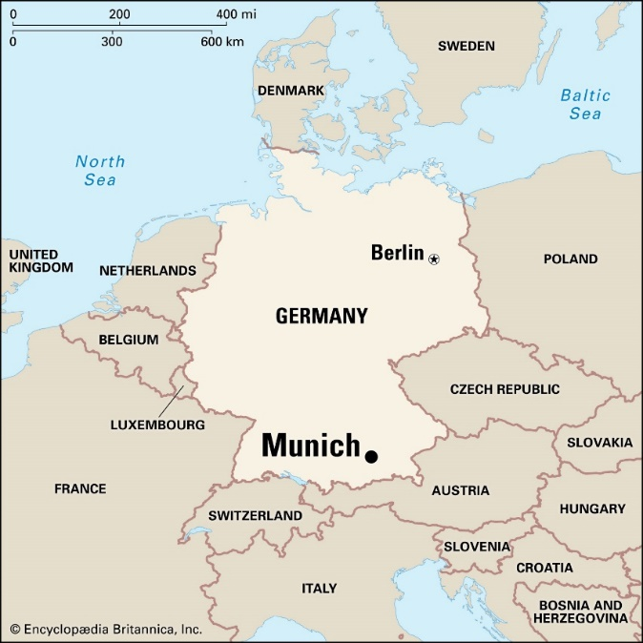
Munich is the capital of the state of Bavaria and is one of Germany’s largest cities. It is known as the “gateway to the Alps” and is also one of Germany’s most popular tourist sites. It is located in the South of Germany near the Austrian border, along the Isar River. Its German name is München.
July is the hottest month in Munich with an average temperature of 17.5°C (64°F) and the coldest is January at -1°C (30°F).
Munich is connected by rail to all the main cities of Germany and Austria. There is a modern subway system, the U-Bahn to get around the city and much of the city centre is closed to cars.
Marienplatz is a central square in the heart of Munich and is the city’s historic “old town” section. The world famous Glockenspiel in the tower of the Neues Rathaus (New Town Hall) chimes every day with life size figurines representing stories from Munich’s history moving to the chimes.
There are many wonderful museums in Munich, for example The Deutsches Museum is one of the oldest and largest science and technology museums in the world and the BMW Car Museum.
Munich’s Englischer Garten (English Garden), is a large green space to explore and play and Munich’s oldest and best open-air market (Viktualienmarkt) offers a varied range of local food and drink.

Places to Visit in Munich
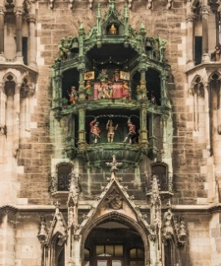
- Rathaus
This city hall has a 100-year old Glockenspiel. This old clock chimes twice (at 11:00 a.m. and noon) with 32 life-sized figures retelling Bavaria's history.
2. The English Garden
The English Garden is a large park in Munich. You can. rent a paddle boat, walk along wooded paths, visit a playground, feed the ducks or watch the surfers on the river Eisbach.
3.The Museum
The German Museum (Deutsches Museum) is one of the oldest and biggest science and technology museums in the world.At “Kid’s Kingdom,” young explorers can sit behind the wheel of a real fire engine, fly into the air, or play on a giant guitar. There are 1,000 child-friendly activities at the German Museum.
4 Bavaria Film Studios.
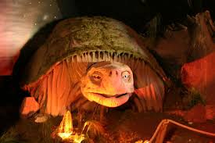
In Europe’s largest filmmaking center, kids can take a ride on Falkor the dragon from The NeverEnding Story . There is also a stunt show, which includes fistfights, fire, falls and a 92-feet deep plunge.

5. Visit a German Beer Garden (not to drink beer of course! )
Most beer gardens have a playground or at the very least a sandbox. The beer garden at Hirschgarten even features a small deer park. .Kids will love the beer garden food, too: Sausages, potato salad, pretzels, and apple strudel.
6.Viktualien Market
The bustling Viktualienmarkt is Munich’s oldest and best open-air farmers market. There are booths decorated with garlands of sausages, mountains of fresh vegetables, and pyramids of fruits.
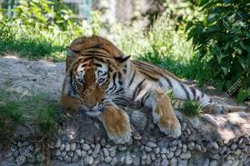
7.Visit Munich Zoo
The zoo has 5,000 animals from all over the world which are grouped according to their regions and roam the park in their natural habitats. There’s also a petting zoo, pony and camel rides in summer, and a penguin parade in winter.

8.Toy Museum
The Spielzeugmuseum (Munich’s Toy Museum) is full of historical toys from Europe and the United States. There are dolls, teddies, toy trains, and vintage Barbies.

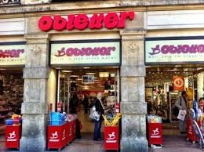
9. Toy Shop
Munich’s largest toy store. Obletter Spielwaren is full of toys for kids of all ages and is in the center of Munich’s Old Town. The store has everything from stuffed animals, dolls, and wooden toys, to games, books, and musical instruments.

Paris, France
https://school.eb.co.uk/levels/intermediate/article/Paris/276286
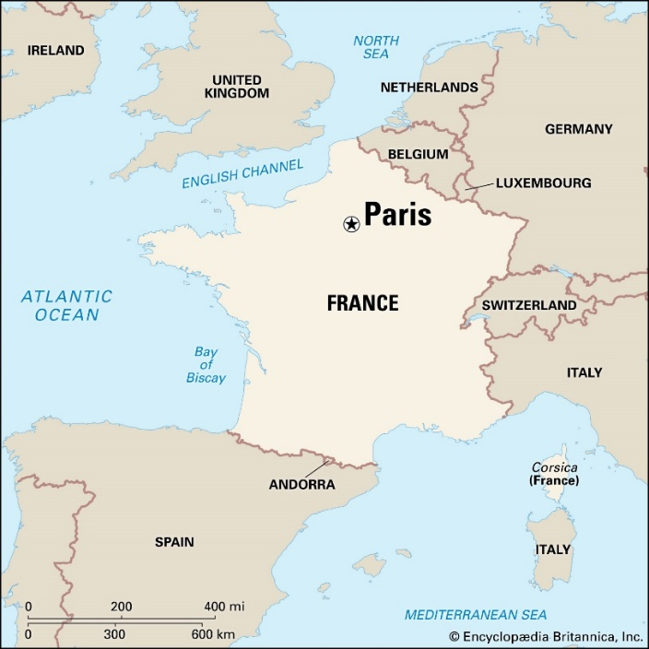
Paris is the capital of France and is the country’s most important centre of business and culture. It is known as the “City of Light” and is located in the north-central part of France. The Seine River flows through the centre of the city.
July is the hottest month in Paris with an average temperature of 20°C (68°F) and the coldest is January at 5°C (41°F).
There are many ways to travel around Paris including the Paris Métro, one of the oldest (opened in 1900) and the best underground systems in the world.
Paris has many museums, libraries, art galleries, theatres and cafés, Paris’s most famous art museum, the Louvre contains the famous painting, Mona Lisa by Leonardo da Vinci. One of many parks in Paris is the famous Tuileries Gardens with flowers and sculptures to see.
The best-known Parisian landmark is the Eiffel Tower, built in 1889, it is 300m high and can be seen from all over the city. A famous long and wide street called the Champs-Élysées is famous for its theatres, cafés, luxury shops, the Bastille Day military parade, and the finish of the Tour de France cycle race. It has the historic landmarks of the Arc de Triomphe at one end and the Place de la Concorde at the other. The most famous church in Paris is the cathedral of Notre-Dame dating back to 1300, it is situated on the Île de la Cité, the island in the Seine River.

Places to visit in Paris
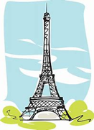
- Eiffel Tower
A world famous landmark which was completed in 1889

- Louvre
The world’s greatest art museum and home to the Mona Lisa. Will her eyes follow you around the room?

- Arc de Triomphe
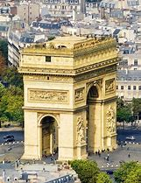
Built by Napoleon Bonaparte who fought many battles and became Emperor of France. He built it to honour the victories of his army – he took that idea from the ancient Romans.

- Montmartre
A little village in the heart of Paris. Lots of restaurants and cafes.
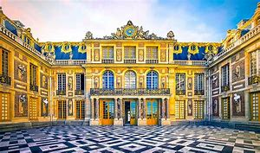
- Versailles
One of the largest palaces in the world. Unchanged rooms will make you feel like you have gone back in time to the 17^{th and} 18th Centuries

- Disneyland Paris
Full of fun rides and thrills for everyone!

City squares
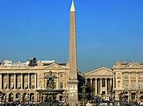
- Place de la Concorde
Largest public square in Paris. It was also home to the guillotine during the French Revolution.

- Champs Elysees
A long avenue with many shops, theatres and exhibitions.
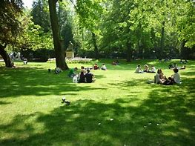
Parks
- Luxembourg Gardens
A large park to relax in and enjoy a picnic.

- Jardin du Palais Royal
A small but beautiful garden in the centre of Paris.

Rome, Italy
https://school.eb.co.uk/levels/intermediate/article/Rome/276781
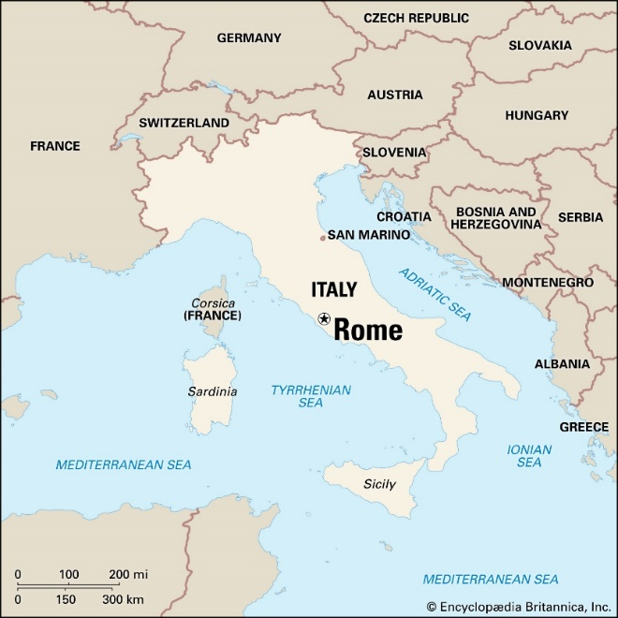
Rome is the capital city of Italy, it is known as the “Eternal City” and is located in central Italy on the Tiber River, built on seven hills. Across the Tiber River is Vatican City (an independent nation), home of the Pope and one of the largest churches in the world, St Peter’s Basilica.
On average, July is the hottest month of the year 25°C (77°F), with January being the coldest month, 8°C (46°F).
The public transport system (bus and metro system) is the best way to travel around Rome.
Rome has many historical places to visit including The Colosseum, a giant amphitheatre built in the 1st century, where fighters called gladiators fought fierce battles. The Pantheon is an ancient building famous for the size, construction and design of its dome. The Piazza Venezia is in the centre of Rome with a huge white marble monument, which gives the best views of Rome.
There are many fountains in Rome which are illuminated at night. The best known fountain is the 18th-century Trevi Fountain, it is a tradition for visitors to throw coins to ensure they return to Rome. The water in the Roman fountains comes from aqueducts built 2,000 years ago.
Rome is ideal to spend leisure time outdoors. Villa Borghese is Rome’s central park with bikes and rowing boats, there is also the Cinema dei Piccoli, the world’s smallest cinema.

Places to visit in Rome
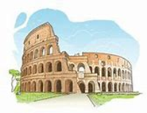
- Colosseum and Roman Forum
Ancient amphitheatre where the gladiators fought for the entertainment of the people and the Forum which was the heart of the ancient city

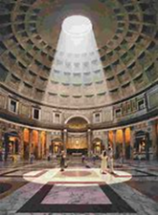
- Pantheon
Perfectly preserved ancient temple with a giant opening in the roof

- Vatican City
Home to the Pope, head of the Catholic Church

- Museo Nazionale Romano
A collection of ancient art and sculptures in five buildings across the city

- Castel Sant’Angelo
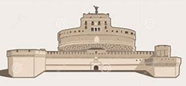
Built as a tomb for the Emperor Hadrian then strengthened and used as a castle. Contains lots of winding passageways and secret lookouts

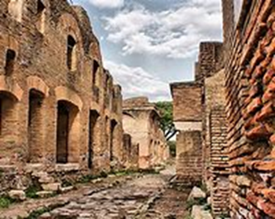
- Ostia Antica
The ruins of what was once ancient Rome’s main port city, containing houses, baths and a theatre

City squares
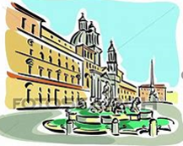
- Piazza Navona
Oval shaped square which was built on top of an ancient stadium. Lots of fountains and gelato!

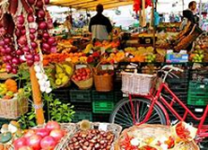
- Campo de’Fiori
The name comes from the morning flower market. Surrounded by many different osteria and trattoria (places to eat)

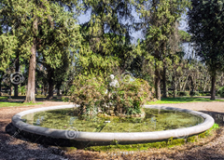
Parks
- Villa Borghese
A large park full of fountains with shady places to sit

- Villa Celimontana
Where picnics have long been a tradition since the 16th Century

London in England
https://school.eb.co.uk/levels/intermediate/article/London/275528
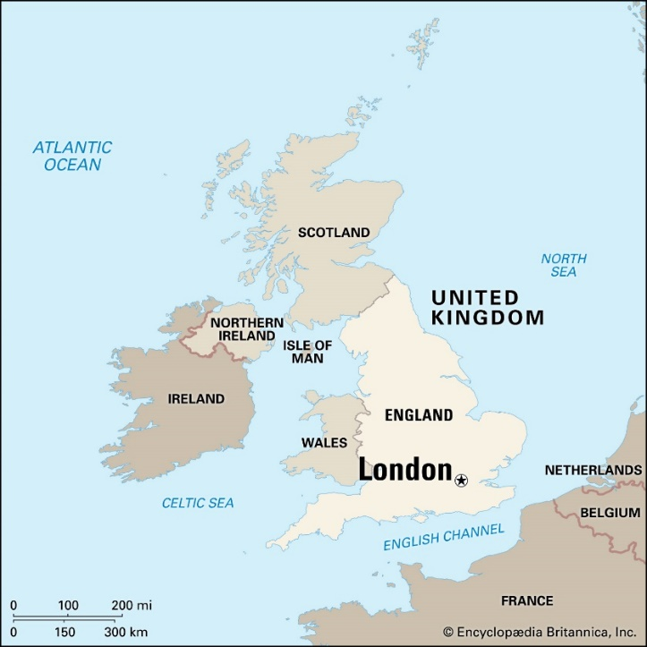
London is the capital and largest city of the United Kingdom and is situated along the banks of the Thames River in Southeast England.
London has a temperate climate, average temperatures in London peak in summer, and in July and August are around 22°C (72°C).
There are panoramic views of London from the BT Tower (a communications tower) and the Ferris wheel called the London Eye, which raises visitors 440 feet (135m) above the Thames River.
London has many places of interest. Westminster Abbey is an ancient church in the West End. All of England’s kings and queens have been crowned in the abbey since 1066. The Palace of Westminster is the London government building and contains the House of Commons and the House of Lords. The well-known clock tower Big Ben rises 98 metres (320 feet) high over the palace.
Buckingham Palace is where the queen lives and The Tower of London is one of the oldest buildings in the city, it was a prison but nowadays, people are able to visit the tower and see the Crown Jewels displayed there.
There are many museums in London, including the British Museum, Madame Tussauds Waxworks and the Science Museum. Other attractions include Warner Studios – The Making of Harry Potter, Sea Life London Aquarium and Legoland Windsor.

Places to visit in London
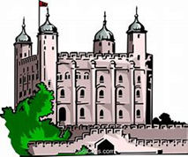
- Tower of London
London’s castle which has been both a royal palace and a prison. Meet the ravens- Guardians of the Tower

- London Eye
See the city from a glass pod on one of the world’s largest wheels!

- Museum of Natural History
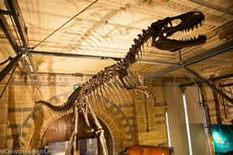
A world famous museum where you can find out about the natural world

- St Paul’s Cathedral
Rebuilt after the fire of London. Climb the stairs to get an amazing view of the city

- British Museum
Discover 2 million years of human history including Egyptian mummies!

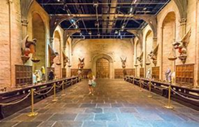
- Warner Bros Studio Tour
Step into the wizarding world of Harry Potter. See the film sets and walk through the Great Hall and Diagon Alley

City squares
- Trafalgar Square
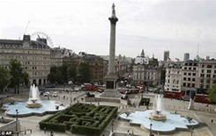
Large square surrounded by art galleries and cafes. Full of fountains and lions!

- Leicester Square
Large square surrounded by theatres and films where many film premieres take place
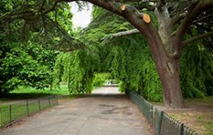
Parks
- Hyde Park
Large park full of spaces to relax- you will forget you are in the centre of London!

- St James’ Park
A large park along the Mall where you can watch the changing of the guard and the pelicans being fed

Cape Town in South Africa
https://school.eb.co.uk/levels/intermediate/article/Cape-Town/273504
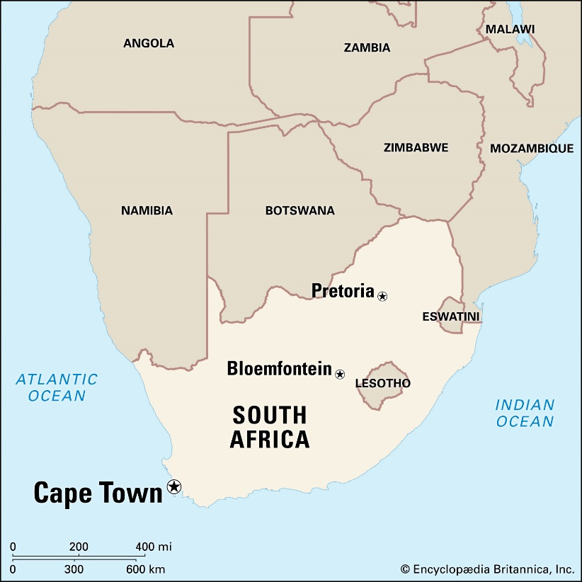
Cape Town is situated on the southernmost tip of Africa, it is one of the largest cities in South Africa, a major seaport and is one of the world's most beautiful and interesting cities.
The city has a Mediterranean climate, with mild winters (June to August) and warm summers. Temperatures drop to an average low of about 55° F (13° C) in July and reach an average high of about 70° F (21° C) in January.
The city is overlooked by its most prominent landmark, Table Mountain, which is a 600-million-year-old flat-topped mountain and is the emblem of Cape Town. It is part of Table Mountain National Park, southerly winds can produce a cloud cover over the mountain called the “tablecloth”. The journey to the summit takes just three minutes in a cable car or can be climbed which will take at least 2 hours. Table Mountain is 1,000m above sea level and visitors can enjoy a magnificent view over the Cape region and Table Bay.
The Kirstenbosch National Botanical Garden is located on Table Mountain’s eastern slopes.
The 90-mile (145km) coastline has many good places for swimming, fishing, and diving. Cape Town is home to the national library, museums and theatres for concerts, opera, ballet, and plays.

Places to visit in Capetown
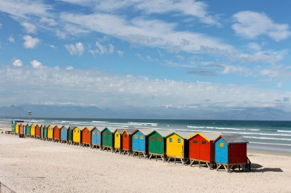
- Muizenberg Beach
The sandy beach isn’t very long, but the water is warmer to swim in than other beaches and it is a great place to try surfing because of the big waves.

- Castle of Good Hope
The Castle of Good Hope, shaped like a pentagon, is the oldest surviving colonial building in South Africa. The Military Museum tells the history of the Cape,
- National Botanical Gardens
The Kirstenbosch National Botanic Gardens, established in 1913, is one of the world’s great botanical gardens. It was the first to concentrate on a country’s own native plants. It now has plants from all over Africa.
- Cape Point
It is part of the Table Mountain National Park. Cape Point is home to about 250 species of birds as well as baboons and zebra. You can either walk up a steep path or taking a funicular to the light house at the top..
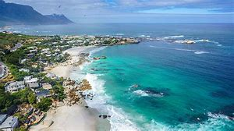
- Clifton Beach
All the beaches have almost pure white sand and offer beautiful views and sunsets. Unfortunately though the water looks blue and appealing, is in fact always very chilly and only bearable on a hot summer day.

- Bo-Kaap
Bo-Kaap is a multicultural area, home to Muslim mosques and shrines, and the Bo-Kaap Museum that shows the life of early Muslims in the area.
- Victoria and Alfred Waterfront
The waterfront is home to art galleries, an aquarium, an amphitheater with live entertainment that is usually free, and a ship museum, among other attractions.
- Boulders Beach
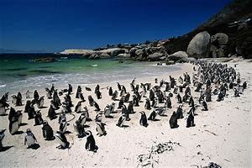
.More than 2,000 penguins call this beach home. These are African penguins, sometimes called “jackass” penguins because their chirps sound more like a donkey’s bray than a bird tweet.

- .Robben Island
The Islands most famous prisoner was Nelson Mandela, who was imprisoned here for 18 years; he went on to become president of South Africa following his release.
- Table Mountain
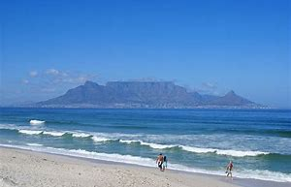
Situated within a national park, Table Mountain is one of the most famous landmarks in South Africa and from the top you can see all across Cape Town.

Copenhagen, Denmark
https://school.eb.co.uk/levels/intermediate/article/Copenhagen/273800
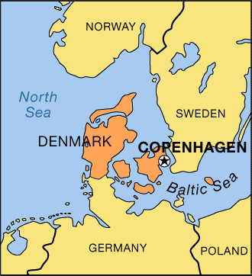
Copenhagen is the capital of Denmark and is also the country’s largest city. It is located on the islands of Zealand (Sjælland) and Amager, which are at the southern end of a strait called The Sound, which leads to the Baltic Sea.
July is the hottest month in Copenhagen with an average temperature of 17°C (63°F) and the coldest is January at 0°C (32°F)
In the harbour there is a statue of the Little Mermaid, a fairy tale by Hans Christian Andersen and is regarded as the symbol of Copenhagen.
Copenhagen has many museums and art galleries. The most famous are the National Museum, the Ny Carlsberg Glyptotek, the Royal Museum of Fine Arts and the Thorvaldsen Museum.
The Town Hall houses Jens Olsen’s astronomical clock, this huge timepiece shows the time in various parts of the world as well as the orbits of planets. Close to the Town Hall Square is Strøget - the main shopping district of Copenhagen.
Also near to the Town Hall Square is Tivoli, a world-famous amusement park which has cafés, restaurants, open-air theatres scattered among Tivoli’s extensive flower gardens. Fireworks, coloured floodlights, and illuminated fountains brighten the park at night. The city also has orchestras, a ballet company and many small theatres.

Places to Visit in Copenhagen
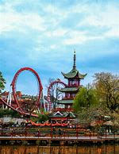
- Tivoli Gardens-
One of the oldest theme parks in the world with lots to see and do for everyone!

- Rosenborg Castle-
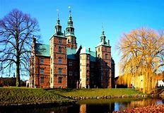
Beautiful palace from the 1600’s. You can see the Danish crown jewels here

- Little Mermaid Statue-
This is a statue of the famous mermaid character from one of Hans Christian Andersen’s famous fairytales

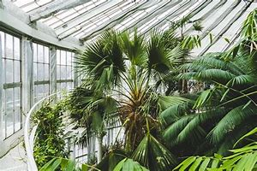
- Botanical Gardens-
These gardens are home to 13000 types of plants. Visit the glasshouses and the Arctic house with its polar temperatures!

- Christiansborg Palace-
Home to Denmark’s Supreme Court and the Parliament

- Bakken Amusement Park
There has been an amusement park in this place since 1583 – it has been updated of course but you might want to play in the world’s oldest amusement pack!
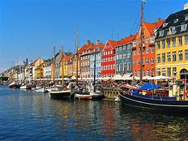
City spaces
- Nyhavn-
Historic area built around a canal with colourful houses which are 200-300 years old. Lots of cafes and restaurants

- Stroget-
One of the largest pedestrian streets in the world, full of shops!

Parks
- King’s Garden-
Lovely old gardens well known for their colourful flowers in summer

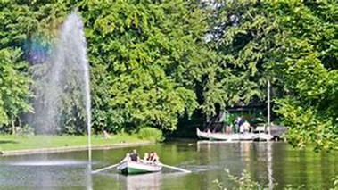
- Frederiksberg Gardens-
Beautiful gardens where you can take a boat tour on the canals just like the king used to do!

Reykjavik, Iceland
https://school.eb.co.uk/levels/intermediate/article/Reykjav%C3%ADk/334467
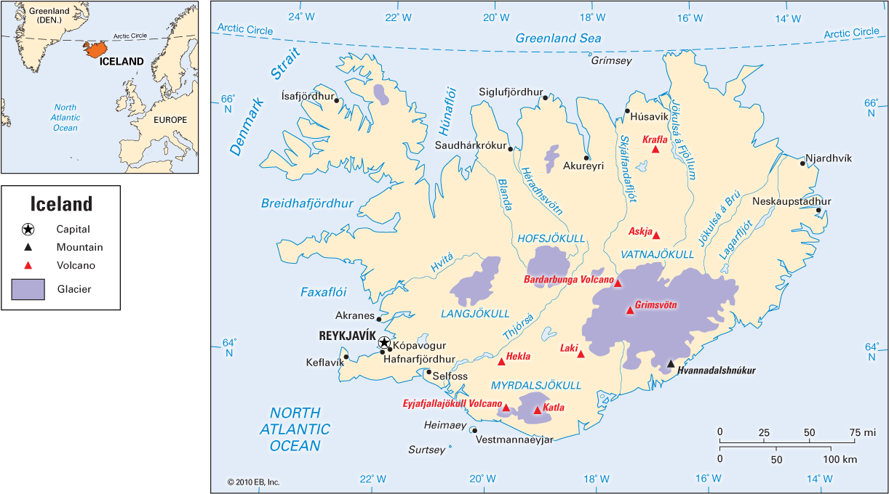
Reykjavik is the capital city of Iceland. Much of Iceland is unpopulated because the land is covered with permanent snow and ice fields, most of the people live in Reykjavik.
The climate is cool throughout the year. The average temperature in January is 31 °F (–0.6 °C) and 52 °F (11.2 °C) in June.
Travelling in Iceland is by road as there are no trains.
Reykjavik has a wonderful natural landscape—in particular, its hot springs, geysers, and volcanoes.
The name Reykjavík means “bay of smokes.” It refers to the steaming-hot water that spouts from the ground at nearby hot springs. Water piped from the hot springs is used to heat the city and its many public outdoor swimming pools. Swimming in naturally heated pools, horseback riding, and various ball games are popular things to do.
There are many national and local festivals, for example The Reykjavík Arts Festival, The Sumardargurinn Fyrsti festival celebrating the first day of summer and the largest festival is the annual Independence Day celebration.
The National Gallery of Iceland, the Reykjavík Art Museum, and the Sigurjón Ólafsson Museum are among the city’s many museums and galleries.

Places to visit in Reykjavik
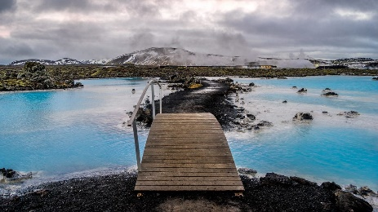
- The Blue Lagoon
The blue lagoon is a hot pool where people can come to swim. .You can watch it bubbling and steaming, even on a cold day. Its name comes from the beautiful blue colour of the water.

2 .Laugavegur Street
Laugavegur Street is Reykjavik’s high street There’s plenty of shops to peek into. You’ll also see plenty cafes to eat lunch. It is also famous for the graffiti on its buildings.
- Harpa Opera House
The opera house is famous for its concerts but also for its unusual design which sparkle in the light.
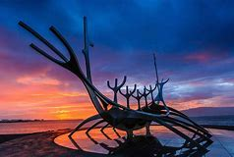
- Solfar
Solfrar, or the Sun Voyager. It looks like a skeletal Viking longboat but it wasn’t designed with Vikings in mind – it’s a dream boat.

- Hallsgrimkirkja
Hallsgrimkirkja is Reykjavik’s church. Standing in front of Hallgrimkirkja is a statue of Leifur Eiriksson, a famous explorer . he is thought to discovered the Americas, 500 years before Columbus.
- The National Museum of Iceland
The National Museum of Iceland has a collection that started in 1863. The most treasured artefact is the Valþjófsstaður door from the early 13th century. The exhibition, has over 2,000 objects and 1,000 photographs, beginning with a longboat and ending with a modern airport.

- The Saga Museum
This museum tells the story of Iceland. It has lots of information about earthquakes, volcanic eruptions and diseases. The clothes, weapons, furniture, tools and jewellery were all crafted using centuries-old techniques.
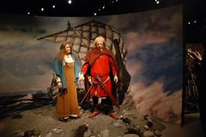
- Perlan
In this museum is the Glaciers and Ice exhibition, where you’ll put on cold weather gear and make your way through a 100-metre ice cave, peering into its crevasses and learning about the millennia of volcanic ash in its walls.
9.Volcano Museum
This museum has a free exhibition about Iceland’s exciting geology and volcanoes, with examples of ash, pumice, obsidian and lava .
Whale and Puffin watching
Reykjavík is one of the best places in Iceland to see whales. You are most likely t to see a humpback or minke whale breaching, but there’s more to look out for: Most trips will take you past Akurey, which has a large puffin population

Orlando, Florida
https://school.eb.co.uk/levels/advanced/article/Florida/274350
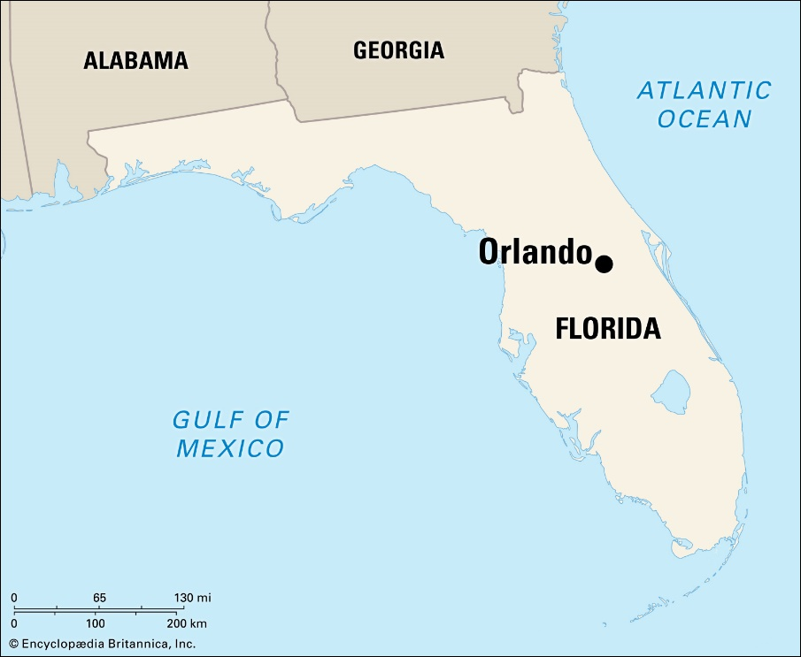
Orlando is a city in the U.S. state of Florida and the county seat of Orange County in central Florida, a region with many lakes. It is well known as a citrus fruit producer and as a popular destination for millions of tourists.
July is the hottest month in Orlando with an average temperature of 28°C (82°F) and the coldest is January at 15°C (59°F).
There are plenty of public transport options to get around the city.
Several of Orlando’s cultural attractions are located in Loch Haven Park, including the Orlando Museum of Art and the Orlando Science Centre featuring exciting science experiments and the world’s largest planetarium.
Florida has white-sand beaches and thousands of freshwater lakes, the Everglades National Park is a haven for rare plants, birds, and animals and is the largest subtropical wilderness in the United States. Discovery Cove has lagoons and rivers where visitors can swim with dolphins and tropical fish.
Disney World offers a variety of attractions, including the Magic Kingdom, Disney-MGM Studios and Animal Kingdom. Universal Orlando Resort includes the Universal Studios and Islands of Adventure theme parks featuring the Wizarding World of Harry Potter.

Places to visit in Orlando
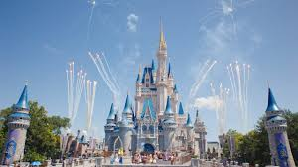
- Walt Disney World
There are lots of rides and thrills at Magic Kingdom, Epcot and Typhoon Lagoon. There are lots of places to have lunch. You can also take, behind-the-scenes tours, try dance parties and watch fireworks .

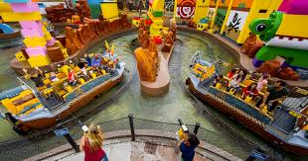
- Legoland
In Legoland , there are bricks everywhere from Build-a-Raft River and Aquazone Water Racers to the DuploSplash Safari and even the double-decker Grand Carousel, which features Lego-looking stallions.

- Wonderworks
WonderWorks is a cross between a museum and theme park. Children can explore a variety of activities, such as the forensic science exhibit in the imagination zone. There are also the indoor ropes challenge or laser tag arena.
- Orlando Science Museum
There are activities on lots of subjects, including nature, dinosaurs, the solar system and so much more. It also has a STEM discovery center.
- Leu Gardens
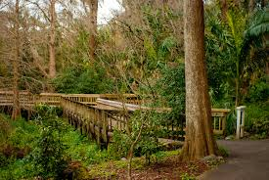
There is lots to see in Leu Gardens, including a rose, butterfly and vegetable garden, scenic trails and and views of Lake Rowena.

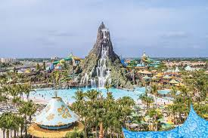
- Universal Orlando Resort
This park is great if you like films. There are lots of themed rides and activities featuring your favorite characters.

- Orlando Eye
This is a 400-foot-tall wheel which is the sixth largest in the world. It has views of theme parks and downtown Orlando. You can even watch the sunset from the top.
- Gatorland
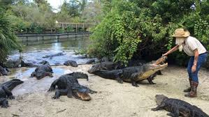
This theme park and wildlife preserve has lot of animals. See wildcats, alligators, crocodiles, birds, snakes and other neat creatures on foot or zoom via zip lines 350 feet over the Alligator Breeding Marsh.

- International Drive
You can see over 500 animal skeletons at the Museum of Osteology and you can visit Titanic: The Artifact Exhibition, where you can see the Grand Staircase, Verandah Cafe, and a three-ton section of the ship’s hull as well as activities to try.
- Kennedy Space Centre
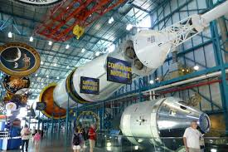
This is great if you like space. You can see the control room, real space shuttles and lots of memorabilia from the NASA space missions. You can take a tour of the whole site.

Rio de Janeiro, Brazil
https://school.eb.co.uk/levels/intermediate/article/Rio-de-Janeiro/276734
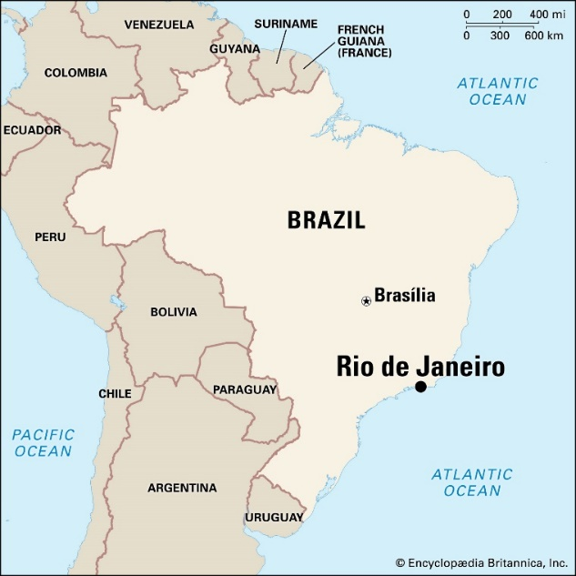
Rio de Janeiro is Brazil’s second largest city and the capital of Rio de Janeiro state. It lies at the entrance to Guanabara Bay along a strip of Brazil’s Atlantic coast and is considered one of the world’s most beautiful cities.
Rio de Janeiro has a spectacular coastline with white beaches and blue sea and also has dramatic mountains. Pão de Açúcar (Sugar Loaf), is 395m high near the entrance to the Bay, and Mount Corcovado is 704m high on which stands a 30m statue of Jesus, 'Christo Redentor' - One of the Seven Modern Wonders of the World. The mountains are accessible by cable car and funicular railway.
The summer months are December – March and the winter months are June – September so February is the hottest month in Rio de Janeiro with an average temperature of 27°C (81°F) and the coldest is July at 21°C (70°F).
There are many museums and cultural places to visit including National Museum, Modern Art Museum and Science Museum. Beautiful green spaces to visit include the famous Jardim Botanico (Botanical Garden) and the Tijuca National Park. Copacabana beach is world famous and is one of the best places in Rio to shop for souvenirs.
Rio is famous for its annual Carnival Festival, with samba dancers and elaborate floats.
Maracanã is a famous football stadium in Rio de Janeiro, it hosted matches during the 2014 World Cup and the finals of the 2016 Olympics Football tournaments.

Places to Visit –Rio de Janeiro
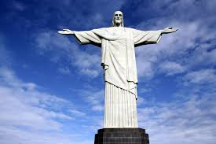
- Statue of Christ the Redeemer
This statue of Jesus Christ stands with arms outstretched to the city from above Corcovado Mountain's at a height of 2,330 feet. It welcomes visitors to the city.

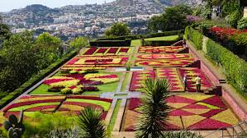
- Jardim Botanica
These large gardens contain more than 6,000 plants which grow in the country as well as some from other countries. You might recognise some of the plants that now grow in our homes and gardens.

- Tijuca National Park
Tijuca National Park is the largest urban rainforest on the planet. It has waterfalls, more than 1,600 types of plants and more than 350 different species of mammals, birds, amphibians and reptiles.
- Ipanema Beach
The beach has beautiful sand, gorgeous mountain views, and blue water. You might see people playing futevolei (the Brazilian version of volleyball without hands) and smell fresh shrimp being grilled on barbeques..
- Sugar Loaf Mountain
The mountain sits high above the bay and to get there you need to take two cable cars. It gives great views over the city. In the park there is also a history museum and an interactive Cable Car Plaza.

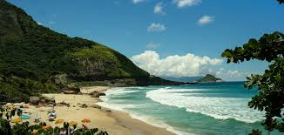
- .Prainha Beach
This remote beach is outside the town and next to the rainforest. Surfers like the waves here and if you stay until the sun goes down the sunset is amazing.,
- Copacabana Beach
It is one of Rio's busiest beaches. The beach has lots of lifeguard stations to keep swimmers safe. At the end of the beach is the .Historical Museum of the Army and Copacabana Fort.
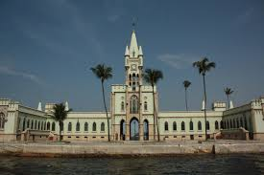
- Ilha fiscal
This castle is on an island in the Guanabara Bay Inside the castle, you'll find mosaic floors, elaborate stained glass, as well as the Ceremonial Room that's now used for Navy formal events.

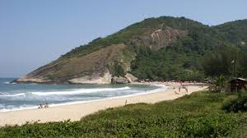
- Grumari Beach
This quiet beach nearly 2 miles of white and red sand. As well as being a beach it is also an environmental reserve to look after the plants and animals.

Singapore
https://school.eb.co.uk/levels/intermediate/article/Singapore/313557
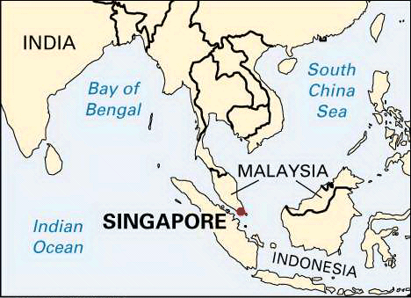
The Republic of Singapore is an island nation of South-east Asia. The country consists of a main island and about 60 small islands in the Indian Ocean. The capital is the city of Singapore, which occupies the southern part of the main island. Singapore is known as the “Garden City” for its many parks and tree-lined streets.
February is the hottest month in Singapore with an average temperature of 27°C (81°F) and the coldest is January at 26°C (79°F).
The best way to get around Singapore is the hop-on, hop-off sightseeing bus.
Singapore has a variety of museums celebrating history and art of Asia.
The Jurong Bird Park has hundreds of different kinds of birds and the Singapore Botanic Gardens feature many rare tropical plants.
One of city’s most popular attraction is Sentosa Island in Singapore Harbour. It offers a variety of exciting experiences including nature walks, swimming with dolphins and a waterpark.
The famous Universal Studios in Singapore is a movie magic amusement park with rides such as a 3D Transformers ride and the Mummy Rollercoaster.

Places to visit in Singapore

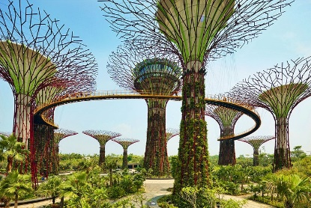
- Bay East Garden
This large garden has a Supertree Grove, which look very futuristic. You can also visit the Cloud Forest Dome to see the world's tallest indoor waterfall.

- The Botanical Gardens
The Botanical gardens have many different areas to visit. You can choose from visiting the eco-garden, eco-lake, bonsai garden, sculptures, and several other formal gardens.
- The Zoo
This is a rainforest zoo. Among the animals there is a large chimpanzee family, zebras, meerkats, a komodo dragon, mole rats, white tigers, kangaroos, and many other creatures. You can watch the animals being fed.
- Universal Studio Singapore
At Universal Studios Singapore you can visit New York City, Hollywood, Madagascar, and a trip back to Ancient Egypt. You can also visit Shrek's Far Far Away, Lost World, and Sci-Fi City, where you can try Battlestar Galactica-themed dueling roller coasters and an indoor dark coaster, Revenge of the Mummy,
- Night Safari
Night Safari Singapore lets you visit the animals at night. The Leopard Trail has, leopards, as well as lions, flying foxes, civets, and porcupines among other animals. The Fishing Cat Trail tours the habitat of animals native to Singapore, including the fish-loving felines, pangolin, binturong, and other species both common and endangered. East Lodge Trail features Malayan tigers and spotted hyenas, and the Wallaby Trail introduces visitors to the marsupials of Australia.

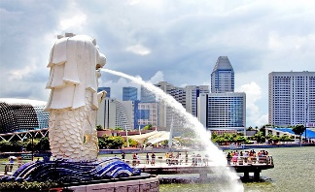
- Merlion Park
Singapore's Merlion has the head of a lion and the body and tail of a fish. The Merlion represents the city beginning as a fishing village combined with its traditional Malay name Singapura, "lion city."
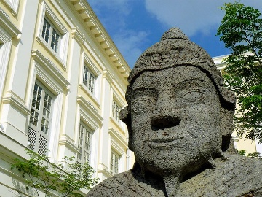
- Asian Civilisations
The Asian Civilisations Museum, looks at the many Asian cultures that helped form Singapore. The museum's collections have topics such as the Indian Ocean trade, stories of faith and belief, and a look at the important role of learning in Chinese culture.

- Fort Canning
The fort was built to defend Singapore against attacks but it became a bunker during World War II and was eventually surrendered to the Japanese in 1942.
- The Maritime Museum
This indoor-outdoor museum is beside the water, and it has lots of fun, interactive exhibits. You’ll also be able to see several ships anchored here.
- Fort Siloso
Fort Siloso, is the country's only intact fort and a military museum., It is on Sentosa Island. You can reach the fort via the Fort Siloso Skywalk trail, a massive steel bridge towering 11 stories up.

Sydney, Australia
https://school.eb.co.uk/levels/intermediate/article/Sydney/277990
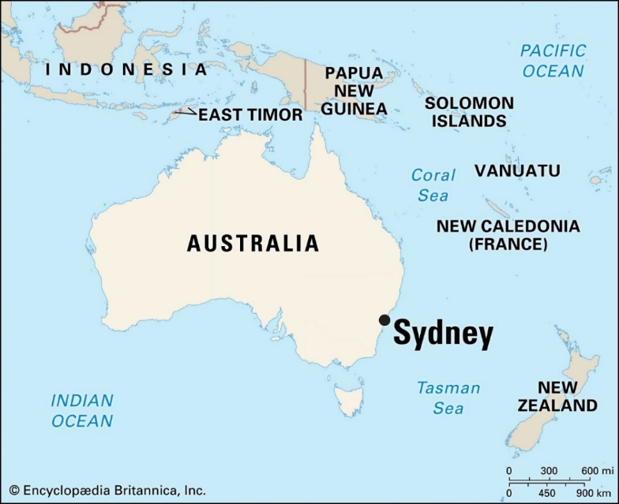
Sydney is the largest and oldest city in Australia and is the capital of the state of New South Wales.
Temperatures in January, the height of summer, average 72 °F (22 °C) and in the winter month of July the average is 55 °F (13 °C).
Sydney has many national and regional parks, the Sydney Harbour National Park was established on cliffed headlands, animal life includes nocturnal possums and flying foxes (bats), as well as scarlet (king) parrots, cockatoos and kookaburras.
The famous Sydney Opera House contains a concert hall, theatres and restaurants. Its roof is made up of a series of gleaming white sail-shaped shells and is one of the most photographed buildings in the world. The Australian Museum has an incomparable collection of Aboriginal artifacts.
Sydney’s Darling Harbour, a waterfront pedestrian precinct houses the Sydney Aquarium and the Australian National Maritime Museum. An underwater road tunnel crosses Sydney Harbour and the Sydney Harbour Bridge is one of the longest steel-arch bridges in the world.
Sydney is the place for sports enthusiasts and Sydney Olympic Park was the location for the Summer Olympics in 2000. Sydney’s beaches are often crowded with sunbathers, swimmers, volleyball players, and surfers. The city has 35 ocean surf beaches Bondi Beach is one of the most famous and is where the Surf Life Saving Club was formed in 1906.

Places to Visit in Sydney
- Bondi Beach
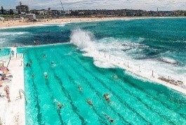
Bondi Beach is a great place to go surfing and you can eat lunch in one of the many cafes here. You can also walk along the coastal trail.

- Taronga Zoo
Taronga Zoo has more than 4,000 animals. You can stay overnight in safari style tents or walk along the high ropes and undertake over 60 challenges.

- Sydney Opera House
The opera house has more than 40 performances a week and is famous for its ‘Armadillo’ shaped building.

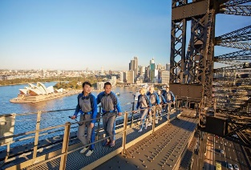
- Sydney Harbour Bridge
You can walk or cycle across the bridge for free or climb to the very top which is 134m above sea level.

- Take the ferry to Manly
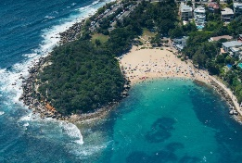
At Manly you can try snorkelling to see over 200 types of fish. Or you could try paddle boarding. They are also famous for their fish and chips, and cinnamon buns.

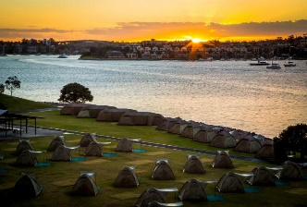
- Camp on Cockatoo Island
Cockatoo island is in the middle of Sydney Harbour and has great views across the Bay. You can get a tent and lanterns at the site.

- Aboriginal Culture
There are lots of ways to find out about Aboriginal culture from walking tours, to learning about the use of plants and watching performing arts groups.
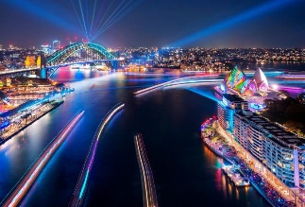
- Festivals
Sydney hosts some of the most thrilling events on the Australian events calendar. Sydney Lunar Festival celebrates Lunar New Year with dragon boat races and colourful markets..

- Luna Park
Luna Park is an amusement park. You’ll have lots of fun on rides such as the Ferris wheel and the Tango Train.
- Sea Life Centre
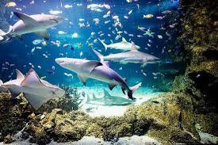
Sea Life Sydney Aquarium has the world’s largest collection of Australian aquatic life. From sharks and dugongs to stingrays and seahorses. You can even snorkel with sharks.

