English language learning
Some useful websites to check out
- http://learnenglishkids.britishcouncil.org/
write
speak
listen
read

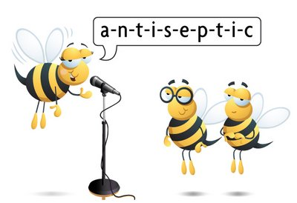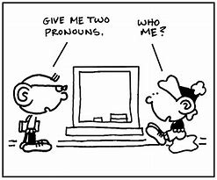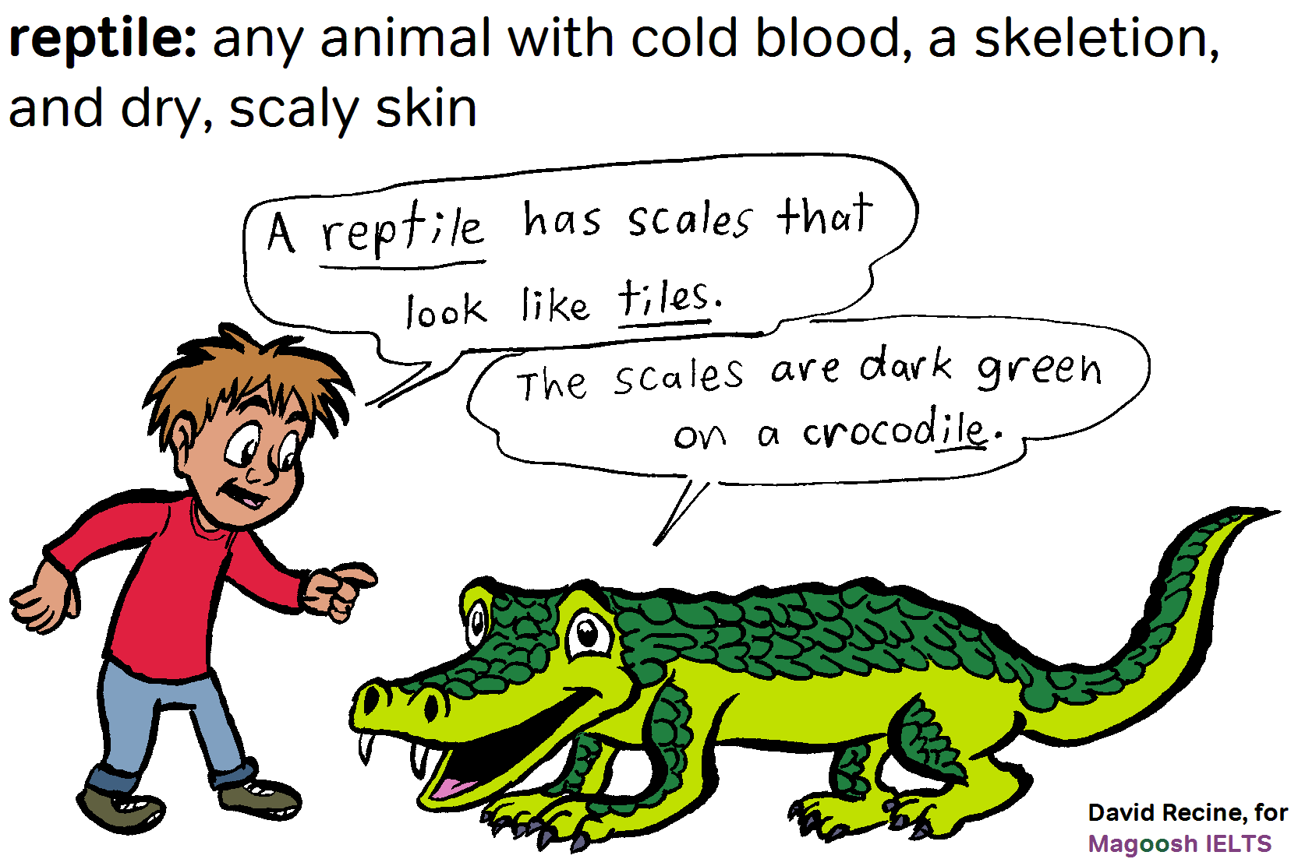
vocabulary
grammar
spell

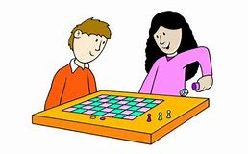
games
- Collins Dictionary Online https://www.collinsdictionary.com/
- Dictionary - You can also listen to the pronounciation of words
- Definitions - What does the word mean
- Synonyms - Words with a same meaning
- Thesaurus - Wordfinder, words with similar meanings are grouped together
- https://learnenglishteens.britishcouncil.org/
LearnEnglish Teens is brought to you by the British Council, the world's English teaching experts. If you want to learn English while having fun, this free website is just for you. LearnEnglish Teens can help improve your English with reading, writing and listening practice, tips for exams, grammar and vocabulary exercises, games and videos. You can also interact with other teenagers from all around the world.

- https://esol.britishcouncil.org/
Improve your English with help from this free website from the British Council with videos, listening activities, texts and grammar exercises for ESOL learners at every level.
In Skills you will find interactive activities to improve your speaking, listening, writing and reading. In Grammar and vocabulary you can watch grammar presentations, complete practice activities and hear people using the grammar to talk about different topics. If you are living and working in the UK you will find lots of useful information in UK Life and English for Work. You can also hear from ESOL learners talking about their lives in the UK in Your turn.

Reading for enjoyment
Some useful websites to check out

International Children’s Digital Library - http://en.childrenslibrary.org/
Browse the library and see if you can find a book in your first language. You might want to read it yourself or someone at home might read the book to you.

150 online books in 30 different languages - www.worldstories.org.uk
or 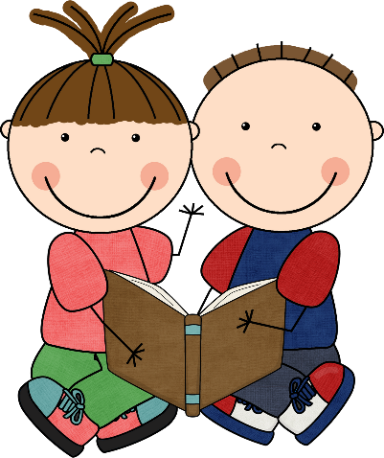

Urdu Fairy Tales - https://www.youtube.com/channel/UCJ5djr7ssnILE9zHQtb0-9g -

Browse Borrow Box for English books and audiobooks - http://www.borrowbox.com/rmunify/login
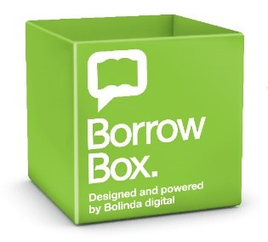

Here is a list of some on-line games/websites you may enjoy and a note of some of the resources on your GLOW page that are available to you.
- BrainPOP – available free to all Falkirk schools. This tile should be showing on your GLOW home page. If it isn’t there, then us the search facility to get it.
- Twig and Tig-Tag are also free on your GLOW home page – Great if you are interested in science.
- https://agendaweb.org/ lots of great ways to learn English
- http://www.funenglishgames.com/ lots of fun stuff
- https://www.bbc.co.uk/cbeebies

From Stirling Council Colleagues - Common words - These PowerPoint files can help you learn to read the common words in English. You can only listen to the words or to the words in a sentence. Each presentation has 10 words. https://glowscotland.sharepoint.com/sites/grp-eal/SitePages/Common-words-in-English.aspx

