Active Approaches to Reading – Early Level

Falkirk Council
December 2014
Active Approaches to Reading – Early Level

What is Literacy?
The set of skills which allows an individual to engage fully in society and in learning, through the different forms of language, and the range of texts, which society values and finds useful. (C.f.E.)

Aims

Falkirk Council’s Literacy Strategy’s main aim is ‘zero tolerance to illiteracy’.

Our aims are that practitioners will continue to:

- Raise standards of literacy in all areas, including Talking & Listening, Reading and Writing through effective planning, teaching and learning

- Provide quality learning literacy experiences for all children which address the significant aspects of learning in literacy and encompasses the Curriculum for Excellence outcomes and experiences

- Work together to ensure a smooth and effective literacy development transition between Nursery and P1

Active Reading

All Falkirk Council establishments use the active reading approach where the 6 comprehension strategies are as follows:

- Prior knowledge and understanding
- Metalinguistics
- Visualisers
- Inference
- Main ideas
- Summarising and paraphrasing

‘The Thinking Reader’ approach is used by many Falkirk establishments and this documents provides practical advice and examples in order to introduce these strategies at early level in both the Nursery and P1 setting.

Building Foundations – Teacher as Model

Teacher as speaker and listener, reader and writer
- Modelling specific vocabulary and sentence patterns
- Recasting
- Repeating and extending
- Showing an interest in what a child says

Nursery/ P1

- Oral learning of a bank of stories and rhymes
- Playing at making up stories
- Sharing a range of texts
- Sharing writing – story mapping, early writing
- Pencil control
- Invention: through play, children’s stories recorded and acted out, devising a group/ class story and turning into a book and sharing
- Imitation – oral learning of stories, rhymes, songs and poems
- Innovation – changing a known text to create a new version
- Story Bus
- Book Swap/ story sacks

Reading – Develop Pleasure and Motivation – Early Years

- Listen to and discuss a range of texts
- Link to own life experiences
- Become familiar with key stories and traditional tales, retelling and considering the features
- Recognise and join in with predictable phrases
- Appreciate rhymes and poems and recite some

Reading – The Literature Spine
- Core stories
- Rhyme/ poem of the week
- Poetry journals and audio CD
- Building the bank – populating the imagination and building vocabulary, sentence and story patterns

Nursery Rhymes to Poetry

- Nursery rhymes – Jack and Jill
- Circle songs – Mulberry Bush
- Action rhymes – I’m a little teapot
- Dips, skips and claps – Pat-a-cake
- Counting rhymes – Ten in the bed
- Tongue twisters – Peter Piper pumpkin eater
- Riddles – Humpty Dumpty
- Rhyming Poetry – Now we are 6

Things to do with a Text
- Learning and performing
- Acting it out
- Playing at it – toys and costumes
- Drawing and painting scenes – visualisers – in your head what do you see? (Strategy 3 – Visualisation)
- Discussion – favourite parts, meaning, puzzles, patterns, questions (Strategy 4/5 – inference/ main ideas)
- Highlighting memorable words/ phrases (Strategy 2 – metalinguistics)
- Drama – hot seating, role play

Story Making – Based on ‘Talk for Writing’ – Pie Corbett

- Preparation – choose a story – not too long – what do you want the children to be able to do with this?
- Learn the story ‘off-by-heart’ with actions

Learn to Re-tell a Story – Story Map

- Draw a class story map (can do this together using computer with younger children). Children then ‘copy’ class map as they need it for making changes (substitutions)

- Re-tell often, children as tellers – teacher as listener. Children increasingly join in – withdraw and prompt. Children as listener – teacher as teller.

Sharing with Parents/ Carers – Ideas to Support at Home

- Supporting Strategy 1 – Prior knowledge and understanding – use these question starters to talk to your children about the texts they have taken home:
- What is the text going to be about?
- Look at the writing on the front of the book, what is the style?
- Does the title give us any clues about the story?
- Look at the illustrations, does it remind you of anything you have heard, seen or read before?
- What is going to happen in this text?
- Put the word _______ into a sentence. (Pick a word from the title or heading)
- Supporting Strategy 2 – Metalinguistics (Words and Phrases) - pick a text and collect a range of words which link to:
- Numbers
- Words with capital letters
- Interesting words/ phrases
- Favourite word in the extract
- Words you don’t understand
- Cross out all the little words e.g. a, as, in, it, but, the (this is really helpful in preparation for summarising)
- Any word containing this week’s phoneme
- Any words from their tricky word list this week
- Supporting Strategy 3 – Visualisation – select an extract – the purpose is to use sensory images to record mental pictures which are produced in our heads when reading – it could be of a really good description of a character/ setting/ turning point in a text. You could use a piece of music too. Examples of visualisation tasks are:
- Draw and label the main character
- Draw a picture of the main character’s bedroom from your imagination
- Draw a picture of the main character on holiday or in a different location
- Create a speech bubble illustration of a scene in the text
- Draw a picture of the story
- Draw a pictures of your favourite part of the story
- Create a mind map of the story
- Create a story web/ timeline/ labelled diagram
- Supporting Strategy 4 – Inference – Find an example of inference at home in a text. Can you create inferential questions about the text?
- Supporting Strategy 5 – Main Ideas – Any of the following activities will support the main ideas of a text, this can be fiction or non-fiction.
- Identify chapters – what is the main idea in each?
- If the chapters do not have chapter headings, can you give them one?
- What is the main idea or theme the author is trying to convey?
- Select words or phrases from the text which justify a main theme
- Tell me the most important event from the whole story
- Group together the main ideas – is there an overall theme?
- What is the theme of the beginning/ middle and end?
- Thinking Reader booklets
- Supporting Strategy 6 – Summarising
- Summarise the text in a tweet
- Summarise the text in less than 20 words
- Summarise the text on a post-it note
- Summarise the text in a picture
- Draw all the characters in the story
- Draw all the settings from the story
- Write a blurb about the book
- Design a poster advertising a film of the text
- Match the summary to the title of the book
- Have two summaries and justify which one best fits and why
- Have 10 words on post it notes – 5 from the story and 5 from a different story – can you sort?
- Encourage your child to pretend to 'read' a book before he or she can read words
- Visit the library as often as possible - take out CDs and DVDs as well as books
- Schedule a regular time for reading - perhaps when you get home from school or just before bed
- Look for books on topics that you know your child is interested in - maybe dragons, insects, cookery or a certain sport
- Make sure that children’s books are easily accessible in different rooms around your house
- Ask your children questions about the story using Blooms fans starters (ask your child’s school about these)
- Role play – can your children act out the story?
- Look at a range of texts around the house e.g. newspapers, magazines, recipes, Newsround, TV programmes and adverts
- A text is anything that communicates meaning e.g.
novels, short stories, plays, poems, reference texts, the spoken word, charts, maps, graphs and timetables, advertisements, promotional leaflets, comics, newspapers and magazines, CVs, letters and emails, films, games and TV programmes , labels, signs and posters, recipes, manuals and instructions, reports and reviews text messages, blogs and social networking sites - how many of these do you have at home that you could use to ask questions about and explore?

Rosie’s Walk

Rosie the hen (flap arms) went for a walk (walk on the spot) but a fox (hands as front paws creeping forward) followed her.

First (one finger up) she went across the yard (hand out move arm across) but a fox (hands as front paws creeping forward) followed her.

Next (two fingers point to one side) she went around the pond (circle starting at top with both hands) but a fox (hands as front paws creeping forward) followed her.

After that (roll hands over in a turning gesture) she went over the haystack (lift leg to step over) but a fox (hands as front paws creeping forward) followed her.

After that (roll hands over in a turning gesture) she went past the mill but a fox (hands as front paws creeping forward) followed her.

After that (roll hands over in a turning gesture) she went through the fence but a fox (hands as front paws creeping forward) followed her.

Finally (palm facing audience like a policeman stopping traffic) she went under the beehives (palms face ceiling and move forward) but a fox (hands as front paws creeping forward) followed her.

In the end (bring hands together as if closing a book) she got back home (hands together to make a triangle) just in time (point to wrist) for dinner (two fingers, two hands move to mouth).

Action Bank

Once upon a time – hands open like a book

Early one morning – hands on one side of head

Who – circle index finger in the air

First – one finger up

Next – two fingers pointed to one side

And – show right palm to audience

Because – hands out open palmed

At that moment/ suddenly/ to his surprise/ unfortunately – hands expressively open as if in surprise

After/ after that – roll hands over in turning gesture

So – rolling hands forward and open as if giving

Finally – palm facing audience like a policeman stopping traffic

In the end – bring hands together as if closing a book

Where – right palm up, sweep arm to the right

When – mime tapping on a wrist

With – clasp hands/ fingers together

Remember – tell the new story with actions, you can add in actions for punctuation too. Remember to have an action for parts you will change e.g. character, setting, and problem

Recommended Picture Books for Early Level for Thinking Reader approach

- We’re Going on a Bear Hunt – Michael Rosen
- Can’t You Sleep Little Bear? Martin Waddell
- Not Now Bernard – David McKee
- Where’s My Teddy? – Jez Alborough
- The Very Hungry Caterpillar – Eric Carle
- The Tiger Who Came to Tea – Judith Kerr
- Room on the Broom – Julia Donaldson and Axel Scheffler
- Lost and Found – Oliver Jeffers
- The Cat in the Hat – Dr. Seuss
- Where the Wild Things Are – Maurice Sendak

Nethermains Primary School and Nursery Class – Reading

Here is a selection of wonderful photographs of pupils engaged in a range of reading activities:
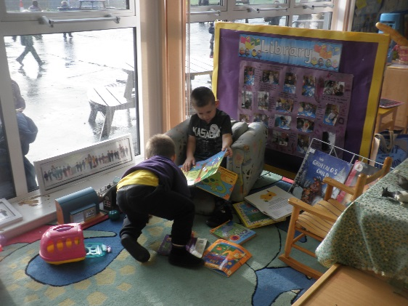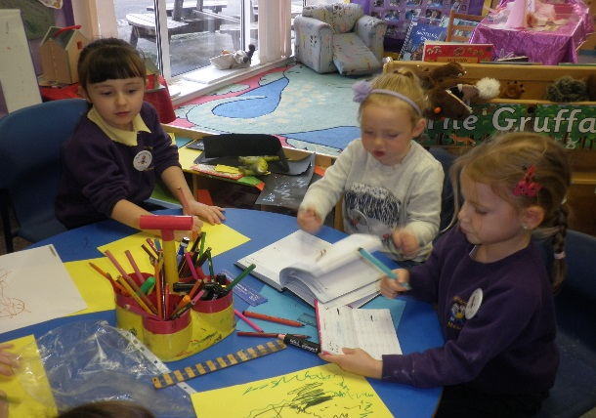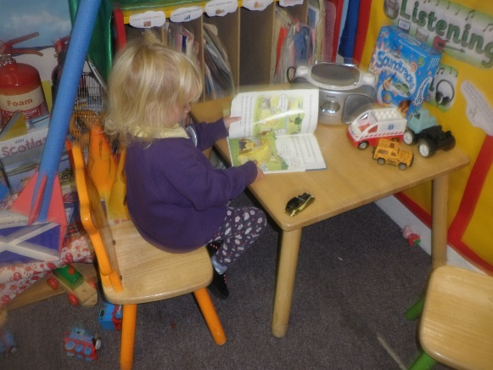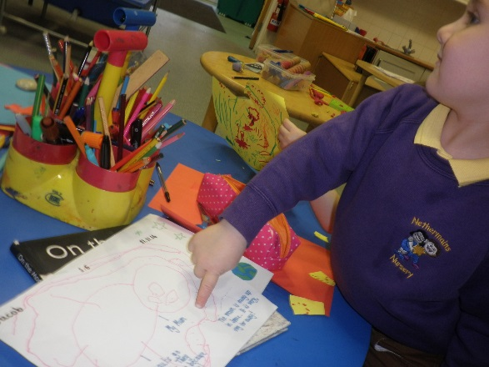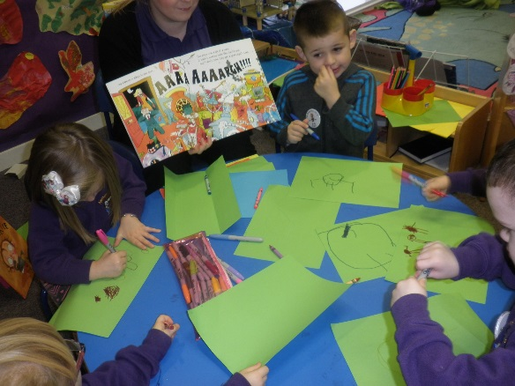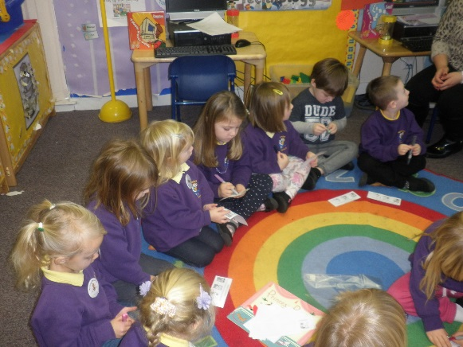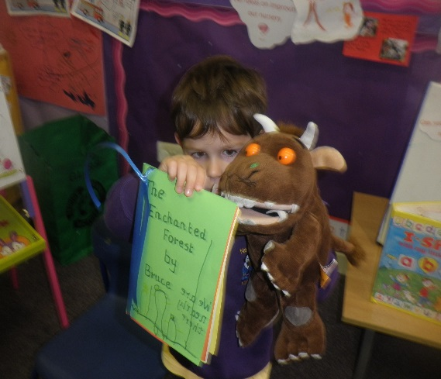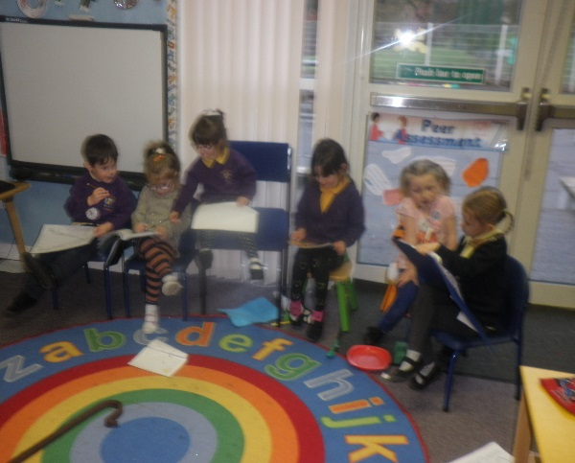
Bainsford Primary School P2/1

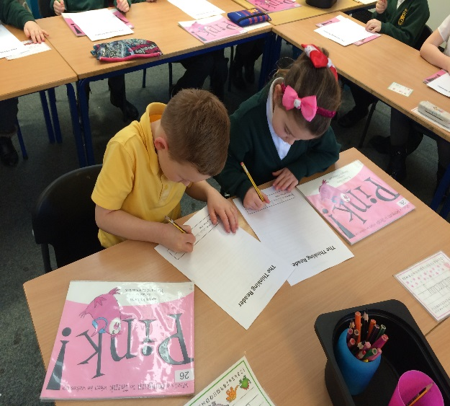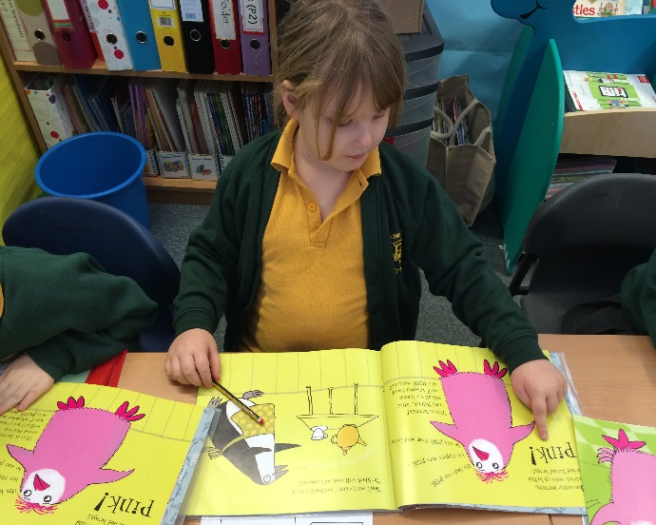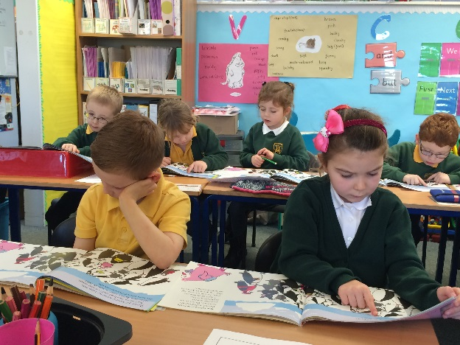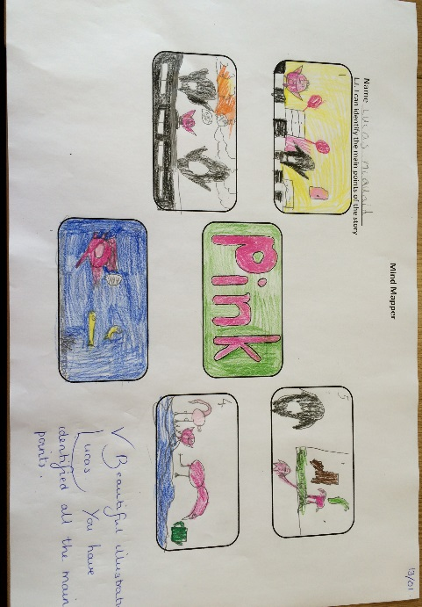

Larbert Day Nursery

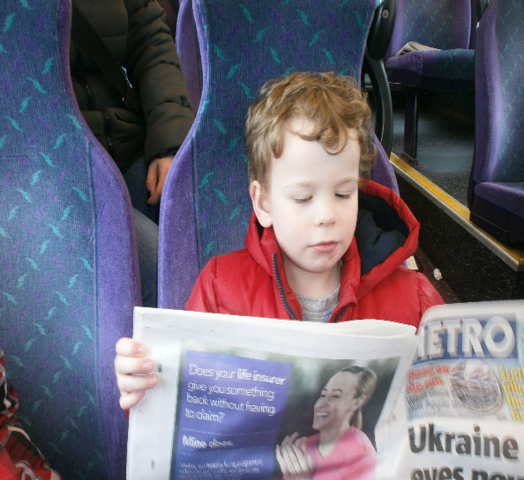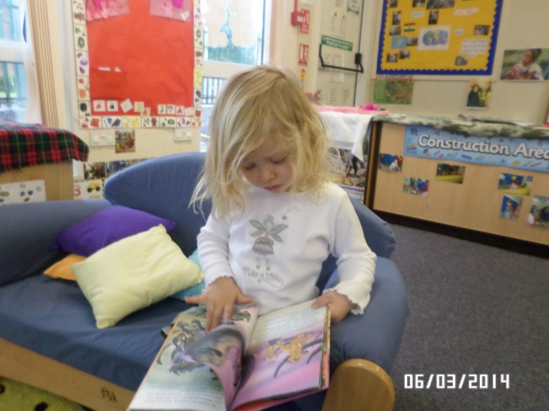

References:

Scottish Government (2010) Pre-Birth to Three: Positive Outcomes for Scotland’s Children and Families, Scottish Executive
Scottish Government (2007) A Curriculum for Excellence, Building the Curriculum 2, Scottish Executive
A Curriculum for Excellence, Scottish Executive
Falkirk Council (2006) Practical Solutions for Early Intervention: Falkirk
Falkirk Council (2008) Practical Phonological Development Activities – Pre-School and Primary 1: Falkirk
Falkirk Council (2009) Learning to Achieve: Falkirk
North Lanarkshire Council (2008) Active Literacy: North Lanarkshire
Pie Corbett and Julia Strong (2011) – Talk for Writing across the Curriculum
Pie Corbett (2006) – The Bumper Book of Storytelling into Writing Key Stage 1 and 2
Pie Corbett (1992) – Action Rhymes
Pat Hutchins (1968) – Rosie’s Walk

For further information, please refer to:

- Falkirk Council’s Literacy Strategy online support tool blog: https://blogs.glowscotland.org.uk/fa/LiteracyStrategy/literacy-strategy-document/
- http://www.youtube.com/watch?v=QWeYMNxNUpc
Thanks to:
Nethermains Primary School and Nursery Class
Bainsford Primary School and Nursery Class
St. Margaret’s Primary School and Nursery Class
Larbert Day Nursery

