Active Literacy Strategy

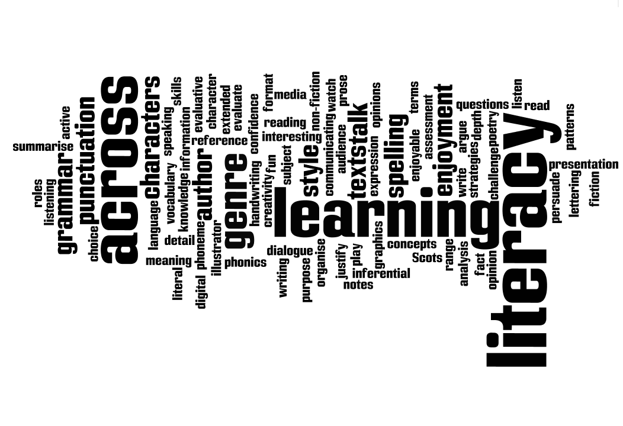

ZERO TOLERANCE TO ILLITERACY

July 2014

Falkirk Council

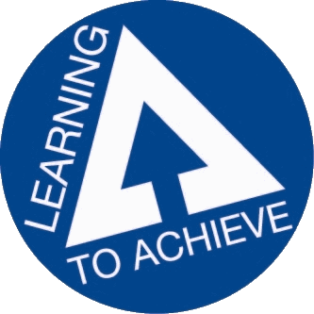

Introduction

This strategy paper aims to identify how Falkirk Council establishments are meeting the needs of our pupils and young people in terms of developing their literacy skills through active methodologies. It examines features of good practice in active literacy and shares views of parents, pupils and teachers. It looks at the history of active literacy in Falkirk, where we are at presently and ways forward for the future of literacy development in Falkirk Council establishments as we model zero tolerance to illiteracy.

Definitions of Literacy

“Language and literacy are of personal, social and economic importance. Our ability to use language lies at the centre of the development and expression of our emotions, our thinking, our learning and our sense of personal identity. Literacy is fundamental to all areas of learning, as it unlocks access to the wider curriculum.”

“The set of skills which allows an individual to engage fully in society and in learning, through the different forms of language, and the range of texts, which society values and finds useful.”

(Pg 1 Literacy and English: principles and practice, A Curriculum for Excellence) Scottish Executive 2009.

What is Active Learning?

Active learning is learning which engages and challenges children and young people’s thinking using real-life and imaginary situations. Active literacy requires pupils to be engaged in purposeful, meaningful, active, relevant and fun learning contexts. Active literacy lessons in Falkirk establishments aim to:

* Meet the requirements of a Curriculum for Excellence and Learning to Achieve
* Equip all children and young people with means of accessing lifelong learning
* Recognise the importance of literacy across all curricular areas and to identify this as a key responsibility of all who have responsibility for the education of children and young people.
* Incorporate active learning approaches to literacy
* Promote language and literacy development
* Provide opportunities to develop critical and creative thinking as well as competence in listening and talking, reading, writing and the personal, interpersonal and team-working skills which are important in life and the world of work

What are the key features of good practice in Active Literacy?

* Each establishment develops, implements and monitors appropriately a “Literacy across the Curriculum” action in partnership with parents and learners
* Teachers engage in Early Intervention strategies are implemented when a need is identified (see Active Approaches to Literacy – Early Level, Falkirk, 2013)
* A wide range of motivational literacy learning opportunities will be provided including effective use of the outdoors and natural environments
* Valuing the contributions and views of learners by listening to others and promoting respectful interaction
* Developing in learners the capacity to read, watch and listen a range of wider texts analytically and to evaluate them
* Educational establishments are sharing good practice to ensure consistency and high standards
* Schools are continually exploring possibilities for different approaches to personalisation and choice
* Teachers are asking the question “How am I meeting the literacy needs of the learners in front of me?” (Pg 31 Literacy and English: principles and practice, A Curriculum for Excellence) Scottish Executive 2009
* Prior learning in literacy must be taken account of by all those involved in educating young people. This is particularly important at key transition times e.g. Nursery into P1 and P7 into S1
* Competence and confidence in literacy, including competence in grammar, spelling and the spoken word, is essential for progress in all areas of the curriculum. Because of this, all teachers have responsibility for promoting language and literacy development. Every teacher in each area of the curriculum needs to find opportunities to encourage children and young people to explain their thinking, debate their ideas and read and write at a level which will help them to develop their language skills further. (Pg 1, A Curriculum for Excellence, Building the Curriculum 1) Scottish Executive 2009
* Learning to Achieve states that learners will be taught by teachers who use active learning approaches to support learners and ensure relevant development of literacy across the curriculum
* The Donaldson Review highlights the importance of “strengthening literacy (and numeracy) skills in order to ensure that all children can progress in their learning and development” (p18: 2012)

Active Literacy in Falkirk in Schools and Nurseries

Falkirk Council use the North Lanarkshire Active Literacy programme in all of our establishments. A study, in collaboration with Dundee University, showed 93% of P3 pupils scored above average in literacy tests. The research also showed that the reading age of children taking part in that scheme was five months ahead of other youngsters who were taught in the previous way. Other advantages of teaching literacy using an active approach are:

It is research based

It provides a clear framework for teaching

There is a structured progression across the stages

All areas of literacy are interlinked

Regular assessments are built in

It takes into account learning inside and outside the classroom

It advocates the approach of children supporting and challenging each other

Children are actively engaged in their learning.

In Falkirk establishments, teachers consider the significant aspects of learning in literacy contained within the Literacy Principles and Practice paper to support the provision of effective learning experiences in literacy. Resources used include the North Lanarkshire’s Active Literacy packs, magnetic boards and letters, as well as ‘Big Writing’ and other useful resources. Teachers adapt these resources and draw on a wide range of active methodologies to meet the needs of their pupils in order to raise attainment in literacy.

Active Literacy first came to Falkirk in 2008 and secondment positions began to support pilot schools in the implementation of the programme. Further secondment positions were filled and training began in session 2009/2010. Initially training was delivered by North Lanarkshire Literacy Development Officers. Training and on-going support for all areas and for a wide range of staff e.g. teachers, SLAs, Speech and Language therapists, parent workshops is now provided by the Falkirk Curriculum Support Team.

Educational establishments in Falkirk have been provided with a range of resources to meet learner’s needs. These include North Lanarkshire’s Active Literacy packs, magnetic whiteboards, magnetic letters and resource CDs. They have also been provided with extensive training covering the areas of: spelling and phonics, reading and writing.

This year the emphasis for the early stages has been on talking and listening. A workshop was held at the Early Years conference in February with Barbara-Anne Cleaver, Speech and Language Therapist N.H.S. with a follow-up session at the St. Mungo’s cluster good practice meeting.

Progress has also been made relating to the progression of skills in Active Literacy into Secondary schools. Five Secondary schools have been working in collaboration with the Curriculum Support Team to develop a consistent approach to raising attainment in literacy. Graeme High School shared good practice in June 2014 with their ‘meta-literacy’ event which showcased literacy across learning in a range of curriculum areas relating to the Active Literacy programme.

Update on the Literacy Strategy

1. Nigel Fletcher has been meeting with clusters regarding the focus and importance of prioritising literacy as well as developing approaches based on the “improvement science approach” which focusses on small steps of change linked to self-evaluation. The focus of any actions is to raise attainment and reduce the opportunity gap. The meetings so far have been well received with many head teachers commenting on the benefit of the discussion within the cluster forum. Other staff groups have already had similar discussions with Nigel and Anne Pearson. There will be further strategic discussions once these meeting have all been concluded. There will also be a link to the School Improvement Planning process and professional update, as well as the approach to validated self-evaluation.
2. The literacy strategy has been issued to all head teachers and officers of the council. There will be a session held centrally for colleagues who wish to be involved in the literacy work streams.
3. Sharon Wallace has consulted with head teachers on the professional development she will be offering next session. Many of these sessions will support use of the professional development materials linked to the Scottish Survey of Literacy and Numeracy and will be led in conjunction with colleagues from Stenhousemuir PS, St. Bernadette’s RCPS and Larbert High School. Sharon will also highlight the significant aspects of learning detailed within the “Assessing progress and Achievement in Literacy and English paper.” These opportunities support staff`s professional learning linked to your school`s S.I.P. Further discussions will take place with all head teachers on further training and other actions required.

What are teachers saying?

Feedback from teachers so far is extremely positive. Most schools began by implementing the spelling and phonics part of the packs, with a move then towards implementing the approaches to writing and reading as identified in the active literacy resource packs. Comments from staff who have attended C.P.D. for Active Literacy in 2013 - 2014 include:

*“This course was really helpful in helping me plan and organise active literacy in my infant classroom. Discussing resources to use was also a helpful activity.”*

*“A great course, very informative and helpful. This course was delivered at a good pace and included a lot of good information and links to relevant ICT activities...”*

*“Fantastic delivery and support being given by the presenter to enable me to feel confident with using it at P1 level...”*

*“This course allowed me to have a better understanding of Stage 1 Active Literacy and I am now more confident teaching this stage. Thank you.”*

*“I feel this CPD session was beneficial as it highlighted the vast number of literacy skills pupils can develop through Science subjects. It also emphasized the high level of literacy pupils require to be able to access and retrieve information from a question in a National 4 or 5 end of unit assessment or a National 5 exam. For many pupils, they may understand the Science being asked in the* question, but the high level of literacy required in the questions can be a barrier to their success.”

*“An extremely useful CPD which highlighted the ways in which use of the Thinking Reader approach can encourage higher order thinking skills in learners through Reading.”*

Successful active literacy parent workshops have been carried out in a number of schools during 2013 - 2014. Comments from parents include:

* *Excellent presentation which was very informative and interesting*
* *Makes it easier to understand homework and how to help*
* *I liked that the children were involved in presenting*
* *Great presentation-enjoyed the children’s participation*
* *Kids were excellent and good to find out how the kids are learning in class so homework ties in better*
* *Very helpful and informative*
* *Very good and informative! Great idea!*
* *Interesting and entertaining presentation. Children did a great job helping to explain concepts used.*
* *Very informative. Good to learn new techniques the children are using*
* *Excellent presentation! Very informative. Very useful to understand the techniques used in school and has given me a good structure to follow at home to support the children*
* *Really enjoyed the presentation and learning activities*
* *Fantastic evening. Very informative and very helpful. Well thought out. Thank you.*
* *Enjoyed the children teaching the adults!*
* *Simplifies the spelling of words*
* *Liked learning about the difference from my experience of learning!*
* *Very informative. Will try to stop calling it the ‘magic e’. Sharon is a very engaging presenter. Thank you.*

What are the pupils saying?

Pupil comments include:

*“It makes learning new words fun”*

*“I like when the whole class reads out loud at the same time because it stops you being scared to read in front of everybody. You can hear how good everyone is at reading”*

*“It can sometimes be challenging, but that makes us think harder”*

*“It allows you to be creative, and create new ideas and thinking”*

*“I like graffiti words. I like art and it lets you use your imagination to help you”*

*“Mnemonics help with my spelling because they make it easy to remember the words”*

*“Picture words help me because you can put an image in your head to help you spell the word in your jotters”*

*“I like active literacy because it helps me improve on my story writing and phonemes. I really like the active literacy homework. I like the spellings”*

*“I like active literacy, my favourite part is Elkonin boxes. I prefer Elkonin boxes to diacritical marking, but at least it is helping with my vocabulary and spelling. For homework I like the jingles. My spelling has improved since I started Active Literacy”*

What are we seeing in schools and nurseries?

When visiting educational establishments, it is evident that active approaches to literacy are becoming embedded in most Falkirk establishments. Such strategies enable pupils to increase their attainment in literacy such as the five finger strategy, phoneme of the week, tricky words, completed diacritical marking charts and reading comprehension charts We are also seeing evidence that although spelling and phonics was the starting point for most schools, the move this year has been towards looking at the 6 key comprehension strategies in reading. Twitter communications, jotter work and professional discussions indicate that these comprehension strategies are becoming more embedded in pupils learning experiences and pupils are able to discuss their reading making reference to skills such as: metalinguistics, inference, main points, summarising and paraphrasing.

What about assessment?

Effective assessment is carried out with active literacy in the same way other areas are assessed building on the principles of Assessment is for Learning. Effective learning intentions and success criteria are evident in some Falkirk establishments. There are a range of assessments included within the Active Literacy programme and pupils’ complete self and peer assessments in the different areas of spelling and phonics, reading and writing.

Curriculum for Excellence suggests that assessment in literacy will focus on children and young people’s progress in developing and applying essential skills in listening and talking, reading and writing. (Pg 6: Principles and Practice).

Active Literacy Development Programme for Falkirk Schools and Nurseries

Active Literacy training to date has been provided for:

* Stages 1 – 7 – spelling and phonics, reading and writing
* Cluster moderation/ good practice meetings
* Supported by Education Scotland
* Speech and Language Therapists
* Early Years Officers/ Early level colleagues
* Support for Learning and Enhanced Provision Teachers
* Senior Management Teams – monitoring active literacy
* Library Resource Services
* Support for Learning Assistants
* Parents and carers
* Bespoke support for schools
* Support for RACI groups within establishments
* Bespoke training for schools/ individuals
* CAT sessions – focus on Reading and Writing
* Using ICT to support active literacy
* INSET training
* Early Years – making effective transition links for literacy

Examples of Good Practice in Active Literacy

* This session Education Scotland have produced annotated exemplars in literacy from early to fourth level and the work exemplified in this resource shows work which is deemed to typify the achievement of a level. The work builds on the Assessing Progress and Achievement papers using the Significant Aspects of Learning, identified in those papers, and the progression frameworks, to guide exemplification. Falkirk Council have eight pieces of writing contained within this resource from three local schools: Kinneil P.S., St. Bernadette’s R.C.P.S. and Maddiston P.S
* CEM results are showing that the greatest gain in phonics at P1 was made in 2014 and reflects the good work being undertaken in schools in the context of Active Literacy. Performance in reading in P3 and P5 improved for the first time in 2014. In P7, performance has improved year on year, but remains below the UK average.
* Active Literacy Networks have been running for four years. They have been run three times a year with a focus on different areas within Active Literacy with some being hosted and led by classroom practitioners.

During 2013 – 2014, the three sessions were:

1. Creating resources for active literacy using Smart notebook
2. Reading – using other ‘texts’ – sharing good practice and creating resources using ABC Ya and other online sources
3. Supported by Library Resource Services and Education Scotland Scots Language Officer – hosted at Deanburn Primary School and Denny Primary School

These network meetings will continue to run next session, with the first meeting being held in Library Resource Services.

* Lorna Swinney from Larbert High School delivered CPD for Education Scotland on The Slab Boys - a drama text that is part of the new CfE Higher English - to representatives from all Scottish secondary schools. The feedback was overwhelming – and following this event, the PT English, John Doherty had people contacting him from all over Scotland! Heather Stevenson from Braes High School delivered “The Cone Gatherers” for the new Higher English course. For this, Heather sourced resources relating to the novel and condensed the material to be used by pupils sitting the new Higher. This was presented to the attendees in an active learning style examining higher order questioning skills too
* Laura Swan (Stenhousemuir P.S.) and Lisa Clezy (St. Bernadette’s R.C.P.S) were involved in a consultation for Education Scotland in relation to the new POLAAR (Primary One Literacy Assessment and Action Resource) which is due to be published in October 2014

Future Development for Active Literacy

The following courses will be delivered in 2014/2015:

Active literacy training for colleagues who are new to:

1. Stages 1 to 7
2. Active approaches to literacy at early level
3. Active literacy for composite classes (supported by classroom practitioners)
4. The Thinking Reader
5. Using Media – Film as text (supported by John Doherty, PT English and Literacy at Larbert High School)
6. Sharing good practice in literacy
7. SFLAs – Active Literacy overview – how to support learners effectively
8. SMT – an overview of Active Literacy
9. Significant aspects of learning in literacy in talking and listening, reading and writing (supported by Laura Baird – Stenhousemuir PS, Marianne Savage PT at St. Bernadette’s RCPS, John Doherty – PT English Larbert High School and Lorna Swinney – Larbert High School)
10. The art of storytelling

This document should be read in conjunction with Falkirk Council’s ‘Literacy Strategy’ which can be accessed from: <https://blogs.glowscotland.org.uk/fa/LiteracyStrategy/>

References

* Scottish Executive (2009) A *Curriculum for Excellence.* Edinburgh:  Scottish Executive.
* North Lanarkshire (2005) *Active Literacy*: North Lanarkshire.
* Scottish Government, (2011) *Teaching Scotland's Future – Report of a Review of Teacher Education in Scotland*: Edinburgh, Scottish Government
* Falkirk Council (2013) *Active Approaches to Literacy – Early Level*: Falkirk
* Annotated exemplars in literacy <http://www.educationscotland.gov.uk/learningteachingandassessment/assessment/progressandachievement/annotatedexemplification/literacyandenglish.asp>
* Principles and Practice in literacy and English <http://www.educationscotland.gov.uk/images/literacy_english_principles_practice_tcm4-540165.pdf>