Active Literacy Strategy

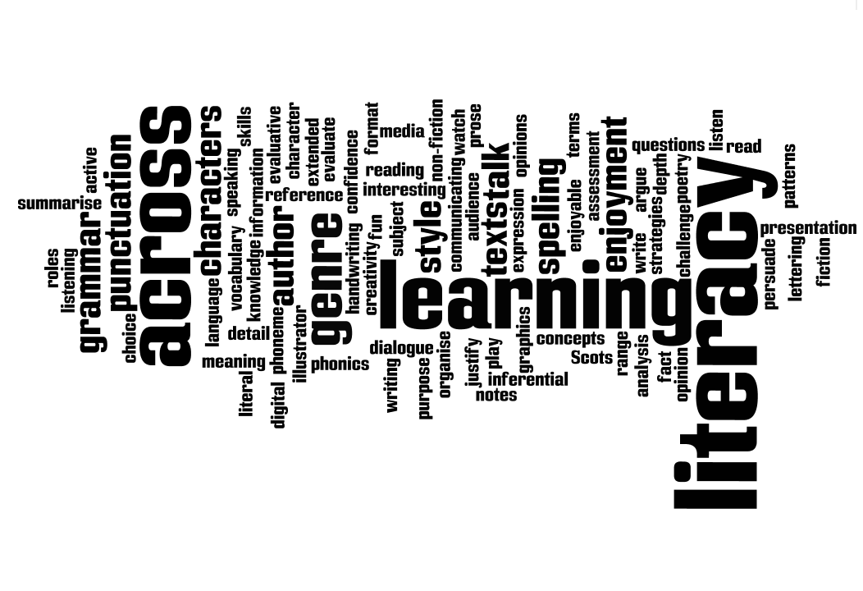

July 2013

Falkirk Council

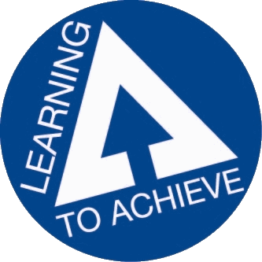

Active Literacy Strategy

**Introduction**

This strategy paper aims to identify how Falkirk Council establishments are meeting the needs of our pupils and young people in terms of developing their literacy skills through active methodologies. It examines features of good practice in active literacy and identifies views of parents, pupils and teachers. It looks at the history of active literacy in Falkirk, where we are at presently and ways forward for the future of literacy development in Falkirk Council establishments.

Definitions of Literacy

“Language and literacy are of personal, social and economic importance. Our ability to use language lies at the centre of the development and expression of our emotions, our thinking, our learning and our sense of personal identity. Literacy is fundamental to all areas of learning, as it unlocks access to the wider curriculum.”

“The set of skills which allows an individual to engage fully in society and in learning, through the different forms of language, and the range of texts, which society values and finds useful.”

(Pg 1 Literacy and English: principles and practice, A Curriculum for Excellence) Scottish Executive 2009.

What is Active Learning?

Active learning is learning which engages and challenges children and young people’s thinking using real-life and imaginary situations. Active literacy requires pupils to be engaged in purposeful, meaningful, active, relevant and fun learning contexts. Active literacy lessons in Falkirk establishments aim to:

* Meet the requirements of a Curriculum for Excellence and Learning to Achieve
* Equip all children and young people with means of accessing lifelong learning
* Recognise the importance of literacy across all curricular areas and to identify this as a key responsibility of all who have responsibility for the education of children and young people.
* Incorporate active learning approaches to literacy
* Promote language and literacy development
* Provide opportunities to develop critical and creative thinking as well as competence in listening and talking, reading, writing and the personal, interpersonal and team-working skills which are important in life and the world of work

What are the key features of good practice in Active Literacy?

* Each establishment develops, implements and monitors appropriately a “Literacy across the Curriculum” policy in partnership with parents and learners
* Teachers engage in Early Intervention strategies are implemented when a need is identified (see Active Approaches to Literacy – Early Level, Falkirk, 2013)
* A wide range of motivational literacy learning opportunities will be provided both within and out-with educational establishments
* Valuing the contributions and views of learners by listening to others and promoting respectful interaction
* Developing in learners the capacity to read, watch and listen analytically and to evaluate
* Educational establishments are sharing good practice to ensure consistency and high standards
* Schools are continually exploring possibilities for different approaches to personalisation and choice
* Teachers are asking the question “How am I meeting the literacy needs of the learners in front of me?” (Pg 31 Literacy and English: principles and practice, A Curriculum for Excellence) Scottish Executive 2009
* Prior learning in literacy must be taken account of by all those involved in educating young people. This is particularly important at key transition times e.g. Nursery into P1 and P7 into S1
* Competence and confidence in literacy, including competence in grammar, spelling and the spoken word, is essential for progress in all areas of the curriculum. Because of this, all teachers have responsibility for promoting language and literacy development. Every teacher in each area of the curriculum needs to find opportunities to encourage children and young people to explain their thinking, debate their ideas and read and write at a level which will help them to develop their language skills further. (Pg 1, A Curriculum for Excellence, Building the Curriculum 1) Scottish Executive 2009
* Learning to Achieve states that learners will be taught by teachers who use active learning approaches to support learners and ensure relevant development of literacy across the curriculum
* The Donaldson Review highlights the importance of “strengthening literacy (and numeracy) skills in order to ensure that all children can progress in their learning and development” (p18: 2012)

Active Literacy in Falkirk in Schools and Nurseries

Falkirk Council recommends the North Lanarkshire Active Literacy approach to raising attainment in literacy. A study, in collaboration with Dundee University, showed 93% of P3 pupils scored above average in literacy tests. The research also showed that the reading age of children taking part in that scheme was five months ahead of other youngsters who were taught in the previous way. Other advantages of teaching literacy using an active approach are:

It is research based

It provides a clear framework for teaching

There is a structured progression across the stages

All areas of literacy are interlinked

Regular assessments are built in

It takes into account learning inside and outside the classroom

It advocates the approach of children supporting and challenging each other

Children are actively engaged in their learning.

In Falkirk establishments, teachers address the experiences and outcomes from Curriculum for Excellence for literacy and use a variety of resources to help deliver these. These resources include the North Lanarkshire’s Active Literacy packs, magnetic boards and letters, as well as ‘Big Writing’ and other useful resources. Teachers adapt these resources and draw on a wide range of active methodologies to meet the needs of their pupils in order to raise attainment in literacy.

Active Literacy first came to Falkirk in 2008 and secondment positions began to support pilot schools in the implementation of the programme. Further secondment positions were filled and training began in session 2009/2010. Initially training was delivered by North Lanarkshire Literacy Development Officers. Training and on-going support for all areas and for a wide range of staff e.g. teachers, SLAs, Speech and Language therapists, parent workshops is now provided by the Falkirk Curriculum Support Team.

Educational establishments in Falkirk have been provided with a range of resources to meet learner’s needs. These include North Lanarkshire’s Active Literacy packs, magnetic whiteboards, magnetic letters and resource CDs. They have also been provided with extensive training covering the areas of: spelling and phonics, reading and writing.

This year there has been a big emphasis on transition from Nursery to P1 with workshops being held at the Early Years conference in February and follow-up sessions across three cluster good practice meetings.

Progress has also been made relating to the progression of skills in Active Literacy into Secondary schools. An overview of the Active Literacy programme was provided at a SSIP meeting and was positively received. Three high school Rectors and other teachers have observed Active Literacy in the primary context. The progression of Active Literacy skills, relating to reading and national examinations was shared at all of the CMG groups with a follow-up task to examine how to develop reading skills across a wide range of texts in all subject areas. Several Secondary schools are now working in collaboration with the Curriculum Support Team to develop a consistent approach to raising attainment in literacy.

Education Scotland delivered a ‘Literacy across Learning’ conference to approximately six representatives from each high school, including representatives from Forth Valley Collage. A teacher focus group (English teachers only) was set up this year and has been examining how English is currently taught at BGE and the commonalities/ differences in terms of the Active Literacy programme. This group is currently looking at ways we can improve transition and develop literacy skills across learning.

**What are teachers saying?**

Feedback from teachers so far is extremely positive. Most schools began by implementing the spelling and phonics part of the packs, with a move then towards implementing the approaches to writing and reading as identified in the active literacy resource packs. Comments from staff who have attended C.P.D. for Active Literacy include:

*“Staff really value the modelling of excellent classroom practice from a practitioner who is approachable, well organised, informative and willing to share resources. Active literacy approaches across the school have improved as staff has grown in confidence due to the support and advice offered. Staff now feel more confident in sharing their own practice and discussing next steps.”*

*“As always, taking away some new ideas and an enthusiasm boost.”*

*“Loads to think about. Great to discuss ideas and moderation with others. Enthused me for going back into class.”*

*“Really enjoyed the course, it has helped me to visualise how active literacy is taught... was presented clearly and lots of resources were very valuable’” (Probationer Teacher)*

*“The course has allowed me to become more secure in delivering Active Literacy.”*

**Successful active literacy parent workshops have been carried out in a number of schools. Comments from parents include:**

“*I think it was great to see the children involved in the workshop. It made it easier to see how it related to the classroom and how we can support at home.”*

“*I enjoyed the experience of the children teaching us. A very good approach for the kids to learn and show the skills that they are achieving.”*

“*Great presentation which put across the new literacy strategies very well. Excellent idea to have the children showcasing the strategies in action. I have now got a better idea of how to support my child with literacy at home”.*

*“Fantastic! Wonderful to have ‘active’ insights into our child’s learning process/ progress.”*

*“I learned what phonemes are and can now understand a bit more what they are learning. Very informative.”*

**What are the pupils saying?**

Pupil comments include:

“*I like interesting facts about the new words and sounds” (P2 Airth)*

*“It makes learning new words fun” (P2 Airth)*

*“I like when the whole class reads out loud at the same time because it stops you being scared to read in front of everybody. You can hear how good everyone is at reading” (P4 Airth)*

*“Spelling is fun when we do rainbow writing, pyramid writing and backwards writing” (P4 Airth)*

*“It can sometimes be challenging, but that makes us think harder” (P5 Airth)*

*“It allows you to be creative, and create new ideas and thinking” (P5 Airth)*

*“I like graffiti words. I like art and it lets you use your imagination to help you” (Head of Muir)*

*“Mnemonics help with my spelling because they make it easy to remember the words” (Head of Muir)*

*“Picture words help me because you can put an image in your head to help you spell the word in your jotters” (Head of Muir)*

*“I like active literacy because it helps me improve on my story writing and phonemes. I really like the active literacy homework. I like the spellings” (P4 St. Bernadette’s)*

*“I like active literacy, my favourite part is Elkonin boxes. I prefer Elkonin boxes to diacritical marking, but at least it is helping with my vocabulary and spelling. For homework I like the jingles. My spelling has improved since I started Active Literacy” (P7 St. Bernadette’s)*

**What are we seeing in schools?**

When visiting educational establishments, it is evident that active approaches to literacy are becoming embedded in Falkirk establishments. Displays include: the five finger strategy, phoneme of the week, tricky words and completed diacritical marking charts. Such strategies enable pupils to increase their attainment in literacy. We are also seeing evidence that spelling and phonics was the starting point for most schools, with a move this year towards looking at the 6 key comprehension strategies in reading. A lot of schools are also asking to make connections between ‘Big Writing’ and ‘Active Literacy’ writing.

**What about assessment?**

Effective assessment is carried out with active literacy in the same way other areas are assessed building on the principles of Assessment is for Learning. Effective learning intentions and success criteria are evident in Falkirk establishments. There are a range of assessments included within the Active Literacy programme and pupils complete self and peer assessments in the different areas of spelling and phonics, reading and writing.

Curriculum for excellence suggests that assessment in literacy will focus on children and young people’s progress in developing and applying essential skills in listening and talking, reading and writing. (Pg 6: Principles and Practice).

**Active Literacy Development Programme for Falkirk Schools and Nurseries**

Active Literacy training provided for:

* Stages 1 – 7 – spelling and phonics, reading and writing
* Progression from Stages 4/5 to Stages 6/7
* Cluster moderation/ good practice meetings
* Education Scotland – provision of network session re: standards in writing/ Literacy across learning (Secondary Schools)
* Speech and Language Therapists
* Early Years Officers
* Support for Learning and Enhanced Provision Teachers
* Senior Management Teams – monitoring active literacy
* Schools Library Support
* Support for Learning Assistants
* Parents
* Bespoke support for schools
* Bespoke training for schools/ individuals
* CAT sessions – focus on Spelling and Phonics, Reading and Writing
* Using ICT to support active literacy
* INSET training
* Active Literacy and the Outdoor Environment
* Active Literacy – the links between Active Literacy and Big Writing
* Active Literacy surgeries
* Active Literacy and the Specialist Teacher (incorporating Art, Drama, P.E. and Music)
* Higher order reading skills/ Critical literacy (Education Scotland)
* Early Years – making effective transition links for literacy
* All subject CMGs – what are the literacy skills for your subject?

**Examples of Good Practice in Active Literacy**

At a recent HMIe inspection, in Sacred Heart RC Primary School ‘approaches to active literacy’ was identified as a key strength of the school.

During another HMIe inspection (January 2013) – HMIe recognised the delivery of the Active literacy programme having a direct impact on pupils progress in writing.

Active Literacy Networks have been running for three years. They have been run three times a year with a focus on different areas within Active Literacy with some being hosted and led by classroom practitioners.

During 2012 – 2013, the three sessions were:

1. Spelling and phonics
2. Reading – using other ‘texts’ – sharing good practice from Bonnybridge Primary School and Stenhousemuir Primary School
3. Writing – supported by Education Scotland, taking a look at SSLN materials and moderating writing from early to third level.

The network meetings held during this session have been extremely well attended, with a massive 108 applicants for the last session. Feedback will be used to plan further CPD sessions and a possibility of dividing these meetings into levels.

**Future Development of Active Literacy**

The following courses have been delivered in 2012/2013:

Active literacy training for colleagues who are new to:

1. Stages 1 to 7
2. An overview of strategies from previous stages for P6/7
3. Stages 6/7/S1
4. Active Literacy and the Outdoor Environment
5. Recall sessions
6. Big Writing and Active Literacy
7. Active Literacy for Secondary Schools
8. Early Years and Active Literacy
9. Transition from nursery to P1 and P7 to S1 – ensuring continuity between schools
10. Secondary Schools
11. Recall sessions for where we are at and next steps

This document should be read in conjunction with Falkirk Council’s ‘Literacy Strategy’ which can be accessed from: <https://blogs.glowscotland.org.uk/fa/LiteracyStrategy/>

**References**

* Scottish Executive (2009) A *Curriculum for Excellence.* Edinburgh:  Scottish Executive.
* North Lanarkshire (2005) *Active Literacy*: North Lanarkshire.
* Scottish Government, (2011) *Teaching Scotland's Future – Report of a Review of Teacher Education in Scotland*: Edinburgh, Scottish Government
* Falkirk Council (2013) *Active Approaches to Literacy – Early Level*: Falkirk