Active Approaches to Literacy – Early Level

Falkirk Council
7/1/2014
Active Approaches to Literacy – Early Level

Contents

Introduction
- What is literacy?
- What is active learning?

Aims

Key Messages

Good Practice

The Learning Environment

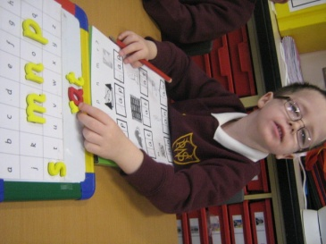

Active Approaches to Literacy in Falkirk – Early Level.

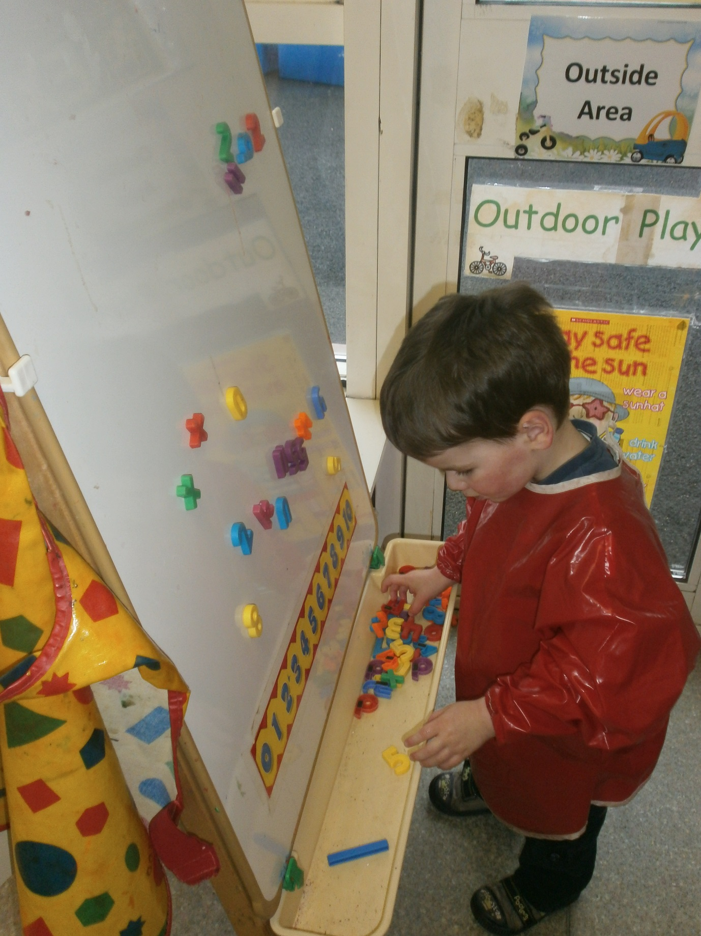

“The earliest years lay the important foundations for literacy development, which can be built upon through lifelong learning.”
(Pre-Birth to Three, 2010)

Within Falkirk Council, we believe in the importance of developing literacy skills within the Early Years through experiential play and the transferring of these skills to everyday life. Our document provides an overview for staff of active approaches to literacy within Curriculum for Excellence Early Level.

What is Literacy?
The set of skills which allows an individual to engage fully in society and in learning, through the different forms of language, and the range of texts, which society values and finds useful. (C.f.E.)

What is Active Learning?

Active learning is engagement of the brain whilst participating in activities relating to Talking & Listening, Reading and Writing. Learning to Achieve advocates the use of active learning approaches to ensure relevant development of literacy across the curriculum.

Building the Curriculum 2 (2007) describe Active learning as ‘...learning which engages and challenges children’s thinking using real-life and imaginary situations. All areas of the curriculum, at all stages, can be enriched and developed through an active approach.
It takes full advantage of the opportunities for learning presented by:
- Spontaneous play
- Planned, purposeful play
- Investigating and exploring
- Events and life experiences
- Focused learning and teaching

Aims

Falkirk Council’s Literacy Strategy’s main aim is ‘zero tolerance of illiteracy’.

Our aims are that practitioners will continue to:

- Raise standards of literacy in all areas, including Talking & Listening, Reading and Writing through effective planning, teaching and learning

- Provide quality learning literacy experiences for all children which address the significant aspects of learning in literacy and encompasses the Curriculum for Excellence outcomes and experiences

- Work together to ensure a smooth and effective literacy development transition between Nursery and P1

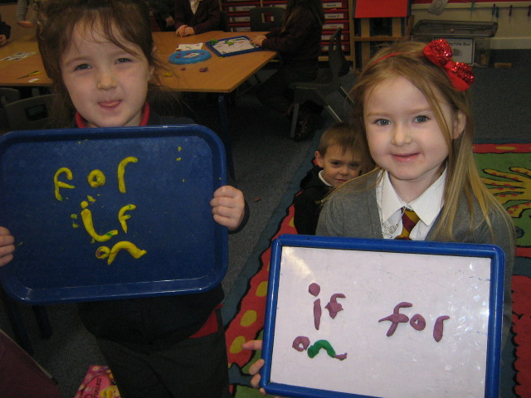
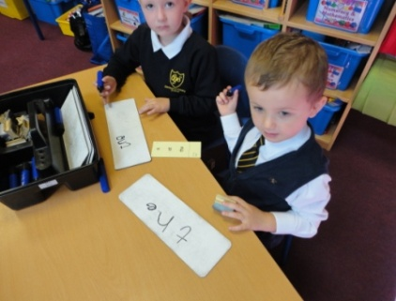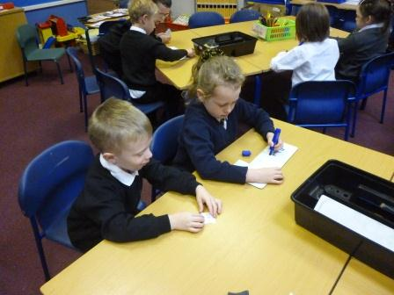

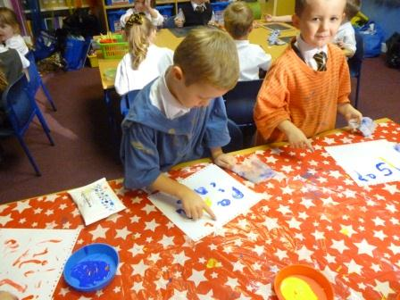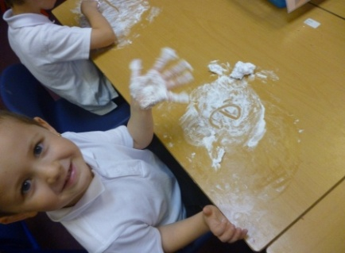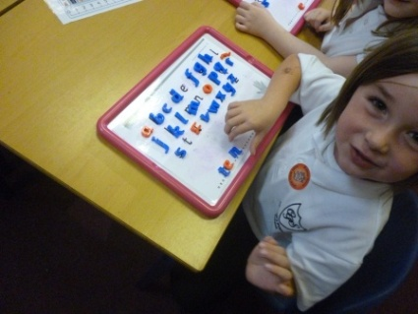

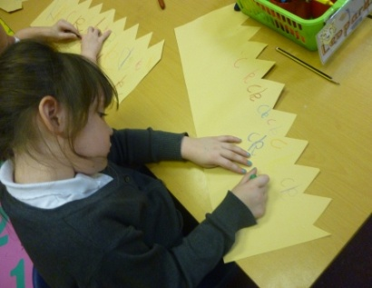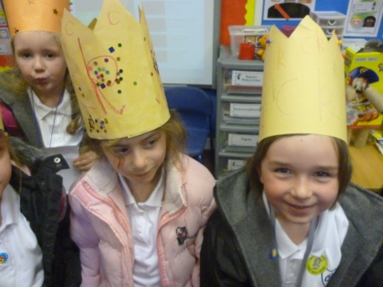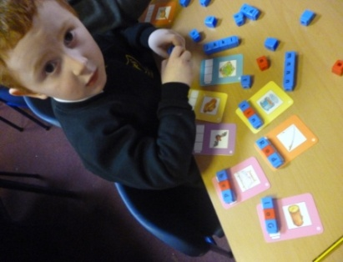

Key Messages

Our key messages for Active Approaches to Literacy at Early Level are:

- To ensure a consistent approach is used throughout all Falkirk Council establishments

- In partnership with parents/ carers, we identify value and acknowledge the literacy skills children bring from home. We regularly inform parents/ carers of their child’s participation in literacy learning opportunities and encourage them to support this at home

- To establish effective learning and teaching strategies to facilitate early success in active literacy across all Falkirk Council establishments

- Effective liaison between Early Years and Primary 1 staff to effect a continuous progression of the child’s literacy skills

- Reciprocal Teaching is used effectively in the development of literacy across all stages. This is a strategy used and developed in all literacy contexts in this programme across all stages. Using this strategy, the children take on the role of teacher to support and challenge each other

- To value the importance of oral talk and the development of pupil vocabulary

- To build on the development of literacy learning in the context of purposeful play across these stages

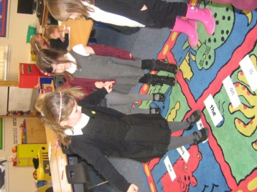
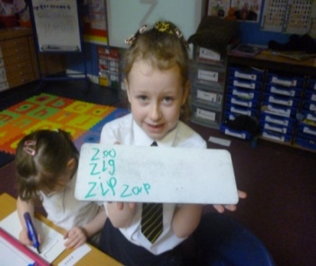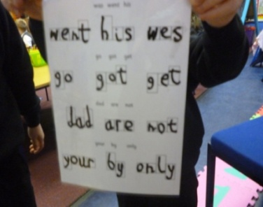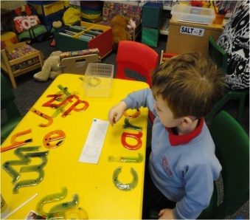

Good Practice

An effective environment for literacy would be expected to incorporate elements of good practice, for example:

- Co-operative learning strategies and activities such as ‘think, pair, share’, the inclusion of social goals, roles

- The explicit teaching of social goals linked to literacy concept development e.g. Good listening, following instructions, asking questions

- Learning journeys/floor books – consultation with pupils

- Effective assessment strategies being used which incorporate Assessment is for Learning strategies, e.g. thumbs up, fist to five, traffic lights, smiley faces

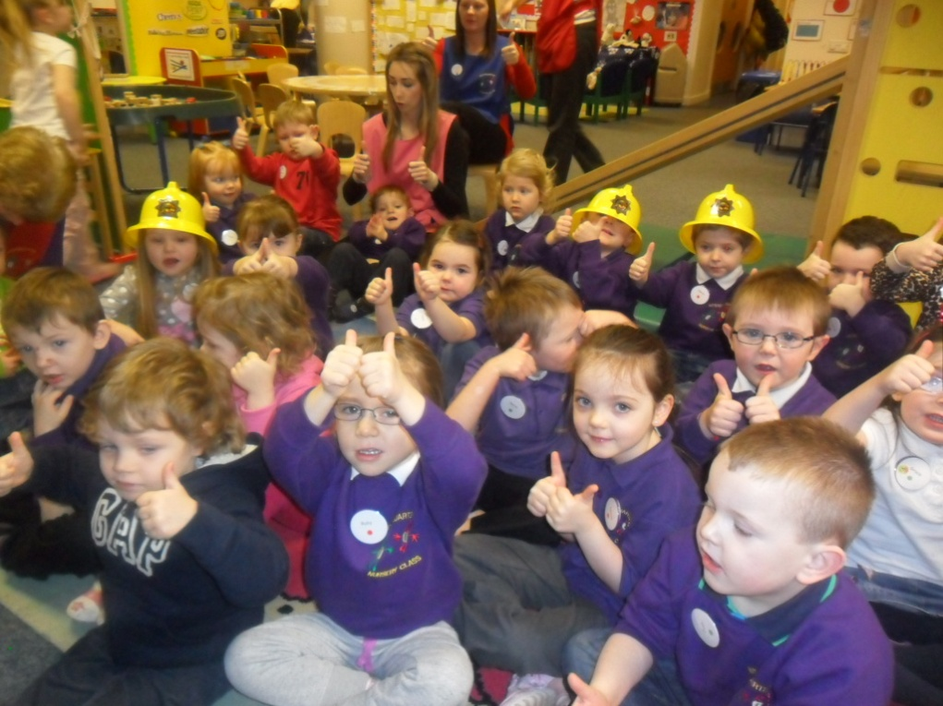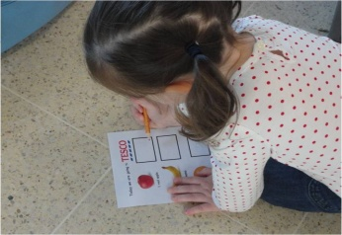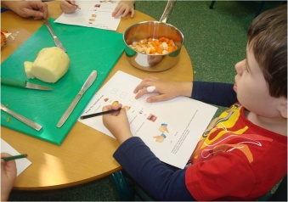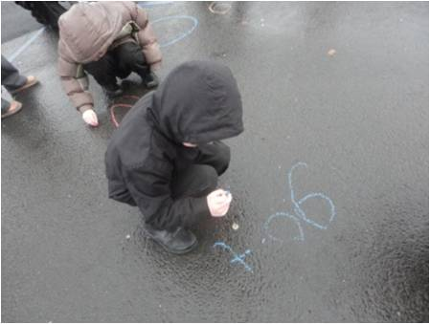
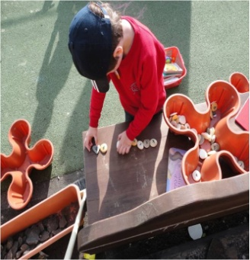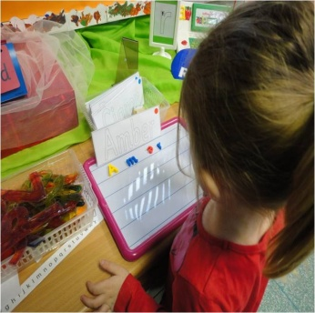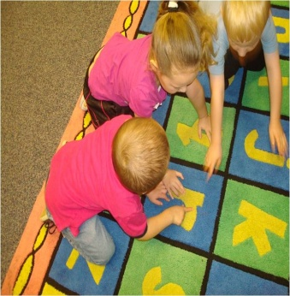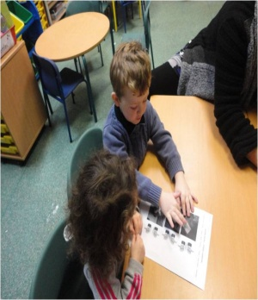

The Learning Environment

When planning for the use of resources and space available for effective literacy development, the learning environments in both Nursery and P1 spaces should:

- Provide opportunities to promote, enhance and develop Talking & Listening, Reading and Writing

- Incorporate a layout which facilitates opportunities for Reciprocal Teaching experiences

- The use of familiar resources e.g. whiteboards/ magnetic letters in both Nursery and the P1 learning spaces

Further guidance on this can be found in ‘Practical Solutions for Early Intervention’ (Falkirk Council, 2006).

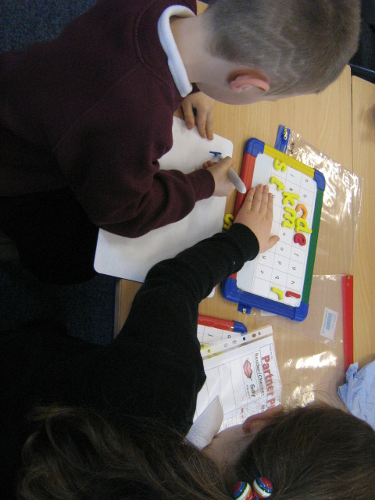

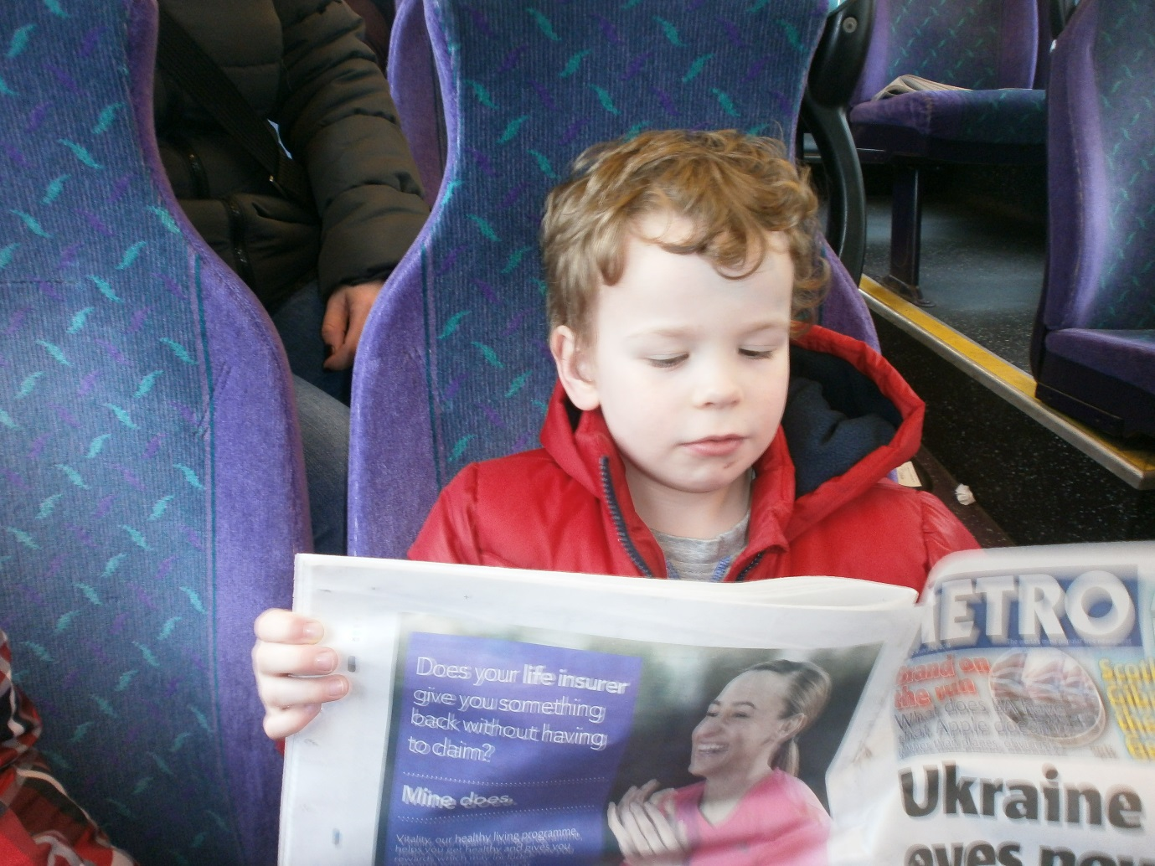

References:

Scottish Government (2010) Pre-Birth to Three: Positive Outcomes for Scotland’s Children and Families, Scottish Executive
Scottish Government (2007) A Curriculum for Excellence, Building the Curriculum 2, Scottish Executive
A Curriculum for Excellence, Scottish Executive
Falkirk Council (2006) Practical Solutions for Early Intervention: Falkirk
Falkirk Council (2008) Practical Phonological Development Activities – Pre-School and Primary 1: Falkirk
Falkirk Council (2009) Learning to Achieve: Falkirk
North Lanarkshire Council (2008) Active Literacy: North Lanarkshire

For further information, please refer to:

- Falkirk Council’s Literacy Strategy online support tool blog: https://blogs.glowscotland.org.uk/fa/LiteracyStrategy/literacy-strategy-document/
- Angus Council Experiences and Outcomes (accessible on Glow)
- http://www.youtube.com/watch?v=QWeYMNxNUpc

Acknowledgements:

Thanks to colleagues who assisted in the development of this booklet:
Airth Primary School and Nursery Class
Bantaskin Primary School and Nursery Class
Bonnybridge Primary School and Nursery Class
Camelon Nursery
Carmuirs Primary School and Nursery Class
Carronbank Nursery
Denny Primary School and Nursery Class
Dunipace Primary School and Nursery Class
Kinnaird Primary School and Nursery Class
Larbert Day Nursery
Maddiston Primary School and Nursery Class
South Ayrshire Council
St. Bernadette’s Primary School and Nursery Class
Wallacestone Primary School and Nursery Class
Westquarter Primary School and Nursery Class

