**Yvonne McBlain Notes – Inquiry Based Learning (As a pedagogical approach useful for Interdisciplinary Teaching and Learning)**

Examples of practice can be viewed in Leigh Watson’s Padlet - [**https://padlet.com/leighwatson3/idl-innovation-lab-dglyvn7jyybh6evp**](https://links.uk.defend.egress.com/Warning?crId=666810b2317e4011e207a588&Domain=falkirk.gov.uk&Lang=en&Base64Url=eNoFwlEKgDAIANATLT-Cgm7j2piGqTBZePt4jyJ8XgCOTXpst70gnQd9GNN0B25SWNUWBpsWwVrakFx6PpmVjr78B1uIGY8%3D&@OriginalLink=padlet.com)

These notes were taken from the Edge Foundation link - [Home | Edge Foundation](https://www.edge.co.uk/) - registration required.

Self-guided Toolkit on Practice Dashboard: Strategies to Develop Inquiry Based Learning [Strategies to Develop Inquiry Based Learning | Edge Foundation](https://www.edge.co.uk/practice/dashboard/self-guided-toolkits/strategies-to-develop-inquiry-based-learning/)

**Notes from this page:**

**Definition of IBL -** Inquiry (or enquiry) based learning approaches are centred on **real world problems or scenarios**, which develop student learning through the stages of **problem-solving through inquiry, application, production, solution design and consequences**, with the weighting of student or teacher led dependent on the needs of the students.

**Inquiry Based Learning** covers a broad spectrum of teacher directed to student led approaches. Inquiry based approaches seek to develop students’ ability to critically analyse and problem solve through real world scenarios**.**

**The problem or scenario alongside the methods and processes which students experience, enable them to review and re-shape their understanding of the world and their own learning progress.**

**Inquiry based approaches must align with the whole school curriculum, assessment processes, learner development and progression.**

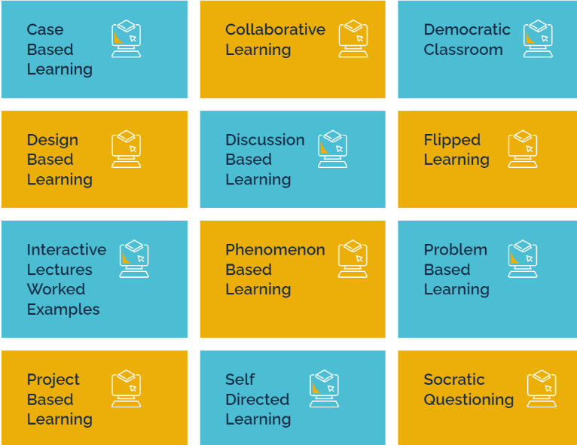**List of strategies offered via the list below:**

**Case-based =** used in medical, higher education. Real-life case is used as a teaching/learning context. Problem shared by teacher, students work in groups with the information shared to reach their conclusion and offer a solution with rationale. Requires application of subject knowledge and skills plus social and collaborative, and communication skills. Students care because they know that the characters were real people. They develop their ability to use multiple perspectives to solve problems.

**Collaborative Learning** = communication skills are key. Group goals are set by teacher where all students are individually and collectively accountable for achievement. Need to build on and learn reciprocally from each other. Taks will be set to be beyond the individuals but achievable by the collective responsibility.

**Democratic classroom** = is basically maximisation of student voice and agency in decision-making relating to their learning. There are high levels of trust between the teacher and students and power is genuinely shared. Features teacher planning of activities which will appeal to the broad perspectives of their students. Possibly also contexts which are stimulating and current. Working in this way develops the whole person and their ability to contribute effectively and with confidence to their group and the task in hand.

**Discussion Based Learning** = teacher initiates problem or scenario and supports group working of students. Individual contributions and perceptions extend the learning of all so that discussion-based proposals and plans result.

**Flipped Learning** = independent student pre-learning (usually of lower order skills/knowledge) to inform and support the use of the new knowledge or skills to specific classroom tasks (usually higher order application). New concepts are learning independently rather than through traditional transmission from teacher to students.

**Interactive Lectures** = adding learning activities to the traditional teacher-led lecture format. Includes metacognitive elements where the structure, content and purpose of the learning is framed by the teacher at least at the beginning and perhaps throughout. Includes worked examples shared by the teacher to model key learning.

**Phenomenon Based Learning** = used in Finland, multidisciplinary, builds metacognitive skills, embeds technology. 5 areas of learning = holistic approach, authenticity and contextuality, inquiry-based approaches and open-ended learning. Not abstract – pupils are presented with authentic problems or scenarios which they then work individually or collaboratively on. They are required to identify the knowledge and skills which they will need to solve this challenge. Similar to PBL, problem-based learning and design-based thinking but unlike these it focusses on global issues potentially IDL in nature. Also requires development of soft skills and much critical thinking. Constructivist in nature and personalised to student interest and experience.

**Problem Based Learning** = like project-based learning but may not result in a product. Widely used in higher education – medicine, engineering, etc. Allows exploration of potential (and possibly diverse) solutions to problems. Constructivist approach requiring application of knowledge and skills – students co-create their learning. They work collaboratively learning from each other as they go.

**Project** **Based Learning =** inquiry-based, enables students to learn over extended period of time to investigate real-life problems, questions or challenges. Involves deep application of subject knowledge, critical thinking, creativity, collaboration and communication. Usually results in a product of some kind which is collaboratively created and shared with an audience. Allows for multiple solutions, also transfer of key skills and knowledge and the recognition of the interconnection/interdependence of the real world. Is thematic and useful way to connect learning in disciplines.

**Self-directed Learning** = student led learning objectives and processes including decisions about what will be studied. Usually superseded by teacher decisions about learning focus to ensure curriculum coverages in UK. Requires self-regulation, motivation, autonomy and personal responsibility. Develops independent study skills and requires intrinsically motivated behaviours from students – including when and how to ask for help when needed.

**Socratic Questioning** = use of open-ended questions (usually philosophical & complex) within a discussion-based, dialogic questioning approach. Teacher’s skilled use of high and lower order questioning scaffolds the development of student knowledge and understanding. May use structured question and response approaches with protocols or strategies to support discussion or a seminar format. Can follow on from flipped learning use of a video or other source of stimulus/knowledge/question. Subject content will be open ended, ambiguous and/or challenging/complex in nature.