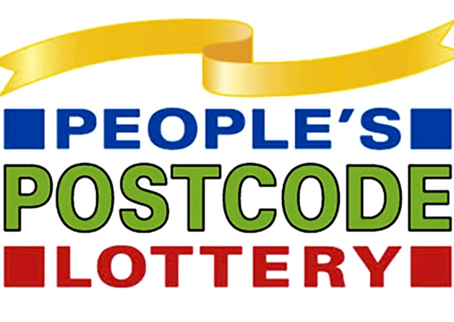
Dear Residents of QS 23UL,

Firstly, thank you for your recent entry to our weekly Postcode lottery draw. As I am sure you will remember all newcomers were entered into a separate prize draw for the opportunity to win a holiday of a lifetime ‘Travelling Europe’.
I am delighted to inform you that you are the winner of our recent competition. You are your neighbours who are part of the Postcode lottery syndicate every week now have the opportunity to plan a holiday of a lifetime around Europe.
Please decide on your destination, you may choose a maximum of 3. As you will all travel together to bond as a community it is very important that you all agree on where you may wish to visit in Europe.
Your trip will begin on the 15th of February and you can be away for a maximum of 4 weeks. Please reply with your choices to:
Peoples Postcode Lottery
PO BOX 123
London
England
PXO 1762

Congratulations once again,
Paul
Executive Founder of the Postcode Lottery.

