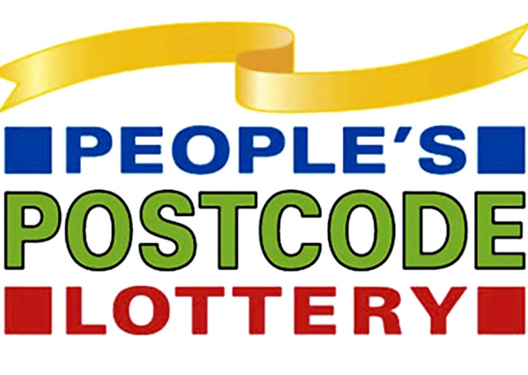

Dear Residents,
During our recent check we noticed that you are not yet part of our Postcode Lottery syndicate. We would like to take this opportunity to explain about the postcode lottery to you.
For just £2 a week your postcode will be entered into our weekly draw. Every week we place all postcodes into a random generator which gives us a lucky postcode winner! What’s not to love?

Here are some testimonials from some of our previous winners local to you!
“We won £5000 each and we all got our gardens landscaped to make our neighbourhood look like a better place to be.” The Reynolds, Carronshore.
“We were the only people in our street that had signed up to the postcode lottery. We took all the winnings, £45,000. We sold our house and went travelling round the world.” The Forresters, Larbert.
“I won £12,500. I bought a new car and lots of other luxuries that I would never have had before.” Steven, Stenhousemuir.
Here’s the best bit. All new entries to the Postcode lottery will get the opportunity to win a holiday of a lifetime ‘Travelling Europe’!

We look forward to hearing from you,
Paul
Executive Founder of the Postcode Lottery.

