The Water Source – Storyline Project
Nicola Harding P6H
Head of Muir Primary School

During the course of term 2, we have been working on a storyline topic featuring the water source. The core Experiences and Outcomes covered during the course of the topic are:

I have investigated different water samples from the environment and explored methods that can be used to clean and conserve water and I am aware of the properties and uses of water.
SCN 2-18a
I can consider the advantages and disadvantages of a proposed land use development and discuss the impact this may have on the community.
SOC 2-08b
I can explain how the physical environment influences the ways in which people use land by comparing my local area with a contrasting area.
SOC 2-13a
I can gather and use information about forms of discrimination against people in societies and consider the impact this has on people’s lives.
SOC 2-16b
Inspired by a range of stimuli, I can express and communicate my ideas, thoughts and feelings through drama.
EXA 2-13a
As I explore the rights to which I and others are entitled, I am able to exercise these rights appropriately and accept the responsibilities that go with them. I show respect for the rights of others.
HWB 2-09a
I can understand how advertising and the media are used to influence consumers.
HWB 2-37a

We started our topic by creating a strong foundation of community. Following initial research into what the term means, we set about creating our own fictional community to become our ‘home’ for the next 8 weeks. Learners were fully engaged with the process from the beginning, largely because they had full ownership of the village and sense of community. We discussed the careers and responsibilities needed to support a village and created characters/families based on these ‘needs’.

Here is our village display. We brought in a selection of junk items and were free to create our buildings in our own way using our own ideas for design and materials. We all worked together to create the river, road and houses.

Since we created our ‘families’, they have become very important to us and we do a lot of things together. We update our character diaries on a weekly basis detailing each new and exciting thing we have been involved in.

The Water Celebration

We initially looking at different types of festivals/celebrations across the world. I then decided that to keep the momentum going with the storyline theme, we would create a big event to celebrate out fictional community. This was split over two lessons in one day – morning and afternoon. The morning session consisted of planning for the big event. Pupils worked in their ‘family’ groups and each was responsible for planning one aspect of the event – the parade, the ceremony, the feast and the party. The children really enjoyed this and the fact that they were planning for a ‘real’ event gave them a huge sense of pride and responsibility.

The planning sheets were set out in a way that pupils could logically organise their ideas and could discuss who would be responsible for each part. To maintain the theme of organisation and structure cooperative learning I also introduced role cards for each job within the team. These roles included – team representative, resource manager, note taker, time keeper, facilitator and quality checker. The children are familiar with doing group work in this way so naturally adopted the challenge.
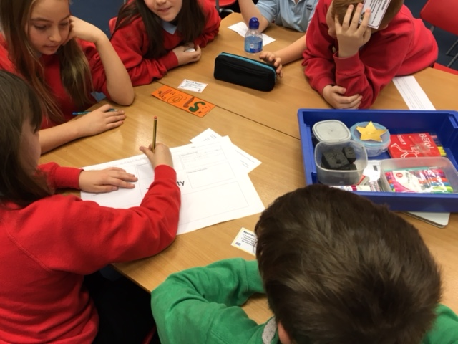
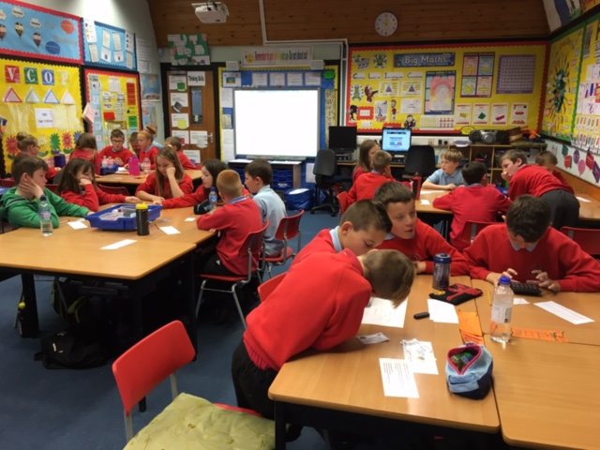
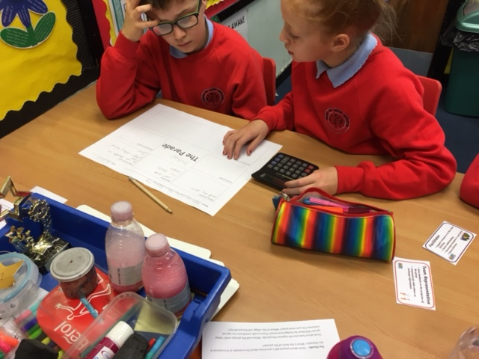
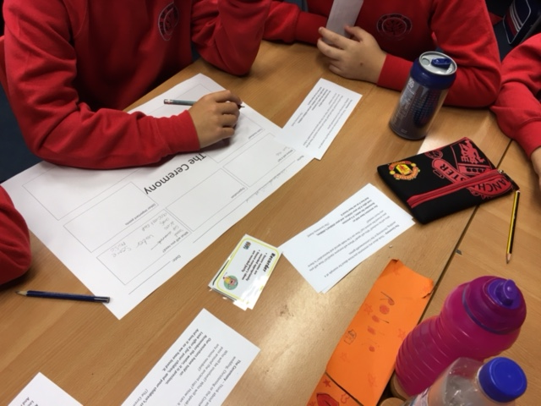
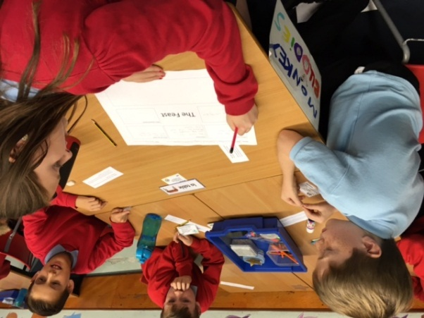
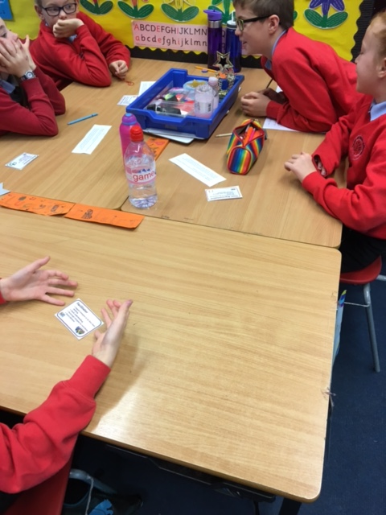
The smaller sheets of paper seen in the images above was a guide to help children plan effectively. Each group had a few examples of a similar event to their own with a selection of open questions to probe and prompt thinking.

Here are the completed planning sheets. During this time, learners also made the decision to rearrange the classroom and set about making props and visual aids for the event. One team created invitations and set up a DJ station, another set up the room ready for a formal sit-down ceremony, the third group created parade floats and the fourth began to prepare food and drink.
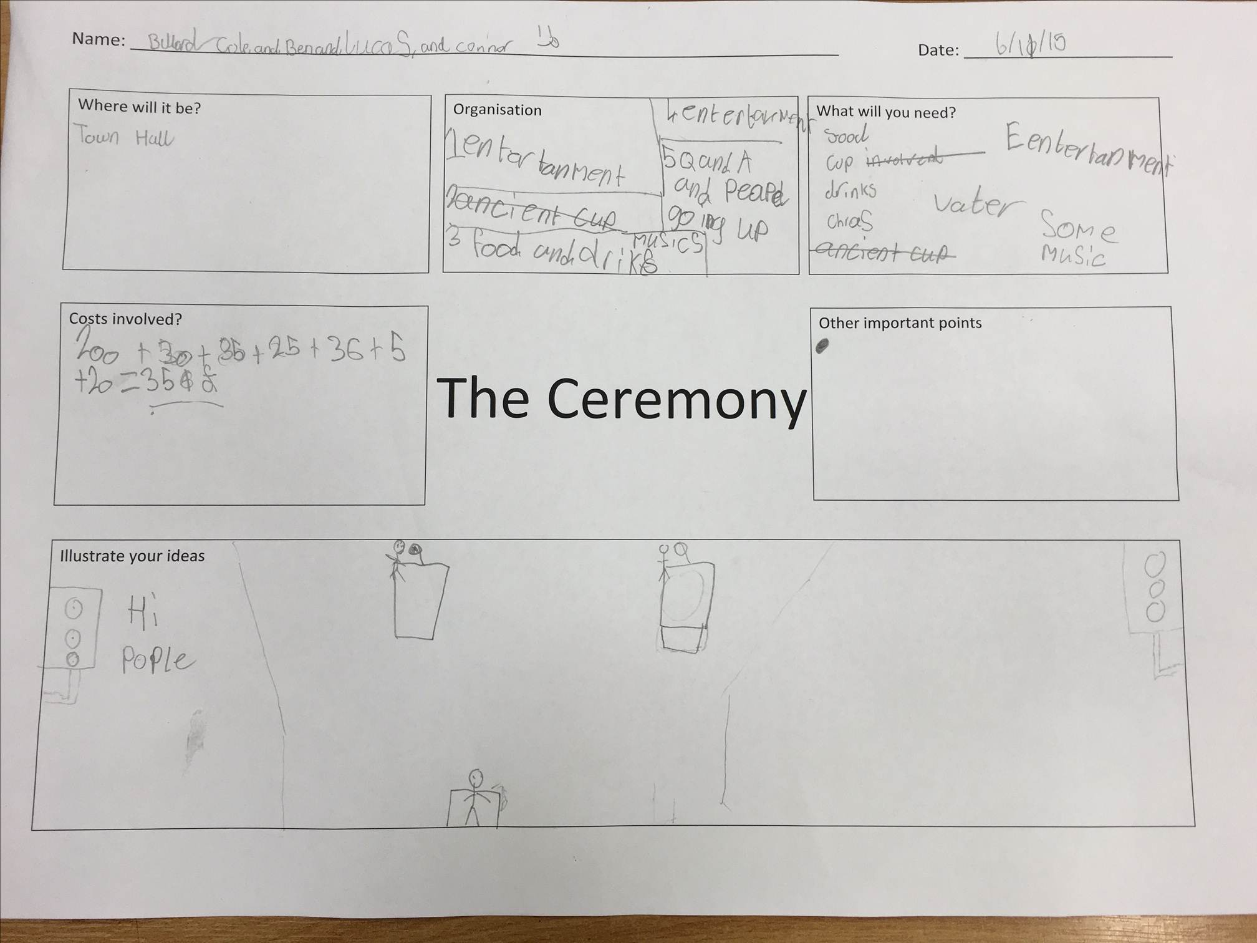

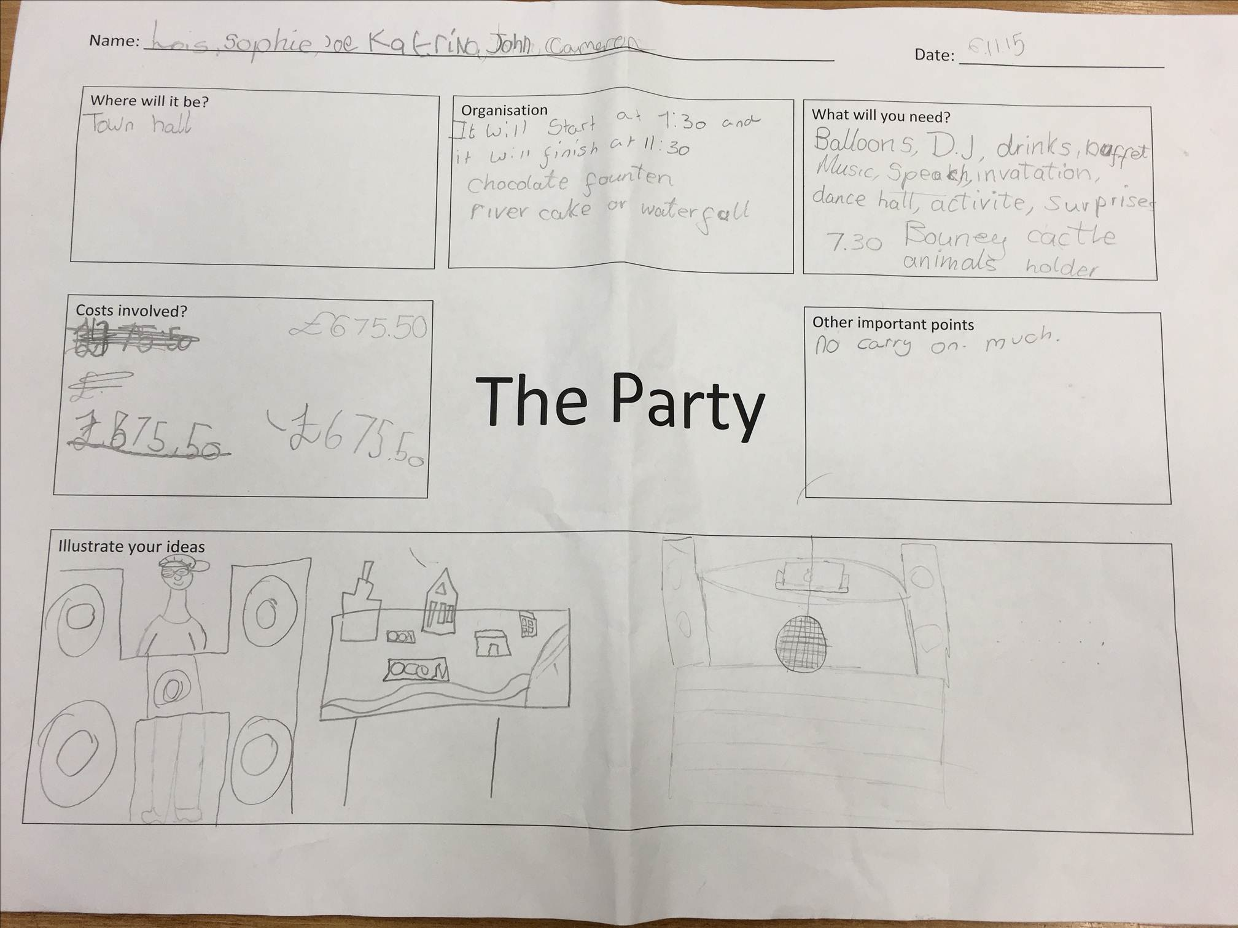

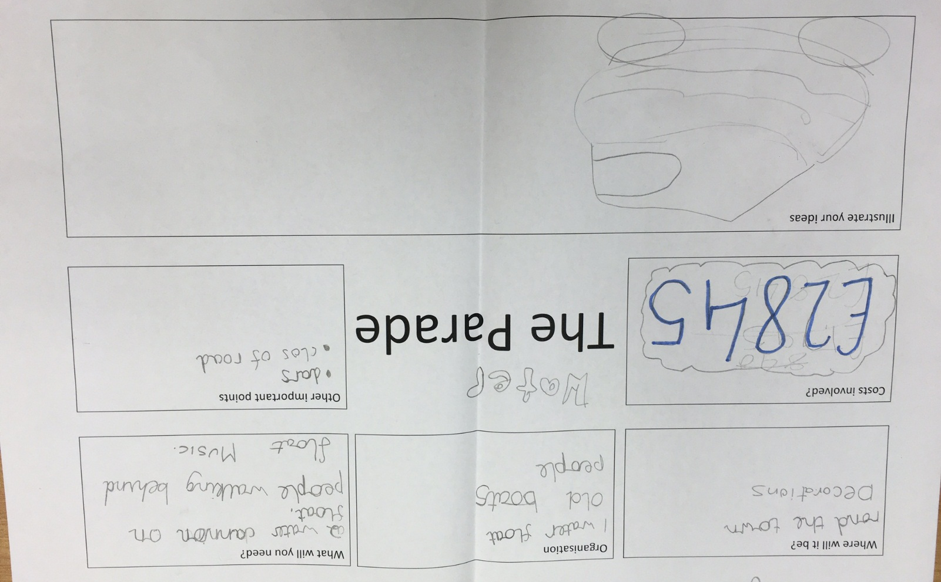

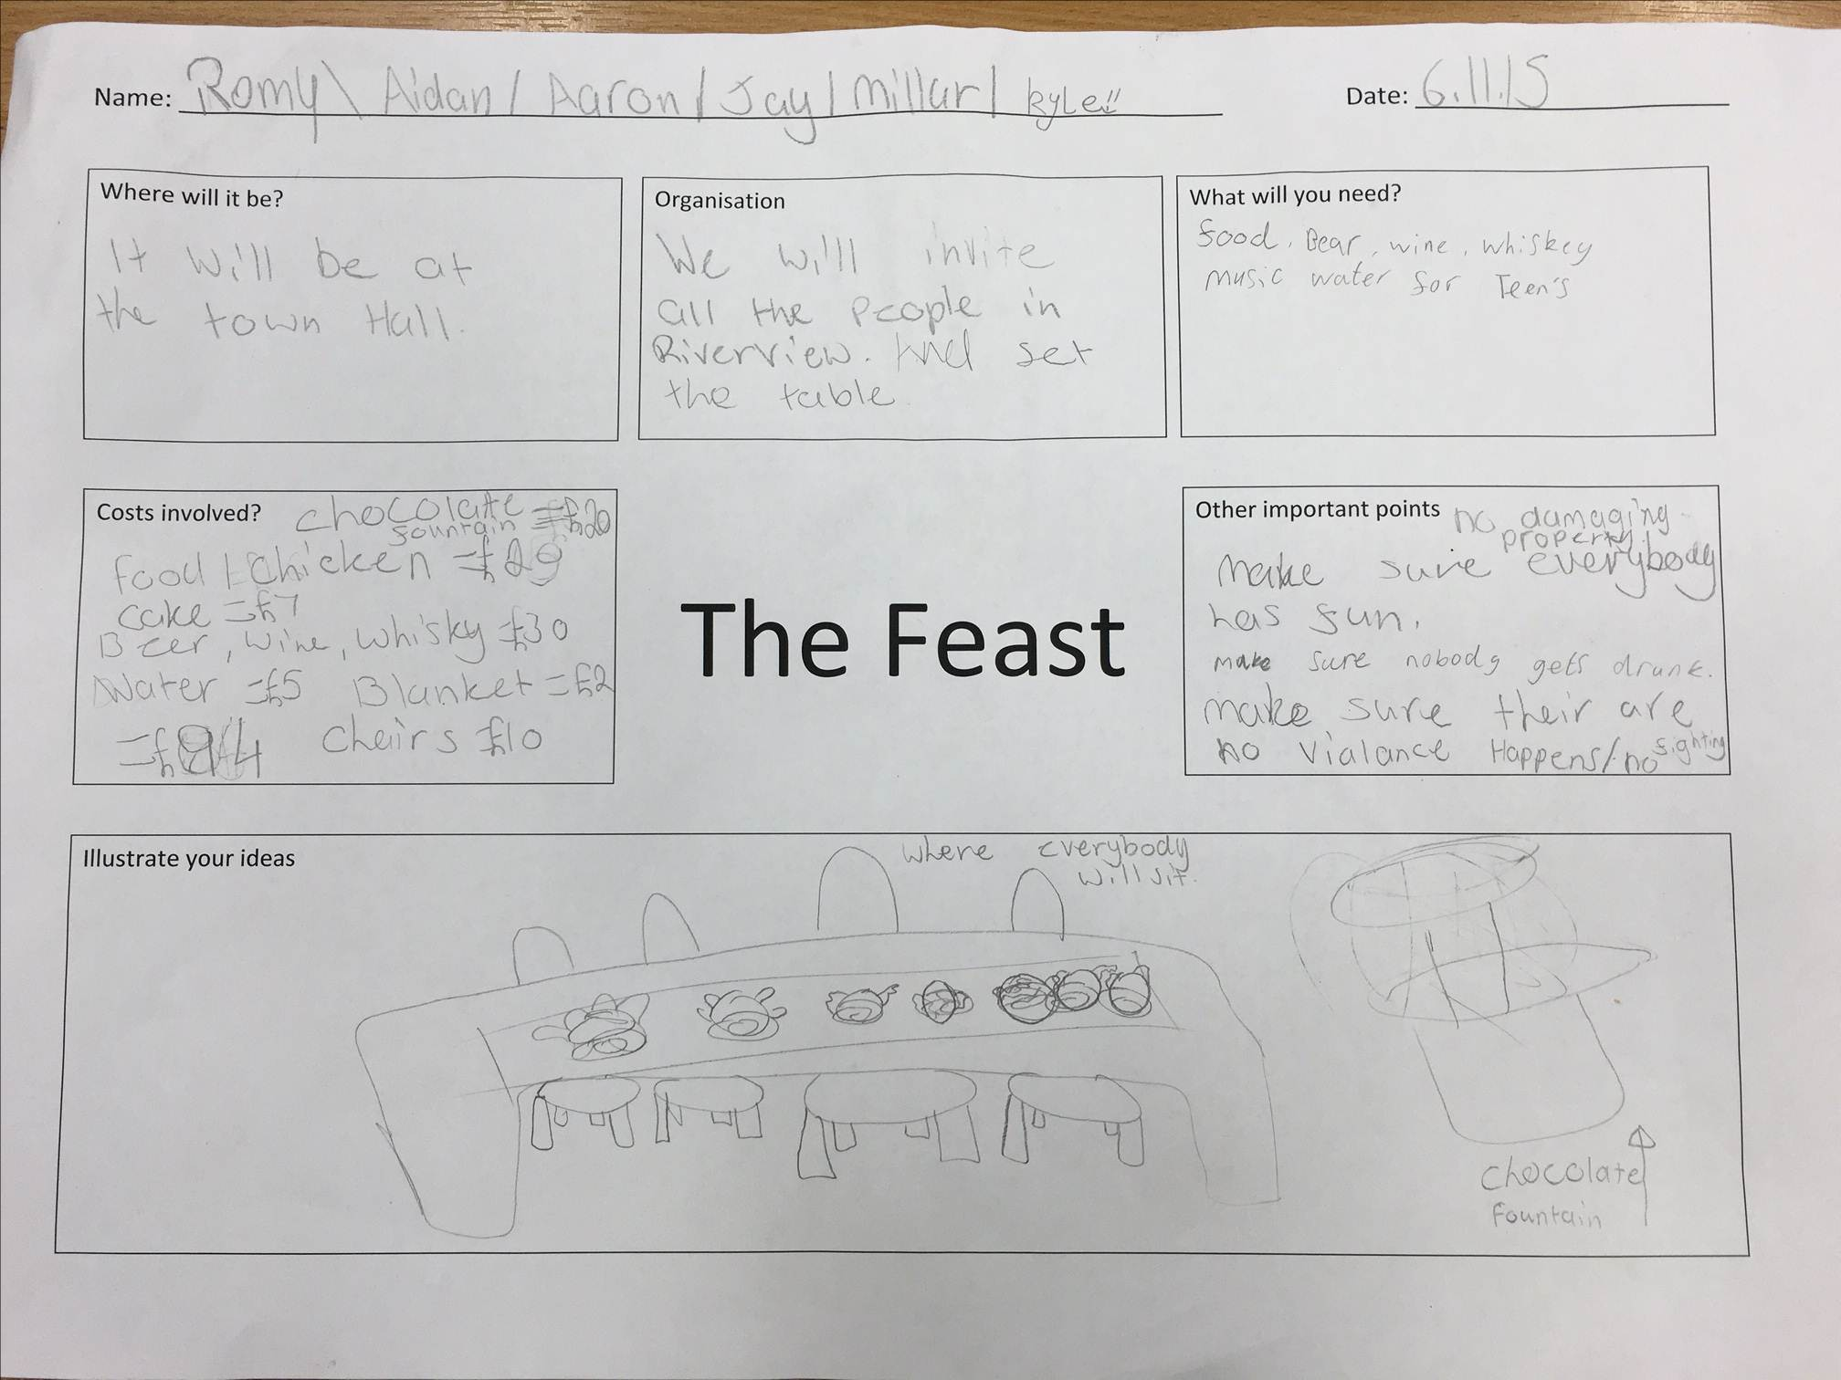

You will see from the planning worksheets shown that learners had a wide range of aspects to consider including cost implications. This was very interesting as some children had reasonable cost considerations whereas other were entirely unrealistic. Following the planning session we engaged in a whole class discussion where each team had the opportunity to share their thoughts and ideas for the celebration.

We then went on to work on planning for the short drama scene which would form the parade. Each group created their own scene with the given criteria: must have a spoken part; include reference to water; include repetition; include movement; chorale speaking; percussion instruments optional. During this time, two groups worked very well and the other experienced some difficulties on agreeing the way forward. We picked this up again in the afternoon for a short recap before performing for real and the time lapse had been perfect to allow pupils to reflect and work together productively.

Finally, we acted out the entire celebration in order. We filmed the parade to allow us to watch back later and peer assess performance. Other aspects of the celebration were photographed and we later discussed what went well and how any problems could have been addressed.
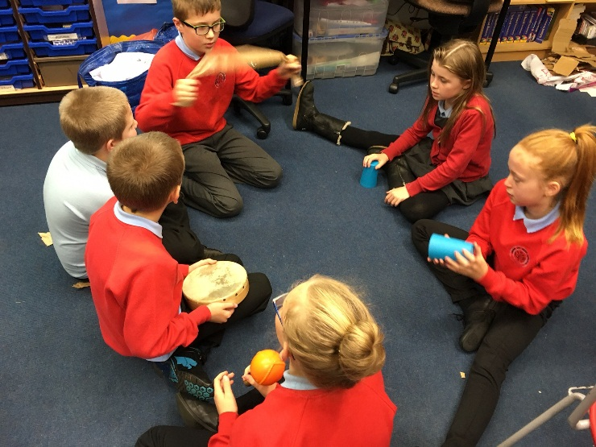
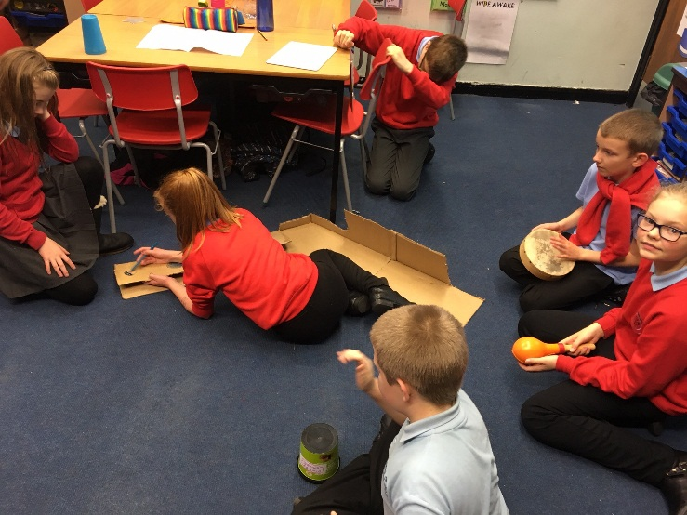
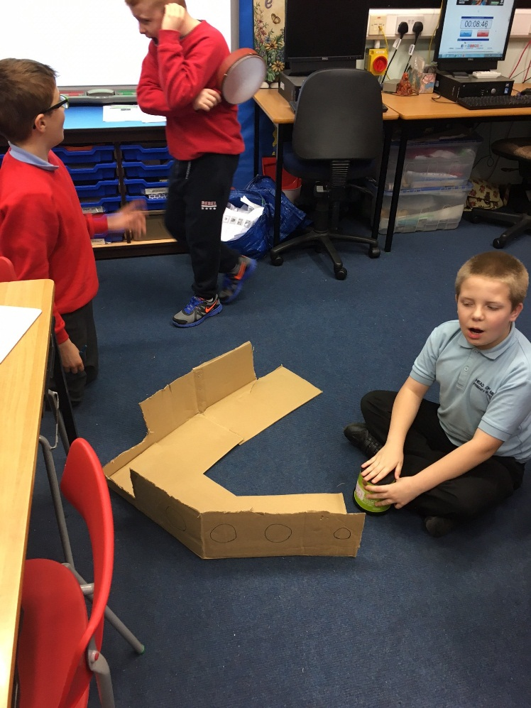
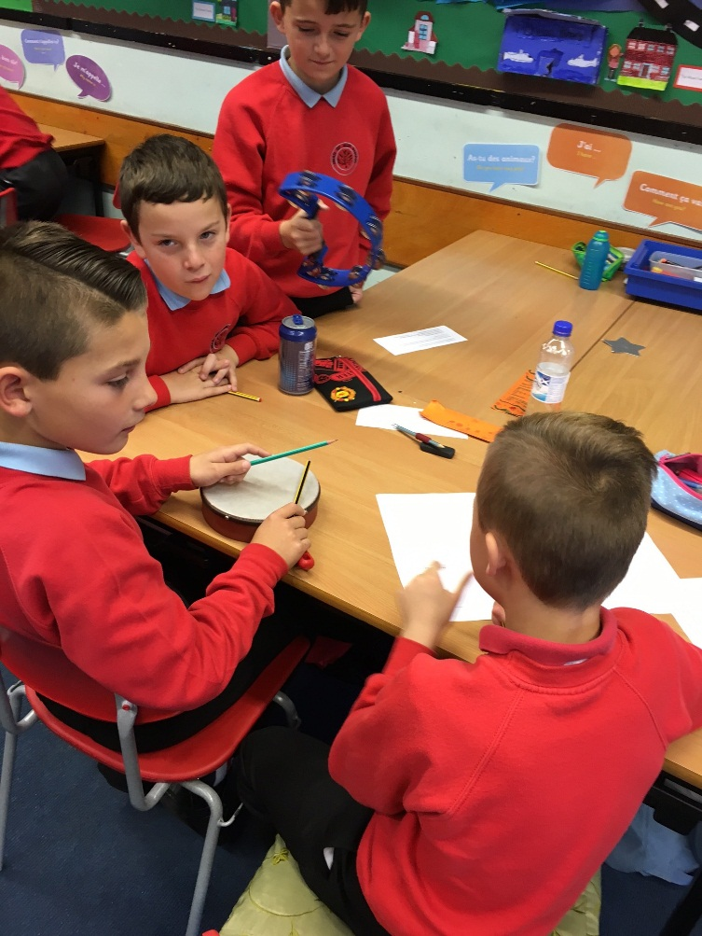
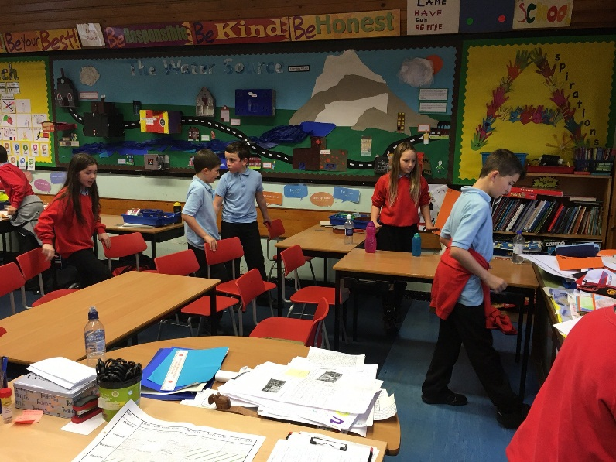
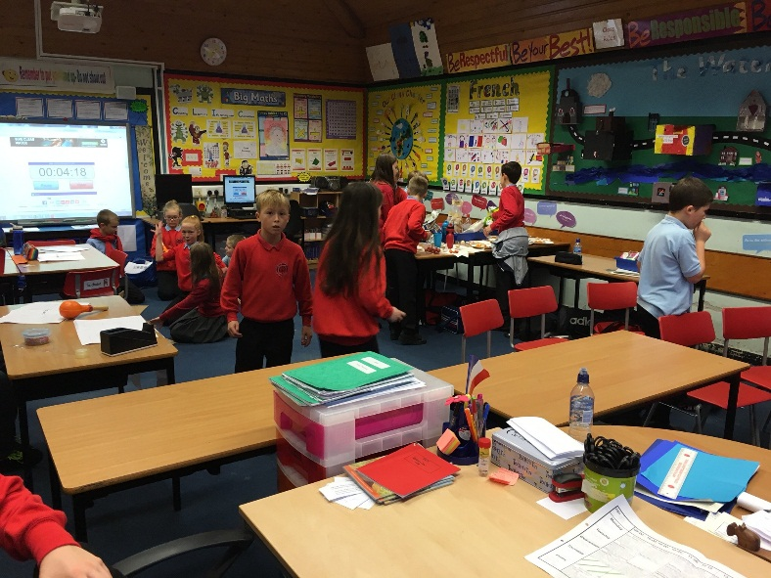
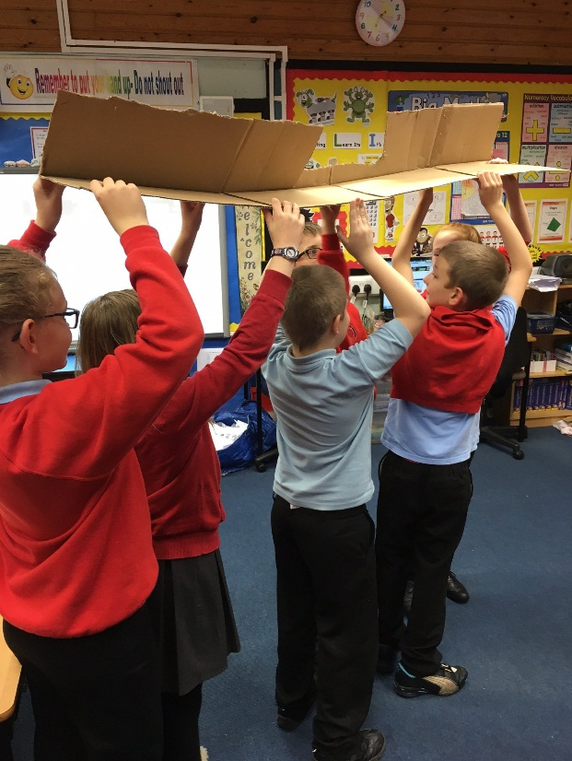
Parade Preparations

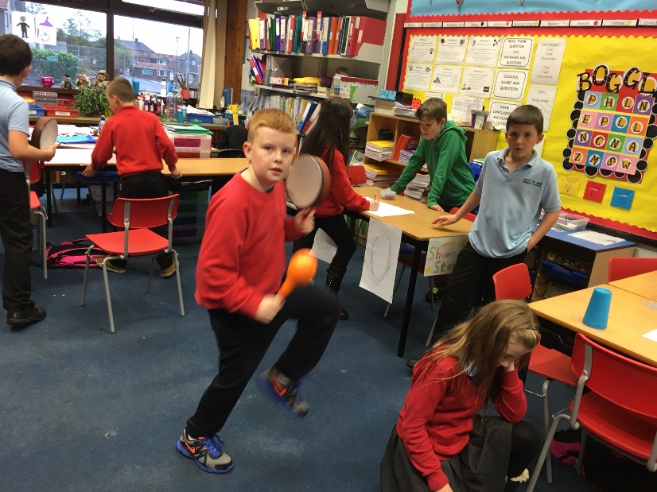

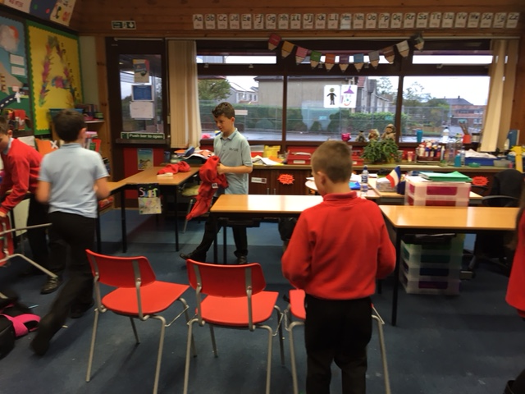
The Ceremony
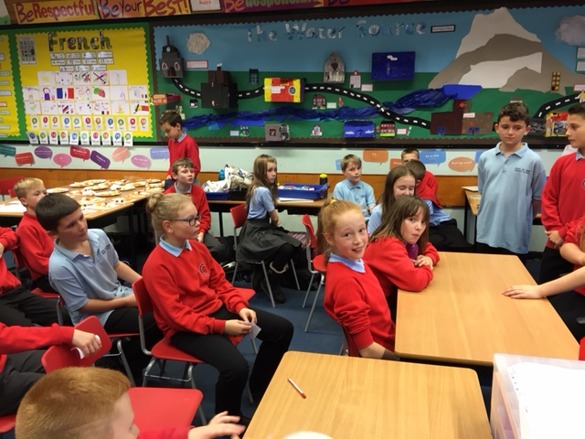
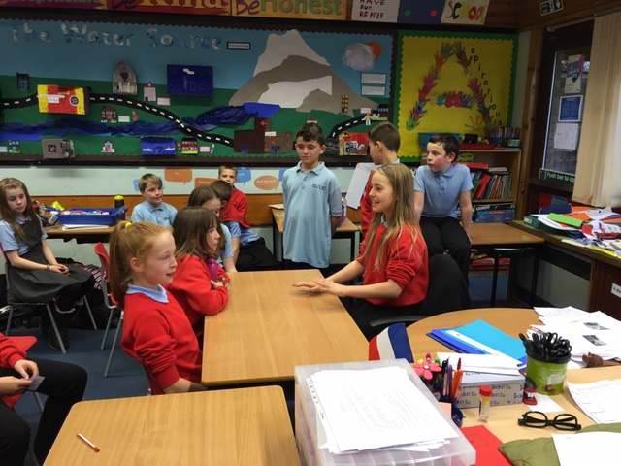
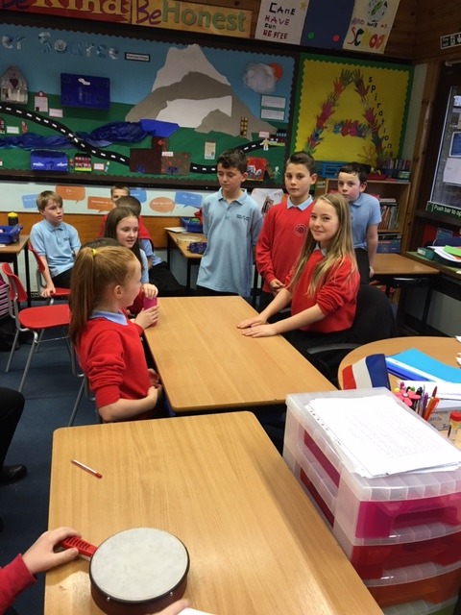
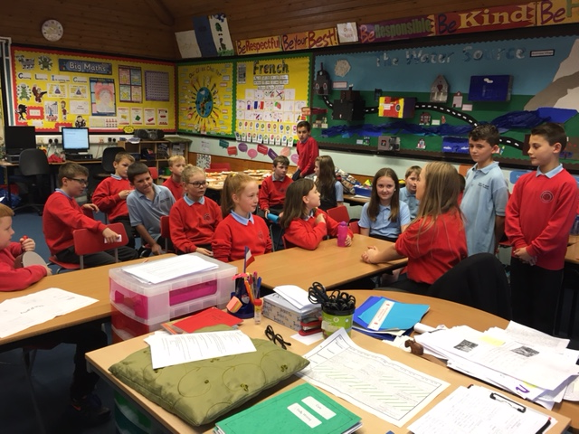
The Feast
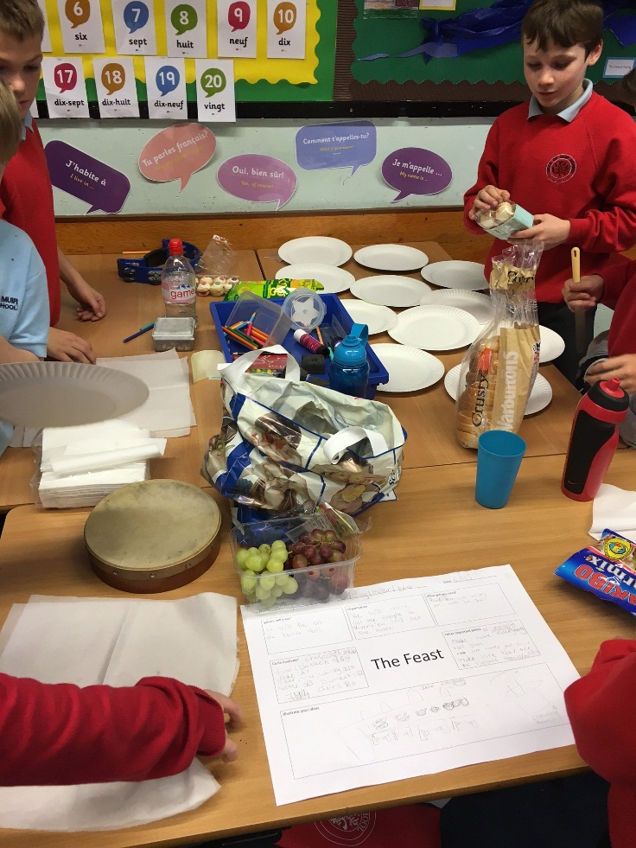
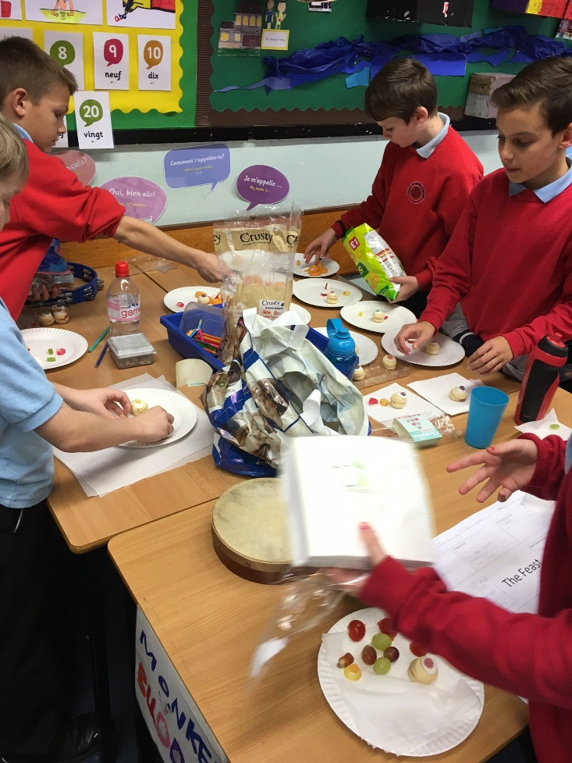

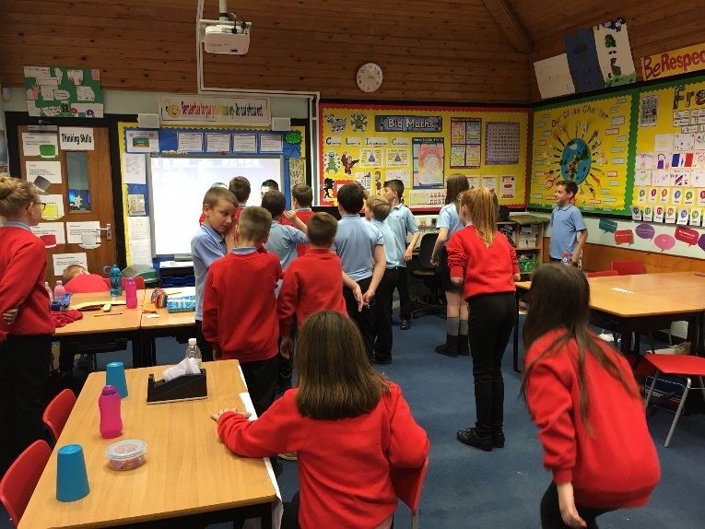
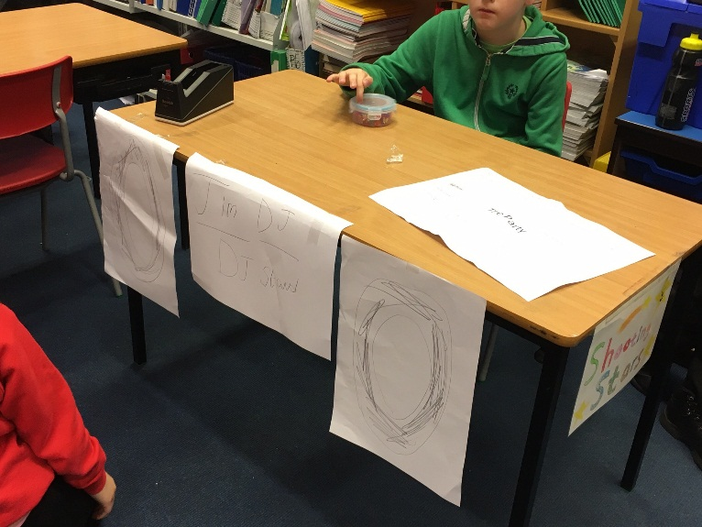
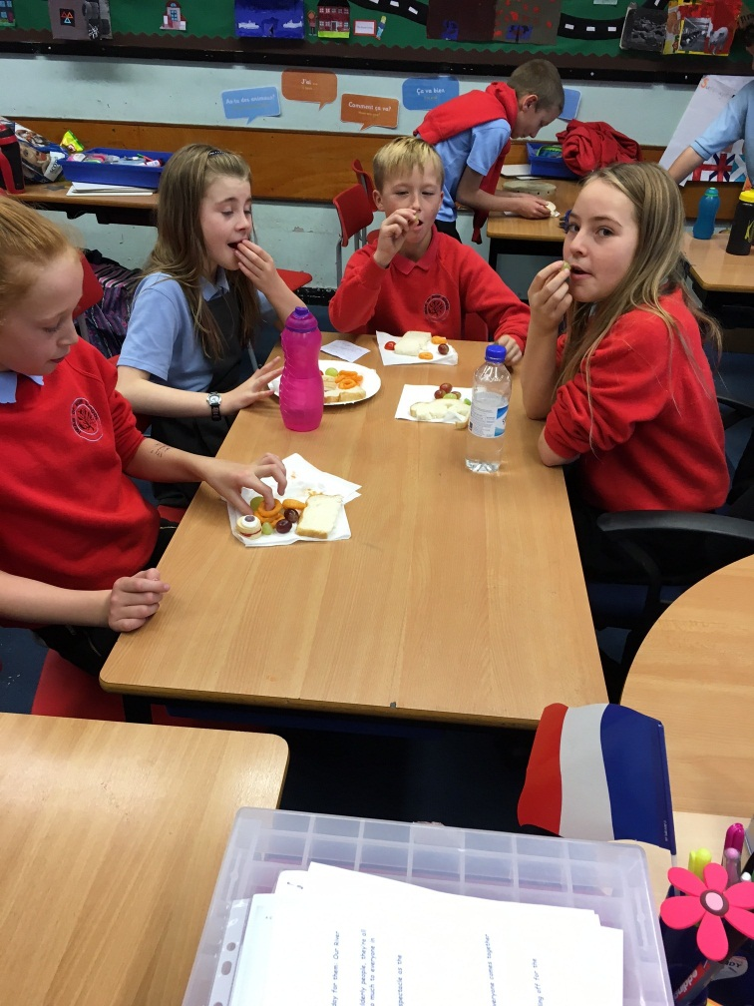
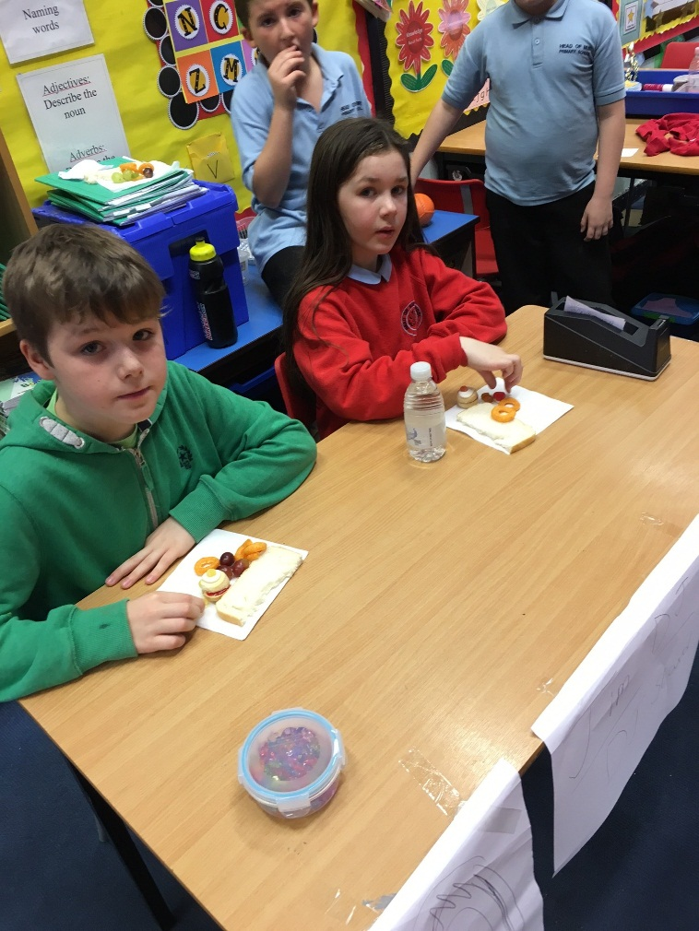
The Party

The children really enjoyed the whole process. They enjoyed the variety of tasks and also the ability to work with peers in small focused, and larger groups. The exercise allowed learners to broaden their horizons, particularly within the realms of drama and explore how a theme could really come to life.
Not only were drama and technology themes explored through topic IDL but also collaborative learning, organisational and reasoning skills were considered. The learning intention and success criteria for learning was continuously referred back to and was displayed for learners to see:
Learning Intention: Select and organise relevant information to plan one aspect of a special event.
Success Criteria:
- Identify resources needed. (including music) - Agree on organisation for event.
- Create step by step instructions for success. - Estimate costs involved.

