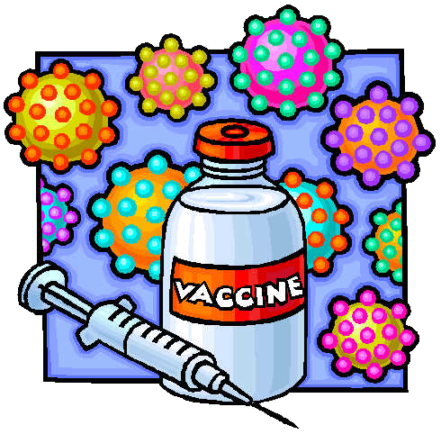
“BRAES ANATOMY”
RMPS MARKING SCHEME
Moral issues surrounding the creation and use of Vaccines

The following are illustrative responses. The pupils may include other, relevant information.
N.B When pupils are talking about ‘playing God’ it should not be assumed that they are talking about a particular religious God but a being of higher power/a creator.

- Playing God negatively:

    - God created us; if we change his creation by using vaccines we are becoming God and that is wrong.

    - God has a made us the way we are for a reason; we should not being changing or adding to it.

    - God has a plan for us; by using vaccines we could be changing his plan.

    - God decides who lives and who dies; by administering vaccines we could be seen to be taking on that role.

    - God only lets us deal with pain and suffering that we can cope with as it beings out qualities that we did not know we had; by using vaccines are we stopping ourselves from being tested.

    - The way in which some vaccines are made could involve the use of stem cells; this is a part of God creation and the use of them is seen as murder by many religious groups.

    - The HPV vaccine is new; how do we know that implications it might have in the future therefore playing God.

    - Contracting HPV might be a part of God’s plan; we should not be meddling with the plan.

- Playing God positively:

  - God gave us free will; therefore allowing us to use vaccines.

  - We are helping maintain Gods creation; therefore a good thing.
  - If God did not want use to us vaccines we would not have been given the ability in the first place.

  - Some religious groups believe that life does not begin until after conception and if using stem cells is for the greater good then it can be allowed.

  - God gave us the ability to research and make vaccines therefore we should use them.

  - God did not create HPV this was a consequence of human free will; therefore anything we can do to help Gods creation is good.

  - God only started creation what we do next is up to us.

- Not playing God:

  - People should not die from curable illnesses therefore anything we can do to help this is a good thing.

  - We have a vaccine; we should use it.

  - The vaccine stops people going through pain and suffering then we should use it.

  - The vaccine could stop families having to deal with loosing a loved one; therefore it should be used.

  - Medical advancements are happening all the time; we should take advantage of them.

  - What if you do not believe in god; why should you not benefit from the vaccine?

  - This vaccine could save millions of lives; we should be developing and using it.

  - Medical professions and scientists are not playing God they are just doing their job.

  - If the creation of a vaccine means using stem cells then this is what must be done to help the people already here.

