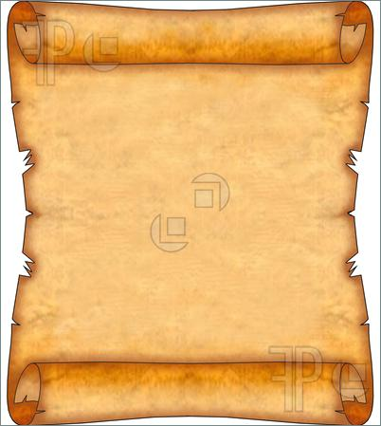

Dear Primary 1,

I have heard that you are learning all about toys and I have sent you a very precious toy to help you.

It is my oldest teddy that I made a long time ago when I first became a toymaker. Now he is looking a bit old and tired and I am sure that you have lots of ideas to make him look new.

Can you make me some new teddy bear designs to put in my shop?

Lots of love

The Toymaker

x x x