Heathrigg Nursery School



January/February 2014
Newsletter



We hope you all had a Merry Christmas and a Happy New Year. Many thanks for all the cards, good wishes and gifts, they were very much appreciated.

Christmas Raffle

A huge ‘Thank You’ to everyone who donated prizes and bought tickets for the Xmas Raffle. £129.00 was raised which will be spent on new playroom equipment and resources for the nursery.

Raffle Prize winners were:

1st Food Hamper Margaret Graham
2nd Pamper Hamper Jack Mackie
3rd Toy’s Hamper Tracy Jarvie

Ellie McCourtney was the lucky winner of the story telling bear which was donated by staff.

Christmas Sing-a-Long

Thank you to all parents and extended family who attended our Rainbow Room & Sunbeam Room Sing-alongs. Both events were a great success and we have had some very positive verbal & written comments from those who attended. If anyone has any further comments they would like to add please place the completed slips in the comments box in the main entrance.

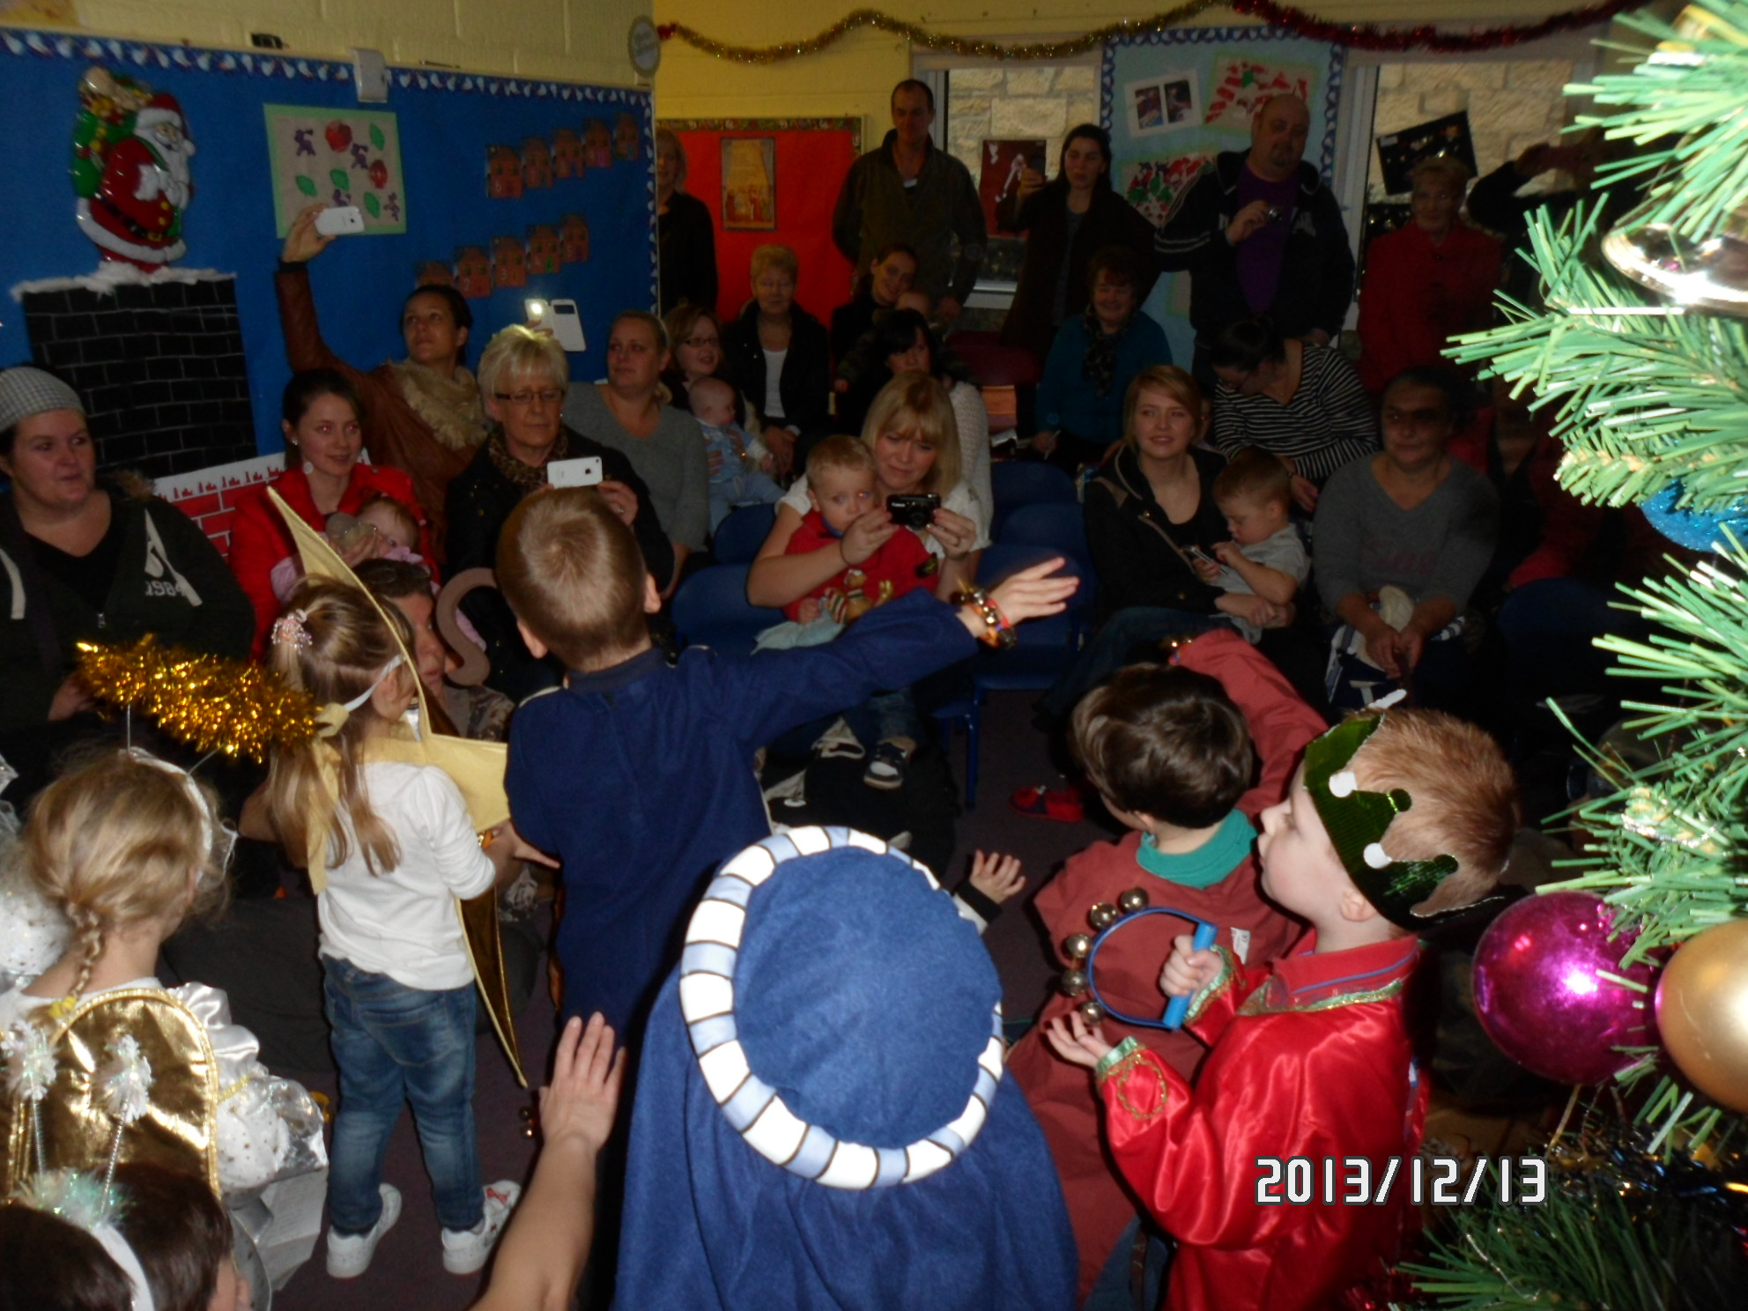
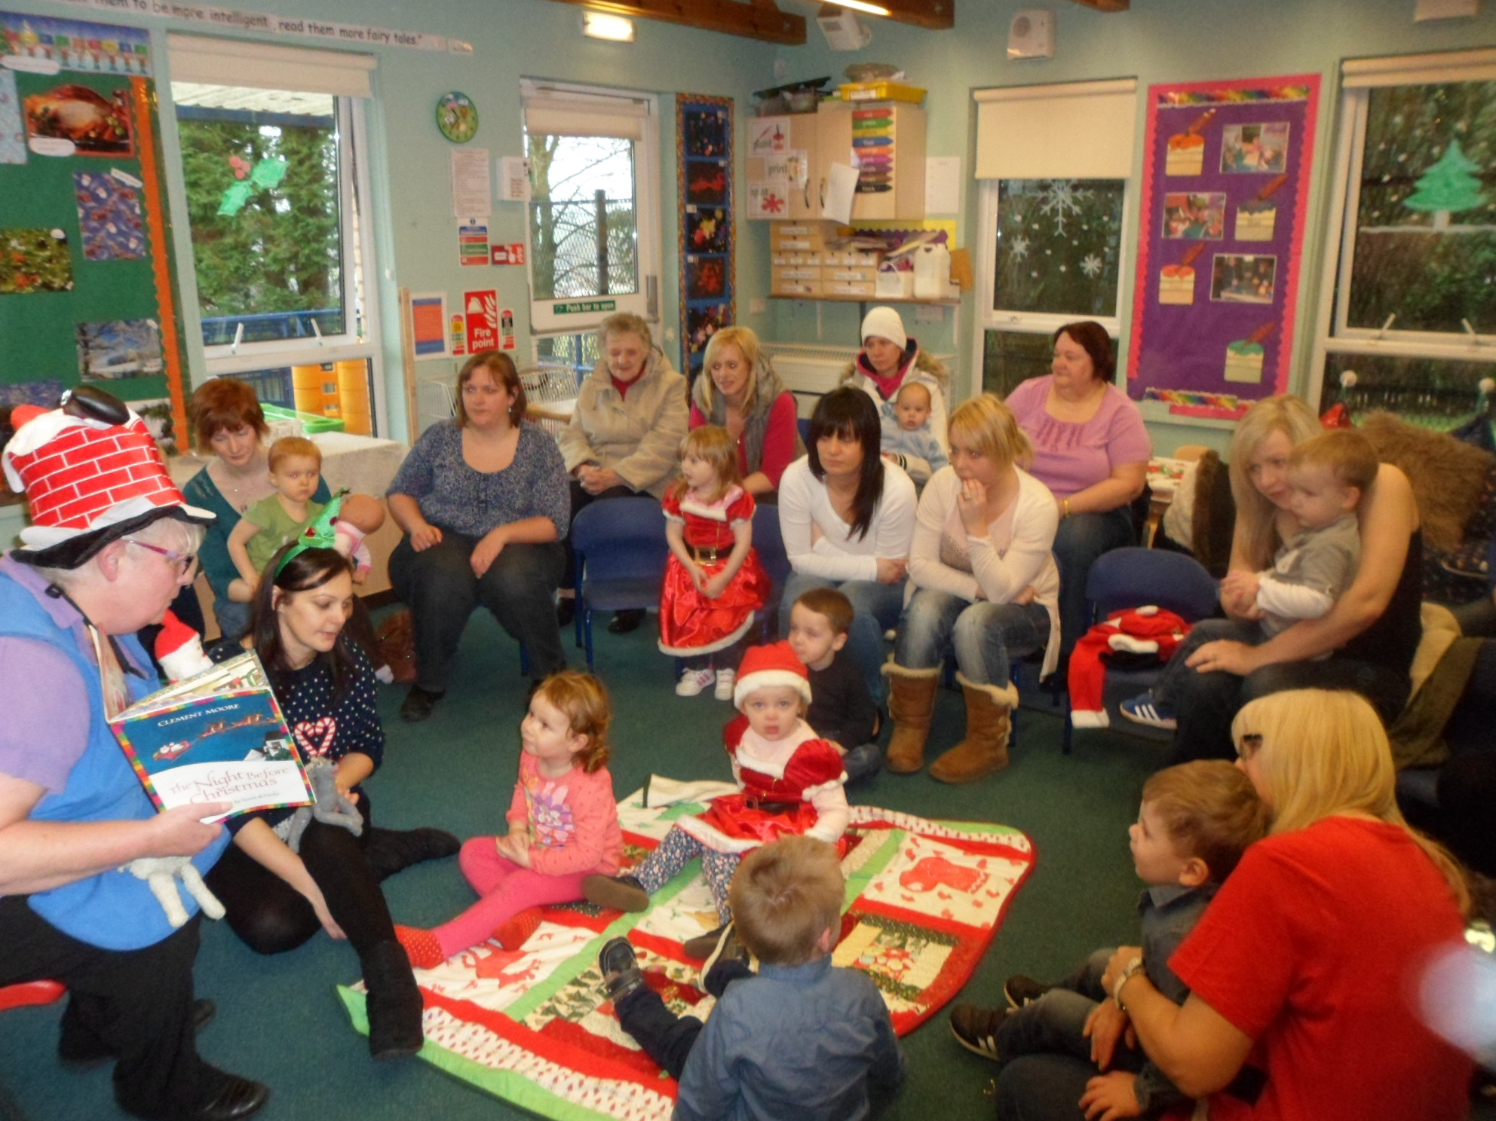

Christmas Parties

The children’s parties were also well attended and we would like to take this opportunity to thank everyone who help make them such a success.

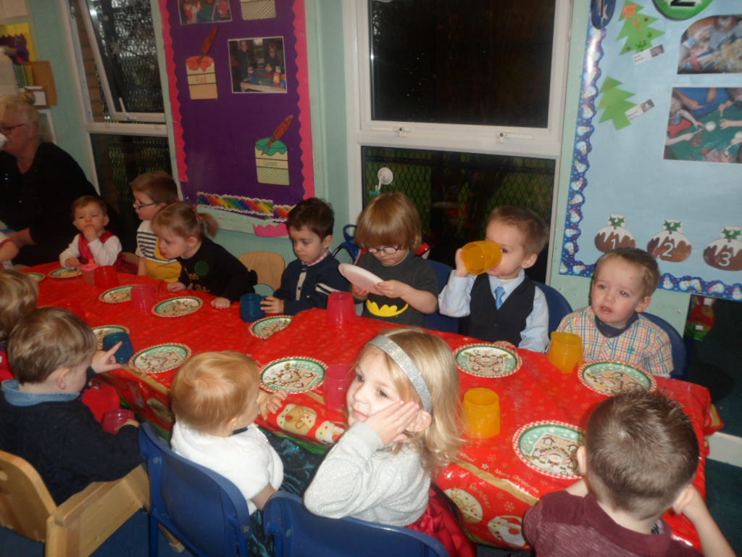
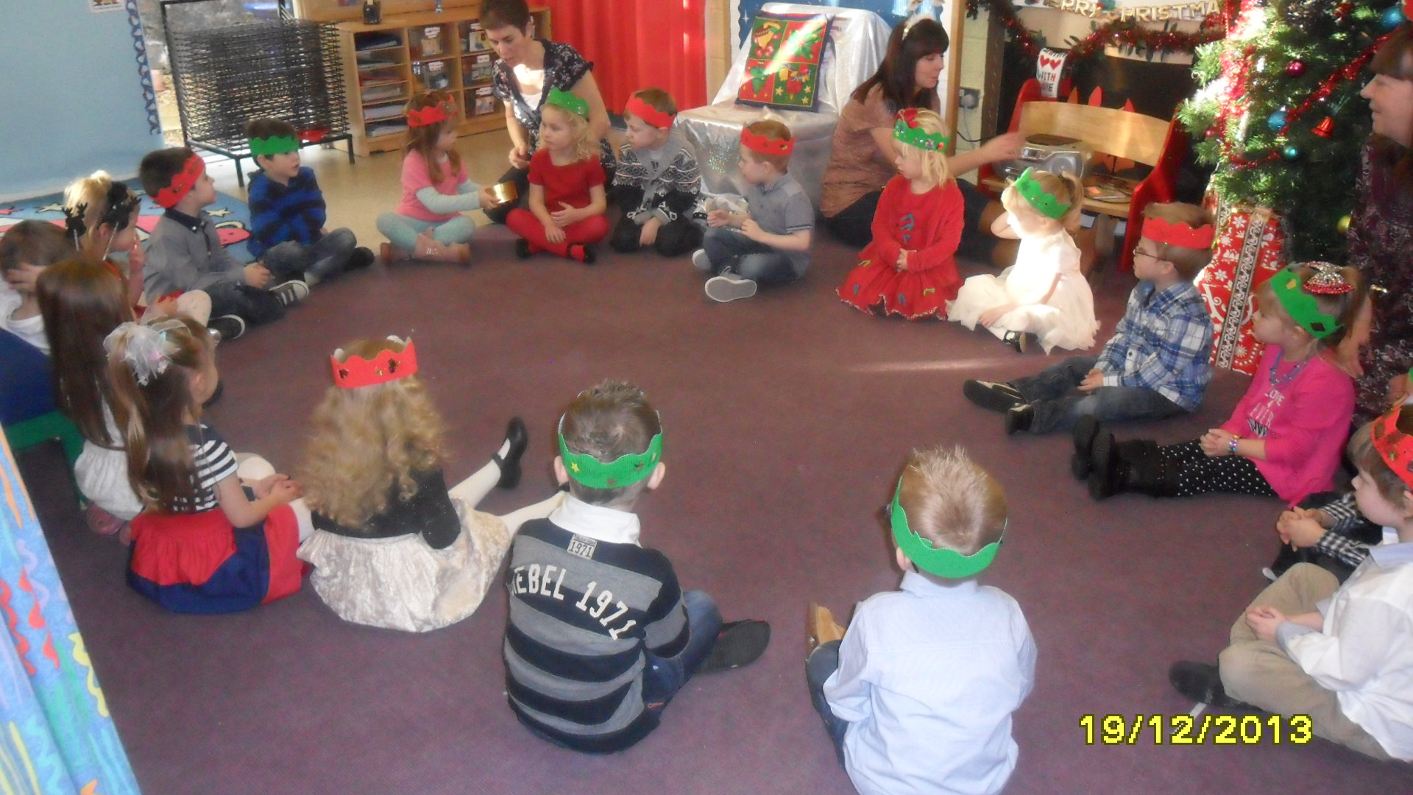

Staff Update

In the absence of Susan, Isabel Bott will be taking on the role of Acting Depute Manger. Please do not hesitate to contact Isabel should you have any queries.

Work Experience Pupils

We will have work experience pupils in nursery weeks beginning 20th January and 27th January. This gives school pupils a taste of working life and an opportunity to try different work environments.

Holiday Dates for your diary

Thursday 13th February 2014 - Entire nursery closed for Staff Development Day.

Friday 14th February and Monday 17th February 2014 - Term Holiday - closed to term time children.

Monday 7th April to Friday 18th April 2014 – Easter Holidays - closed to term time children.

Friday 18th April and Monday 21st April 2014 - Easter Weekend - Entire nursery closed for Public Holiday.

Monday 5th May 2014 - May Holiday - Entire nursery closed for Public Holiday.

Friday 27th June 2014 - Summer Holidays – End of Term – last day for term time children.

In-Service Training Days

On Thursday 13th February, all staff shall be attending an Early Years Conference at Forth Valley College where there will be the opportunity to listen to speakers, attend a variety of workshops, and share practice with other early years staff.
Although we appreciate these closure days can at times be inconvenient for parents, they are vital for staff to regularly update their training and knowledge in order to fully support your child’s development and learning.

Coughs and Sneezes Spread Diseases


As you know there are a lot of nasty viruses doing the rounds. If your child is poorly, has a temperature, headache, runny nose, cough or is sick the best place for them is cuddled up at home, even if they say they want to come to Nursery.

Please respect Forth Valley Heath Board’s advice of keeping children off nursery for 48 clear hours after their last bout of sickness/diarrhoea. This ensures bugs are not passed on to other children or staff.

Oral Health

Evelyn Kidd, oral health training officer visited the nursery on Monday 27th January to provide Sunbeam Room parents and children with information on oral health and how to prevent tooth decay. Evelyn provided parents with information on how to care for their children’s teeth and what to give them as healthy snacks.

Rainbow Room News

The children previously spent lots time exploring through their sense on touch, taste and smell. We will continue to provide opportunities for the children to further develop these senses and have also introduced a dark den with a ranges of resources to explore using their sense of sight.

The children have been experimenting with the musical instruments and learning some traditional nursery rhymes. They have also been listening to traditional stories such as Goldilocks and the Three Bears and The Gingerbread Man.
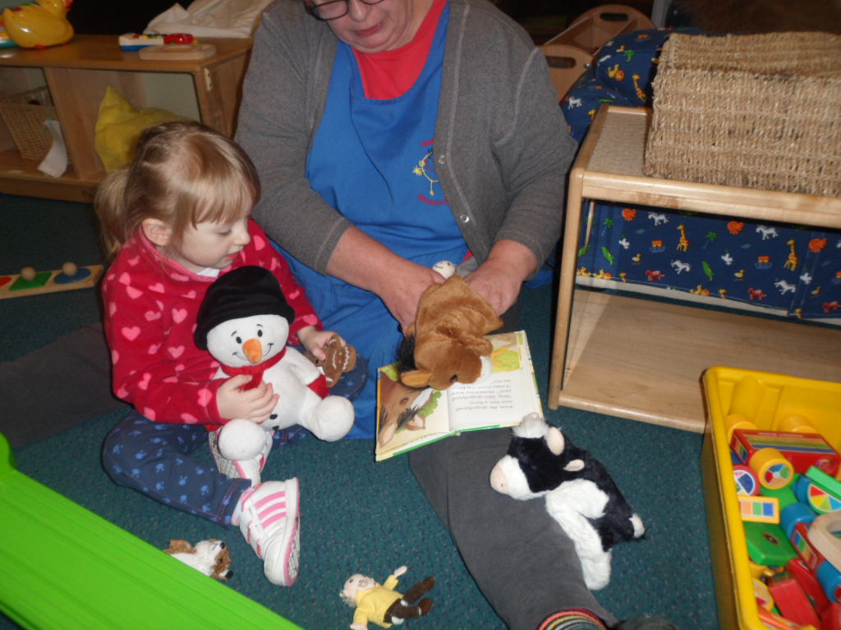
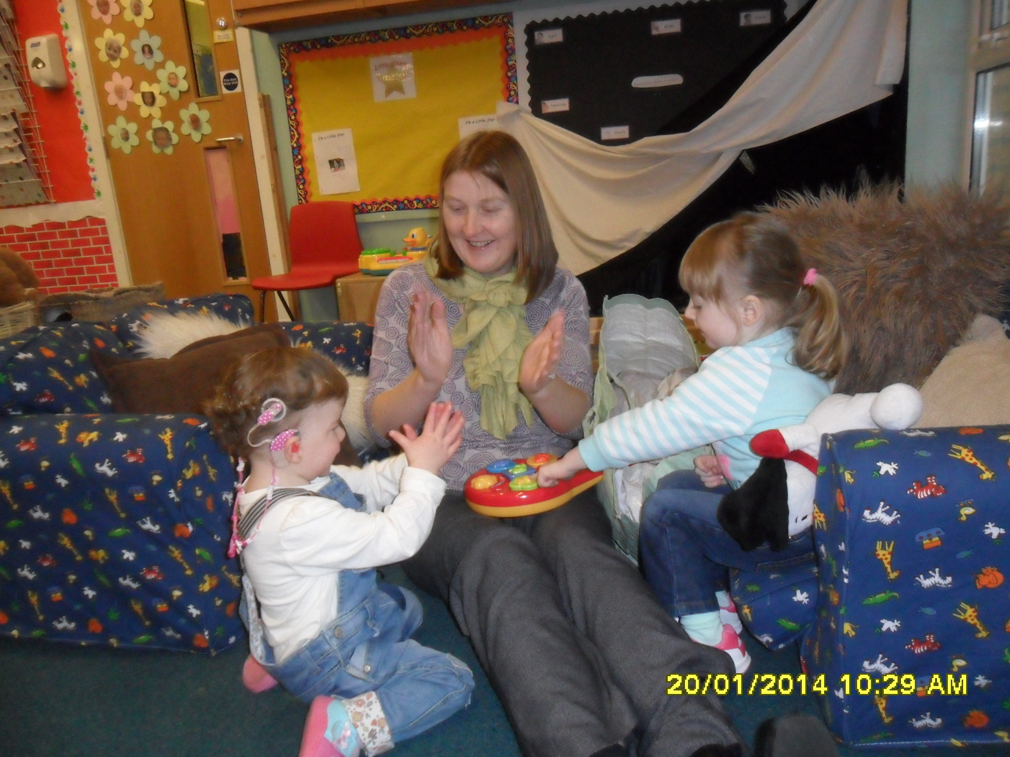

If you haven’t already done so we would encourage you to have a look at the Rainbow Room blog for information on the planned experiences and special events the staff are providing for the children. There are also fun video of the stories and nursery rhymes and lots of other interesting information there too. The web address of the blog is:-

https://blogs.glowscotland.org.uk/fa/HeathriggNurseryRainbowRoom

You can also access the blog by typing Heathrigg Nursery Rainbow Room in to Google search and the blog will be the first site in the list of results.

Sunbeam Room News

We have been exploring food, focussing on healthy food. As part of this topic the children have enjoyed making soup, fruit kebabs and fruit salad for their snack. We plan to grow vegetables in the nursery garden and eat them at snack.
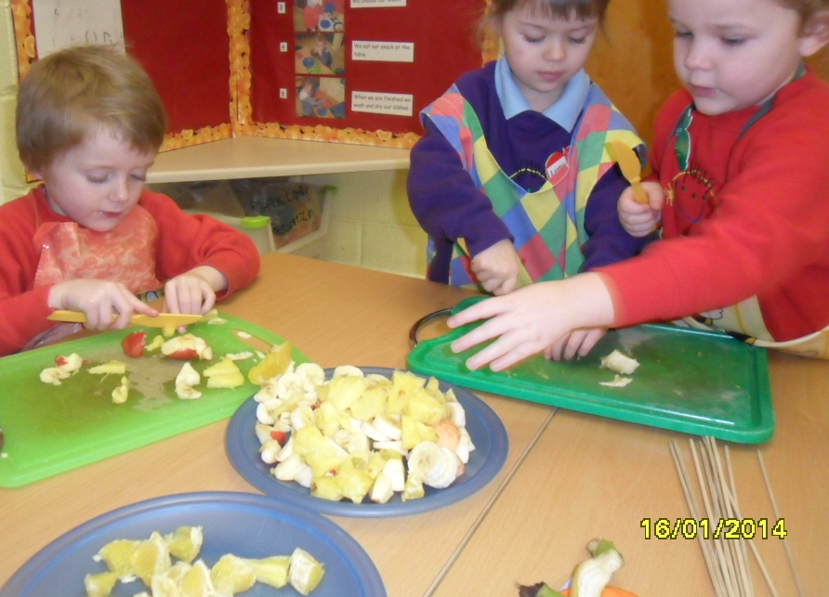

The pre-school children performed songs at the Scottish Assembly at Slamannan Primary School.

We celebrated Burns Day and had haggis, neeps and tatties for snack. The children designed their own tartan at the arts and crafts area and danced to Scottish music.

We are also going to celebrate Chinese New Year. The children will learn about Chinese culture and have the opportunity to sample oriental cuisine, with or without chopsticks!

Regards,

P. Adamson Isabel Bott
Interim Headteacher Acting Depute Manager

