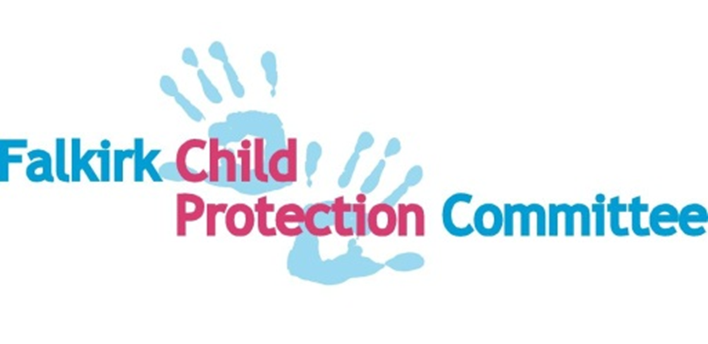
Multiagency Children’s Services Learning and Development Programme May 2021 – March 2022
Please see below for all Multi Agency training, learning and development opportunities and courses being offered in 2021 -22. For further information and to submit your application, please click on the flyer. All virtual/online courses require you to access via a laptop, tablet or desktop P.C. with a webcam and audio capability. Relevant Teams/diary invites will be forwarded to you via email to confirm that a place has been booked.
It is acknowledged that staff from across different workforces may have learning needs that do not fit neatly into the suggested target workforce levels. It is therefore expected that managers and supervisors will have discussions with staff as part of any Continuous Professional Development framework in terms of agreeing the most appropriate learning and development activities to attend.
Managers should be aware that in some instances staff may require more than the recommended training – dependant on client group, specific circumstances, activities etc.
The plan tries to identify the different service focus of these learning opportunities: A = Adult services focus; CFY = Children, Families and Young People’s services focus; B = both adults and Children, Families and Young People focus.
Should you have any queries/require further information please email ChildProtectionCommittee@falkirk.gov.uk with the subject heading Learning and Development
The General Contact Workforce  (Informed) | The Specific Contact Workforce  (Skilled) | The Intensive Contact Workforce  (Enhanced) | The Management and Leadership Workforce  (Specialist)
Informed------------------------------------Skilled--------------------------Enhanced------------------------------Specialist--------------------
The general contact workforce is defined as workers who, as part of their job are likely to encounter children, young people and other family members. The frequency of the this will vary, but these workers will not usually be involved in any in-depth personal work with them. If you are a member of the General Contact Workforce you will need to have the confidence and awareness to recognise a wellbeing concern about a child or young person and/or if they may be in need of protection, and how to respond. | The specific contact workforce is defined as those who: support children, young people or other family members; and/or form trusting relationships with them; and/or work in specific services supporting them. If you are a member of this workforce group, you may meet regular with a child, young person, or adult (although this will not always be the case). You may meet in their home or another setting (e.g. an office, school, community facility etc.). It may involve meeting one to one, or meeting in a group. You may be asked to contribute to the wellbeing and/or risk assessment and the Child’s Plan and/or risk management process and may be involved as a member of the Team Around the Child, in providing ongoing support to some children, young people and other family members. | The intensive contact workforce is defined as those who have specific designated responsibility or require to fulfil statutory duties in relation to children and young people as part of their role (e.g. where this is linked to their post, or where they are the Named Person and/or Lead Professional); and/or those who will be involved in undertaking child protection work or working with complex cases (e.g. providing particular forms of support relating directly to child protection). | The management and leadership workforce is defined as those who have responsibilities for or are required to focus on the development and maintenance of the range of knowledge and skills required for staff, who work across the other workforces. Staff in this workforce, because of their role and/or practice setting, play a specialist role.

GIRFEC & CHILD PROTECTION
Training/Learning & Development Opportunity | Workforce | Service Focus |  | When will it run? | Brief details and Booking arrangements.
Corporate Parenting | All the Workforce | B |  | Always Available | Corporate parenting represents the principles, duties and actions necessary to uphold the rights and secure the wellbeing of a looked after child or care leaver, and through which physical, emotional, spiritual, social and educational development is promoted, from infancy through to adulthood.  Corporate Parenting Briefing available here  What Does A Corporate Parent Mean to you? Watch our introduction to Corporate Parents… here
GIRFEC National Practice Model (Refresh) | The General & Specific Contact Workforce  (Informed & Skilled) | B |  | Monthly – September-November 2021 | Refresh and enhance your knowledge in the use of the National Practice Model in multi-agency work with children and their family and parents/carers. More information available here
Content and analysis of Chronologies  Short focussed practice learning sessions.  (Approx. 2-2½ hrs) | Specific & Intensive Contact Workforce  (Skilled & Enhanced) | CFY |  | Bi-monthly | These sessions will help participants understand: what is a chronology and why are they helpful; understand significant events to be included in a chronology; using a chronology in practice to identify patterns particularly in relation to risk and protective factors; and using a chronology as a live tool to review and analyse available information  Flyer and booking form here
Using the Resilience Matrix in assessments.  Short focussed practice learning sessions. (Approx. 2-2½ hrs) | Specific & Intensive Contact Workforce  (Skilled & Enhanced) | CFY |  | Bi-monthly | These sessions will help practitioners develop skills knowledge and experience in the use of the Resilience Matrix to: weigh up particular risks against protective factors; enable practitioners to weigh up the strengths and risks already identified from any initial assessment framework and any other specialist assessments; develop an understanding that the Matrix is used to assist practitioners in making sense of the relationship between the child’s vulnerability or resilience and the world around them; help identify or highlight areas of risk requiring more comprehensive or specialist assessment and analysis  Flyer and booking form here
Multi Agency Risk Assessment | Specific & Intensive Contact Workforce  (Skilled & Enhanced) | CFY |  | June – (more dates to follow) | Considered need and risk, explore the processes and stages of assessment and the impact of relationship-based practice  More information available here
Protection – Basic Awareness  E-Learning  (Approx. 45-60 minutes) | The General Contact Workforce  (Informed) | B |  | Always available | This online course is designed for all staff and volunteers and aims to:  - Prompt you to think about your own values.  - Raise your awareness of what is meant by protection.  - Help you understand your role in protection.  - Encourage you to respond if you suspect someone is at risk of harm.  - Know what to do if you are concerned that a person is potentially at risk of harm.  Available on OLLE
Child Protection E-Learning  (Approx. 45-60 minutes) | The General Contact Workforce  (Informed) | B |  | Always available | This online course is designed for all staff and volunteers and aims to: Raise awareness about child protection; Explain the indicators of possible abuse or neglect; Tell you what you should do if you are worried that a child may be being abused or neglected.  Available on OLLE
Public Protection (basic Child Protection and Adult Support & Protection).  Currently a half-day course presented via Microsoft Teams. (Approx. 3½ hrs) | The General Contact Workforce  (Informed) | B |  | Monthly | This course will enable participants to: identify the needs of children as outlined in GIRFEC; Identify the needs of adults at risk of harm; describe key terms in relation to child & adult protection; recognise some of the indicators of abuse and harm; know how to respond record and report to a concern.  Public protection training flyer and booking form
Child Protection Key Processes  Forth Valley  (1 hr pre-course reading/study + 3hrs on course) | Specific & Intensive Contact Workforce  (Skilled & Enhanced) | CFY |  | Always available | This essential training will cover the role and responsibilities of education, health, police and social work in regard to the child protection process referencing the Forth Valley Child Protection Guidance.  Booking information available here
Introduction to Domestic Abuse | All the Workforce | B |  | Always available | General awareness raising resource and introduction to domestic abuse and coercive control.  Available on OLLE and DAART here
Domestic Abuse, Recovering Together (DART™) | Specific Contact Workforce  (Skilled) |  |  | Always available | Helping children and mothers after domestic abuse.  Through Domestic Abuse, Recovering Together (DART™), children and mothers can talk to each other about domestic abuse, learn to communicate and rebuild their relationship. Available via NSPCC here
Safe and Together -  Supporting domestic violence-informed practice and organizational change | Specific & Intensive Contact Workforce  (Skilled & Enhanced) | B |  | Always available | Using reality-based scenarios and interactive practice activities, e-courses are designed to be “standalone” or as part of a wider implementation of domestic violence-informed systems change. Watch the video.  Find an e-course here
Zero Suicide Alliance Online Suicide Awareness Training | All the Workforce | B |  | Always available | Materials can be accessed via their website www.zerosuicidealliance.com
National Trauma Training Programme. Transforming Psychological Trauma | All the Workforce | B |  | Always available | Essential and core knowledge and skills to ensure the needs of children and adults who are affected by trauma are recognised, understood, and responded to in a way which recognises individual strengths and acknowledges rights. The framework also has an essential focus on staff wellbeing  Available via TURAS here
Trauma Skilled Practice Training | Intensive, Leadership & Management Contact Workforce  (Skilled, Enhanced, Specialist) | B |  | September with more dates to follow | To provide participants with the knowledge, skills and confidence to realise, recognise and to respond to trauma.
Scottish Drug Forum:  Drug Awareness – An Introductory Course | The General & Specific Contact Workforce  (Informed & Skilled) | B |  |  | This must be completed prior to undertaking further training opportunities via this link  Drug Awareness eLearning Module  SDF Training link: https://www.sdftraining.org.uk/training?start=10 – required for individuals to book a place on training
7 MINUTE BRIEFINGS
Active Listening  Assessment, Analysis & Risk  Case Recording  Child’s Plan  Child Sexual Exploitation  Children (Equal Protection from Assault)(Scotland) Act2019  Chronologies |  |  | Health and Social Care Standards  Learning from Initial Case Reviews (ICRs)  Neglect  Professional Curiosity  SCR – Child D SCR – Child F  Working with Resistance
ADULT/PUBLIC PROTECTION
FOR FULL DETAILS click here
WORKFORCE DEVELOPMENT & WELLBEING
Training/Learning & Development Opportunity | Workforce | Service Focus |  | When will it run? | Brief details and Booking arrangements.
Meeting the Mental Health Needs of the workforce  - Taking care of myself  - Taking care of other people  - Taking care of your staff | All of the Workforce | B |  | Always available to staff | These key resources to support the mental health and wellbeing of you and your staff members. Includes sections on managing stress, coping and resilience.  Accessed via TURAS here
Mental health improvement, and prevention of self-harm and suicide: | All of the Workforce | B |  | Always available to staff | These resources will support staff across the public sector and beyond to develop the knowledge and skills needed to promote good mental health and wellbeing across the whole population and to prevent mental ill health, self-harm or suicide.  currently accessed via practitioner Accessed via TURAS here
Supporting and developing resilience in social work |  |  |  |  | In this free course you will explore the idea of resilience and develop your own emotional resilience toolkit of skills and strategies  Accessed via OpenLearn here
UNDER DEVELOPMENT & FUTURE DEVELOPMENT
Training/Learning & Development Opportunity | Workforce | Service Focus |  | When will it run? | Brief details and Booking arrangements.
Team Around the Child | Specific & Intensive Contact Workforce  (Skilled & Enhanced) | CFY |  | Future development
GIRFEC Childs Plan (Detail to be specified | Specific & Intensive Contact Workforce  (Skilled & Enhanced) |  |  | Under development | Final draft circulated for comment
Managing Difficult Conversations | Specific & Intensive Contact Workforce  (Skilled & Enhanced) | CFY |  | Future development
Outcome Focused Planning | Specific & Intensive Contact Workforce  (Skilled & Enhanced) | CFY |  | Future development
Integrated Assessment & Plan | Specific & Intensive Contact Workforce  (Skilled & Enhanced) | CFY |  | Future development
Updated Neglect Toolkit workshop | Specific & Intensive Contact Workforce  (Skilled & Enhanced) | CFY |  | Future development
Impact of Parental Substance Misuse | Specific & Intensive Contact Workforce  (Skilled & Enhanced) | B |  | Under development
(Trafficking, CCE and Missing)  Contextual Safeguarding | Specific & Intensive Contact Workforce  (Skilled & Enhanced) | B |  | Future development
Shadowing & mentoring AT ALL LEVELS & ACROSS SERVICES | All the Workforce | B |  | Future development
Neglect, Self-neglect, and Hoarding | All the Workforce | B |  | Under development
Group Supervision | Intensive, Leadership & Management Contact Workforce  (Skilled, Enhanced, Specialist) | B |  | Future development
Quality Assurance/Auditing Practice | Intensive, Leadership & Management Contact Workforce  (Skilled, Enhanced, Specialist) | B |  | Future development
Trauma Practice Skills Training | Intensive, Leadership & Management Contact Workforce  (Skilled, Enhanced, Specialist) | B |  | Future development
Intro to Trainer Skills | Intensive Contact Workforce  (Enhanced) | B |  | Future development
Safe and Together | Specific & Intensive Contact Workforce  (Skilled & Enhanced) | B |  | Future development | local CORE and Supervisor training
Age of Criminal Responsibility | Specific & Intensive Contact Workforce  (Skilled & Enhanced) | B |  | Under development
#keepingthepromise | All the Workforce | B |  | Under development
Corporate Parenting | All the Workforce | B |  | Under development | Being the best Corporate Parent programme

