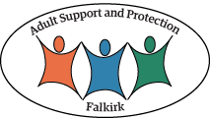

Hoarding Toolkit

Introduction

This toolkit should be used in conjunction with the Self Neglect and Hoarding Policy and Guidance.

Process for Clutter Image Rating Tool (CIRT)

The flow chart below sets out the process for use of the Clutter Image Rating Tool. If in doubt, please ask your team leader / manager for assistance.
Joint Assessment if unknown or unclear
Housing Adult Social care Primary Care
Mental Health
Vol sector/ Independent Sector
Assessment (using clutter image and assessment tool)
Case identified

Assess Capacity using the Decision specific screening tool (App 2) if necessary consider provisions of the Adults with Incapacity (Scotland) Act 2000
Level 2 – Escalate Concerns
Level 1 – Signposting & ongoing monitoring

Monitor and Review

Level 3 – Adult Protection Concern

Please use the clutter image rating to assess what level the adult’s hoarding problem is at:
Images 1- 3 indicate Level 1
Images 4- 6 indicate Level 2
Images 7- 9 indicate Level 3

Then refer to the clutter assessment tool to guide which details the appropriate action you should take. Record all actions undertaken in the agency’s recording system, detailing conversations with other professionals, actions taken and action yet to be taken.

Clutter Image Rating Scale- Bedroom

Please select the photo that most accurately reflects the amount of clutter in the room
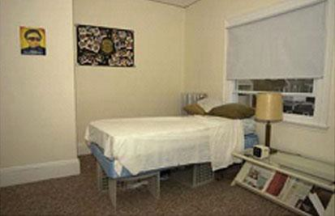
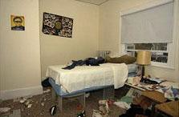
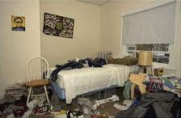

1 | 2 | 3
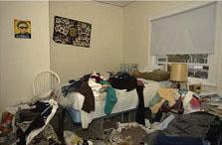
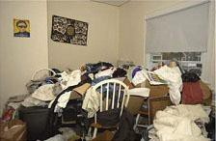
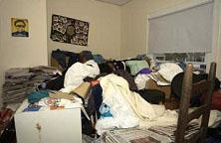

4 | 5 | 6
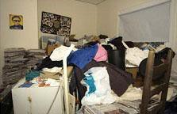
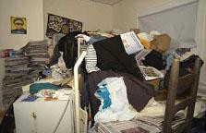
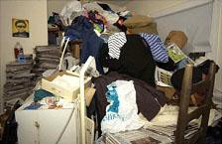

7 | 8 | 9

Clutter Image Rating Scale - Lounge

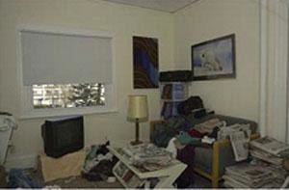
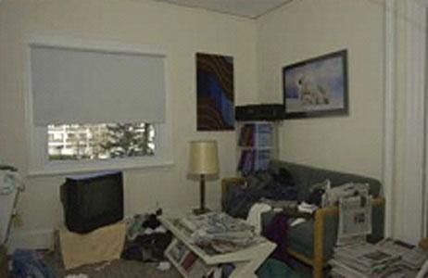
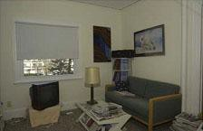
Please select the photo that most accurately reflects the amount of clutter in the room

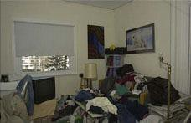
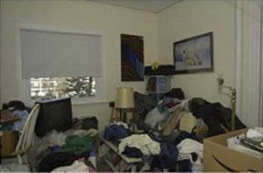
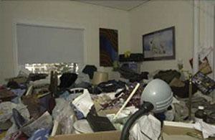
1 | 2 | 3

4 | 5 | 6
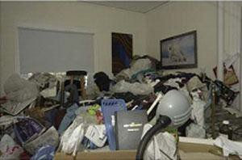
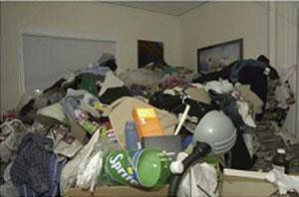
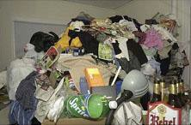

7 | 8 | 9

Clutter Image Rating Scale – Kitchen

Please select the photo that most accurately reflects the amount of clutter in the room
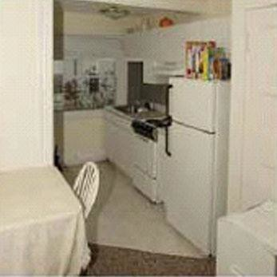
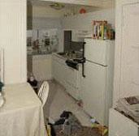
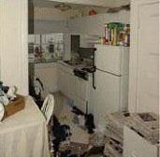

1 | 2 | 3

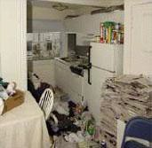
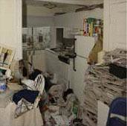
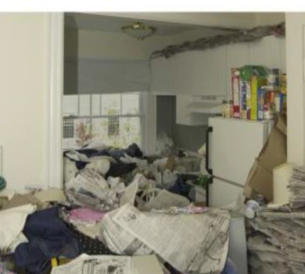

4 | 5 | 6
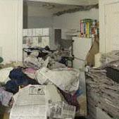
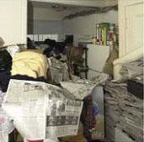
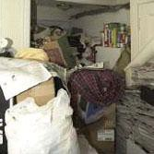

7 | 8 | 9

Assessment Tool Guidelines

See Appendix 1 for guidance on questions which could be used during an assessment

- Property structure  services and garden area | - Assess the access to all entrances and exits for the property. (Note impact on any communal entrances & exits). Include access to roof space.  - Can the occupant escape from all rooms in the event of a fire or other emergency?  - Is there a clear plan of what to do in the event of a fire or other emergency and does everyone in the home know it?  - Does the property have a working smoke alarm?  - Carry out a cursory visual assessment of the condition of the services within the property e.g. plumbing, electrics, gas, air conditioning, heating; this will help inform your next course of action.  - Are the services connected?  - Assess the garden; size, access and condition.
- Household  Functions | - Assess the current functionality of the rooms and the safety for their proposed use. e.g. can the kitchen be safely used for cooking, can the occupier(s) properly use the bathroom/ WC or does the level of clutter within the room prevent their normal use.  - Select the appropriate rating on the clutter scale.  - Please estimate the % of floor space covered by clutter  - Please estimate the height of the clutter in each room
- Health and Safety | - Assess the level of sanitation in the property.  - Are the floors clean and are readily cleansed?  - Are the work surfaces clean?  - Are you aware of any odours in the property?  - Is there rotting food?  - Does the resident use candles, portable electric or gas heaters?  - Did you witness a higher than expected number of flies and other insects?  - Are household members struggling with personal care?  - Is there random or chaotic writing on the walls on the property?  - Are there unreasonable amounts of medication collected? (Prescribed or over the counter?)  - Is there evidence of illegal drug use?  - Is the resident aware of any fire risk associated to the clutter in the property?  - Is there faecal matter, urine or other body fluids visible within the property?
- Protection of Children & Family members | - Do any rooms rate 7 or above on the clutter rating scale?  - Does the household contain young people or children?  - Are there adults in the household who require care and or support?
- Animals and Pests | - Are the any pets at the property?  - Are the pets well cared for; are you concerned about their health?  - Is there evidence of any infestation? e.g. bed bugs, cockroaches, fleas, rats, mice, etc.  - Are animals being hoarded at the property? If so, are they healthy and being well looked after.  - Are outside areas seen by the resident as a wildlife area?  - Does the resident leave food out in the garden to feed foxes etc.

- Personal health and safety | - Following your assessment do you recommend the use of Personal protective equipment (PPE) at future visits? Please detail.  - Following your assessment do you recommend the resident is visited in pairs or with the Police? Please detail.

Clutter/ Hygiene rating framework

Level 1  Clutter image rating 1-3 | Household environment is considered reasonable. No specialised assistance is needed. If the resident would like some assistance with general housework or feels they are declining towards a higher clutter scale, appropriate referrals can be made subject to age and  circumstances.
- Property  structure, services & garden area | - All entrances and exits, stairways, roof space and windows accessible.  - Smoke alarms fitted and functional or referrals made to Scottish Fire and Rescue to visit and install.  - All services functional and maintained in good working order.  - Garden is accessible, tidy and maintained
- Household  Functions | - No excessive clutter, all rooms can be safely used for their intended purpose.  - All rooms are rated 0-3 on the Clutter Rating Scale  - No additional unused household appliances appear in unusual locations around the property  - Property is maintained within terms of any lease or tenancy agreements where appropriate.  - Property is not at risk of action by Environmental Health.
- Health and Safety | - Property is clean with no odours, (pet or other)  - No rotting food  - No concerning use of candles  - No concern over flies  - Residents managing personal care  - No writing on the walls  - Quantities of medication are within appropriate limits, in date and stored appropriately.
- Protection of Children & Family members | - No concerns for household members.
- Animals and Pests | - Any pets at the property are well cared for  - No pests or infestations at the property
- Personal health  and safety | - No Personal protective equipment(PPE) required  - No visit in pairs required.

Clutter/ Hygiene Rating Level 1: Actions

Level 1 | Actions
- Agency holding  the case | - Discuss concerns with resident  - Raise a request to the Fire and Rescue Service to provide fire safety advice  - Refer for support assessment if appropriate.  - Refer to GP if appropriate
- Environmental  Health | No Action
- Social Landlords | - Provide details on debt advice if appropriate to circumstances  - Refer to GP if appropriate  - Refer for support assessment if appropriate.  - Provide details of support streams open to the resident via charities and self-help groups.  - Provide details on debt advice if appropriate to circumstances  - Ensure residents are maintaining all tenancy conditions
- Practitioners | - Complete Hoarding Assessment  - Make appropriate referrals for support  - Refer to social landlord if the client is their tenant or leaseholder
- Emergency  Services | - Ensure information is shared with statutory agencies & feedback is provided to referring agency on completion of home visits.
- Animal Welfare | No action unless advice requested
- Protecting  Children & Adults | - No action unless other concerns of abuse are noted.  - Consider whether it is necessary to refer any children or young persons present to Children’s services  - In the event of any identified signs of abuse a Child Protection referral must be made immediately.

Level 2  Clutter image rating 4-6 | Household environment requires professional assistance to resolve the clutter and the maintenance issues of the property.
- Property structure, services & garden area | - Only major exit is blocked  - Only one of the services is not fully functional  - Concern that services are not well maintained  - Smoke alarms are not installed or not functioning  - Garden is not accessible due to clutter, or is not maintained  - Evidence of indoor items stored outside  - Evidence of light structural damage including damp  - Interior doors missing or blocked open
- Household Functions | - Clutter is causing congestion in the living spaces and is impacting on the use of the rooms for their intended purpose.  - Clutter is causing congestion between the rooms and entrances.  - Room(s) scores between 4-5 on the clutter scale.  - Inconsistent levels of housekeeping throughout the property  - Some household appliances are not functioning properly and there may be additional units in unusual places.  Property is not maintained within terms of lease or tenancy agreement where applicable.  - Evidence of outdoor items being stored inside

- Health and Safety | - Kitchen and bathroom are not kept clean  - Offensive odour in the property  - Resident is not maintaining safe cooking environment  - Some concern with the quantity of medication, or its storage or expiry dates.  - No rotting food  - No concerning use of candles  - Resident trying to manage personal care but struggling
- Safeguard of Children & Family members | - Hoarding on clutter scale 4 - 7 doesn’t automatically constitute an adult or child protection referral.  - Please note all additional concerns for householders  - Properties with children or vulnerable residents with additional support needs may trigger an adult or child protection referral under a different risk.
- Animals & Pests | - Pets at the property are not well cared for  - Resident is not unable to control the animals  - Animal’s living area is not maintained and smells  - Animals appear to be under nourished or over fed  - Sound of mice heard at the property.  - Spider webs in house  - Light insect infestation (bed bugs, lice, fleas, cockroaches, ants, etc.)  - Refer to Scottish SPCA for advice and guidance.
- Personal health and safety | - Latex Gloves, boots or needle stick safe shoes, face mask, hand sanitizer, insect repellent.  - Personal protective equipment required.

Clutter /Hygiene rating Level 2 Actions

Level 2 | Actions
- Agency holding the case | - Refer to landlord if resident is a tenant  - Refer to Environmental Health  - Raise a request to the Fire and Rescue service to provide fire prevention advice  - Provide details of garden services  - Refer for support assessment  - Referral to GP  - Referral to debt advice if appropriate  - Refer to Animal welfare if there are animals at the property.  - Ensure information sharing with all agencies involved to ensure a collaborative approach and a sustainable resolution.
- Environmental Health | - Refer to Environmental Health with details of client, landlord (if relevant) referrer’s details and overview of problems where appropriate  - At time of inspection, Environmental Health Officer decides on appropriate course of action  - Consider serving notices under, Environmental Protection Act 1990, Public Health Etc (Scotland) Act 2008 Prevention of Damage by Pests Act 1949, or Housing (Scotland) Act 2014.  - Consider Works in Default if notices not complied with by occupier

- Social Landlords | - Visit resident to inspect the property & assess support needs  - Refer for housing related support.  - Ensure residents are maintaining all tenancy conditions  - Enforce tenancy conditions relating to residents’ responsibilities  - Ensure information sharing with all agencies involved to ensure a collaborative approach and a sustainable resolution.
- Practitioners | - Refer to “Hoarding Guidance Questions for practitioners” Appendix 1  - Complete Practitioners Assessment Tool  - Ensure information sharing with all agencies involved to ensure a collaborative approach and a sustainable resolution.
- Emergency Services | - Ensure information sharing with all agencies involved to ensure a collaborative approach and a sustainable resolution.  - Provide feedback to referring agency on completion of home visits.
- Animal Welfare | - Visit property to undertake a wellbeing check on animals at the property.  - Educate client regarding animal welfare if appropriate- seek advice from the Scottish SPCA.  - Provide advice / assistance with re-homing animals
- Protecting Children & Adults | - For adults no action may be required unless other concerns of abuse are noted.  - If other concerns of abuse are noted or have been reported, progression to adult protection referral, duty to report, or investigation may be necessary.  - Consider referring any children or young persons present to relevant Children and Families Team, on welfare or protection grounds depending on concerns.

Level 3  Clutter image rating 7-9 | Household environment will require intervention with a collaborative multi-agency approach with the involvement from a wide range of professionals. This level of hoarding constitutes a Safeguarding alert due to the significant risk to health of the householders, surrounding properties and residents. Residents are often unaware of the implication of their hoarding actions and oblivious to the risk it poses.
- Property structure, services & garden area | - Limited access to the property due to extreme clutter  - Evidence may be seen of extreme clutter seen at windows  - Evidence may be seen of extreme clutter outside the property  - Garden not accessible and extensively overgrown  - Services not connected or not functioning properly  - Smoke alarms not fitted or not functioning  - Property lacks ventilation due to clutter  - Interior doors missing or blocked open  - Evidence of structural damage or outstanding repairs including damp  - There may be evidence of internal damp and / or mould.  - Evidence of indoor items stored outside
- Household Functions | - Clutter is obstructing the living spaces and is preventing the use of the rooms for their intended purpose.  - Room(s) scores 7 - 9 on the clutter image scale  - Rooms not used for intended purposes or very limited  - Beds inaccessible or unusable due to clutter or infestation  - Entrances, hallways and stairs blocked or difficult to pass  - Toilets, sinks not functioning or not in use  - Resident at risk due to living environment

- Household appliances are not functioning or inaccessible
- Resident has no safe cooking environment
- Resident is using candles, electric or gas heating appliances
- Evidence of outdoor clutter being stored indoors.
- No evidence of housekeeping being undertaken
- Broken household items not discarded e.g. broken glass or plates
- Concern for declining mental health
- Property is not maintained within terms of lease or tenancy agreement where applicable
- Property is at risk of notice being served by Environmental Health
- Health and Safety | - Human urine and or excrement may be present  - Excessive odour in the property, may also be evident from the outside  - Rotting food may be present  - Evidence may be seen of unclean, unused and or buried plates & dishes.  - Broken household items not discarded e.g. broken glass or plates  - Inappropriate quantities or storage of medication.  - Pungent odour can be smelt inside the property and possibly from outside.  - Concern with the integrity of the electrics  - Inappropriate use of electrical extension cords or evidence of unqualified work to the electrics.  - Concern for declining mental health
- Protection of  Children & Family members | - Hoarding on clutter scale 7-9 constitutes a Safeguarding Alert.  - Please note all additional concerns for householders
- Animals and Pests | - Animals at the property at risk due the level of clutter in the property  - Resident may not able to control the animals at the property  - Animal’s living area is not maintained and smells  - Animals appear to be under nourished or over fed  - Hoarding of animals at the property  - Heavy insect infestation (bed bugs, lice, fleas, cockroaches, ants, silverfish, etc.)  - Visible rodent infestation  - Refer to Scottish SPCA
- Personal health and safety | - Visits where Personal protective equipment (PPE) required: i.e. Latex Gloves, boots or needle stick safe shoes, face mask, hand sanitizer, insect repellent.

Level 3 | Actions
- Agency holding the case | - Raise Adult Protection Referral within 24 hours  - Raise a request to the Fire and Rescue service within 24 hours to provide fire prevention advice.
- Environmental Health | - Refer to Environmental Health with details of client, landlord (if relevant) referrer’s details and overview of problems  - At time of inspection, EHO decides on appropriate course of action  - Consider serving notices under, Environmental Protection Act 1990, Public Health Etc (Scotland) Act 2008 Prevention of Damage By Pests Act 1949 or Housing (Scotland) Act 2014.  - Consider “Works in Default” if notices not complied with by occupier (or equivalent in Scotland)
- Landlord | - Visit resident to inspect the property & assess support needs  - Attend Multiagency Risk Management meeting  - Enforce tenancy conditions relating to residents’ responsibilities  - If resident refuses to engage serve Notice of Seeking Possession under Ground 14 to Schedule 2 of the Housing (Scotland) Act 1988
- Practitioners | - Refer to “Hoarding Guidance Questions for practitioners” See Appendix 1  - Complete Practitioners Assessment Tool  - Ensure information sharing with all agencies involved to ensure a collaborative approach and a sustainable resolution.
- Emergency Services | - Attend Multiagency Risk Management meeting on request  - Ensure information sharing with all agencies involved to enables a collaborative approach and a sustainable resolution.  - Provide feedback to case holding agency on completion of home visits.

- Emergency Services | - Attend Multiagency Risk Management meeting on request  - Ensure information sharing with all agencies involved to enables a collaborative approach and a sustainable resolution.  - Provide feedback to case holding agency on completion of home visits.
- Animal Welfare | - Notify the Scottish SPCA for further advice and guidance.  - Visit property to undertake a wellbeing check on animals at the property.  - Remove animals to a safe environment  - Educate client regarding animal welfare if appropriate  - Take legal action for animal cruelty if appropriate  - Provide advice / assistance with re-homing animals
- Safeguarding Children, Young People & Adults | - Adult Protection concerns should progress to referral for multi-agency approach and further investigation of any concerns of harm.  - Ensure that Child Protection referral is made to Children’s services immediately or within 24 hours

Guidance for Practitioners (from all agencies)

Hoarding Insight characteristics

Use this guide as a baseline to describe the adult’s attitude towards their hoarding. Provide additional information in your referrals and reports to enable a tailored approach that is relevant the adult.

Good or fair insight:

The Adult recognises that hoarding – related beliefs and behaviours (relating to difficulty discarding items, clutter or excessive acquisition) are problematic. The sdult recognises these behaviours in themselves.

Poor insight

The adult is mostly convinced that hoarding – related beliefs and behaviours (relating to difficulty discarding items, clutter or excessive acquisition) are not problematic despite evidence to the contrary. The adult might recognise a storage problem but has little self – recognition or acceptance of their own hoarding behaviour.

Absent (delusional) insight

The adult is convinced that hoarding related beliefs and behaviours (relating to difficulty discarding items, clutter or excessive acquisition) are not problematic despite evidence to the contrary. The adult is completely accepting of their living environment despite the hoarding and possibly a risk to health.

Detached with assigned blame

The adult has been away from their property for an extended period. The adult has formed a detachment from the hoarded property and is now convinced a 3rd party is to blame for the condition of the property. For example a burglary has taken place, squatters or other household members

Practitioners Hoarding Assessment Tool

The assessment tool below should be completed by the practitioner of the agency holding the case or that has most recent or current contact with the individual.

Date of home
assessment
Clients Name
Clients date of birth
Address
Client contact details
Type of dwelling
Owner occupier | Leaseholder |  |  | Tenant - Name and address of  landlord
Household Members |  |  |  | Name |  |  |  | Relationship |  |  | Date of birth
Pets - indicate what pets and any concerns
Agencies currently involved - with contact details
Non agency support currently in place
Clients attitude towards hoarding
Please indicate if present at the property
Structural  damage to property |  |  | Insect or  rodent infestation |  |  |  | Large  number of animals |  |  | Clutter outside
Rotten food |  |  | Animal waste in house |  |  |  | Concerns over the cleanliness |  |  | Visible human faeces

 |  |  |  |  |  |  | of the property
Concern of self- neglect |  |  | Concerned for children at the  property |  |  |  | Concerned for other adults at the  property
Using the Clutter Image Scale please score each of the room below
Bedroom 1 |  |  |  |  | Bedroom 4 |  |  |  | Separate toilet
Bedroom 2 |  |  |  |  | Kitchen |  |  |  | Lounge
Bedroom 3 |  |  |  |  | Bathroom |  |  |  | Dining Room
Please provide a description of the hoarding problem ;( presence of human or animal waste,
rodents or insects, rotting food, are utilities operational, structural damage, problems with blocked exits, are there combustibles, is there a fire risk?
Please refer to the multi-agency hoarding Strategy and Guidance Document tool, based on the information provided above, what level is your case graded?
Level 1 Green |  |  |  |  | Level 2 Amber |  |  |  | Level 3 RED- Take case to  High Risk Panel
Name of practitioner
undertaking assessment
Name of organisations
Contact details
Next actions to be taken
List of agencies refereed to with dates and contact names

The Adult Care Harm Reduction Protocol

This protocol aims to provide guidance to staff on how they might support ‘adults in need’ and make efforts to try and reduce and manage risks.It encourages partner agencies to proactively share information and, when certain thresholds have been reached, to consider the arranging of an Initial Referral Discussion (IRD) or planning meeting to jointly assess risks and decide if risk management plans are required.

In certain cases, it will be necessary to arrange an escalating concerns meeting regarding the individual in order that other professionals and/or the subject can be invited to provide input. This protocol does not replace existing procedures for protecting adults at risk of harm. When any legislative responsibilities apply - for example criminal law, duties under the Adults with Incapacity (Scotland) Act 2000, Mental Health (Care and Treatment) (Scotland) Act 2003 or the Adult Support and Protection (Scotland) 2007 Act (or any other legislation) - that legislation and accompanying Code of Practice (or local procedures) should be applied and take precedence over this protocol.

However, when no other such legislation applies, and the risks are ongoing this protocol aims to provide guidance to staff in how they might manage the presenting risks.

More information can be obtained by directly referring to the Harm Reduction Protocol available on the Practitioner Pages.

Advocacy and support

It is essential to ensure all efforts are made to ensure the person experiencing self-neglecting and/ or hoarding is consulted with and included in discussions, with concerns raised directly with them at the earliest opportunity.

The individual concerned should be invited to participate in any risk management meeting convened and be offered the necessary support to do so by the case holding agency. If the person’s choice is not to attend the meeting the case holding agency must feedback back any decision that is made to the person within a reasonable time period.

If there is concern that the person is in need of additional support to ensure they understand the concerns raised, the involvement of an appropriate advocate must be considered where it is deemed necessary to do so. This may be a friend or family member, or a representative from a voluntary agency such an independent advocacy provider.

Employees

For employees dealing with cases of self-neglect and or hoarding this can be a stressful time and all agencies should have robust support mechanisms and policies in place, to ensure the health and safety of its employees. This should include practice supervision, peer support, lone working systems and where appropriate access to health and welfare advisory support services.

To enable employees to be effective in dealing with cases of self-neglect and hoarding, employees should also have access to a range of learning and development opportunities either offered by their own organisation, or by a multiagency approach.

Appendix 1

Guidance questions which could be used during an assessment
Listed below are examples of questions to ask where you are concerned about someone’s safety in their own home, where you suspect a risk of self- neglect and hoarding? The information gained from these questions will inform a Hoarding Assessment and provide the information needed to alert other agencies. Most clients with a hoarding problem will be embarrassed about their surroundings so adapt the question to suit your assessment with the person.

- How do you get in and out of your property, do you feel safe living here?
- Have you ever had an accident, slipped, tripped up or fallen? How did it happen?
- How have you made your home safer to prevent this (above) from happening again?
- How do move safely around your home (where the floor is uneven or covered, or there are exposed wires, damp, rot, or other hazards)
- Has a fire ever started by accident?
- How do you get hot water, lighting, heating in here? Do these services work properly? Have they ever been tested?
- Do you ever use candles or an open flame to heat and light here or cook with camping gas?
- How do you manage to keep yourself warm? Especially in winter?
- When did you last go out in your garden? Do you feel safe to go out there?
- Are you worried about other people getting in to your garden to try and break-in? Has this ever happened?
- Are you worried about mice, rats or foxes, or other pests? Do you leave food out for them?
- Have you ever seen mice or rats in your home? Have they eaten any of your food? Or got upstairs and be nesting anywhere?
- Can you prepare food, cook and wash up in your kitchen?
- Do you use your fridge? Can I have look in it? How do you keep things cold in the hot weather?
- How do you keep yourself clean? Can I see your bathroom? Are you able to use your bathroom and use the toilet ok? Have a wash, bath? Shower?
- Can you show me where you sleep and let me see your upstairs rooms? Are the stairs safe to walk up? (if there are any)
- What do you do with your dirty washing?
- Where do you sleep? Are you able to change your bed linen regularly? When did you last change them?
- How do you keep yourself warm at night? Have you got extra coverings to put on your bed if you are cold?
- Are there any broken windows in your home? Any repairs that need to be done?
- Because of the number of possessions you have, do you find it difficult to use some of your rooms? If so which ones?
- Do you struggle with discarding things or to what extent do you have difficulty discarding (or recycling, selling, giving away) ordinary things that other people would get rid of?

Appendix 2
NHS Forth Valley Referral Guidance requesting a Capacity Assessment for persons with a learning disability, aged 16 or over

The learning disability teams will consider referrals for capacity to make specific decisions, where there is uncertainty and/or complex. We support multi-disciplinary and multi-agency groups of professionals considering questions of capacity in advance of such a referral, but where no consensus can be reached we would consider providing a formal assessment.

Any referral for assessment of capacity should be:
- Specific with regard to a particular decision to be made
- Focused, rather than a number of questions we would encourage referrers to focus on one or two questions which need examined
- Timely, i.e., assessed at the time the person is required to make the decision
- With a clear potential outcome, such as considering Guardianship under the Adults with Incapacity (Scotland) Act 2000

It is useful if the question relates to the powers being considered under AWIA (2000) legislation, with common examples below…
- To make decisions regarding where they reside
- To make decisions regarding with whom they consort
- To make decisions regarding financial matters
- Whether the person has the capacity to protect themselves from harm in relation to the Adult Support and Protection Act
- To make decisions regarding medical treatment

It is important that a person has been given information regarding their choices to allow them the opportunity to make a full informed decision. The Decision- Specific Screening Tool (attached below) to be completed by referrer will aid in providing clarity regarding the individual’s capacity to make particular decisions.

Under legislation, certificates of incapacity AWI [1] for Guardianship Orders can only be signed by 2 medical practitioners, one of whom has to be Section 22 approved (namely a Psychiatrist). The other medical practitioner is usually the person’s GP.
Of note, for questions over medical treatment in relation to physical health or dental treatment, any assessment in terms of Part 5 of the AWIA Act would need to be undertaken by the prescribing medical practitioner/dentist/pre-approved professionals (such as ophthalmic optician/ registered nurse) providing the treatment/intervention, although the learning disability team members can provide advice to them. If the client is within the acute hospital setting, advice can be sought from the Learning Disability Acute Liaison Nurse.

Who would undertake a further assessment of capacity if a patient’s decision making is still unclear following completion of Decision- Specific Screening Tool?
Each referral will be discussed within the team meetings and allocated to the most appropriate professional. Input may be multidisciplinary, requiring specific input from particular professionals e.g. speech and language therapy. Of note, assessments may take some time to complete, depending on the complexity and engagement of the person being assessed.

DECISION-SPECIFIC SCREENING TOOL
Further guidance available by consulting
NHS FV Referral Guidance requesting a Capacity Assessment and
Communication and Assessing Capacity Guide:
http://www.scotland.gov.uk/Resource/Doc/210958/0055759.pdf

Name of Adult |  |  |  |  |  | SWIS Number
Worker Details |  |  |  |  |  | Date
Capacity is the ability to understand information relevant to a specific decision or action and to appreciate the reasonably foreseeable consequences of taking or not taking that decision or action.
This tool aims to assist the practitioner consider the various elements involved in the decision making process. It could be used to gather evidence of an adult having or lacking capacity in relation to non- medical decisions and to consider whether a more formal, health capacity assessment is required in order to pursue measures under the Adult with Incapacity (Scotland) Act 2000. It is not suitable for medical or complex decisions

Details of the Decision to
be made or action to be taken

Who was consulted in forming your opinion of the Adult’s decision-making ability
Name |  |  | Relationship with Adult |  |  |  | Contact Details
Consider: Does the Adult repeatedly make seemingly unwise decisions which place her/him at significant risk or serious exploitation? Is she/he making a decision which defies all notion of rationality and/or is markedly out of character?

An unwise or eccentric choice doesn’t necessarily mean the person is unable to make a decision – consider the person’s views, values, preferences and previous decisions.
Q1: Does the Adult have a mental disorder (diagnosed or suspected) or is unable to communicate because of a physical disability? |  | Yes |  | No | Not Sure |  | Condition  (Dementia, learning disability, brain injury, personality disorder, neurological condition,)
Q2 Do you consider the Adult able to understand the information relevant to the decision and that this information has been provided in way that he/she is most probably able to understand? |  |  |  |  |  |  | An elderly widow who has never dealt with money matters may need to receive the information in as simple a manner as possible and helped to understand it. It may be that she will learn to manage her finances with support.
Q3 Do you consider the Adult able to retain the information for long enough to use it in order to make a choice or an effective decision? |  |  |  |  |  |  | It may take several visits going over the information to see if the response is consistent (even if the person cannot remember being asked before). A consistent response may indicate sufficient capacity to understand the decision in hand.
Q4 Do you consider the Adult able to use or weigh that information as part of the process of making the decision? |  |  |  |  |  |  | Certain types of disorders (brain injury, neurological conditions) cause people who are able to understand information, to act impulsively regardless of the information available and their understanding of it.
Q5 Do you consider the Adult able to communicate the decision? |  |  |  |  |  |  | Every effort should be made to facilitate communication including talking mats.
Q6 Do you consider the Adult able to act upon the decision? |  |  |  |  |  |  | An individual may not be able to act on a decision because they trust, fear or feel responsible for another person. A mother who is being physically threatened or abused by her son may not be able ask him to leave her home
Any Further Comments

If you have answered YES consistently to Q2-Q6, the Adult is considered on the balance of probability, to have the capacity to make this particular decision at this time.

Sign/date this form and record the outcome within the Adult's records

If you have answered NO or NOT SURE to any of the questions proceed to Q7.

 |  | Yes | No | Not Sure
Q7 Overall, do you consider on the balance of probability that the impairment or disability noted in Q.1 is sufficient that the adult lacks the capacity to make this particular decision? |  |  |  |  | On the balance of probability the Adult lacks capacity to make this specific decision at this particular time
If you have answered 'Not Sure' to any questions, please consider a referral by completing the Community Learning Disability Service Capacity Referral Form.

Signature |  |  | Date Assessment Completed
Form developed with support from NHS Lothian and City of Edinburgh council

