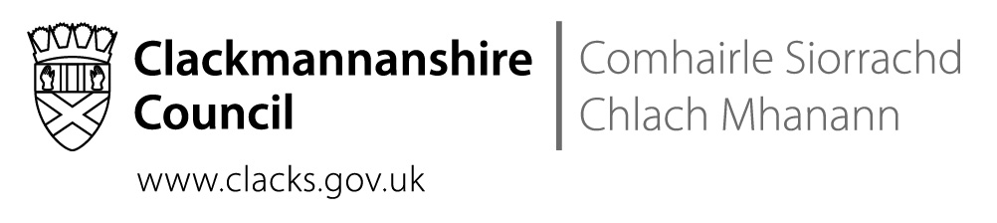

Contact Contract
Due to the Covid 19 pandemic Health and Safety guidance to prevent the spread of the virus must be strictly upheld to Save Lives and Protect the NHS.
I have agreed to adhere to all Government guidance and Clackmannanshire Council’s Health and Safety Risk Assessment to prevent the spread of the virus during contact arrangements with …………………………………………………………………………………………
I agree to the following:
- I will follow social distance guidance identified by Scottish Government and Clackmannanshire Health and Safety at the time of the contact.
- I will wear PPE assessed as necessary during contact.
- I will notifying Social Work Services if I develop any symptoms linked to Corona Virus and isolate accordingly.
- If during contact I develop any symptoms linked to Corona Virus, contact will be terminated until I have completed necessary quarantine period in line with guidance.
- I will notify Social Work Services if I have developed Corona Virus symptoms following contact with staff or children involved in contact arrangements.
- I will follow all aspects of the risk assessment identified to promote safe contact and prevent the spread of the virus.
If during the contact the Parent, Carer, Family member compromises the Health and Safety of children and or staff during this contact, the contact will be terminated immediately. A Children’s Hearing will be requested by Social Work Staff to discuss if direct contact can be safely achieved during COVID 19 restrictions.
Name………………………………………………………………………………..
Date………………………………………………………………………………….
Social Worker……………………………………………………………………..
Date……………………………………………………………………………… ….

