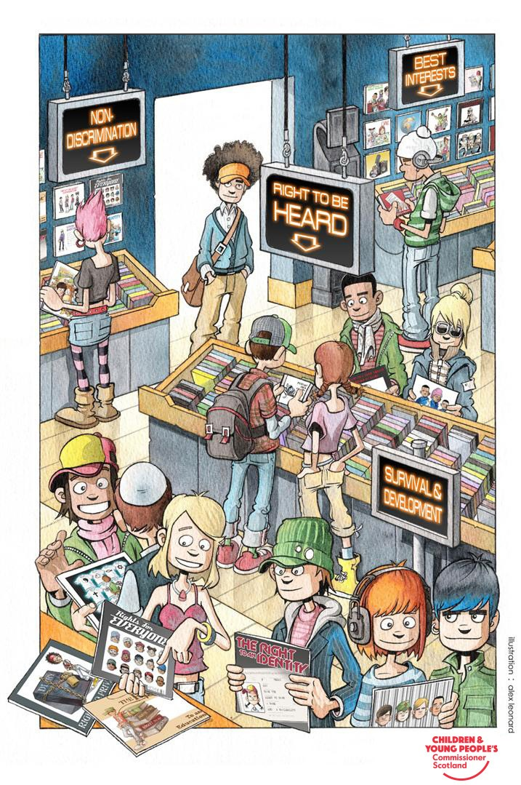
Plan

Clackmannanshire Child & Young Person GIRFEC Integrated Assessment & Care Plan – LAAC Review

Section 4 – Assessment of Development & Wellbeing

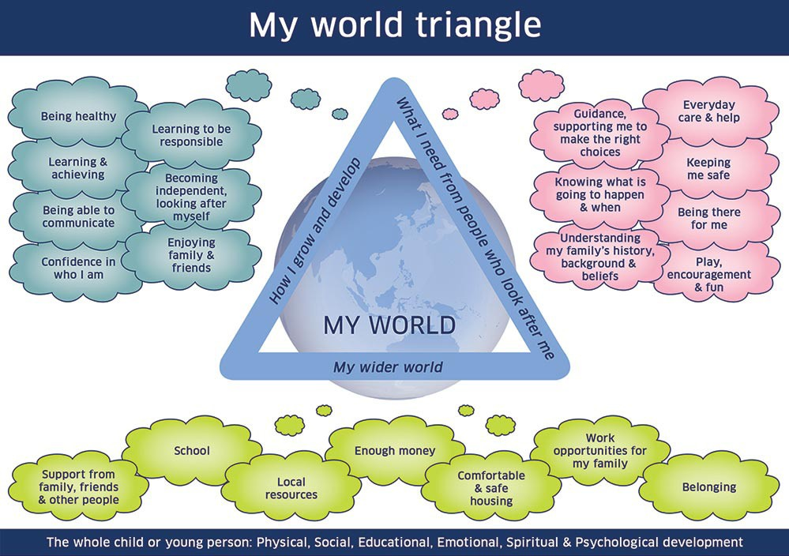
How well is the child / young person growing and developing?
(PLEASE USE THE 8 INDICATORS OF WELLBEING)

What does the child / young person need from the people who look after them?

Detail any current / proposed contact arrangements and the impact of this on the child / young person? This must also include sibling contact. The views of the child regarding contact must also be clearly stated in this section.

What does the child / young person need from the wider environment?

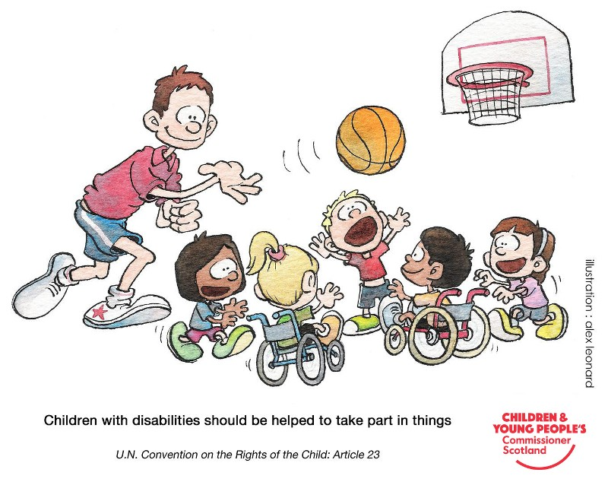
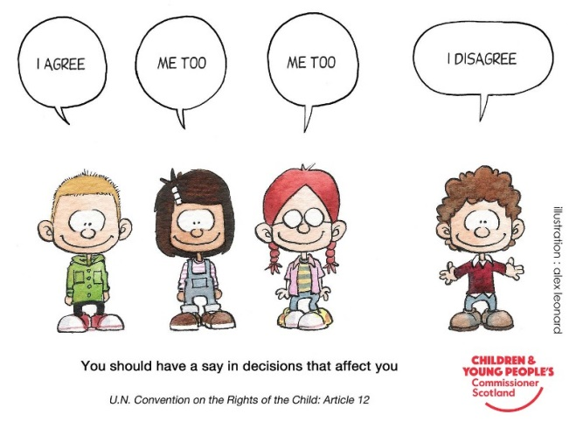

Child’s Wellbeing Plan
Child/Young Person’s Forename | Child/Young Person’s Surname | DOB/EDD
Child’s Young Persons Legal status | Choose an item.
Any Conditions:

Current Placement | Meeting Type
Choose an item. | Choose an item.
Date of Meeting | If review, date plan effective from | Venue

Plan Partners

Role / Relationship | Child / Adult Concerned | Name of Professional
Address
Tel. No.

Role / Relationship | Child / Adult Concerned | Name of Professional
Address
Tel. No.

What is the immediate plan for the child’s / young person’s wellbeing?

What is the longer term desired outcome for the child / young person?

Action

SAFE
Need / Risk | Desired Outcome | Action
What resources are required? | Who is responsible for this action? | By When?

HEALTHY
Need / Risk | Desired Outcome | Action
What resources are required? | Who is responsible for this action? | By When?

ACHIEVING
Need / Risk | Desired Outcome | Action
What resources are required? | Who is responsible for this action? | By When?

NURTURED
Need / Risk | Desired Outcome | Action
What resources are required? | Who is responsible for this action? | By When?

ACTIVE
Need / Risk | Desired Outcome | Action
What resources are required? | Who is responsible for this action? | By When?

RESPECTED
Need / Risk | Desired Outcome | Action
What resources are required? | Who is responsible for this action? | By When?

RESPONSIBLE
Need / Risk | Desired Outcome | Action
What resources are required? | Who is responsible for this action? | By When?

INCLUDED
Need / Risk | Desired Outcome | Action
What resources are required? | Who is responsible for this action? | By When?

Contingency

What action will be taken if outcomes or agreements are not reached within specified timescales or if there are increased concerns for the safety, care or wellbeing of the child / young person?

Monitoring and Reviewing of the Child / Young Person’s Plan

What arrangements are in place for monitoring and reviewing the Child / Young Person’s Wellbeing Plan?

What is the Child / Young Person’s View of their Plan?

What is the Parent / Carer’s View of the Child’s Plan?

Next Review Date

Date
Time
Venue

Lead Professional

Signature
Name
Job Title
Agency*
E-mail Address
Address
Tel. No*
Date

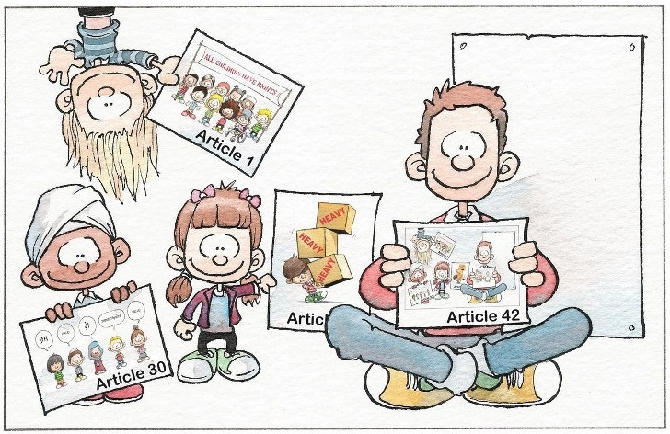

EVERYONE should know about the Convention on the Rights of the Child
U.N. Convention on the Rights of the Child: Article 42

