WORKFORCE DEVELOPMENT ONLINE TRAINING
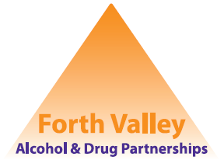

The following courses are available online for free via the Scottish Drugs Forum (SDF)
Course Titles
- Contraception information for people who use drugs

- Motivational Interviewing in Brief Conversation

- Drug Awareness – an Introductory Course

- Hepatitis C and New Treatments

- Overdose Prevention, intervention and Naloxone

- Bacterial Infections and Drug Use

- New drugs, New Tend? A worker’s toolkit for NPS (Novel Psychoactive Substances)

For more information on each course, to create and account and to register please use the following link SDF E-Learning

Please note:
These courses are free but you need to create an account to be able to register on to a course. When creating your account please add your job title/department name and Council area to assist with reporting.

