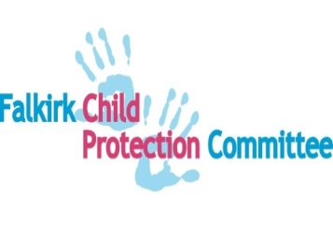
FALKIRK CHILD PROTECTION COMMITTEE

IMPROVEMENT PLAN
RESPONSE TO SIGNIFICANT CASE REVIEW LEARNING AND FINDINGS CHILD D
A significant case review is a multi-agency process initiated by chief officers and child protection committees in accordance with national guidance. These reviews are intended to establish the lessons that can be learned from situations where a child has died or been significantly harmed through abuse or neglect. The review for Child D followed the ‘Learning Together’ approach which has 3 principles at its core- to avoid hindsight bias, to appraise and explain practice and to provide a ‘window on the system’.
Child Protection Committee and Public Protection Chief Officers have fully committed to reviewing the findings and identifying the way forward. Shared ownership and informed discussions by agencies has underpinned agreements about what actions should be included in this improvement plan.
The 5 review findings are:
- There is reduced inter-agency assessment and planning in cases that sit before or after the child protection system which is not being picked up in supervision, making joint working and effective information sharing less likely.
- Service demands have resulted in raised thresholds for case allocation and child protection action- with practice becoming more reactive than reflective- to the detriment of best information sharing and planning in the wider children’s system. This has particular implications for recognition of and response to child neglect.
- Do staff in Falkirk have access to the tools, resources and knowledge required to assess the impact that mental health issues and learning disability has on parenting?
- Services in Falkirk work effectively and skilfully together when it is recognised clear child protection concerns have occurred and appropriate time and resources are allocated.
- Is there a collective understanding of the role of the Reporter in making enquiries in cases where children’s needs may not be being met?
The approach taken in Falkirk is to have a series of actions that sit under 4 improvement themes. This takes account of the inter-related nature of the work to address the individual findings. We want our systems, culture and practices to change for the better and the benefit and impact of this for children, to be clearly seen.
The improvement areas are:
- Recognising and responding to unmet needs and risk for children
- Resources in the system
- Enhancing staff knowledge and skill through education and support
- Strengthening quality assurance

Falkirk Public Protection Chief Officers Group – Short Life Woking Group

Action Plan
Key strategic areas of focus | Actions | Responsible | Timescale
Continue to champion and ensure ongoing priority focus and support to the child protection committee and associated improvement plan. | Development of a dedicated risk assessed performance improvement progress report at each COG meeting. | Falkirk PPCOG – Short Life Working Group | Summer 2020
Enhance strategic and tactical multi-agency effectiveness in pursuit of high quality and safe public protection. | Scope, review and explore approaches to enhance multi-agency shared and joint working spaces. | Falkirk PPCOG – Short Life Working Group | Autumn 2020
Develop a comprehensive inclusive performance management approach to deliver improvements and requirements across the public protection agenda. | Create a dedicated balance score card and performance measures (KPI’s) and existing child improvement plan actions, associated data sets and national standards. | Falkirk PPCOG – Short Life Working Group | Autumn 2020
Chief officers group strategic direction and leadership vision delivery and engagement plan in support of public protection. | Develop a suite of dedicated communication and engagement activities in support of delivering with our workforce high quality and safe public protection. | Chief Officers Group  Child Independence Chair  Falkirk PPCOG - Short Life Working Group | Autumn 2020

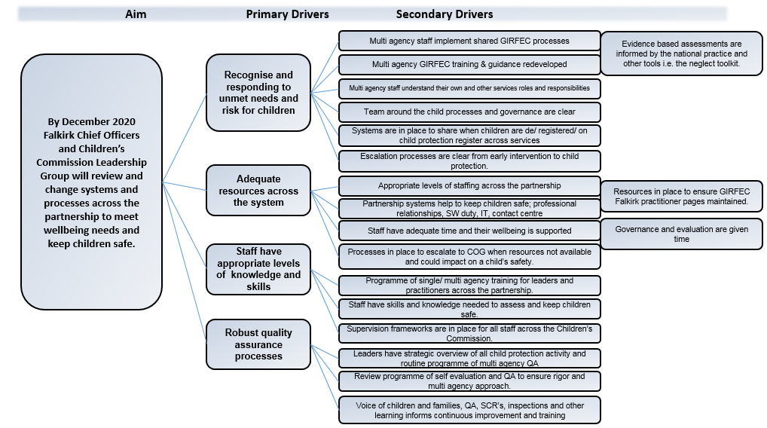
OUTCOME |  | A. Recognising and responding to unmet needs and risk for children
No | Aim | Action | Measures | Governance/ reporting group | Due date
A.1 | Children’s Service Partnership staff work collaboratively and effectively to recognise and respond to unmet needs and risks at earliest opportunity. | Develop clear governance (culture, systems and practice) arrangements for GIRFEC (incl. TAC processes and guidance, and when to appoint a Lead Professional), and escalation processes. | Develop measures in relation to agreed audit and evaluation arrangements. | Commission Leadership Group | July 2020
A.2 |  | GIRFEC Group to be re-established to develop and deliver GIRFEC pathway and training for all staff incl. commissioned services. | % staff reporting confident use of GIRFEC pathway.  % Children’s plans that evidence early intervention. | Commission Leadership Group | Sept 2020
A.3 |  | GIRFEC programme of training developed with a focus on analysis, assessment, ongoing risk, neglect, thresholds, chronologies, and planning for children. | 100% staff complete GIRFEC training. | Commission Leadership Group | Dec  2020
A.4 |  | Falkirk Children’s Commission Information sharing protocol is updated and implemented. | Updated information sharing guidance is included in Child’s Plan and on GIRFEC Falkirk Practitioner Pages. | Commission Leadership Group | July 2020
A.5 |  | Develop SW initial response systems that are accessible, and responsive and informed by multi agency assessment. | % of child concern referrals to social work are screened and actioned within 24 hours. | Child Protection Committee | Sept 2020
A.6 |  | Risk and escalation processes are clear as part of GIRFEC pathway and child protection procedures. | Multi agency escalation (incl. thresholds) policy produced and implemented.  % practitioners who complete GIRFEC/ CP training.  % staff reporting escalation processes are understood. | Children’s Commission Leadership Group & Child Protection Committee. | Dec  2020
A.7 |  | Escalation concerns are recorded via agreed multi-agency processes to ensure strategic oversight and improvement themes actioned. | Processes developed and implemented.  % staff who feel escalations are resolved. | Child Protection Committee | Dec 2020
A.8 |  | Staff understand remit of Reporter and refer appropriately to the service. | % of referrals to SCRA from universal services.  % of cases sent to SCRA progress from referral to Children’s Hearing. | Child Protection Committee | Dec 2020
A.9 |  | Review all services discharge/ closing case guidance, considering the impact on outcomes for the child, as part of GIRFEC pathway. | Measures to be agreed once improvement areas identified. | Children’s Commission Leadership Group & Child Protection Committee. | Sept 2020
A.10 |  | Single agency Child Protection Leads have agreed roles across the partnership, are clearly identified and visible in each agency. | % staff across services for children who report they know who and when to contact lead officer. | Chief Officers Group | Aug  2020

OUTCOME |  | B. Resources in the system
No | Aims | Action | Measures | Governance/ reporting group | Due date
B.1 | Multi-agency staffing levels and operational systems (IT, service data) are sufficiently resourced to enable practitioners to identify and respond to unmet needs and risks for children. | Every agency will develop systems to ensure minimum staffing levels are met and reported to Child Protection Committee (CPC). | Benchmark against comparator authorities. | Chief Officers Group | Sept 2020
B.2 |  | Workload management tools are used to ensure effective caseload management and sufficient capacity in the system. | Benchmark against comparator authorities. | Chief Officers Group | Nov 2020
B.3 |  | Review current staffing resources in place across agencies to provide data, and support improvement. | Measures to be developed once reviewed. | Child Protection Committee | Sept 2020
B.4 |  | Review current staffing resources in place to deliver GIRFEC training and other multi-agency training. | No. of staff released to facilitate and attend training. | Children’s Commission Leadership Group | Sept 2020
B.5 |  | Review and evaluate SW Duty and support systems incl. business support & contact centre. | New system developed and implemented.  % calls received and recorded using agreed systems. | Child Protection Committee | Sept 2020
B.6 |  | Map current processes and develop a system to share child protection registration and de-registration information across agencies. | Measures to be agreed once improvement areas identified. | Child Protection Committee | Oct 2020
B.7 |  | Develop SW IT systems that are easily accessible, inform assessment and support information sharing across agencies. | Liquid Logic system rolled out. | Children’s Services Senior Management Team | Dec  2020
B.8 |  | Education IT systems are used to record concerns/ risks and support integrated assessments. | Measures to be agreed. | Children’s Services Senior Management Team | Dec 2020

OUTCOME |  | - Enhancing staff knowledge and skill through education and support
No | Aim | Action | Measures | Governance/ reporting group | Due date
C.1 | All staff will have the knowledge and skills required to recognise and respond to unmet needs and risk for children. | Establish a programme of multi-agency learning & development for leaders and managers focused on analysis of assessment, ongoing risk, neglect, thresholds, chronologies, planning for children, decision making and quality assurance role. | % managers trained | Children’s Commission Leadership Group  Child Protection Committee | Dec 2020
C.2 |  | Deliver multi-agency training for practitioners based on the findings from the SCR including:  - Roles & responsibilities of staff incl. identification of lead professional  - Assessing parental capacity, incl. impact of learning disability and mental health (IPSU).  - Professional curiosity  - Respectful challenge  - Disguised compliance  - The voice of the child  - Information sharing  - Child Protection thresholds and requirements for compulsory measures of supervision (SCRA)  - Assessment and analysis/ impact of interventions on outcomes for the child  - Chronologies  - Neglect  - Cumulative harm  - Neglect  - Cumulative harm | % case files audited where improvements in practice.  Breadth of agencies trained.  % staff who report increased confidence  % staff reporting improved practice as a result of training.  100% plans reflect child’s views (including younger children and those with verbal and non-verbal communication) | Child Protection Committee  &  Children’s Commission Leadership Group |  | Dec 2020
C.3 |  | Design and deliver a programme of learning for Council call-handling staff and develop a system to log, track and direct all calls. | % staff trained  % staff who report they feel confident to handle calls. | Child Protection Lead Officer |  | Sept 2020
C.4 |  | Establish support and supervision frameworks for all practitioners implementing a Named Person/ Lead Professional role to allow reflection and constructive challenge in practice. | % staff receiving regular one to one supervision  % of files audited where assessment and plans are good or better (care inspectorate)  % case files audited that evidence worker supervision/ manager oversight. | Heads of Service |  | March 2021
C.5 |  | Carry out annual performance reviews to promote practitioner confidence, competency and quality assurance. | % staff receiving annual performance review | Heads of Service |  | April 2021
C.6 |  | Maintain a multi-agency learning and development database to ensure staff have required knowledge and skills. | Databases established in each service. | Heads of Service |  | Dec 2020
C.7 |  | Develop a system of QA to ensure training is positively impacting on practice. | Shared system and measures developed and implemented. | Commission Leadership Group |  | Dec 2020
C.8 |  | Develop a mechanism for identifying improvement and sharing good practice examples within and between agencies | Examples are accessible on practitioner pages. | Commission Leadership Group |  | Oct 2020
C.9 |  | Multi-agency GIRFEC training and guidance is redeveloped and implemented. Key elements  - GIRFEC 5 Key Qs.  - GIRFEC national practice model  - Falkirk GIRFEC Pathway  - Assessment & Planning  - Roles and responsibilities  - Risk and resource – including referrals to SCRA.  - Working with resistance guidance | % practitioners who complete training.  % staff reporting they understand GIRFEC roles and pathway.  % staff trained in assessment and planning  % staff reporting that they use the Falkirk child’s plan guidance.  % dip sampled plans rated very good or excellent (as per care inspectorate guidance) by multi-agency plan reviewers. | Commission Leadership Group |  | Oct 2020
C.10 |  | Multi-agency staff understand their own and other services roles and responsibilities re GIRFEC incl. Child Protection. | % practitioners who report they understand role re GIRFEC  % practitioners who report they know when to escalate a concern/ risk.  % practitioners who report they know how to escalate a concern/ risk. | Commission Leadership Group |  | Oct 2020
C.11 |  | Resources are in place to ensure GIRFEC Falkirk practitioner pages are easy to navigate and maintained. | No. of hits on pages.  Staff feedback that pages are easy to use and information is accessible. | Commission Leadership Group |  | July 2020
C.12 |  | Implement system to share information re attendance at NHS Hospital Emergency Departments (ED) with health visitors and school nurses to inform assessments and identify sibling concerns and risks. | % in emergency department (ED) alerts received by health visitors and school nurses.  % staff who report using ED alerts to inform assessment. | NHS Service Manager |  | Oct 2020
OUTCOME |  | D. Strengthening quality assurance
No | Aim | Action | Measures | Governance/ reporting group |  | Due date
D.1 | Child centred services will be delivered by practitioners and leaders taking a systems based approach to quality assurance. | Apply the “Quality Framework for Children and Young People in Need of Care  and Protection - Revised August 2019” Care Inspectorate Framework and develop a single and multi-agency rolling Programme of QA to: ensure strategic oversight and improvement themes identified. | Measures to be agreed when Relevant PI’s selected. | Chief Officers Group  Child Protection Committee  Children’s Commission Leadership Group |  | Oct 2020
D.2 |  | Through audit and review, single agencies improve compliance to national child protection guidance and timescales in national dataset. | National Indicators from CP minimum data set: Assessing Local Response and Child Protection Processes:  14-18b  Local Indicators:  % children meet with social worker weekly.  % core group minutes & plans circulated within agreed timescales.  % CP Conference minutes & plans circulated within agreed timescales. | Child Protection Committee |  | Quarterly  Bi – annual to Child Protection Committee
D.3 |  | Managers ensure Named Person/ Lead Professional role is understood and embedded in practice. | Programme of evaluation developed with an agreed shared template.  % records audited by managers. | Chief Officers Group  Child Protection Committee  Children’s Commission Leadership Group |  | Oct 2020
D.4 |  | Develop a monitoring tool to report impact and wellbeing outcomes of CYP for commissioned services. | % outcomes improved from referral. | Children’s Commission Leadership Group |  | Nov 2020
D.5 |  | Conclude revised Inter-agency Referral Discussion (IRD) guidance and provide clarity about when it is used, IRD thresholds and application in practice. | Guidance redeveloped and shared across the partnership. | Child Protection Committee |  | Oct 2020
D.6 |  | Develop systems and processes to co-ordinate and engage children and families in evaluation, service feedback, co-production and design of services. | % families who feel included in their TAC and Child’s Plan.  % Families who feel their needs have been met  % families who feel views have been listened to. | Children’s Commission Leadership Group |  | Oct 2020
D.7 |  | Communication strategy to be developed across strategic groups and agencies to ensure leaders and managers have strategic overview of all key GIRFEC and child protection activity. | Communication strategy agreed and key strategic developments and plans shared across the partnership. | Chief Officers Group  Children’s Commission Leadership Group |  | Aug 2020
D.8 |  | Develop routine systems to share findings from:  self-evaluation activities including:  - Single and multi-agency audits  - ICR’s/ SCR’s  - Inspections to inform learning and development programme across the partnership.  - Themes from escalation processes | Commission L & D Plan is directly informed by findings from:  JSNA  CPC Audit  ICR’s  SCR’s  JISCYP | Chief Officers Group  Child Protection Committee  Children’s Commission Leadership Group |  | Sept 2020
D.9 |  | Schools validated self-evaluation process to include audit of GIRFEC assessment and plans. | % plans audited  Improvement themes identified and actioned. | Child Protection Committee |  | Dec 2020

