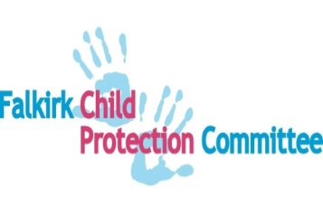
FALKIRK CHILD PROTECTION COMMITTEE

COVID Action Plan – Version 8 08.10.2020

Foreword
The COVID-19 pandemic, and the measures in place to control the spread of the coronavirus, have had a profound impact on everyone’s life. Stresses and risks can arise for children and families which are not always visible. In lockdown these include a lack of physical access to normal relationships, such as friends and extended family, a reduced reach from universal and specialist services, barriers caused by increased use of digital platforms and financial pressures. Through the phased approach to recovery and the reopening of schools and workplaces, we continue to need careful, co-ordinated planning to protect children. It is essential that across our communities, children who are vulnerable, children who have experienced harm and children who may be at increased risk of harm during the pandemic are able to access supportive and robust protective services when they need them.
The Scottish Government has issued updated national child protection guidance https://www.gov.scot/collections/coronavirus-covid-19-guidance/ This supplementary guidance emphasises that the rights of children have not changed, and explains child protection is part of a continuum of collaborative responsibilities upon agencies working with children, which commences pre-birth. It requires good professional judgement, based on assessment and evidence, informed by the perspectives of the team around the child, including the child and family.’
Falkirk’s partnership approach to wellbeing and protection has not stopped. This plan aims to ensure that we have effective protection and provision of support in response to COVID 19 and that this is embedded at a local strategic level. Specifically, in producing this plan, we have:
- Identified the priorities from the Child Protection Committee improvement plan 2018-20.
- Made connections to priorities in other local plans including SCR (Child D), ICSP, and updated our GIRFEC guidance accordingly.
- Reviewed our child protection key operational processes in line with the supplementary national child protection guidance.
- Produced this new, joined up action plan for child protection to set out our actions in the short term (during periods of lockdown and other social restrictions), medium term (as restrictions are lifted and we move towards recovery) and long term (as partners transition to a ‘new normal’).

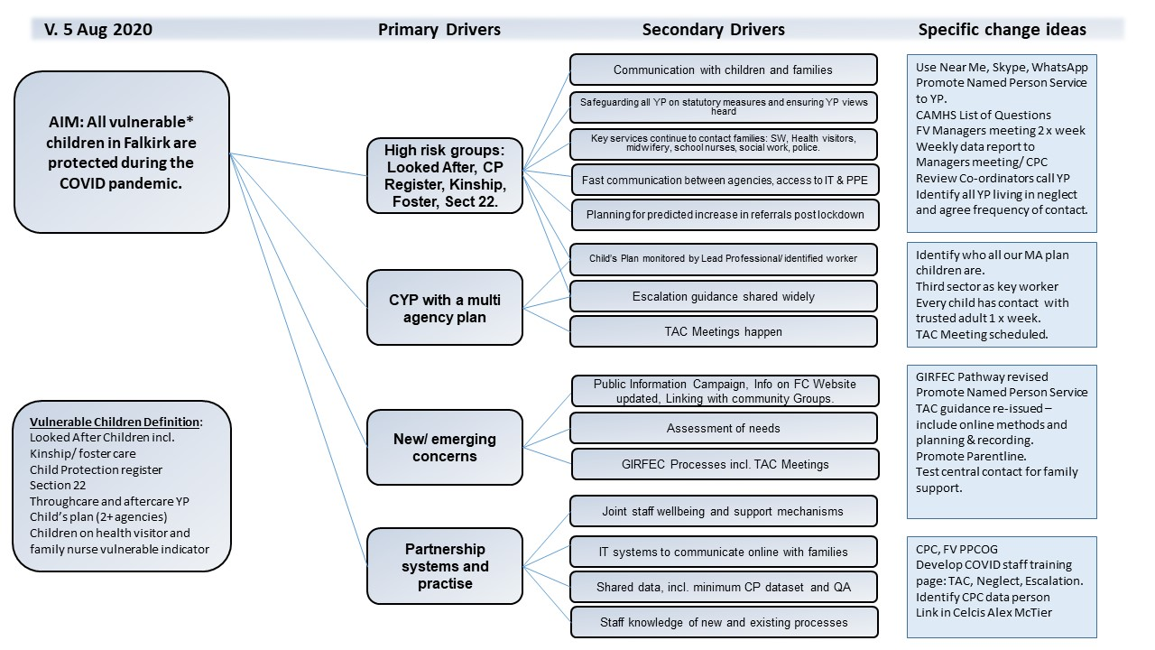
AIM: All children and young people in Falkirk are protected during the COVID-19 Pandemic. Child Protection and GIRFEC processes are streamlined and enhanced without compromising actions to protect children.
PRIMARY DRIVER | HIGH RISK GROUPS
AREA AS PER SUPPLEMENTARY NATIONAL CP GUIDANCE | COVID MITIGATING ACTIONS | HOW WILL WE KNOW? | TIMESCALE  Brackets indicate change to timescale
1. Child protection during the Covid19 outbreak (collective leadership) | 1.1 CPC to meet remotely and more frequently. Vice chair to be agreed. | Monthly mtgs scheduled. Actions completed. | 18 June 2020/monthly
 | 1.2 CPC COVID Action Group to meet weekly with agreed TOR (replacing CCIG, data group, SCR Review Team) to ensure coordinated focus for continuous improvement. | Weekly mtgs scheduled. | June 2020/ weekly
 | 1.3 FV multi-agency group to meet weekly to ensure coordinated focus on operational processes. | Weekly mtgs scheduled.  Actions completed | April 2020/Ongoing
 | 1.4 FV PPCOG to meet remotely and agree and maintain risk register. | mtgs scheduled.  Actions completed | 10 June 2020 / 8 weekly
 | 1.5 Ensure there is a system in place whereby single agencies (NHS, police, children’s services, SCRA) routinely collate their staffing information and report on staffing pressures to CPC monthly. | Staffing levels maintained | (July 2020)  October 2020
 | 1.6 Short life working group to be set up to consider a merged system reporting on the assessed collective impact of staffing pressures and what joint plans or solutions might be made in response. | Partnership has shared solutions to staffing pressures | December 2020
 | 1.7 Develop and review Falkirk Child and Adult Protection COVID-19 Communication Strategy to support public information campaign.  Strategy will be updated regularly during COVID-19 currently V. 3 August 2020. | No. of SW Referrals.  No. hits on FC website.  Confidence survey via volunteer hubs. | Started May 2020  Phase 3  August 2020
2. Self-care, support and supervision of staff | 2.1 CPC COVID Action Group to review current procedures and processes re support and supervision to ensure staff wellbeing. | Procedures implemented | Completed – July 2020
 | 2.2 Ensure all staff are aware of staff wellbeing project May – July, including helpline for staff, IT, PPE and staff wellbeing support and newsletters. | Number of calls to helpline  Staff feel supported | April 2020/Ongoing during COVID  Analysis of project to be shared August 2020
 | 2.3 Voluntary Sector Children’s Services Forum, PPU and other police and education contacts to receive flyer and newsletters. Central contact points to be agreed. | Staff have access to wellbeing project | Completed – May 2020
 | 2.4 Implement guidance for social workers and residential childcare staff as per Supplementary National CP guidance V1.2 | Guidance implemented | Completed – June 2020
 | 2.5 All agencies are following single agency and public health guidance and safe practice when face to face contact is required. | All staff continue to have access to PPE.  Ongoing meetings with public health. | April 2020/ Ongoing  Further public health updates re schools and levels of PPE shared with schools.
3. Named Person | 3.1 Continue to support and promote the role of named person.  GIRFEC guidance to be reissued across the partnership | GIRFEC update issued to all staff | (June 2020)  October 2020.
 | 3.2 Develop a multi-agency GIRFEC training programme to ensure early concerns are recognised and responded to. | Training developed and staff attend.  Staff report increased knowledge and awareness of NP role. | (October 2020 and ongoing)  February 2021
4. Information Sharing | 4.1 Falkirk Children’s Commission Information Sharing Protocol is updated and implemented, as part of GIRFEC Guidance. | Issued to all staff | (August 2020)  October 2020
5. Inter- agency referral discussion (IRD) | 5.1 Normal IRD processes continuing and prioritised to inform Child’s Plan. | No. IRDs as agreed by police/ NHS | April 2020/Ongoing
 | 5.2 QA of IRDs continues (multi-agency review of 6 IRDs per month) | QA –themes identified evidencing good practice | May 2020/Ongoing  August 2020 review (to be shared with Group)
 | 5.3 Staff capacity for IRDs analysed at weekly FV operational meeting | No IRD postponed due to staff capacity | Weekly/ Ongoing
6. Investigation and assessment | 6.1 Assessment and investigation processes continue as normal. Children who need to be seen are seen in their living environment following public health advice. | No. SW referrals/ assessments and source of referral | April 2020/Ongoing
 | 6.2 Lead Professional initial child protection assessment written report test of change started. | Template agreed.  No. written reports produced  Quality of reports in improving outcomes for children. | (September 2020)
 | 6.3 Medicals continue within appropriate timescale, revised medicals guidance has been agreed and issued to partners via NHS Forth Valley. | % cases requiring medical completed by skilled practitioner as per Care Inspectorate Guidance | May 2020
 | 6.4 EDT processes and work practices streamlined. To ensure sufficient Emergency Duty Team (EDT) staff to assess needs if crisis situation arises out of hours. Discuss at weekly FV operational meeting if required. | Levels of staffing | April 2020/ Ongoing discussions at weekly meetings taking place where required.
 | 6.5 Care and Risk Management Meetings (CARM) continue– all young people at high risk continue to be prioritised. | No. of CARM meetings | May 2020/ Ongoing
7. Child assessment and child protection orders | 7.1 Continue to follow the Coronavirus (Scotland) Act 2020 re CP orders. | No. of CP Orders applied for and granted. | May 2020
8. Compulsory supervision orders , secure care and place of safety placements | 8.1 SCRA rolling out virtual hearings, digital papers and implementing new guidance as per supplementary CP Guidance v1.3.  Children’s hearings prioritised for those most at risk, adhering to national revised timescales and issuing contact directions. V Scene used as digital platform. | No. of hearings taking place.  Feedback from YP and families on experiences of hearings | April 2020 -  August 2020
 | 8.2 Planned re-start of face to face hearings mid/ end of July with a blend of virtual and face to face hearings continuing to ensure fully participative and safe hearings for families. | No. of hearings taking place.  Feedback from YP and families on experiences of hearings. | (July 2020)  Restarted 10 August 2020
 | 8.3. Planning to ensure social distancing can be adhered to at SCRA venues and all appropriate staff can attend to represent child’s views and assessment. | Falkirk Municipal Buildings identified. | (July 2020)  August 2020
 | 8.4 Analyse SCRA referrals to understand reasons for referral and imbalance in numbers of referrals from police and universal/ GIRFEC processes. | Increase in no. of referrals from universal/ GIRFEC pathway. | August 2020  Ongoing
 | 8.5 Children’s Rights Officer capturing experiences and view of young people re. virtual hearings and participation. | YP views inform processes and methods for holding meetings. | (July 2020)
9. Child protection planning meeting i.e. case conference/ core group | 9.1 Initial and pre-birth conferences prioritised initially. Routine review conferences subsequently restarted.  Families to be offered range of means to ensure they can take part.  Children and YP can chose how to participate in their meetings (face to face, on line, before after calls). | % child/ YP participating in case conferences/ CP meetings.  No. of case conferences taking place, recording views listened to.  No children/YP speaking to Chair before meeting. | Data monitored monthly at CPC COVID Action Group Meeting.
 | 9.2 CPC identify reasons for increase in CP registrations, and develop/ monitor improvement actions and understand implications for staffing.  Data will be analysed by CPC COVID Action Group and report submitted to CPC. | Monitor numbers of children on register per 10,000 compared to Scottish average. | November 2020
 | 9.3 CP registration numbers to be analysed biannually. | Monitor numbers of children on register per 10,000 compared to Scottish average. | Biannually  October 2020  April 2021
 | 9.4 Forth Valley Pre-birth pathway and guidance to be signed off by CPC and implemented with partners. | Revised Child’s Plan issued.  No. of new pre-birth assessments carried out using new pathway. | (June 2020)  October 2020.
 | 9.5 Quality assurance mechanism in place aligned to the Forth Valley pre-birth pathway and guidance. | QA –themes identified evidencing good practice | December 2020
 | 9.6 Falkirk pre-birth assessment guidance and assessment tool to be implemented. | Guidance and tool issued. | June 2020
 | 9.7 During the course of the health pandemic multi-agency assessments continue to take place for children on CP Register. | No. of case conferences taking place with multi-agency assessments (Form 3, 5) | (August 2020)  October 2020  Ongoing
 | 9.8 Via GIRFEC guidance and training, staff to be reminded of Child’s plan guidance assessment and chronologies sections, escalation guidance and talking to partners to discuss concerns and integrate assessments/ plans. | GIRFEC Guidance issued.  Training developed and staff attend. | (June 2020)  February 2021  (In service days)
 | 9.9 Children’s Rights Service, Champions Board and Barnardos pilot to capture views of YP re virtual conferences and areas for improvement. | Views of YP inform CPC Plan. | July 2020
 | 9.10 Quality assure child protection case conferences during COVID using Care Inspectorate template and using peer review to identify improvement actions and good practice from crisis response. | 5-7 cases every 3 months.  No. of cases at very good or excellent. | Ongoing 3 monthly  ( 8 cases identified to audit by October 2020)  December 2020
 | 9.11 Ensure effective system in place to measure referrals made direct from case conferences to the Reporter. | No. of cases | Monthly from June 2020
 | 9.10 Report on the data in relation to the referrals made direct from case conferences to the Reporter monthly. | No. of cases | Quarterly
10. Timescales | 10.1 Ensure a quality standard is maintained for initial and pre-birth case conference timescales and report monthly to COVID group. | 90% cases within the national timescales | September 2020
 | 10.2 Ensure a quality standard is maintained for core group timescales and report monthly to COVID group. | 90% of core groups within national timescales | September 2020
 | 10.3 Ensure effective system in place for SW Team Managers to submit record of core group to service manager for regular quality assurance of core group activity. | No. records of core groups | November 2020
 | 10.4 Data will be reported on SCRA number of reporter decisions on referrals within 50 working days. | 78% of decisions within national timescales.  100% Hearings. | September 2020
 | 10.5 Data will be captured and reviewed more regularly combining the quarterly national Child Protection and weekly SOLACE data sets. Data will be presented to CPC for analysis and action at monthly CPC/COVID group meetings. | Monthly data shared and used to update CPC Plan. | June 2020  Ongoing
11. Child protection register | 11.1 Childcare Review Team Business Support maintains CP register and updates national child protection flagging system. | Register updated | June 2020
 | 11.2 Process to be developed to ensure register information is shared weekly to ELCs and Schools. SEEMIS access to be given to business support. | Register shared daily with Police, and weekly with Education, FV NHS. | June 2020
 | 11.3 All children on register are being visited weekly by SW. Arrangements during Lockdown developed to layer support to all registered children on a partnership basis. This will come from social work, education, health and third sector. Planner to be shared between partners to ensure a co-ordinated approach to visits across services during operation of hubs. | Visits and contacts with families are coordinated.  % children/YP on CP register seen during previous 2 weeks | June 2020
 | 11.4 System developed for families to be offered options of child protection action plans and minutes to be posted out to them or hand delivered by social workers. |  | November 2020
12. keeping children safe | 12.1 If a local lockdown resulted in school closures, all vulnerable children whilst not in school will be visible and supported. A shared list of vulnerable children has been be developed from education, social work, and third sector and there will be a minimum of weekly contact and assessment of need and risk for vulnerable children across services. This will be recorded on SEEMIS and submitted to SG if required and to CPC/COVID group. | Definition of Vulnerable children updated August 2020  % weekly contacts | (June 2020)  November 2020
 | 12.2 Assessment and information sharing continues coordinated by Lead Professional to ensure joint analysis of risk factors (domestic abuse, substance use, learning disability, mental health) to protect children.  GIRFEC guidance contains section on Lead Professional Roles, making the role clear in relation to multi-agency plans that are not child protection plans. | GIRFEC Guidance issued. | (June 2020)  October 2020
 | 12.3 Calls to social work initially re-routed to business support in Sealock to ensure quick access to SW to discuss concerns. They re-started through Contact Centre with tracked times to ensure there is no delay and system in place for escalation. | Partners have access to SW to discuss concerns quickly.  Collate data on calls and feedback from schools and other forums | Review August 2020
 | 12.4 Develop and put into operation, Information and Support Service for Falkirk Families. | % children seen  Number of advice/ support calls. | 6th July 2020
 | 12.5 Data on calls to the Information and Support Service be analysed and decision about continuation of line to be agreed. | Report produced | August 2020
13. Engagement with children and families who are self-isolating or shielding a child or carer | 13.1 Pre visit risk assessments carried out and need for immediate contact or not is assessed on case by case basis. Guidance for SW on home visits and direct contact interviews with children and families to be followed as per supplementary CP guidance V1.2 June 2020. | Guidance followed | April 2020 and refreshed June 2020/ ongoing during COVID
PRIMARY DRIVER | NON CP MULTI AGENCY PLANS & NEW CONCERNS
GIRFEC THEMES | COVID MITIGATING ACTIONS | HOW WILL WE KNOW? | TIMESCALE
14. Team Around the Child Meetings | 14.1 Guidance for TAC Meetings developed as part of GIRFEC Guidance including; involvement of YP, Parents, assessment, information sharing, recording and escalation guidance. | Guidance produced and distributed. | June 2020  October 2020
 | 14.2 TACs will continue to take place for all children, YP with a multi-agency plan and for emerging needs requiring multi-agency support and a quality assurance mechanism will be developed in line with GIRFEC guidance. | quality of child’s plan and reviewing arrangements | (June 2020)  February 2021
15. Analysis of risk factors | 15.1 Track areas of risk, analysing any changing pattern in relation to children on the register, subject of IRDs and consider emerging themes and responses from services. | Report produced | (July 2020)  December 2020
16. Domestic Abuse | 16.1 Agencies and practitioners to maintain awareness of dynamics of coercive control and apply Safe& Together approach , working with CEA, SHAKTI, FV Migrant Support and Central Advocacy Partners as appropriate. | Report produced  Safe &Together Institute reports | June 2020  Ongoing
17. IT, online meeting facilities, technology, devices. | 17.1 Establish a partnership IT COVID approach to resolve multi-agency IT issues using Microsoft Teams. | Platforms agreed.  All staff can support young people and access online meetings  365 & Microsoft Teams being rolled out in Falkirk Council and is used by Health, Police and 3rd Sector | June 2020  Aug 2020 – some FC now have office 365
 | 18.2 Ensure young people have access to required IT for video conferencing. | All young people can access online meetings | Aug 2020- some initiatives in place
18. Practitioner Pages | 18.1 Develop COVID practitioner page. Develop a practitioner pages team to support ongoing development and updates to pages. | Page developed and team in place to update and support. | (June 2020)  September 2020.
19. Data | 19.1 Shared data set developed by CPC Data Group and used to inform CPC plan. | Data set agreed and shared across partnership | 18 June 2020 for CPC.
 | 19.2 Data dashboard to be developed. | Dashboard in use | September 2020

