Practitioner Pages Super User Guidance – October 2020
Use Ctrl F and click ‘Headings’ to help navigate through the headings of this document.
Or use Ctrl F to search this document for a specific term.
Contents
- Navigating the GLOW Dashboard
- Jetpack
- Media
- Posts & Pages
- Links
- Comments
- Appearance
- Menus
- Plugins
- Users
- Your Profile
- Finding Help with GLOW Online
- Editing the Practitioner Pages Request Form
- Recovering Deleted Posts, Pages & Information
- Displaying Recent Posts on the Home Page

- Navigating the GLOW Dashboard
When you log in to GLOW and select the ‘Practitioner Pages’ you will be taken to the dashboard, with options along the left hand side.
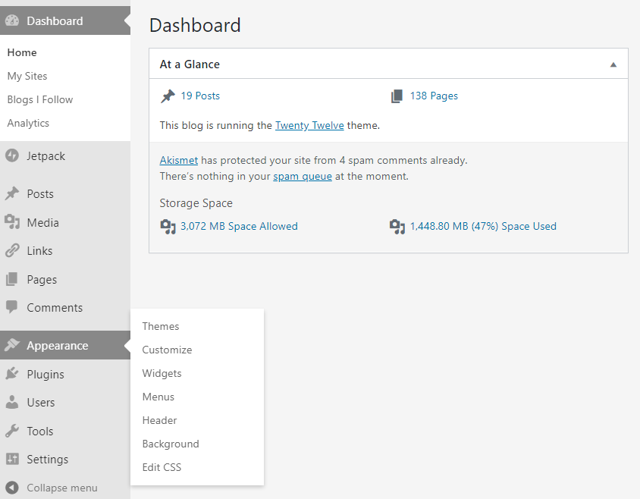
1.1 Home
You are brought to the ‘Home’ page to begin with.
At A Glance gives a very basic rundown of the GLOW site you are on the dashboard of.
- The spam queue (see green box above). The site should not be open to comments, so if there is anything sitting in the spam queue this is something to look into (comments will be explained later in the document).
- The storage space section is another one to keep an eye on – this shows how much space all the Media uploaded to the site is taking up. If you see the percentage of storage nearing full capacity (see blue circle) please contact Malcolm Wilson, who can ask for more storage.
Glow Blogs Help is where FAQ sessions or news about updates will appear – this is updated regularly and is worth checking as it will keep you up to date with any changes to GLOW as a service and will help you operate and make the most of any new features.
Quick Draft is a shortcut to creating a draft post (not a page), you cannot publish a post from here and it is usually best to go in through the ‘New Page’ feature as it gives more editing options and lets you preview your post.
Activity shows the latest items published on the GLOW site including posts and pages.

1.2 My Sites
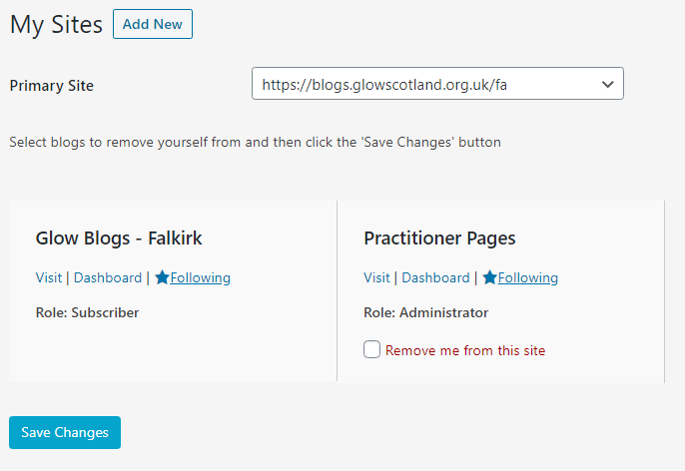
Here you can see GLOW blogs you are attached to and the roles you are assigned, the different roles are…
- Administrator – somebody who has access to all the administration features within a single site.
- Editor – somebody who can publish and manage posts including the posts of other users.
- Author – somebody who can publish and manage their own posts.
- Contributor (+ Upload) – like Contributors (see below) but with the ability to upload files. (This is not a standard WordPress role but one developed for Glow. It allows pupils or staff who have the role to create posts with images and other media and save them as pending. Editors or Admins can then publish)
- Contributor – somebody who can write and manage their own posts but cannot publish them.
- Subscriber – somebody who can only manage their profile.
1.3 Blogs I Follow
If you follow any other blogs, this page shows any unread posts. In terms of making changes to the Practitioner’s Pages it’s not important.
1.4 Analytics
This gives information such as – how many times your site has been viewed, where these views are coming from and how they accessed the site (search engines, direct link, etc.)
‘Sessions’ – show how many people have clicked onto the pages and stayed on, to visit multiple pages and interact.
‘Views’ – shows the number of views of all pages across the site.
The map shows where the highest concentration of views have taken place over the last 30 days.
The graph shows a more specific view of the number of sessions and views in the last 30 days.
The pie chart shows how users are accessing the website, e.g through Google, direct through using the URL, through Bing, or through links found on other webpages.

1.5 Capturing Analytics
The analytics for the site should be captured approximately monthly. The steps for this are below…
- Open the ‘Analytics’ tab in Glow.
- In the Taskbar of your computer use the search function to open the ‘Snipping Tool’
- Click ‘New’ in Snipping Tool with the Analytics page open
- Drag the cursor across the screen to capture the analytics.
- In Snipping Tool right click the image created and save it in the Practitioner Pages folder in the Sealock Drive.
- Save it with the format ‘PP Analytics DD.MM.YYYY’

- Jetpack
Jetpack shows a number of features that can change how your blog looks, the ways it can be navigated, and how administrators can view or use the site.
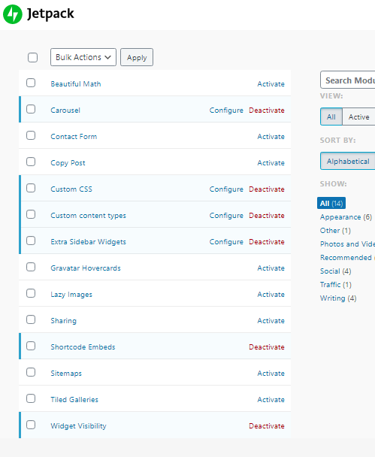
An example is:
Extra Sidebar Widgets (see green box above) – expands the choice of widgets you can add to your blog in the sidebar.
If you want to know what any of the features do you can click the name and access a Jetpack page which explains that feature.
Features can be activated and deactivated whenever is suitable. It is a good idea to check the site after making any changes here though, in case any important information is affected.
Jetpack Plugins that should be activated:
Carousel, Custom CSS, Custom Content Types, Extra Sidebar Widgets, Shortcode Embeds, Widget Visibility
- Media
This shows all the media files (Images, Audio, Video, Documents etc.) ever uploaded to the GLOW site.
You can sort by Date, Title, Author and Type of Media. Here you can open, add or remove media.
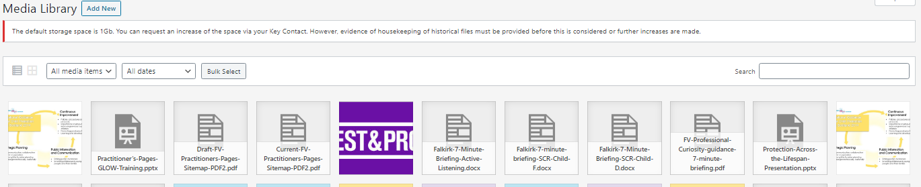
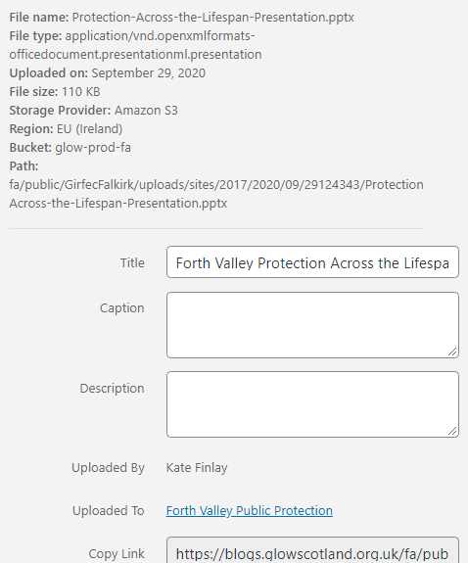
By clicking on any media file you can see the ‘Attachment Details’.
From here you can change the title, see who uploaded the media file, access the link, and see which page it was uploaded to.
However, if a file does not have an ‘uploaded’ page this does not mean it is not on the site, it could be displayed via a link rather than being embedded/added to a page.
- Before you delete any media file (unless it is obviously outdated) it is best to search the document title on the Practitioner’s Pages themselves, this will highlight if the document sits, or is referenced, anywhere.

There is limited storage for media, by storage GLOW means how much space all the Media uploaded to the site over ALL of its existence, not just what’s currently on display on the pages. This means that running out of storage is a possibility. However, contact Malcolm Wilson if the storage space is running out and more will be requested.

More Details on Adding/Editing Media
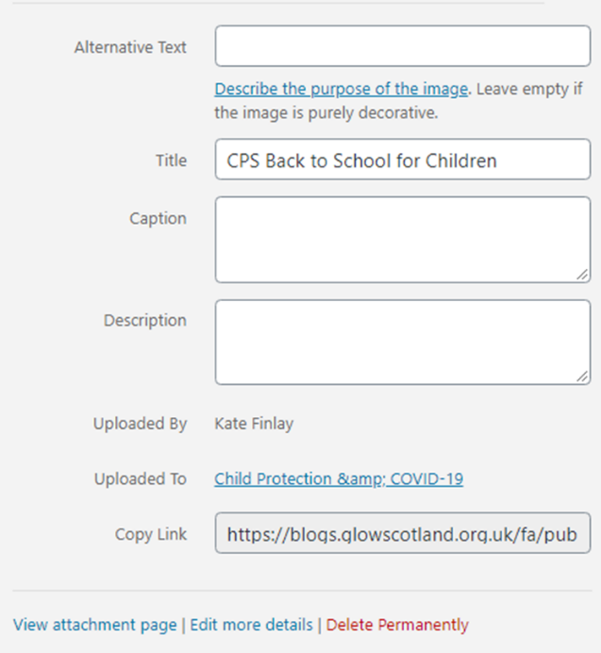
The Title is what will appear if it is added straight onto a page, it will take anyone who clicks to the hyperlink shown.
The caption and description are usually best left blank as different themes have been found to display them differently, if using an image to allow for accessibility you can use the Alternative Text box (see red square)
For decorative images this isn’t necessary but it is important that anyone with accessibility issues is not missing out on information included within images. GLOW have linked a decision tree underneath the Alternative Text box to help you with when alternative text is necessary.

- Posts & Pages
These tabs show all posts or pages drafted and published for the site – you can sort by title, date, author, categories, and tags.
From here you can Edit, Quick, Edit, Trash, Schedule and Preview posts or pages.

Quick Edit gives limited options for editing but doesn’t take you to a new page – it is good for changing the title, categories and the status of the post or page. It does not work to edit content within the post.
Edit takes you to a page where you can edit all aspects of the post/page and have full options for editing, you can also preview from this page as well as changing parent pages.
View allows you to open up the post in a separate tab to see what it looks like (or for drafts - will look like) for anyone visiting the site.
Posts > Categories
In this page you can view all current categories, add and remove any.
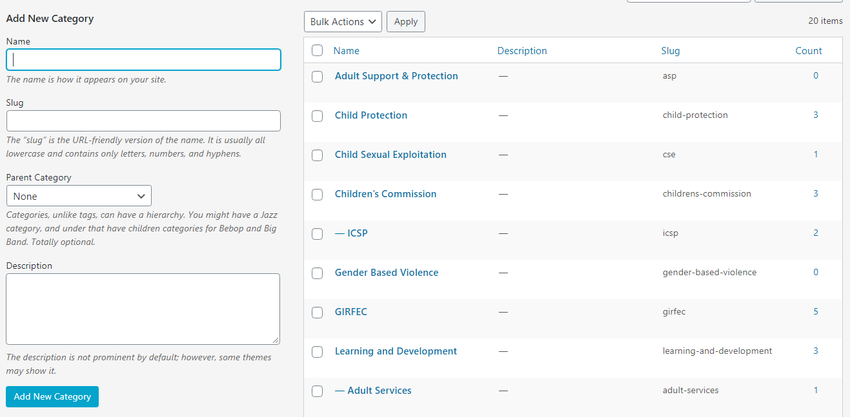
On the left, you can create a new category, and pick a parent category to choose where it sits within the hierarchy. Categories, similar to pages can have a hierarchy (tabs cannot).
On the left hand side you can see all of the existing categories and ‘Count’ (see blue circle) shows how many posts currently are under that category.
Only posts can be assigned categories.
- Links
There are currently no links stored in the Links library on the practitioner’s pages.
All external links have just been copied and pasted in.
- Comments
There shouldn’t be any comments on the Practitioner Pages as for now we don’t wish to have them open for discussions
If a comment has appeared, check which page or post it is on and then in ‘Quick Edit’ for that specific page or post make sure that ‘Allow comments’ is not ticked (see green square below), then click the blue ‘Update’ button.
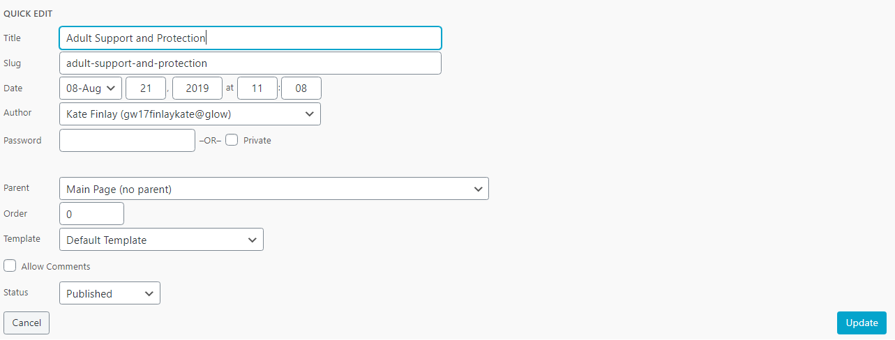

- Appearance
Themes
This shows all the themes that are available for the GLOW site.
Theme changes shouldn’t happen too often as they do require a lot of editing and checking the site as it changes the entire site.
If another theme change does take place the priority for the Practitioner Pages is picking one with a drop down navigation menu, this really improves usability for the pages.
It is also important that during and after a theme change, the way the site looks on mobile is continuously checked as some themes don’t translate well to mobiles/iPads/other devices.
Customizing
Customization options differ between themes. The current theme we are running on is TwentyTwelve. Below are the customization options for this theme.
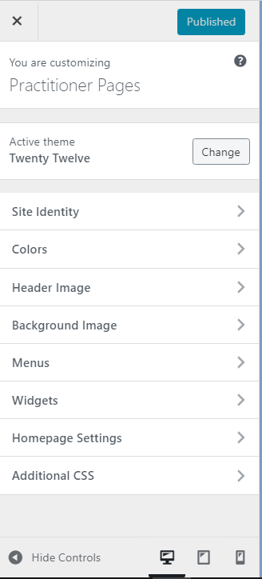
Under Site Identity you can change the tagline and the title of the pages, you can also change the site image, which is what appears in browser tabs when they page is open (for this a square image works best)
Under Colours you can change the main colours featured on the page – sometimes in order to make sure colours are exact matches for others used throughout or on other content it is best to take down the hex triplet (hashtag then six digits e.g #ffffff for white) this can help to create consistency if you are incorporating colours for branding purposes.
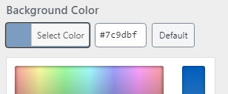
You can add or change the Header Image of the pages, this is the image that appears below the menu and above the content. This looks best when it is a long and narrow image, GLOW does give the option to crop images to see what looks best.

The Background Image appears behind the main columns of the site, if you’d prefer an image to a block colour you can upload it and position it correctly using this tab.
- Menus
Menus or Navigation menus help users to navigate the site by displaying the different pages in a specific order or hierarchy.
Menus can be displayed in multiple places on the site, multiple menus can also be displayed if necessary. To add an additional menu to the sidebar you will need to use a widget (covered later).
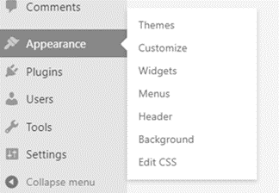
Usually, the menu selected as the primary menu will be the one that appears at the top of the page.
For the Practitioner Pages we alphabetize the menu, please keep this in mind and encourage the editors to do so as well.
If someone cannot find a newly published page in the drop down menu, you will need to check the ‘Menus’ tab

You can edit menus within customization mode but it is easier to click back to the dashboard and access it through the drop down that sits under ‘Appearance’ (see red circle)

Here you can manage menus, add new items, reorder, change which one is the ‘primary’ menu and create entirely new menus.
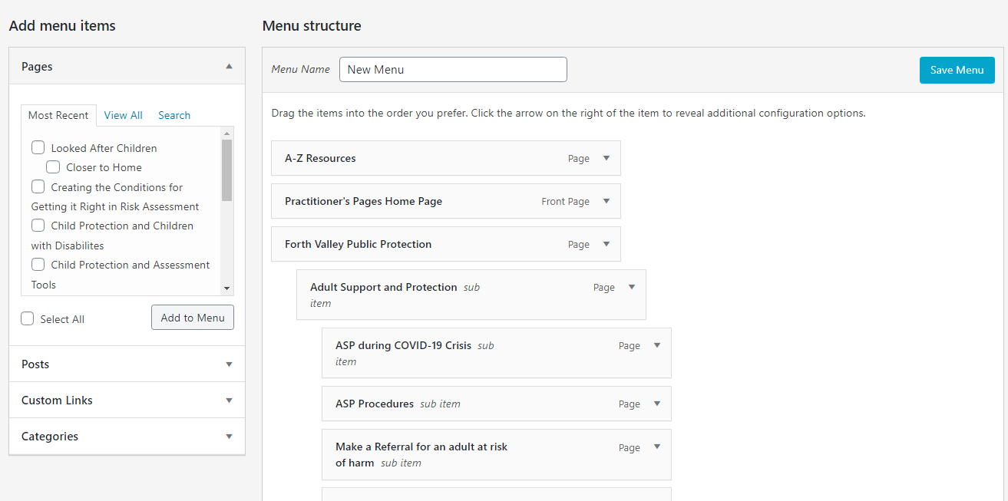
Reordering menus works like a drag and drop, to sit a page under another as a sub-page just drag it below and indent it slightly. You can create any number of sub-pages, although if there are too many subpages within subpages the drop down menu does become harder to use.
To add a new page to the menu:
- In the ‘Pages’ box on the left, tick the box beside the page you wish to add.
- The page might be visible under ‘Most Recent’ or you may have to Search
- Once the box is ticked click ‘Add to Menu’
- The new page will then appear at the bottom of the list of pages.
- Drag and drop the page to its position within the hierarchy, ensuring that it sits under the correct ‘Parent Page’ and is not a sub-page unless specified on the request.
- Once in the correct place, scroll to the bottom of the page and click the blue ‘Save Menu’ button (see Red circle).
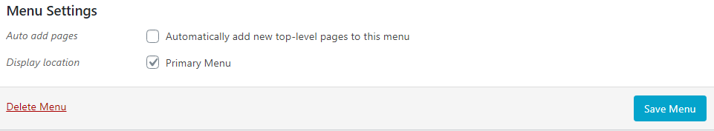
Under Menu Settings you can select the primary menu. There is also the option to automatically add new top level pages to the chosen menu. At the moment this is not ticked, to stop pages being added to the top level when they should sit under an existing category (the requests process should help highlight where in the hierarchy any new pages sit)

Widgets
Widgets allow you to ‘build’ the design of your page, by choosing where certain components sit on your page.
For example (see below) – in the main sidebar, you should have the ‘Search’ and ‘Recent Posts’ widgets, under these you can add more such as ‘Archives’ and ‘Categories’.
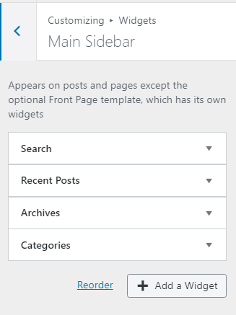
The main place widgets sit is in the sidebar – by using customization you can add, remove or reorder widgets.
When you click ‘Add A Widget’ each available widget should have a small description to tell you its function.
You can also add a widget to the sidebar and it will appear on the preview if you want to check how it looks on the page.

Homepage Settings
Here is where the homepage for the site is selected, there are two options for a homepage
Static Page – the same page and information is shown each time.
Posts Page – posts are displayed from most recent to oldest.
A static page is best for the Practitioner’s Pages as there is information about the purpose of the pages and the requests process that it is best if people view before they browse the content.
- Plugins
Similar to Jetpack, you can see here the possible plugins and their features. These can be activated or deactivated. There is a short description for each one but if you ‘visit plugin site’ you can learn more about what each plugin does. New plugins are rarely added and most of the useful ones for the pages have already been activated.
Plugins that should be activated:
Display Posts, Glow Analytics, Google Calendar Embed, Jetpack by WordPress.com
- Users
Here, under ‘All Users’ you can see others who have permission to work on the Practitioner’s Pages, you can also see their roles, these tell you if they have limits to what they can do on the practitioner’s pages.
  - ADDING A NEW USER TO THE PAGES
- Click the ‘Add New’ button beside ‘Users’ at the top of the page.
- Select the ‘Add Users’ tab
- Type the Glow usernames of the people you want to add to the pages in the box, separate them using new lines or semi-colons.
- In the drop-down box beside ‘Role’ select ‘Editor’ (or Administrator depending on the user’s role)
- Use the blue ‘Add Users’ button to save these changes

  - CHANGING A USER’S ROLE ON THE PAGES
- On the list of users, find the user’s name whose role you want to change.
- Tick the box to the left of their name (see below)
- Once ticked, at the top of the page click the box that says ‘Change role to…’
- A drop down menu will open and will allow you to select the new role for this user.
- Click the new role and then the ‘Change’ button.

  - REMOVING A USER FROM THE PAGES
- On the list of users, find the user’s name that you wish to remove from the pages.
- Tick the box to the left of their name (you can tick multiple names if necessary)
- Once ticked, at the top of the page click the box that says ‘Bulk Actions’
- A drop down menu will open, select ‘Remove’
- Then click the ‘Apply’ button to remove the selected user(s)

- Your Profile
Here you can edit your display preferences for the GLOW dashboard, you can also edit your personal details and how they will appear to other GLOW users.
- Finding Help with GLOW Online
There is a very useful GLOW Help Blog that as far as we know is being continuously updated, the link is below and the site can be browsed for new information or searched for specifics:
https://blogs.glowscotland.org.uk/glowblogs/glowbloghelp/
As GLOW is linked with and operates very similarly to WordPress, if there are any issues that you can’t find a fix for- sometimes googling the issue + WordPress will show fixes you can try, not all of these will work within GLOW but sometimes they can point to the answer. The WordPress support page is linked below
https://wordpress.org/support/

Editing the Practitioner Pages Request Form
The Request Form has been created on a Word doc using the ‘Developer’ tab to create fields that can be filled in like a form.
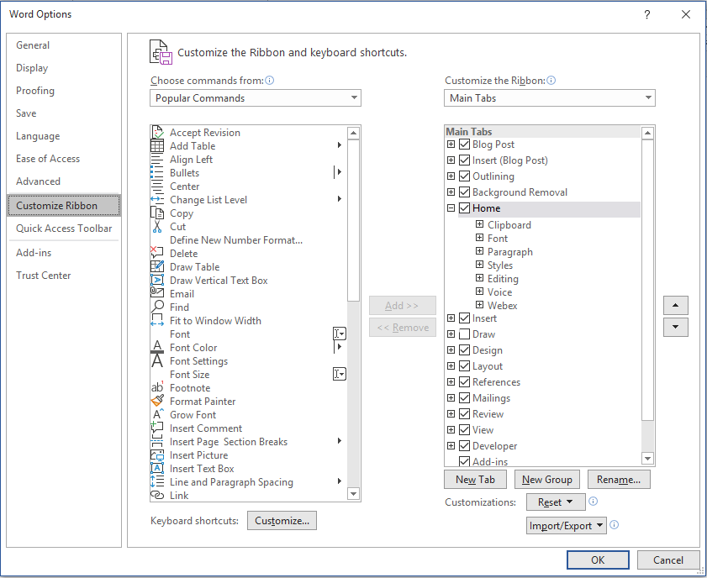
To make any edits to the form you need to enable the ‘Developer’ tab:
- In word, go to ‘File’ in the top left corner.
- In the blue sidebar click ‘Options’ at the bottom left.
- Then click ‘Customize Ribbon’ (see red circle)
- Using the list on the right side, tick the box that says ‘Developer’ (see blue rectangular)
- At the bottom, click ‘OK’ (see green circle)

Enabling this tab allows you to edit, add or remove interactive (form style) boxes.

Next, you have to give yourself editing access to change the document.

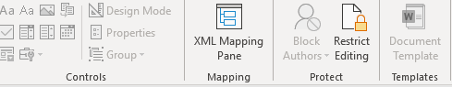

- Click the ‘Developer’ tab at the top of the page.
- Click the ‘Restrict Editing’ (see image to right) button to gain full access.
- In the sidebar that appears to the right of page click ‘Stop Protecting’ at the bottom.

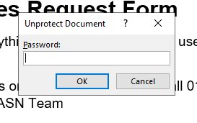
- In the box that appears type the password, which is glowrequest and click ‘OK’
- You should now have access to edit any section of the form, including those within the ‘Developer’ tab.

Most sections of the page can be edited like a normal word document.
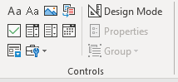
If you would like to edit any of the form fields, use the ‘Developer’
In order, the ones used for the form are: Plain Text Content Control, Check Box Content Control, Drop Down List Content Control
Clicking any of these will add a new field of the selected type to the form.
To edit an existing field, click to select it and then use ‘Properties’ to edit. Your options are shown below…
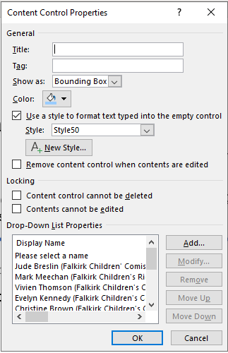
It’s best to leave the Title and Tag blank.
Show as: Bounding Box is also the best option to choose.
‘Color’ selects which colour the box around the field will be.
Under ‘New Style’ you can change the colour, style and size of any text that is typed by the requester.
In this example, a Drop Down is used, using the ‘List Properties’ you can add, modify, remove or reorder the options within the drop down menu.
Make any changes and click ‘OK’.

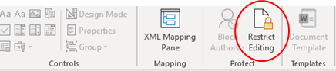
You should save the document as having form access only. To do this…
- Make your changes, then click the ‘Restrict Editing’ button
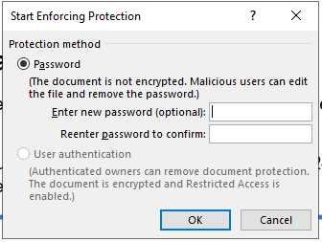
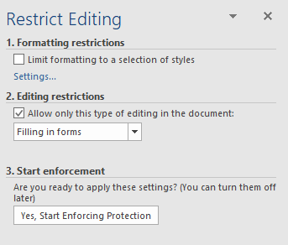
- In the sidebar on the right, make sure the options shown in the image below on the left are selected.
- Then click ‘Yes, Start Enforcing Protection’. Enter the password glowrequest in the fields highlighted in the above right image and click ‘OK’.
- Once you’ve saved, using ‘Save As’, the form is finished and provides form access only to any requesters.

Recovering Deleted Posts, Pages & Information
If a post or page has been deleted accidentally:
- Click ‘Posts’ or ‘Pages’ in the sidebar on the Dashboard (whichever is relevant)
- Click the tab titled ‘Trash’ along the top of the page (see below)
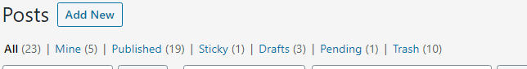
- Find the item that has been deleted accidentally, hover over it, and click ‘Restore’ (shown below)
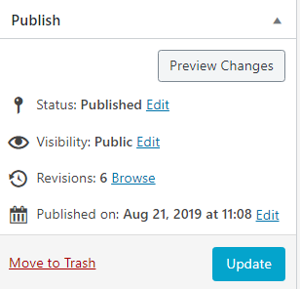
- The page will be recovered, and should be in the ‘Published’ tab, if not check the ‘Drafts’ tab.
If information from a post or page has been deleted accidentally:
- Click ‘Posts’ or ‘Pages’ in the sidebar on the Dashboard (whichever is relevant)
- Find the post or page that has had information deleted in the list, then click the title to edit.
- In the ‘Publish’ box click ‘Browse’ next to Revisions (shown to the right)
- The page shown below will open
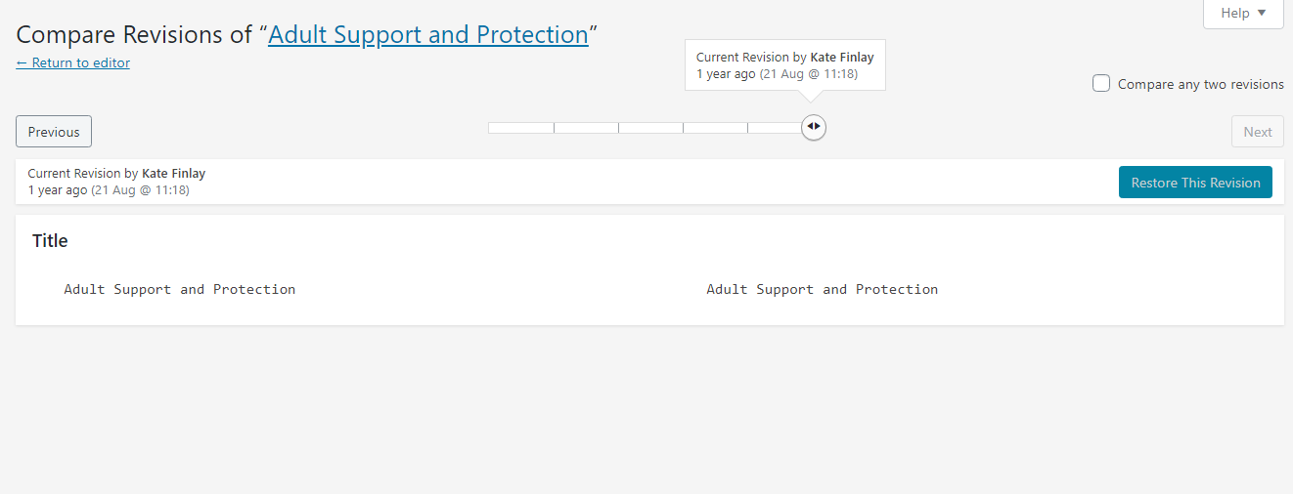

- Use the slider (see green rectangle) to see previous revisions of the page, using this slider you can select the recent version that has the correct information still on there.
- Find this and then click ‘Restore this Revision’ (shown below), as you can see the revision I have restored in this example is from 1 year ago.
- The page will return to the editor, if you didn’t make changes you can use the ‘Return to editor’ button (see green circle above).
- Use preview to check the information has been recovered and if happy, save as draft or publish as normal.

Displaying Recent Posts on the Home Page
Now, on the Practitioner Pages Home Page we are using a Plugin called ‘Display Posts’ to enable us to easily display a changing list of our most recent posts, this is shown below.
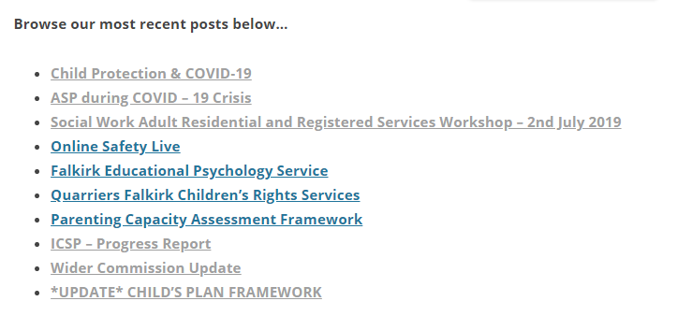
Any new posts published are automatically added, meaning that editors do not have to add these.
The code, which can be found in the ‘Text’ tab of the Home Page, looks like this.
[display-posts]
- Using this code you can replace this section if it gets deleted, paste an identical section on another page if needed.
- If you are pasting it elsewhere it is useful to include a line of text above to explain that the links listed are the most recent posts, e.g ‘Browse our most recent posts below…’

