Guidance for Editors: Practitioner Pages – October 2020

1. Types of Users
2. Logging into GLOW
3. Receiving Requests
4. Processing Requests
5. Add to Page
6. New Page Request
7. Create a New Post
8. Removing/Updating Information
9. Updating the Menu
10. Inserting an email address
11. Adding Items to the A-Z Resources
12. Completing Requests
13. When is a Request Form invalid?
14. Extra Information on Posts
15. Extra Information on Pages
16. Getting Help with the Practitioner Pages
17. Adding ‘Glow Blogs Falkirk’ Tile
18. Glossary
- Types of Users

The guide is for editors of the Practitioner’s Pages. The content covers fulfilling requests, editing the pages and recording changes made.
Superusers
Some GLOW ‘superusers’ have been identified. These people with have a deeper knowledge of the GLOW site, its content and the way it operates. They will have knowledge of GLOW’s features, how best to use them and of ways to fix or tackle any unexpected glitches or problems with the website. They will be members of the Practitioner Pages Governance Group and will oversee any major changes which have been agreed with the Governance Group.
FALKIRK: Alison Durnan
STIRLING & CLACKS: TBC
Editors:
FALKIRK
Business Support FC Children’s Services: Adele Scott, Ailidh Martin, Alison Durnan, Colin Dennis, Joanne Weasenham, Wendy Morrison.
Child Protection Committee: Evelyn MacGregor, Stuart Morrison
STIRLING & CLACKS: TBC
STRATEGIC LEADS
Falkirk: Malcolm Wilson, FC Children’s Services

- Logging In to GLOW

2.1 LOGIN & PASSWORD
Log in to the GLOW Dashboard using your GLOW username and password
https://blogs.glowscotland.org.uk/fa/GirfecFalkirk/wp-admin/
If you need to reset your GLOW password please contact Laurie Lee Moodie or Gordon Robertson.
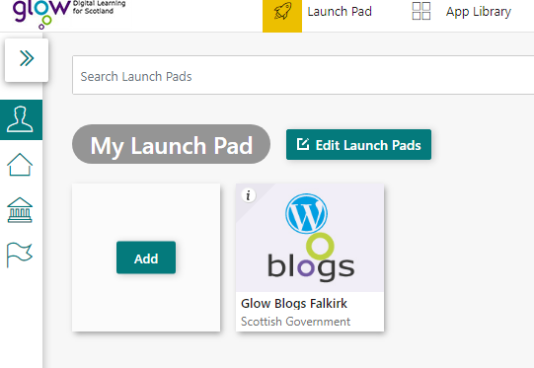
2.2 ACCESSING THE PRACTITIONER PAGES TO EDIT
You will be taken to your Launch Pad.
- Click the tile that says ‘Glow Blogs Falkirk’
      - This will take you to the ‘Glow Blogs Falkirk’ page

- From here click ‘My Sites’

- Here you should see ‘Practitioner Pages’, from here click ‘Dashboard’ to access the Practitioner Pages for editing.
If you cannot find the ‘Glow Blogs Falkirk’ tile, use the ’17. Adding Glow Blogs Falkirk Tile’ section of this guidance to add it.

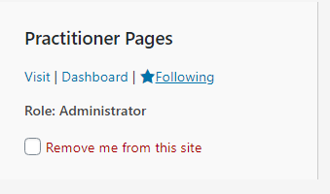
If on ‘My Sites’ you do not have Practitioner Pages listed please speak to the Super User for your area.

- Receiving Requests
The steps below involve checking mailboxes and forms that have been sent in to request changes:,
FALKIRK
3.1 OPEN THE PRACTITIONER PAGES MAILBOX
- General Query - If a general query which can be replied to easily, reply and save reply into Correspondence folder in the Practitioner Pages mail box. Delete the original.
- Forward Query - If query which you are unclear on how to respond, forward to Jude or the person who has approved the request on the form. Save forwarded message in the Queries awaiting response folder in the Practitioner Pages mail box, delete the original.
- Request for upload - If you receive a request and all information is ok, download the request form and save into folder (see step 5 below). Save original email into the ‘Being dealt with’ folder in the Practitioner Pages mail box.
3.2 CHECKING REQUESTS
Requests must be completed using the Request Form. All relevant information should be detailed including; which page/post, its location on the pages, document attached to email, text (if necessary) attached to email.

3.3 FORM INCOMPLETE
If the request form is not fully completed or unclear, contact the person making the request and save the email into the ‘Form Incomplete – return to sender’ Practitioner Pages mail box until details are clarified.
- This may include clarifying where on the page the item is to be published, what is the correct title, missing information, priority status, approval status.
- You may need to clarify with the lead officer if request not completed properly, if new page is being requested or if issues arise.
- Add any notes/tasks to Outlook Calendar e.g. reminder to chase-up or check for further information.
For more information about what makes a request invalid see section 13 of this guidance.

4. Processing Requests
4.1 PROCESSING REQUESTS
If the request form has been fully completed and no clarification is required, continue to processing the request, using this guide as a prompt.
- The sections ‘Add to Page’, ‘New Page Request’ and ‘Create a New Post’ will be useful.
- You can jump to these sections using Ctrl F and clicking ‘Headings’.

4.2 SAVING DOCUMENTS
Save document(s) to be uploaded into the relevant To be Published folder e.g. A-Z Resources and save into the appropriate format.
- All other formats (word, excel, PowerPoint etc) must be saved in PDF format.
- All images to be saved in the Pictures & Logos folder

4.3 MEETING PAPERS
- If it is a single document save it as YYYY.MM.DD Group Name Document Title e.g 2020.09.16 Commission Leadership Group Action Log
- Papers should all be saved as a PDF and then saved into a Zip file if more than one file. If word form (template.dot), these must be saved into Zip file as this type of format is not recognised on the system.
- Save name of Zip file as date and Meeting Papers e.g. 2020.09.16 Commission Leadership Group Meeting Papers.

4.4 TO CREATE A ZIP FOLDER
Open the folder where the documents have been saved, highlight all documents to be zipped. Right-click and choose Send to, then choose Compressed (zipped) folder. Rename the folder as necessary.
Request forms should be saved into the Request Forms folder and saved as date and name of person requesting and a summary of the topic e.g. 2020.09.16 Sue Johnson Request Form CPC Minutes
After saving the files you will normally have three options, Add to Page, New Page Request or Create a New Post. The request form will indicate which option to take.

Add to Page
- From the Dashboard of the Practitioner’s Pages GLOW Blog, click ‘Pages’ in the left hand column.
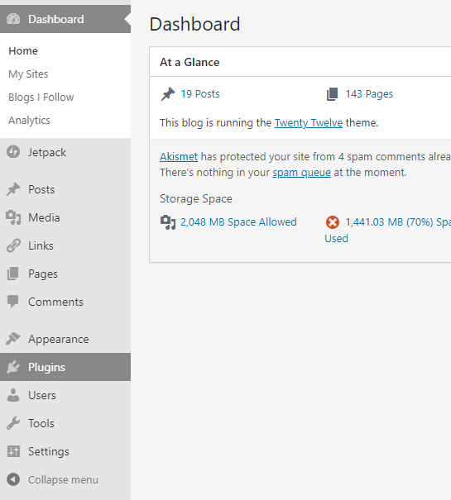
- Use the search bar on the right hand side to search for the page you are going to edit.
- Click the title of the page to begin editing.

- Make sure you have the toolbar toggled (see image below) to provide the full editing options(you can tap the icon shown below or use keyboard shortcut Shift Alt Z)
Toolbar Toggle Icon

5.1 ADDING TEXT
- The view you will see will have two tabs…
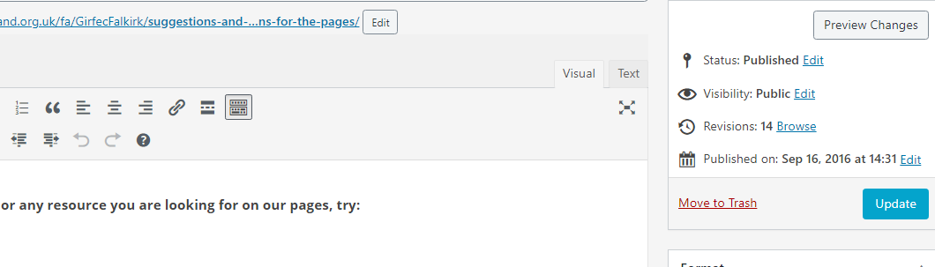
- The ‘Visual’ tab shows you the information on the page and how it looks. If there is text attached to the request form it should be added here.
- The ‘Text’ tab shows more detail like coding and hyperlinks. You only need to use this for copying over large chunks of text, or when adding items to the A-Z resources tables.

5.2 ADDING AN IMAGE, DOCUMENT OR VIDEO
When you’re editing the page as per the request form (see steps above) you can add any images or documents that have been sent over using the ‘Add Media’ button (see image below)

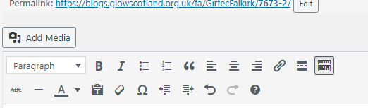
- By using the ‘Add Media’ button you can use a file that has previously been uploaded to the site, or upload a new file attached to the request.

USING AN EXISTING FILE
- To search existing files use the search bar (see green box) e.g. Child Protection Guidance
- Multiple results will appear, if what you want is there, click on it to select it (see blue box with tick)
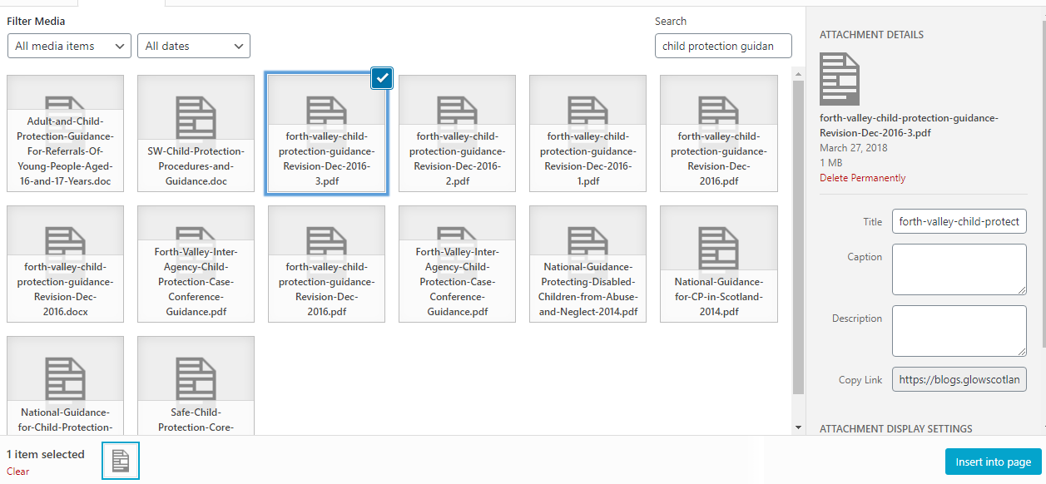

In the attachment box (see red box above), look at the title and see if it needs to be changed to something simpler. The example above would be changed to ‘Forth Valley Child Protection Guidance (Dec 2016)’ - this is how it will appear in the visual tab and to users on the page.
Once the title has been changed, click the blue ‘Insert into page’ button (see above in red box) the media box will close and take you back to the page, in the ‘Visual’ tab with the document inserted.
Once inserted you can change where the link sits on the page using ‘Tab’ ‘Space’ ‘Return’ etc.

5.3 TO UPLOAD FILES NOT ALREADY IN MEDIA
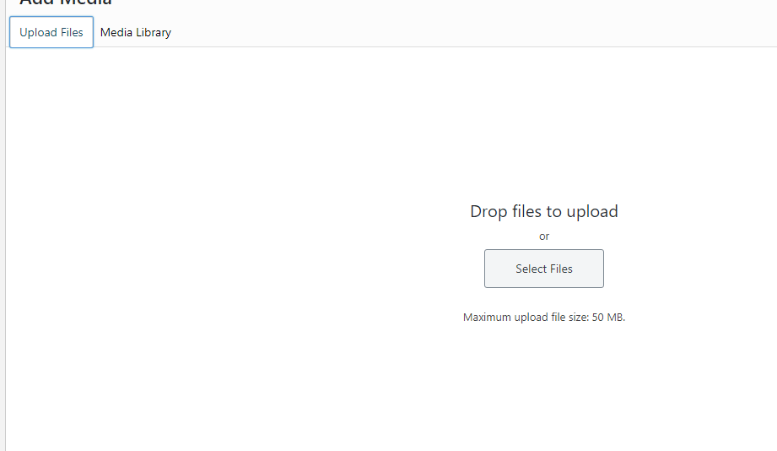
- Click ‘Upload Files’ (see red box above)
- Then click ‘Select Files’ (see green box above)
- A ‘Browse Files’ window will pop up, go into the Practitioner’s Pages files and find the file you want uploaded.
- Once uploaded it will appear in the list of media (see blue box with tick below)
- Follow steps as above to insert into the page.
5.4 ADDING A DIAGRAM OR POSTER
If the image you are uploading has text on it that users should be able to read, they will need to be able to enlarge the image.
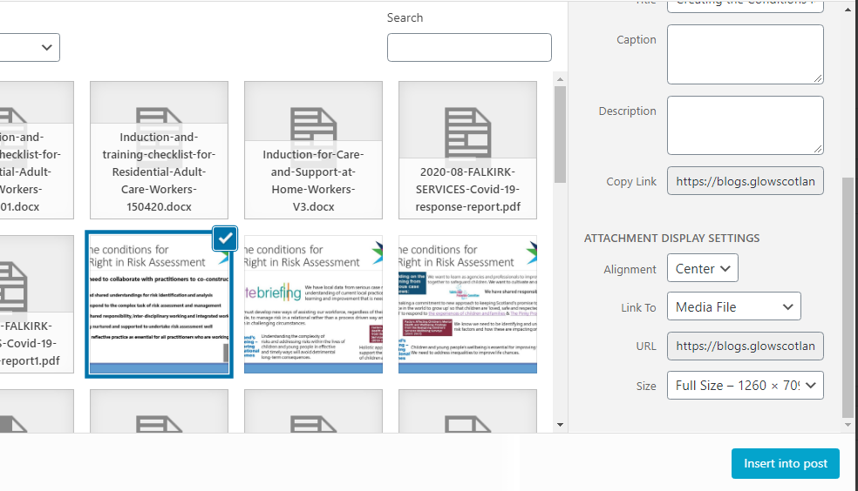
- When the image is selected, go to the ‘Attachment Display Settings’ section on the right (see red box)
- In the ‘Link To’ section select ‘Media File’ from the drop down (see green circle).
- Use the blue ‘Insert into post’ button to add the image to the post or page.
- It is a good idea to include a line of text letting people know that they can click to enlarge the image e.g ‘ Click to enlarge the Risk Assessment diagram below’

5.5 ADDING HYPERLINKS TO EXTERNAL WEBSITES
To use the ‘Insert/edit link’ button …
- From the request form copy the URL link included by the requester.
- In the ‘Visual’ tab of the page type the name of the hyperlink you want to see on the page.
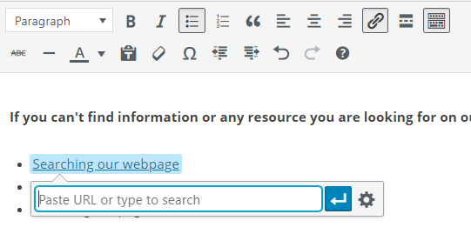
- Highlight this text then click the ‘Insert/edit link’ icon (see red circle below)

- In the box that appears below your text (see red box above) paste the link you have copied over.
- Once pasted click the settings button to the right of the URL.
- Then tick ‘Open link in a new tab’ (this should be done for all links/documents that are added)

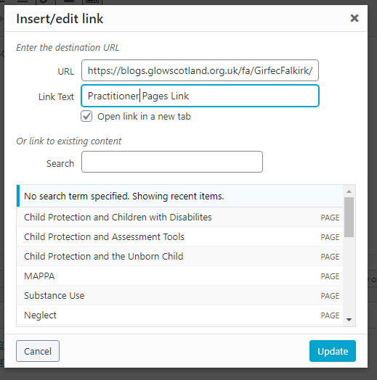
- Click the blue ‘Update’ button, the window will close and the link will be inserted.

5.6 PUBLISHING YOUR PAGE
Once you’ve made all the changes that the requester has asked for, you’re ready to publish your page. This is when the page can be seen by the public.
Go to the right hand side of the page being edited. You will see the menu below…
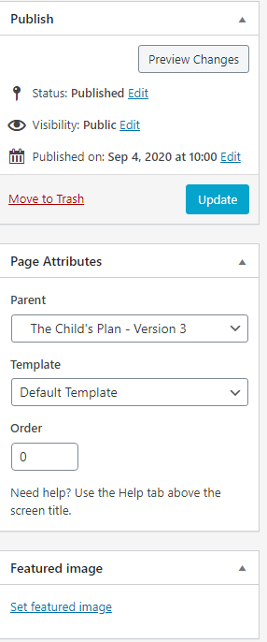
- In the Publish box click the blue ‘Update’ button.

New Page Request

- From the Dashboard of the Practitioner’s Pages GLOW Blog, click ‘Pages’ in the left hand column.
- Then click ‘Add New’ beside ‘Pages’ on the top left hand side.
- Add the Title of the page in the title box, then start to add your content.
- Make sure you have the toolbar toggled to provide the full editing options (you can tap the icon shown below or use keyboard shortcut Shift + Alt + Z)
(Editing makes the pages more interesting, aim to avoid large blocks of unformatted text.)
Toolbox Toggle Icon

6.1 ADDING TEXT
- The view you will see will have a few tabs…
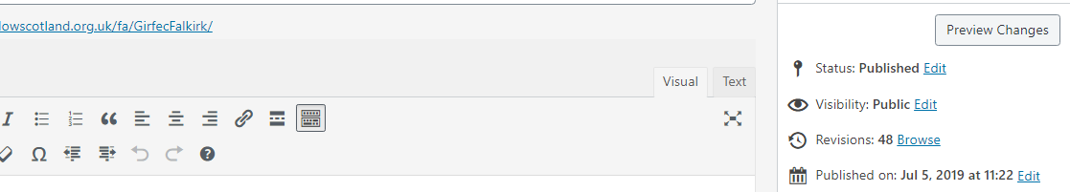
- The ‘Visual’ tab shows you the information on the page
The ‘Text’ tab will show the elements of the post, e.g. if an image is embedded it will show the dimensions, if a link is embedded as text it will show the html, it will also show line breaks using text.
‘Preview Changes’ will show you what the page will look like exactly, without publishing.
- Type any text information into the ‘Visual’ tab, although if you are copying over large sections please use the ‘Text’ tab.
6.2 ADDING AN IMAGE, DOCUMENT OR VIDEO
When you’re editing the page as per the request form (see steps above) you can add any images or documents that have been sent over using the ‘Add Media’ button (see image below)

- By using the ‘Add Media’ button you can use a file that has previously been uploaded to the site, or upload a new file attached to the request.
USING AN EXISTING FILE
- To search existing files use the search bar (see green box) e.g. Child Protection Guidance
- Multiple results will appear, if what you want is there, click on it to select it (see blue box with tick)

In the attachment box (see red box above), look at the title and see if it needs to be changed to something simpler. The example above would be changed to ‘Forth Valley Child Protection Guidance (Dec 2016)’ - this is how it will appear in the visual tab and to users on the page.
Once the title has been changed, click the blue ‘Insert into page’ button (see above in red box) the media box will close and take you back to the page, in the ‘Visual’ tab with the document inserted.
Once inserted you can change where the link sits on the page using ‘Tab’ ‘Space’ ‘Return’ etc.

6.3 TO UPLOAD FILES NOT ALREADY IN MEDIA
- Click ‘Upload Files’ (see red box above)
- Then click ‘Select Files’ (see green box above)
- A ‘Browse Files’ window will pop up, go into the Practitioner’s Pages files and find the file you want uploaded.
- Once uploaded it will appear in the list of media (see blue box with tick below)
- Follow the steps in ‘6.2 Adding an Image, Document or Video’ to insert into the page.

6.4 ADDING A DIAGRAM OR POSTER
If the image you are uploading has text on it that users should be able to read, they will need to be able to enlarge the image.
- When the image is selected, go to the ‘Attachment Display Settings’ section on the right (see red box)
- In the ‘Link To’ section select ‘Media File’ from the drop down (see green circle).
- Use the blue ‘Insert into post’ button to add the image to the post or page.
- It is a good idea to include a line of text letting people know that they can click to enlarge the image e.g ‘ Click to enlarge the Risk Assessment diagram below’
6.5 ADDING HYPERLINKS TO EXTERNAL WEBSITES
To use the ‘Insert/edit link’ button …
- From the request form copy the URL link included by the requester.
- In the ‘Visual’ tab of the page type the name of the hyperlink you want to see on the page.
- Highlight this text then click the ‘Insert/edit link’ icon (see red circle below)

- In the box that appears below your text (see red box above) paste the link you have copied over.
- Once pasted click the settings button to the right of the URL.
- Then tick ‘Open link in a new tab’ (this should be done for all links/documents that are added)

- Click the blue ‘Update’ button, the window will close and the link will be inserted.

6.6 PUBLISHING YOUR PAGE
This is what the options look like on the right hand side of a new page…
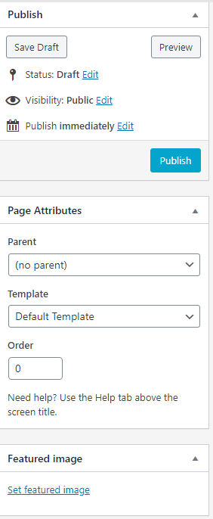
- In the Page Attributes box you should select the parent page that matches the page asked for by the requester. By clicking the drop down you can see which topic the page sits under.
- In the Publish box click the blue ‘Publish’ button.
- Once the new page is published you will need to add it to the site’s Menu – see the ‘Updating the Menu’ section of this guidance for more information.

Create a New Post
- From the Dashboard of the Practitioner’s Pages GLOW site click ‘Posts’ in the left hand column
- Then click ‘Add New’ beside ‘Posts’ on the top left hand side.
- Add the Title of the post in the title box, then start to add your content.
- Make sure you have the toolbar toggled to provide the full editing options (you can tap the icon shown below or use keyboard shortcut Shift + Alt + Z)
(Editing makes the pages more interesting, aim to avoid large blocks of unformatted text.)
Toolbox Toggle Icon

7.1 ADDING TEXT
- The view you will see will have a few tabs…
- The ‘Visual’ tab shows you the information on the page
The ‘Text’ tab will show the elements of the post, e.g. if an image is embedded it will show the dimensions, if a link is embedded as text it will show the html, it will also show line breaks using text.
‘Preview Changes’ will show you what the page will look like exactly, without publishing.
- Type any text information into the ‘Visual’ tab, although if you are copying over large sections please use the ‘Text’ tab.
7.2 ADDING AN IMAGE, DOCUMENT OR VIDEO
When you’re editing the page as per the request form (see steps above) you can add any images or documents that have been sent over using the ‘Add Media’ button (see image below)

- By using the ‘Add Media’ button you can use a file that has previously been uploaded to the site, or upload a new file attached to the request.
USING AN EXISTING FILE
- To search existing files use the search bar (see green box) e.g. Child Protection Guidance
- Multiple results will appear, if what you want is there, click on it to select it (see blue box with tick)

In the attachment box (see red box above), look at the title and see if it needs to be changed to something simpler. The example above would be changed to ‘Forth Valley Child Protection Guidance (Dec 2016)’ - this is how it will appear in the visual tab and to users on the page.
Once the title has been changed, click the blue ‘Insert into page’ button (see above in red box) the media box will close and take you back to the page, in the ‘Visual’ tab with the document inserted.
Once inserted you can change where the link sits on the page using ‘Tab’ ‘Space’ ‘Return’ etc.

7.3 TO UPLOAD FILES NOT ALREADY IN MEDIA
- Click ‘Upload Files’ (see red box above)
- Then click ‘Select Files’ (see green box above)
- A ‘Browse Files’ window will pop up, go into the Practitioner’s Pages files and find the file you want uploaded.
- Once uploaded it will appear in the list of media (see blue box with tick below)
- Follow the steps in ‘6.2 Adding an Image, Document or Video’ to insert into the page.

7.4 ADDING A DIAGRAM OR POSTER
If the image you are uploading has text on it that users should be able to read, they will need to be able to enlarge the image.
- When the image is selected, go to the ‘Attachment Display Settings’ section on the right (see red box)
- In the ‘Link To’ section select ‘Media File’ from the drop down (see green circle).
- Use the blue ‘Insert into post’ button to add the image to the post or page.
- It is a good idea to include a line of text letting people know that they can click to enlarge the image e.g ‘ Click to enlarge the Risk Assessment diagram below’
7.5 ADDING HYPERLINKS TO EXTERNAL WEBSITES
To use the ‘Insert/edit link’ button …
- From the request form copy the URL link included by the requester.
- In the ‘Visual’ tab of the page type the name of the hyperlink you want to see on the page.
- Highlight this text then click the ‘Insert/edit link’ icon (see red circle below)

- In the box that appears below your text (see red box above) paste the link you have copied over.
- Once pasted click the settings button to the right of the URL.
- Then tick ‘Open link in a new tab’ (this should be done for all links/documents that are added)

- Click the blue ‘Update’ button, the window will close and the link will be inserted.

7.6 PUBLISHING YOUR POST
This is what the options will look like on the right hand side of a new post…
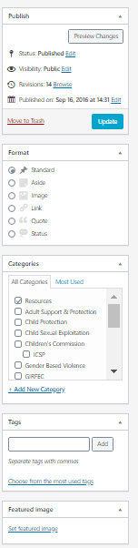

- In the Format box choose Standard (see blue box below right).
- In the Categories box tick the categories that the post comes under that have been included in the request form (see orange box below right).

- In the Publish box you can publish immediately or schedule the post to appear at a later date, or move the post to trash.
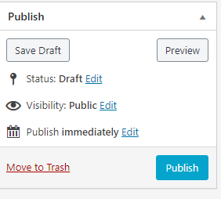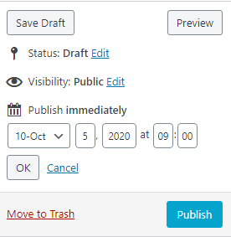
SCHEDULING POSTS
- If scheduling a post click ‘Edit’ beside the ‘Publish’ option (see red circle above).
- Then select the date and time of publishing using the date and time options (see green circle above).
- Then click ‘OK’ under the date and time options.
- Then click the blue ‘Schedule’ button.
PUBLISHING IMMEDIATELY
- When ready to publish click the blue ‘Publish’ button.
MOVING A POST TO TRASH
- To move a post to trash click the red ‘Move to trash’ writing (see purple box in top right) in the ‘Publish’ box.
- You can recover posts that have been moved to trash if you need to.

Removing/Updating Information

8.1 REMOVING AN ENTIRE PAGE/POST
- From the Dashboard of the Practitioner’s Pages GLOW site click ‘Posts’ or ‘Pages’ in the left hand column
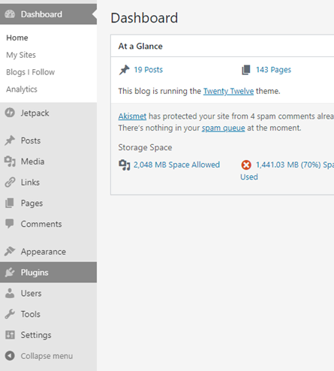
- On the right side of the page, use the search bar (see image below) to search for the page or post that is going to be deleted.

- Once you have found the page, hover over the title and click the red ‘Trash’ button (see image above).
- This will move the page or post to the ‘Trash’ tab, which can be accessed at the top of the page.
- You can check if the page has been deleted by looking in the ‘Trash’ tab at the top of the page.
- Please do not permanently delete any page from the ‘Trash’ unless you have been asked to by the Super User.
- If you have deleted a page, please remove it from the site’s menu, information on how to do this can be found in the ‘9. Updating the Menu’ section of this guidance.

8.2 DELETING SPECIFIC INFORMATION FROM A POST/PAGE
- From the Dashboard of the Practitioner’s Pages GLOW site click ‘Posts’ or ‘Pages’ in the left hand column
- On the right side of the page, use the search bar to search for the page or post that has the information that is being removed (see image below).

- Click the title of the page/post to open it.
- Delete text or links as you would normally.
- To delete an image or video click it and use the cross that appears (see image on right)
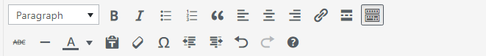
- Use the ‘Preview’ tab to check that the correct information has been deleted, if you have deleted the wrong thing you can use the ‘Undo’ button in the toolbar (see below).

- If you have only been asked to remove information, once the correct information has been deleted you can update the page by clicking the blue ‘Update’ box on the right hand side.
- If you have been asked to replace or update this information, see the processes in the ‘5. Add to Page’ section of this document to add the new content.
If you accidentally delete the wrong page, post or information please speak to your Super User.

Updating the Menu (Drop Down Menus)
In GLOW, the drop downs underneath the headings on the main page that help users navigate the pages are called the ‘Menu’.
The drop down menus on the pages can be changed or re-ordered. The menu needs to be updated manually every time a new page is added, a page is deleted, or the name of a page is changed.
If someone contacts the mailbox about not being able to see a page on the drop down menu, you can also use these steps to check this.
Please keep in mind that the menu should be alphabetized.
9.1 TO BEGIN EDITING THE MENU
To edit the Menu click Appearance in the sidebar and then ‘Menus’ (see image below)
Once on the page to edit the menu, in the ‘Select a menu to edit’ drop down make sure you select ‘New Menu (Primary Menu)’ (see image below)
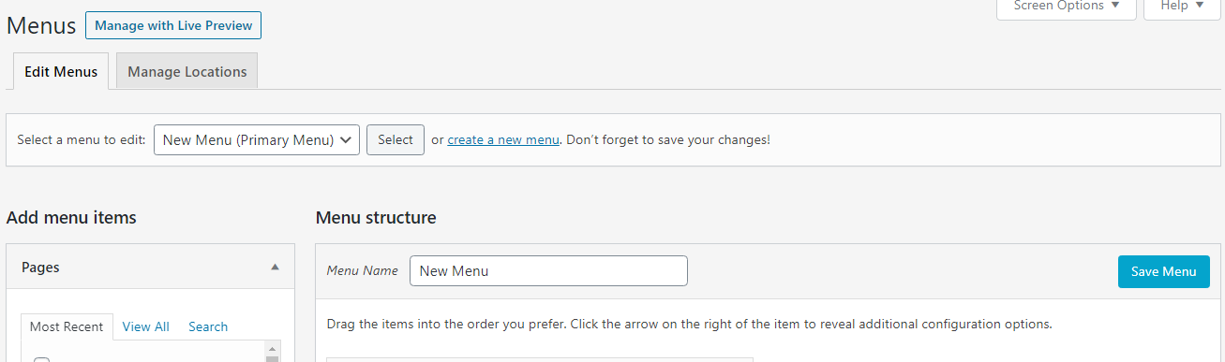
9.2 ADDING A NEW PAGE TO THE MENU
If you have just published a new page you need to add it to the menu, use the ‘Add menu items’ box on the left side of the page to do this. To add a new page to the menu, the page must be published and not in ‘Drafts’.
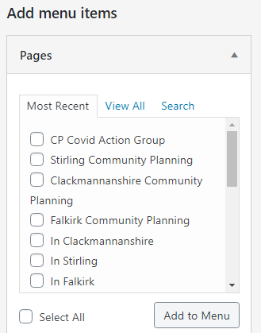
- The page you have just published should be visible
in the ‘Most Recent’ tab, however if you can’t find it you can use the ‘Search’ tab.
- Tick the box next to the page you wish to add.
- Then click ‘Add to Menu’
- The page will be added to the bottom of the menu.
Re-ordering the menu works like a drag and drop (see image below).
Find the new page at the bottom of the menu, and click and drag it to where it should sit (under a specific Parent Page)
Keep in mind that most of the menu should be in alphabetical order (unless asked otherwise – e.g Children’s Commission is in order of group hierarchy.
There are two ways to place a page ‘under’ a Parent page.
1. Indent it slightly by dragging slightly to the right (in the order you would want to see it in the drop down) remembering to keep them in alphabetical order (example shown below).
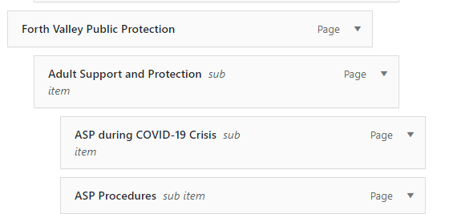
Here, ‘Forth Valley Public Protection’ is the parent page for ‘Adult Support and Protection’ , and ‘Adult Support and Protection’ is the parent page for ‘ASP during COVID-19 Crisis’
This is the option you will normally use. If this doesn’t work or you accidentally drag it into the wrong place, see number 2 below.
2. Clicking on the small arrow beside a page name (see image above) will open this menu.
Use this when dragging doesn’t work, or if a page is stuck in the wrong position.
Usually after using this fix the dragging should start to work again.
You can use ‘Under’ or ‘Out from Under’ to control a page’s position.
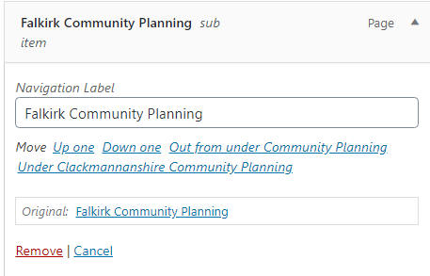
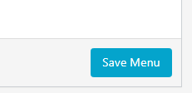
- ‘Under’ indents the page right, i.e. moves it under the new parent page/page above
- ‘Out from under’ indents the page left, i.e. moving it to the same level as the parent page/page above.
Once the page is in the correct place, scroll down to the bottom of the page and click ‘Save Menu’ (see image on right)

9.3 REMOVING A DELETED PAGE FROM THE MENU
If you have recently deleted a page you will have to remove it from the menu.
- Scroll through the menu to find the deleted page - once deleted, it usually turns red (shown below)
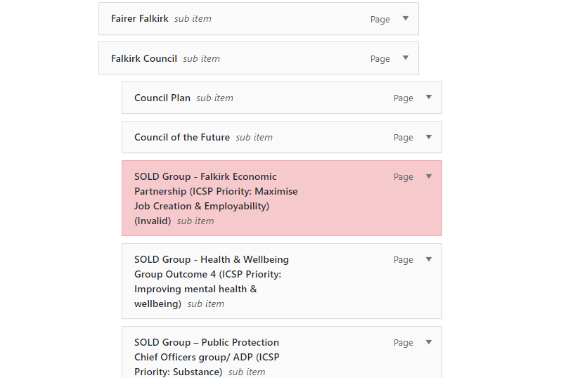

- Once you have found the page, click the arrow shown below

- Once the arrow is clicked the following options will appear
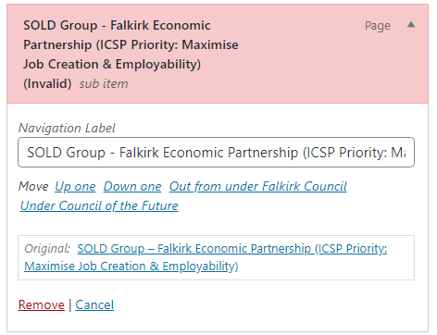
- To remove the page from the menu click the ‘Remove’ button (see red circle above).
- Once the page has been removed, scroll to the bottom of the page and click ‘Save Menu’ (see image on the right).
9.4 CHANGING NAMES OF PAGES ON THE MENU
If someone has asked you to edit the name of a page, you should do this by editing the page itself and then update it on the Menu.
- Find the page that’s name has changed on the menu.
- Once you have found the page, click the arrow shown below
- Once the arrow is clicked the following options will appear
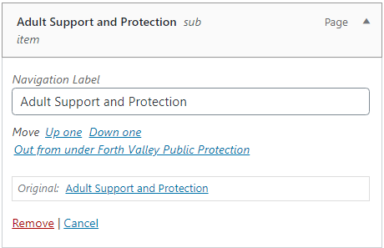
- Edit the ‘Navigation Label’ to match the new name of the page.
- Once the name has been changed scroll to the bottom of the page and click ‘Save Menu’ (see image on the right).

- Inserting an email address
When featuring an email address on the pages include a link to open a new email to that address.
To do this type your text, highlight, select the link button and in the URL box write
mailto:name@falkirk.gov.uk (this is a Falkirk Council example)
Tick Open link in new window under the settings button

- Adding Items to the A-Z Resources
An A-Z Resources page shows a table with topic, link and contact name columns in alphabetical order. When adding a link to an A-Z Resources page you must follow the steps carefully as you need to add a new line in the table using the ‘Text’ formatting.
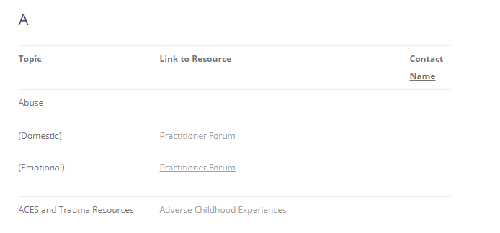
Example – a document regarding domestic abuse is to be published under the topic Abuse. This would be added to resources page ‘A’ under topic Abuse and add link in list in alphabetical order.
- Click ‘Pages’
- Search for the relevant letter page by typing the letter into the search box, when you see it click the title to begin editing.
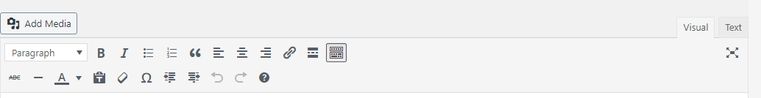
- Click ‘Text’ tab beside the ‘Visual’ tab (this is what you should use when entering information in the A-Z Resources table format)
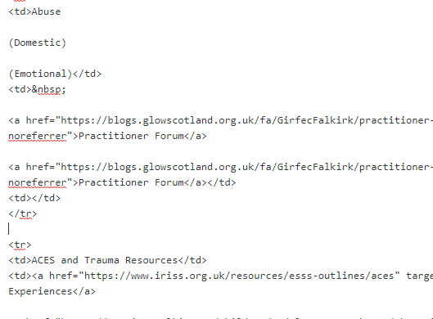
- Go the point in the text where you wish to add a new row - e.g. between Abuse and ACES information (see red circles above)
- Click to create a new line space after </tr> of the previous entry, and before the <tr> of the following entry (see blue boxes above).
- Add the new row in the table by pasting the following text into the space:
<tr>
<td></td>
<td></td>
<td></td>
</tr>
- Click on the ‘Visual’ tab to see if the new row has been inserted correctly, it should look like the image below
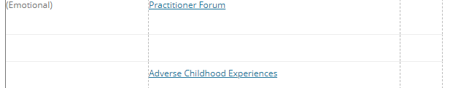

- If the new row is to be added at the end of the table, delete this code from the end:
<td></td>
</tr>
</tbody>
</table>
And replace with this code below:-
<td></td>
</tr>
<tr>
<td></td>
<td></td>
<td></td>
</tr>
</tbody>
</table>
- If you’d prefer you can also copy and paste an existing row of the table to duplicate it
- When the new, blank row is created then you can change the information and links on the ‘Visual’ tab.
- You may have to switch tabs several times when entering text into a table to ensure that the layout is correct.
- In the ‘Visual’ tab type the topic name in the first box and then enter the link name into the ‘Resource’ box of the table, then create the hyperlink the same way you would for a page or a post (help with this is in the ‘Add to Page’ section)
- Before updating try previewing the page to check if it looks correct.
- Then click the blue ‘Update’ button
- Completing Requests
12.1 Respond to Request
Once published, email the person who made the request to let them know it’s been updated. Include a hyperlink to the updated page/post. Delete the original email from the Being dealt with folder. Save the response in the Task completed folder. Then, add any tasks/notes/reminders to Outlook Calendar.
12.2 Filling In Requests Form ‘For Office Use’
On the request form, record details on the ‘For Office Use’ section:-
- Date published – add the date the item was published on the page/post.
- Date to be updated – add the date when the item to be checked/updated/removed.
- Completed by – add the name of the person who completed the task.
- Notes – add any notes regarding the item e.g. any issues, changes, correspondence.
12.3 Filing
When a request has been fully completed, move all documents into the relevant Published folder e.g. A-Z Resources.
12.4 Outlook Calendar
Open Outlook Calendar and tick Practitioner Pages box from the list.
- View the calendar for the period you are covering (e.g. one week)
- Add any tasks to be included (reminders, tasks, notes) for other staff on the rota if details are in the future.
- Complete any tasks that have been added (remove items, update details etc).

When is a Request Form invalid?
If a request form is invalid or does not have enough information it should be sent back to the requester with an explanation of why it could not be fulfilled.
Some things that would make a request invalid…
- Not enough information – if key parts of the form have been left blank.
- Not saying where the page should sit – if the requester has not highlighted a parent page or a topic that the page sits under.
- If the requested information is already on the pages, and the request has not asked for their removal in order to be updated.
- If any links or documents attached to the request don’t work or can’t be accessed.
- If the request is asking an editor to make changes to a file that has been uploaded to the pages – only upload documents, images etc. that are complete, requesters should not be asking you to make changes on files (they need to contact the document owner to make those changes)

Extra Information on Posts
Posts are ideally for more time sensitive information as they are less permanent, they are not usually included in navigation menus on the pages.
The different types of posts are –
Published
Sticky (will remain near the top of any posts list, for information that is important and should be continuously displayed for a period of time – if it’s permanent a page is best)
Draft
Pending (posts that are pending review, they can be drafts or published)
Trash (posts that have been removed, from here you can restore or delete permanently)
Scheduled (posts that are not published immediately but have a date and time indicating when they will automatically publish)

Extra Information on Pages
Compared to posts, pages are more permanent and hold information that doesn’t change as often. They will always be accessible on the pages through the navigation menu, or will sometimes be linked to from another page (signposted).
Page Hierarchy
If a page sits under another page it has a Parent Page, when you open the drop down menu after clicking ‘Parent Page’ you will see the current way the pages are categorised.
- If you are changing the title of a page or its location in a hierarchy, you may have to then go into ‘Menus’ under ‘Appearance’, find the page in the navigation menu and check that it has updated there. This will ensure that the change is made on the navigation menu of the site.

Getting Help with the Practitioner Pages

FALKIRK
If you are having any issues, please contact the Super User for your area, if your Super User is not available please contact Malcolm Wilson.

Adding ‘Glow Blogs Falkirk’ Tile

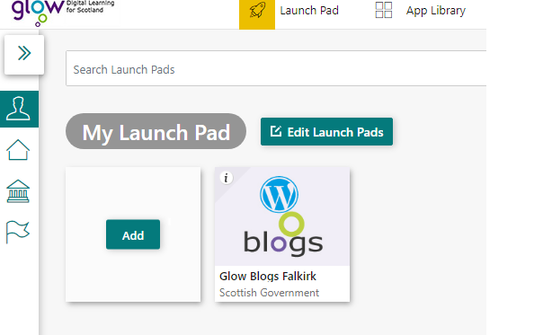
- Click the ‘My Launchpad’ icon at the left (see red circle)
- Click on ‘Add’ blue button (see green circle)
- Click on ‘App from library’ blue button

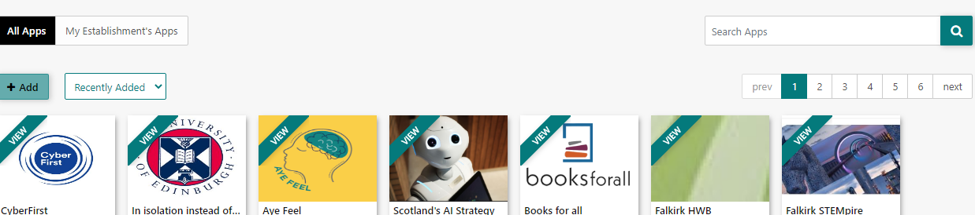
- Using the search bar (see above), search for the ‘Glow Blogs Falkirk’ tile
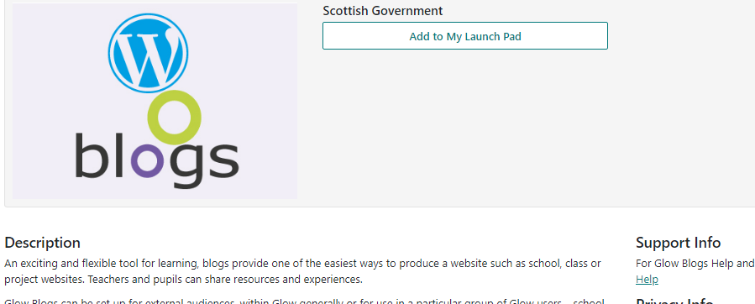
- When you have found it click the tile, then ‘Add to My Launch Pad’ (see below)

- Return to the Launchpad by clicking on the Launch Pad icon at the top of the page (see below)
- The tile should be added, to access the Practitioner Pages follow the steps in section 2 ‘Logging In to GLOW’

- Glossary

Categories – Posts can be put under categories which aids navigation by making searches on the site more effective, it also means that if viewers click the category they can see only posts within it.
CSS – (Cascading Style Sheets) are sections of code that determine how the page looks, it is not usually necessary to add any of these if the theme in use is well made. However, if there is an issue with the way the site looks sometimes seeking help through CSS is quicker than an entire theme change. They can be added, removed or edited through the ‘Custom CSS’ tab.
Dashboard – When logged into GLOW and customizing the blog, this is the main page you will see, from here you can access all of the ways to edit the blog/site.
Draft – Pages and Posts can be drafts. They are not yet published/visible to the public but you are still able to edit their content and preview how they will look on the blog.
Featured Image – This is used if there is an image that fits well with the content of a page or post. It will appear in a search above the page title, and in some themes also when the page itself is opened. It is worth checking how effective feature images look on the theme in use.
Jetpack – Is a plugin created by WordPress to offer more features to self-hosted sites, such as GLOW blogs.
Links – On GLOW sites you can include links to external websites, media uploaded to the site, or to other pages on the site.
Media – GLOW allows you to upload media to the media library attached to that site. From here it can be accessed by anyone who edits the site and it can be easily added to the pages without each individual uploading their own version of that item.
Menu – A menu is a section of the site where users can go to see the pages on the site and to navigate through them. The order usually reflects the page hierarchy although it can be edited. On most themes the menu is somewhere prominent throughout all pages on the website (e.g. the header or sidebar)
Page – A static page on a blog/site. A page can be about any topic. The information on It doesn’t change that regularly, it can be found in the same place on the site every time it is visited. For the Practitioner’s Pages this is better for information that will be relevant for a longer time.
Parent Page – This helps to arrange pages in a hierarchy, If a page has no parent then it is a top level page. If the contents of a page sits under the topic of a top level page you can assign this as the parent page. This will mean the new page is a sub-page. Sub-pages can also be parent pages to other pages.
Post – A post is an article within a blog. A post can be on any topic, and it’s the collection of posts and pages that form the basis of a blog. For the Practitioner’s Pages posts are better for time sensitive information as they aren’t usually added to the navigation menu.
Pending – This means that a post or page is pending review, this label can be applied both to published pages and drafts.
Preview – Whilst editing a post, page, or the appearance of the site you can click the preview button to see what it will look like to visitors without publishing it. It is useful to do this as you go and before you publish, especially if there are links or images on the page/post.
Scheduled – You can choose when to publish a post or page rather than publishing immediately. Once you have selected a date and time for the page to publish it will appear in ‘Scheduled’.
Sidebar - One or more columns generally found on the side of most blogs/sites, they are the same regardless of which section of the site you are on. They usually contain helpful information or features (Widgets) to aid navigation such as a search bar or a list of recent posts.
Signpost – If you want to direct users to an external site, or another page on the site you can add a short bit of text about why they may find it useful and include a link, signposting them to that page.
Slug – The slug is how the page/post/category will appear in HTML form if you were to send it as a link, or what will be in the top bar of someone’s browser when they are on the page. It is good to keep slugs as faithful to the page title as possible to avoid confusion.
Sticky – A post can be sticky if it is very important and you would like a lot of people to see it. Making it sticky prioritises it in ‘recent posts’ lists, this overrides the usual chronological order and places the sticky post near the top.
Tags – Working similarly to categories, tags offer a way to group posts by topic. If a user clicks a tag they can see all posts with that tag. They tend to be more specific than categories.
Theme – These are premade ‘designs’ for a GLOW blog/site that then offer customization options within this theme. They are useful for quickly changing every aspect of the site and giving it a new look. Different features of GLOW do operate and look slightly differently within different themes so it’s good to explore before committing to a theme.
Trash – This is where a page or post goes when it has been deleted, from the ‘Trash’ section you can recover items or delete them permanently.
Widget - Areas of your site that are designed to stand out and usually found in the side bars of your site. They usually have a particular function such as searching. You can choose which widgets to display and whereabouts on the site to display them.
Some of these descriptions were written with the help of Glow Blog Help
If you come across any new terms on GLOW that aren’t covered here, they may be on this glossary…
Glow Blog Help Glossary

