Practitioner’s Pages Request Form
If you want to add or remove anything from the pages please use the form below and complete all the boxes.
If you have more than 3 requests or any questions, please call 01324 506600 and ask to speak to Customer & Business ASN Team

Requested by: Click or tap here to enter text.
Who approved this request?: Choose an item.
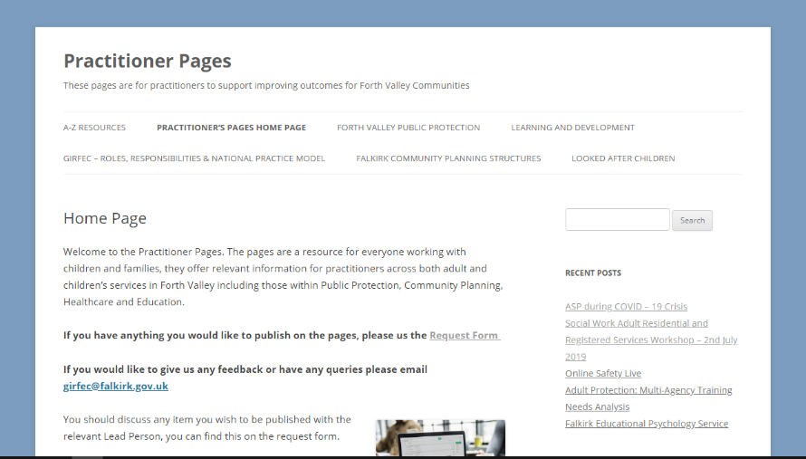
Information you would like uploaded: Choose item
Posts are better for time sensitive information. The most recent posts are displayed on the front page and in the sidebar of the site. They can be sorted using categories and tags.
Pages are displayed in the drop down tabs at the top of the site. They are useful for information that is not time sensitive, and should always be accessible on the pages.

Please select one of the options below. Would you like to - Add to Page, Create a New Page Request, Create a New Post or Remove/Update Content?

☐ Add to Page
Please select which topic the new information will sit under, and which page within this topic.
☐ A-Z Resources – which letter(s)? Click or tap here to enter text.
☐ Forth Valley Public Protection – which page(s)? Click or tap here to enter text.
☐ Learning & Development - which page(s)? Click or tap here to enter text.
☐ GIRFEC – which page? Click or tap here to enter text.
☐ Community Planning – which page(s)? Click or tap here to enter text.
☐ Corporate Parenting – which page(s)? Click or tap here to enter text.

☐ New Page Request
Please give a reason for this request, and indicate below which of the topics this new page should sit under
Reason: Click or tap here to enter text.
☐ Forth Valley Public Protection
☐ Learning & Development
☐ GIRFEC in Falkirk
☐ Falkirk Community Planning Structures
☐ Corporate Parenting
Indicate if it should sit under an existing page within this topic: Click or tap here to enter text.
What is the title of the new page? Click or tap here to enter text.

☐ Create a New Post
Please select which categories the post will come under; you can select multiple by selecting using the drop down menu and typing any additional categories in the ‘Other’ tab.
Categories: Choose an item. Other: Click or tap here to enter text.
What is the title of the new post? Click or tap here to enter text.

☐ Removing/Updating Information
- If you would like to delete a post, please type the title of the post below
Click or tap here to enter text.
- If you would like to remove information from a page or post, please type the title of the page/post the information is on below
Click or tap here to enter text.
What would you like to remove? Choose an item.
If you selected ‘Specific Information’ or ‘A Specific File or Link’ please email us with more information so we delete the right thing (practitionerpages@falkirk.gov.uk)
☐ Tick this box if there is an updated version of the information that you would like to replace the content being removed.
Please also attach this in an email with this form, making it clear which document is the replacement and what it is replacing.

Attaching Information
Please attach the information that you would like added/updated to the post or the page in an email alongside this form.
☐ Text Outline Attached in Email (including any links to external websites you would like to be linked)
☐ Images Attached in Email (recommended)
☐ Resource (Document, Leaflet, Poster) Attached in Email
Any Further Instructions:
Click or tap here to enter text.

Submitting Form
- Complete this form and save it.
- Attach it to an email. If you are sending documents, further information, images along with this request form please also attach these to the same email. Add any further message you wish to inform us about.
- Send the email to practitionerpages@falkirk.gov.uk.
- Your request has been sent.

For Office Use
Date Published: Click or tap to enter a date.
Date to be Updated: Click or tap to enter a date. Other: Click or tap here to enter text.
Completed By: Click or tap here to enter text.
Notes:
Click or tap here to enter text.

