**Corporate Parent Briefing [Issue 1]**

***The Children and Young People (Scotland) Act 2014:***

Corporate Parenting is:

An Organisation’s duty to uphold the rights and safeguard the wellbeing of Looked After children, young people up to the age of 21, and care leavers under the age of 26. To also promote their physical, emotional, spiritual, social and educational development.

***Section 58: 6 Substantive Duties***

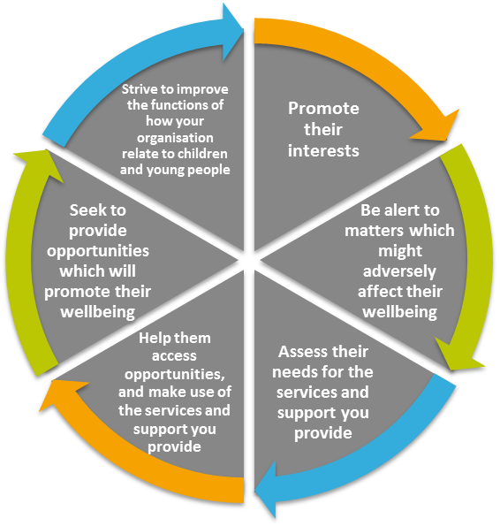

All corporate parents have a duty to prepare and publish a corporate parenting plan. When preparing this plan you must consult with each other, children and young people and any other appropriate person or organisation.

***We are all Corporate Parents…***

|  |  |
| --- | --- |
| **Scottish Ministers**  **A local authority**  **National Convener of Children’s Hearings Scotland**  **The Principal Reporter**  **The Scottish Children’s Reporter Administration**  **Children’s Hearings Scotland** | **A Health Board**  **A board constituted under section 2(1)(b) of the National Health Service (Scotland) Act 1978**  **Healthcare Improvement Scotland**  **The Scottish Qualifications Authority**  **Skills Development Scotland Co. Ltd (registered number SC 202659)** |
| **Social Care and Social Work Improvement Scotland**  **Scottish Social Services Council**  **Scottish Sports Council**  **Chief Constable of the Police Service of Scotland**  **The Scottish Police Authority**  **Children and Young People’s Commissioner Scotland**  **Scottish Fire and Rescue Service** | **Scottish Legal Aid Board**  **Mental Welfare Commission for Scotland**  **Scottish Housing Regulator**  **Bord na Gaidhlig**  **Creative Scotland**  **A body which is a ‘post 16 education body’ for the purposes of the Further and Higher Education (Scotland) Act 2005** |

