**Safe and Together, Domestic Abuse Informed [Issue 1]**

|  |
| --- |
| Concrete Solutions. Meaningful tools. Real Change |

Falkirk Health and Social Care Partnership (HSCP) and Child Protection Committee (CPC) are committed to working more effectively with families affected by Domestic Abuse and supported core training in the Safe & Together Model in 2017. The Safe & Together Model is an international recognised suite of tools and interventions designed to help services become domestic abuse informed. The model provides a framework for partnering with non-offending adults and intervening with domestic abuse perpetrators in order to enhance the safety and wellbeing of children and adult survivors.

The model highlights that focusing only on the risk of physical violence can lead to insufficient attention being paid to:

• the wider needs of child and adult victims,

• failure to consider broader family dynamics (like coercive behaviour)

• and prioritisation of risk management over care.

The Safe and Together model emerged to redress these difficulties, by equipping professionals with strategies to ensure children are living safely with their non-offending parent.

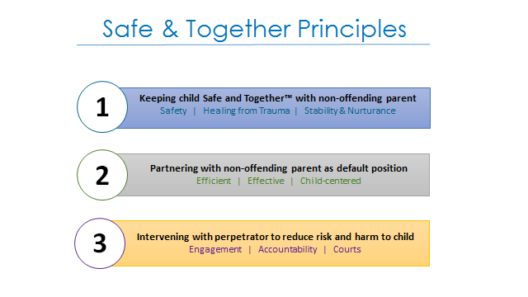

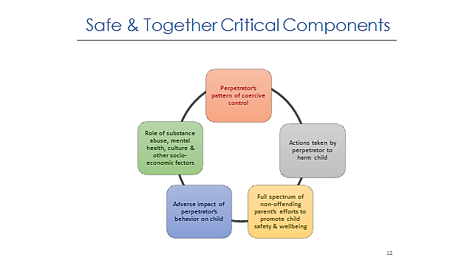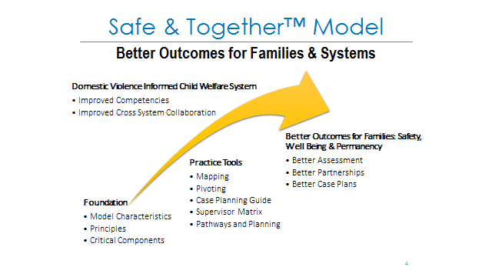**

|  |
| --- |
| There is a recommendation within the Equally Safe Strategy (Scottish Government and COSLA) Delivery Plan for Social Work to establish a Scottish Safe & Together Institute to help Local Authorities implement full systems change. The research on the model highlights that only by fully embedding the model can we expect to see the best outcomes for our families. Social Work Scotland (SWS), The Centre for Inspiring Children’s Futures, Scottish Women’s Aid, Barnardo’s and the Improvement Service are part of a consortium to develop plans for a Scottish Institute. Falkirk Council HSCP & CPC have made a commitment to fund and begin delivering core training on Safe and Together, Domestic Abuse Model from 2017. |

|  |  |
| --- | --- |
| **Examples of good practice since core training in November 2017** |  |
| * Core trained practitioners have used the principles to structure conversations and record what non offending parents do to nurture their children and keep them safe. * Using the term ’Super Powers’ with non offending parents has helped them describe the seemingly subtle coercive behaviours that are harmful to both them and their children. It allows practitioners to understand the impact of these coercive behaviours. It helps non-offending parents tell their stories without fear of being judged. | * Practitioners’ reports using coercive control information has held perpetrators more accountable for their behaviours. * The model has helped practitioners frame their conversations with the non offending parent, quickly after abusive events and has contributed to the victim better understanding coercive control. The model is actively applied in MARAC & MATAC meetings, and has helped highlight the gap in Multi Agency representation at these meetings. * Trained Practitioners report that their colleagues are showing signs of a better understanding of the language, the principles and using both to better manage risk, where previously this has caused conflict and different outcomes. |
| * Practitioners used the model with non offending parents to list what they provide for their children and what they do to keep their children safe, manage the trauma of abusive behaviours and how they provide stability and nurturance for their children. One parent then took this list to their lawyer when applying for an interdict against their abusive partner. * Also within this list by holding both parents accountable for the care of children highlighted the differences in what the two parents did or did not provide. This helped frame the discussion around the harmful ***parenting choices*** of the perpetrator including how this interfered with the care that the non-offending parent was able to provide. The lawyer found the language used so helpful they plan to use it with other parents. * This model helps describe the lived experience of families, and is influencing practitioners in their practice with all families | * The model has helped practitioners influence different decision makers, including Consultants to recognise the coercive controlling pattern of behaviours. This includes the influence these type of behaviours have on the non offending parent to provide for the children. This puts the accountability for harm and change on the perpetrator. * This is particularly noticeable in Reviews/Assessment meetings/ Case conferences where traditionally the non –offending parent have been given a number of tasks/actions to complete and the perpetrator is given one…to stay away. The model is shifting this with the understanding that it is only the perpetrator of Domestic Abuse that can be responsible for reducing the risk and harm, and if not be held accountable for the lack of change/reduction in risk. * The practitioners are noting that the model is influencing them in their wider practice, for example in cases of neglect (alongside the use of the neglect practice toolkit), by taking a strengths based approach it is more likely that change will be achieved as the parent feels supported in looking at the areas of need by firstly recognising what they do well. |



**Safe and Together encourages practitioners to move away from blaming/judgemental questioning style and encourages practitioners to adopt a language that hold both the offending and non-offending parent accountable for the parenting, care and protection of the children. We have put together some alternative ways to explore circumstances with clients to support all practitioners to implement Safe and Together into their practice when working with domestic abuse.**

|  |  |
| --- | --- |
| **Destructive Practice** | **Constructive Practice** |
| Why did you let him in? | What made it feel safer to have him in the house? |
| It’s your responsibility to keep your children safe | Both parents are equally responsible for keeping children safe.  To keep you and your children safe what has worked and has not worked in the past? |
| Why haven’t you ended the relationship?  You’re choosing him over your children. | Tell me what makes you stay in the relationship?  What’s safer about staying in the relationship? |
| If this happens again you need to phone the police | If (partner) were to become abusive today what options do you have? |
| We have received too many police reports | I see you have contacted the police several times due to your partner’s behaviour. Tell me about that behaviour |
| You’re not protecting your children  You need to stop contact and seek legal advice | What can we do to help you feel safer?  How can we work together to make things better? |
| Why isn’t he seeing the children? | Can you help me understand the risks and benefits to him seeing the kids? |

**REMEMBER: *It’s okay to ask if someone is okay!***