Version Control
1.4

Children and Young People Touchpoint Programme

20/04/15
Touchpoint 1

Named Person (Health and Education) receives a wellbeing concern

This Touchpoint is number 1 in a series of 12 designed to assist areas as they prepare to implement Parts 4, 5 and 18 of the Children and Young People (Scotland) Act 2014.

The Touchpoints are generic by design and will need to be further developed in line with local practice and process. They are designed to be used by Strategic and Operational Managers tasked with the implementation of the Children and Young People (Scotland) Act 2014 and will assist them in preparing specific guidance for practitioners.

The Children and Young People (Scotland) Act 2014 legislates for the implementation of Getting It Right For Every Child through Parts 4 (Named Person), 5 (Child’s Plan) and 18 (Wellbeing). Specific duties and responsibilities will follow with commencement in August 2016. These duties include:

- A Named Person made available to every child 0 -18 years (and beyond if still in school);
- A legal requirement to share information with the Named Person as appropriate; and
- A single system for assessment and planning through a Child’s Plan.

Compliance with the legislation can only be achieved through significant transformational change supported by systems, practice and culture change.

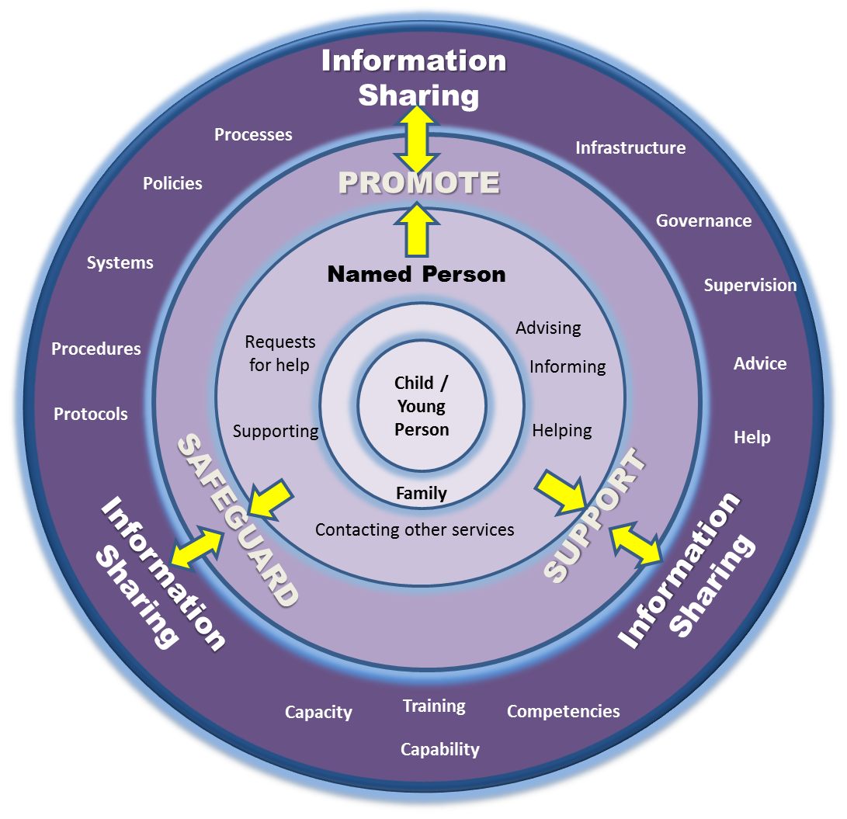

Touchpoint Process 1

The Named Person from health or education services receives a wellbeing concern.
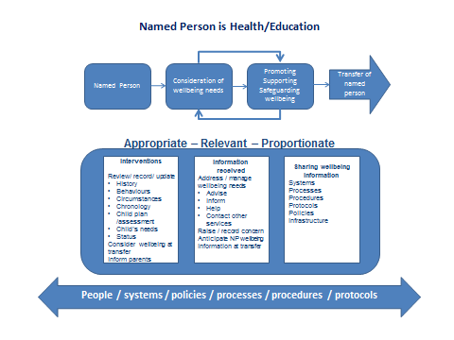

Touchpoint Checklist 1

The following checklist will support the transformational change required for compliance with Parts 4, 5 and 18 of the Children and Young People (Scotland) Act 2014.

Flow  Ref | Activity | Readiness Assessment | Y/N
1.1  . | A communication (email + attachments/ phone call/ report or any other means) is directed to the Named Person advising of a wellbeing concern.  The communication should be saved/ recorded and stored within a secure environment. | 1.1.1 Do you have you an agreed process in place for receiving wellbeing information?  Points to consider:  - Has your organisation agreed how email be used to receive wellbeing information e.g. generic email box or Named Person’s email box?  - Has your organisation got a single point of contact for concerns communicated by telephone and mail and a method to direct these to the Named Person?  - Has your organisation agreed how attachments will be managed?  - Has your organisation set up a secure, space / folders for saving emails and attachments?  - Is access controlled?  - Do you use access controls based on roles?  - Does your system enable access management and audit?
1.2 | A Named Person is made available as required. | 1.2.1 Do your policies, procedures, protocols, systems and processes ensure that a Named Person service is always available to children and families including taking into consideration planned and unplanned variations in operational services:  - Activity out with normal working hours of Named Person (note there is no intention that the Named person service will be available out with working hours – matters requiring urgent attention and action should be dealt with under existing Child and Adult Protection procedures and the Named Person apprised when available);  - Leave;  - Sickness; and  - Named Person not now in the position that was fulfilling the functions?
1.3 | Under the power granted through this act the Named Person may require additional wellbeing information from other colleagues/ internal services/ other agencies or child/parents. | 1.3.1 Is there guidance/ support and/ or training available for staff to help them determine what information should be shared when seeking additional information?  1.3.2 Do you have an agreed format/ process for requesting additional wellbeing information?
1.4 | The Named Person may further share information in relation to their function. | 1.4.1 There is guidance/ support and/ or training available to Named Persons to help them to understand that:  - Each further sharing requires a recorded decision to be made;  - The steps to determine whether the information ‘ought’ to be shared require to be revisited as information is further shared;  - They have the power to share information when making further determinations about the child or young person’s wellbeing; and  - Where the child or young person has siblings with a different Named Person, they have a duty to make that Named Person aware of any matter that is likely to be relevant to the siblings wellbeing.
1.5 | Requests for additional wellbeing information and any information received should be recorded on local system against child’s wellbeing record. | 1.5.1 Does your system enable received additional wellbeing information to be saved with child wellbeing record (i.e. PDF/ email)?
1.6 | The Named Person will review all wellbeing information collated and make an assessment of the child’s wellbeing. | 1.6.1 Is use of the National Practice Model embedded in practice?  1.6.2 Do you have clear procedures in place to manage child protection concerns?
1.7 | The Named Person discusses the transfer of information with the child/ young person and where appropriate the child’s parents, as far as practicable, and has regard to their views. | 1.7.1 Do you have a process for considering the views of the child/ young person, and the parents as appropriate at the point of transfer?  1.7.2 Do you have guidance available to assist in situations where the child/ parent disagrees with a decision made by the Named Person to share information?  1.7.3 Do you have guidance/ advice available to children and parents on such matters?
1. 8 | Using the GIRFEC National Practice Model the Named Person assesses the child’s wellbeing and decides if any additional interventions are required. The 5 practitioner questions should be used to support the decision making process. | 1.8.1 Does your system enable recording and saving of your wellbeing assessment?  1.8.2 Is there a clear process for involving the child and parents in the assessment process, analysis and planning?
1.9 | The Named Person instigates the child planning process with appropriate colleagues/ service providers/ child/ parents as required. | 1.9.1 Does your organisation have an agreed policy and guidance in respect of commencing the Child’s Plan?

Version Control
1.3

Children and Young People Touchpoint Programme

20/04/15
Touchpoint 2

Named Person (Health)
Consideration of the wellbeing needs of the pregnant woman and anticipating the wellbeing of the new-born child

This Touchpoint is number 2 in a series of 12 designed to assist areas as they prepare to implement Parts 4, 5 and 18 of the Children and Young People (Scotland) Act 2014.

The Touchpoints are generic by design and will need to be further developed in line with local practice and process. They are designed to be used by Strategic and Operational Managers tasked with the implementation of the Children and Young People (Scotland) Act 2014 and will assist them in preparing specific guidance for practitioners.

The Children and Young People (Scotland) Act 2014 legislates for the implementation of Getting It Right For Every Child through Parts 4 (Named Person), 5 (Child’s Plan) and 18 (Wellbeing). Specific duties and responsibilities will follow with commencement in August 2016. These duties include:

- A Named Person made available to every child 0 -18 years (and beyond if still in school);
- A legal requirement to share information with the Named Person as appropriate; and
- A single system for assessment and planning through a Child’s Plan.

Compliance with the legislation can only be achieved through significant transformational change supported by systems, practice and culture change.

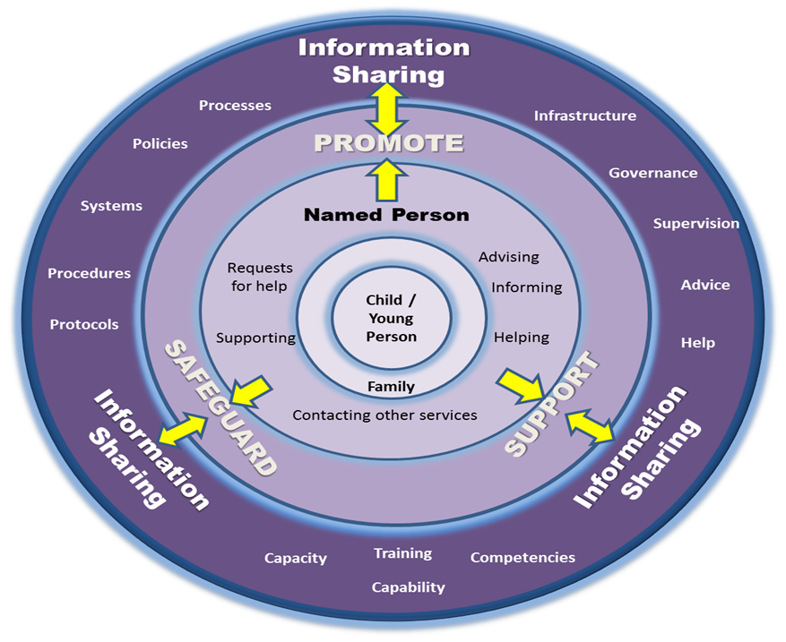

Touchpoint Process 2

Pre-birth consideration of the wellbeing needs of the pregnant woman and anticipating the wellbeing of the new-born.

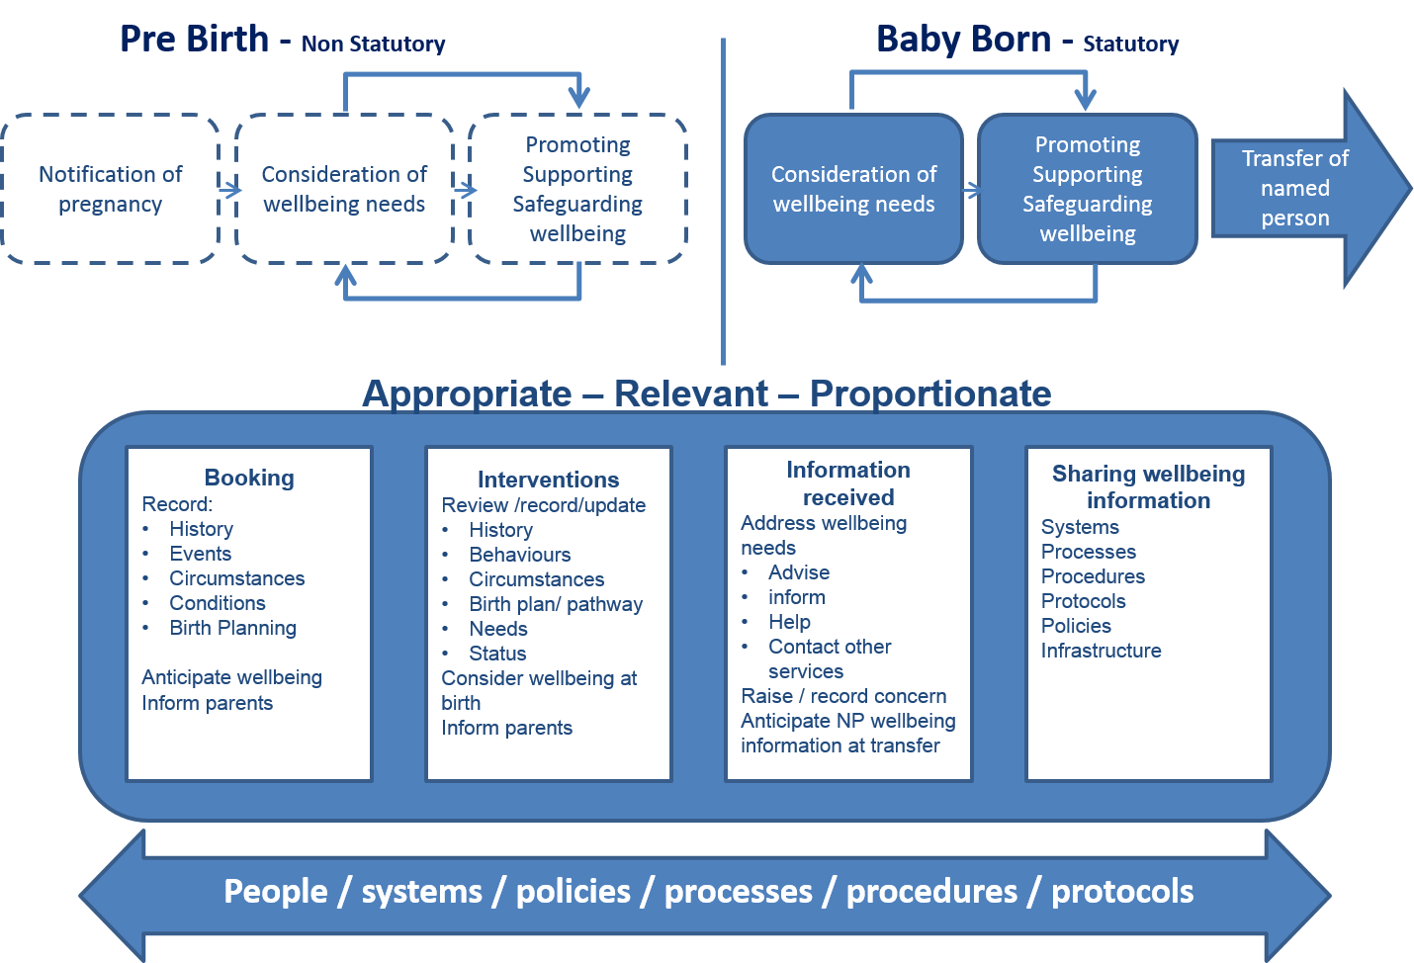

Touchpoint Checklist 2
The following checklist will support the transformational change required for compliance with parts 4, 5 and 18 of the Children and Young People (Scotland) Act 2014.

It must be noted that the provisions of the Act only apply when the child is born. The processes and procedures in relation to the unborn child are drawn from existing good practice and the National Guidance for Child Protection. Further detail on this guidance can be found at:

http://www.scotland.gov.uk/Publications/2014/05/3052

Ref | Activity | Readiness Assessment | Y/N
2.1 | From first contact with health services practitioners consider the risks/ anticipated wellbeing needs of the new-born within the context of the pregnant woman’s wellbeing and circumstances.  Consideration of wellbeing should be in terms of the 8 wellbeing indicators. | 2.1.1 Do all practitioners working with pregnant women have an understanding of wellbeing in terms of the 8 wellbeing indicators and how they may apply to a pregnant woman?
2.2 | Relevant and proportionate information should be shared with the agreement of the pregnant women unless there are child wellbeing or child or adult protection concerns when information should be shared without seeking consent. | 2.2.1 Do your systems enable sharing of pre-birth/ post-birth wellbeing information held on a pregnant woman’s/ mother’s maternity record?
2.3 | The Health Board identifies a lead clinician/ contact for maternity care. | 2.3.1 Does your Health Board have a clear system to identify the lead clinician/ contact for maternity care?
2.4 | The principles of the GIRFEC National Practice Model should be applied when considering the wellbeing of the pregnant woman and the anticipated wellbeing risks and needs of the new-born. | 2.4.1 Do all key personnel working with pregnant women have a clear understanding of the GIRFEC National Practice model and how the principles can be applied to pregnant women?
2.5 | Following the use of the National Practice Model the assessment, analysis and planning should be recorded to eliminate, reduce or mitigate risks to the pregnant woman’s and new-born’s wellbeing. | 2.5.1 Are your systems to document information on pregnant women designed to facilitate recording of assessment, analysis and planning information compatible with the eight wellbeing indicators and the principles of the GIRFEC National Practice Model?  2.5.2 Do you have systems and processes in place that support consideration of potential affect to and the effect on the wellbeing of the new-born following consideration of the risks to wellbeing of the pregnant women?
2.6 | As soon as reasonable practicable, but not later than 28 weeks gestation, the Health Board identifies the Prospective Named Person for the baby at birth – this will normally be the Health Visitor or a Family Nurse, where one is identified, but in exceptional circumstances this may be a nurse of a different designation, a midwife or a medical practitioner. | 2.6.1 Are all practitioners within the organisation and partner organisations aware of the Named Person’s role and their own role in fulfilling the Boards statutory duties in the provision of a Named person Service?  2.6.2 Does your Health Board have a system in place to identify prospective Named Persons and identify these to the lead clinician/ contact for maternity care?
2.7 | Where additional wellbeing needs are anticipated at birth the Health Board identifies the Prospective Named Person for the baby as soon as reasonably practicable after additional needs are identified. | 2.7.1 Are all practitioners within the organisation and partner organisations aware of the Named Person’s role and their own role in fulfilling the Boards statutory duties in the provision of a Named Person service?  2.7.2 Does your Health Board have a system in place to identify prospective Named Persons and identify these to the lead clinician/ contact for maternity care?
2.8 | Consideration should be given to offering the pregnant woman a joint contact between the clinician/ contact leading on maternity care and the prospective Named Person and involvement of the prospective Named Person in planning and providing supports to eliminate, reduce or mitigate risks to wellbeing.  Around 30 weeks gestation, but not later than 36 weeks gestation, the lead clinician/ contact/ contact for maternity care and the prospective Named Person should offer the pregnant women a joint contact with the pregnant woman – preferably in the home setting. | 2.8.1 Do your operational procedures/ systems/ processes support provision and scheduling of joint contacts between the clinician/ contact leading on maternity care and the prospective Named Person?
2.9 | The prospective Named Person for the baby works in partnership with the clinician/ contact leading on maternity care to eliminate, reduce or mitigate risks to the pregnant woman’s and new-born’s wellbeing. | 2.9.1 Do your systems/ processes support joint planning to support the elimination, reduction and mitigation of risks to the wellbeing of the pregnant women and also planning to address the risks to wellbeing of the anticipated baby?
2.10 | When a pregnant women’s (or it is anticipated that a baby’s needs) will require support that is not generally available within the routine service – i.e. when a targeted intervention is required – a single or multi-agency plan should be initiated as appropriate. | 2.10.1 Do Named Persons and clinicians/ contacts leading on maternity care have the capacity, competencies, organisational support required to fulfil their functions including access to advice, information, and support and help to enable them to fulfil their functions?
2.11 | The pregnant woman should be fully involved in planning care and support for her and her baby. | 2.11.1 Does your Health Board and partners have the capacity, systems and processes to develop and manage single and multi-agency planning to address the wellbeing needs of the pregnant women and the anticipated wellbeing needs of the new-born?
2.12 | Where appropriate, a prospective Lead Professional will be appointed and a draft Child’s Plan prepared. | 2.12.1 Do the systems and processes in place to facilitate drafting of a Child’s Plan in anticipation of a new-born with additional wellbeing needs include the facility to record the contents of the Child’s Plan as specified in the Child’s Plan Minimum Data Set  2.12.2 Your organisation has identified designated roles, which will perform the Lead Professional role.  2.12.3 Lead Professionals are aware of their role and functions.  2.12.4 Where there is an identified training need this has been addressed.  2.12.5 There is a management structure and network of support established for Lead Professionals  2.12.6 Lead Professionals are supported with training, systems and processes appropriate to their functions and to the sensitive personal data they are likely to handle at times.  2.12.7 Do you have a resolution policy agreed within the Board and with partners if a Lead Professional cannot be agreed between practitioners and services involved with the child?
2.13 | The prospective Lead Professional will work with the lead clinician/ contact for maternity care in managing and reviewing the draft Child’s Plan. | 2.13.1 Are specialist services and partners aware of their responsibilities to provide assistance in relation to a Child’s Plan?

Version Control
1.4

Children and Young People Touchpoint Programme

20/04/15
Touchpoint 3

Named Person (Health) – Pre-School Child
(Birth to Age of School Commencement)

This Touchpoint is number 3 in a series of 12 designed to assist areas as they prepare to implement Parts 4, 5 and 18 of the Children and Young People (Scotland) Act 2014.

The Touchpoints are generic by design and will need to be further developed in line with local practice and process. They are designed to be used by Strategic and Operational Managers tasked with the implementation of the Children and Young People (Scotland) Act 2014 and will assist them in preparing specific guidance for practitioners.

The Children and Young People (Scotland) Act 2014 legislates for the implementation of Getting It Right For Every Child through Parts 4 (Named Person), 5 (Child’s Plan) and 18 (Wellbeing). Specific duties and responsibilities will follow with commencement in August 2016. These duties include:

- A Named Person made available to every child 0 -18 years (and beyond if still in school);
- A legal requirement to share information with the Named Person as appropriate; and
- A single system for assessment and planning through a Child’s Plan.

Compliance with the legislation can only be achieved through significant transformational change supported by systems, practice and culture change.

Touchpoint Process 3

Named Person – Pre-School Child (Birth to Age of School Commencement)

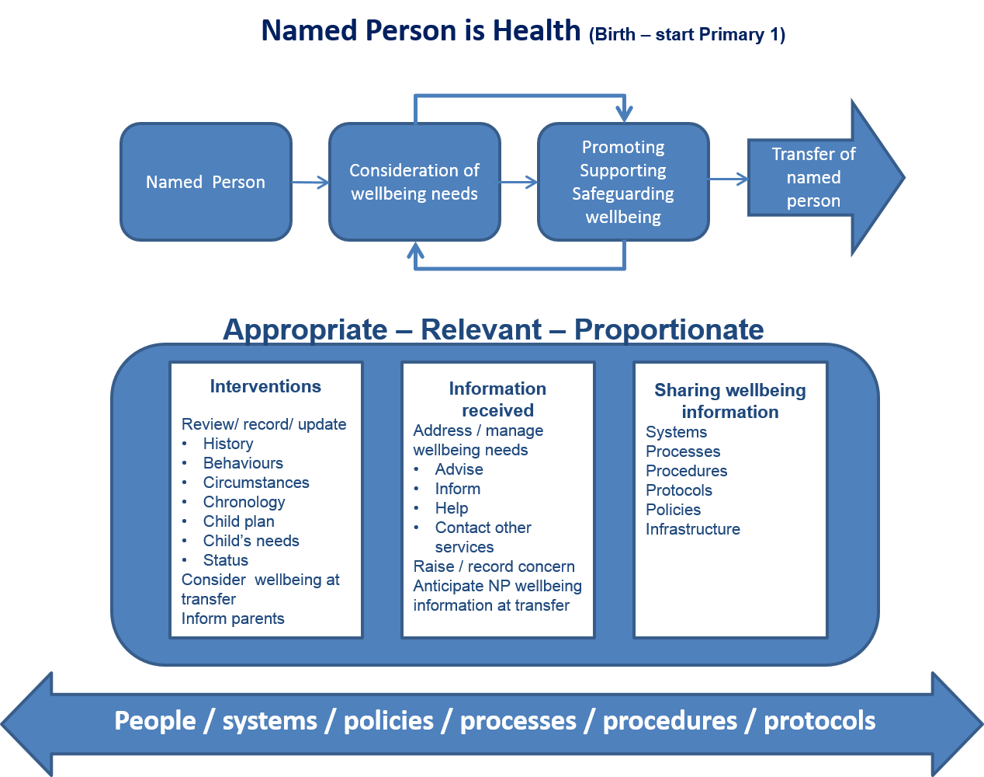

Touchpoint Checklist

The following checklist will support the transformational change required for compliance with Parts 4, 5 and 18 of the Children and Young People (Scotland) Act 2014

Ref | Activity | Readiness Assessment | Y/N
3.1 | By the birth of child, the Health Board had identified a Named Person – in the vast majority of situations this should only be to confirm the Prospective Named Person during the antenatal period as the Named Person for the new-born. | 3.1.1 Do you have systems and processes in place to identify a Named Person for a baby from birth? Normally this will be through notification and confirmation that this is the practitioner who has been acting as a Prospective Named Person in the antenatal period?  3.1.2 Do you have the systems and processes in place to notify parents of who the Named Person will be?
3.2 | Wellbeing assessment of the new-born is carried out using the National Practice Model, including:  - Review any pre-birth wellbeing assessment (which should include a draft Child’s Plan where one has been created);  - Recording of all appropriate baby wellbeing information; and  - Starting a chronology if appropriate. | 3.2.1 Do you have systems and processes in place which use the National Practice Model to record:  - Baby wellbeing assessment;  - Chronology;  - Wellbeing needs;  - Single agency plan; and  - Parental involvement?  3.2.2 If the baby does not have a CHI number do you know how/ where you will record the baby’s wellbeing assessment?  3.2.3 Are those practitioners exercising the functions of Named Person experienced in the application of the National Practice Model to assess a baby’s wellbeing?  3.2.4 Do your systems enable sharing of pre-birth/ post-birth wellbeing information held on mothers maternity record with the:  - Baby’s Named Person; and  - Other appropriate practitioners?
3.3 | A Named Person is made available as required. | 3.3.1 Do your policies, procedures, protocols, systems and processes ensure that a Named Person service is available to children and families including taking into consideration planned and unplanned variations in operational services:  - Leave;  - Sickness; and  - The Named Person not now in the position that was fulfilling the functions?
3.4 | The sharing of relevant and proportionate information to assess wellbeing and consider needs takes place. | 3.4.1 Do your systems/ processes enable sharing of relevant and proportionate wellbeing information with:  - The Named Person; and  - Other appropriate practitioners?
3.5 | Advice, information, support and help is provided as appropriate and others involved to support, promote and safeguard the child’s wellbeing in line with statutory guidance. | 3.5.1 Do Named Persons have the capacity, competencies and organisational support required to fulfil their functions including access to policies, procedures, protocols, advice, supervision, information and help to enable them to fulfil their functions?  3.5.2 Are all practitioners within the organisation and partner organisations aware of the Named Person’s role and their own role in fulfilling the Boards duties in the provision of a Named Person service?  3.5.3 Are there systems and processes to manage statutory requests for help to assist the Named Person in fulfilling their functions including:  - Making requests for help;  - Processing requests received;  - Considering and responding to requests; and  - Ensuring that Named Persons functions are fulfilled when requests for help are declined?
3.6 | Sharing of relevant and proportionate information takes place when transferring Named Person functions. | 3.6.1 Do your systems/ processes enable sharing of relevant and proportionate wellbeing information when there is a transfer between Named Persons?
3.7 | When a child’s needs require support that is not generally available within the routine service, i.e. when a targeted intervention is required, a single or multi-agency, a Child’s Plan is initiated as appropriate.  Parents are fully involved in care and planning wherever possible. | 3.7.1 Are specialist services and partners aware of their responsibilities to provide assistance in relation to a Child’s Plan?  3.7.2 Are the systems and processes in place to facilitate Child’s Planning processes:  - Recording the requirement for the Plan;  - Recording the contents of the Child’s Plan as specified in the minimum dataset;  - Preparing the Plan;  - Delivering the Plan; and  - Managing the Plan.
3.8 | Where appropriate, a Lead Professional is appointed and a Child’s Plan prepared. | 3.8.1 Your organisation has identified designated roles, which will perform the Lead Professional role.  3.8.2 Lead Professionals are aware of their role and functions.  3.8.3 Where there is an identified training need this has been addressed.  3.8.4 There is a management structure and network of support established for Lead Professionals  3.8.5 Lead Professionals are supported with training, systems and processes appropriate to their functions and to the sensitive personal data they are likely to handle at times.  3.8.6 Do you have a resolution policy agreed within the Board and with partners if a Lead Professional cannot be agreed between practitioners and services involved with the child?
3.9 | The Lead Professional manages the Child’s Plan. | 3.9.1 Those taking on the Lead Professional role have the capacity, competencies, organisational support required to fulfil their functions including access to advice, information, support and help to enable them to fulfil their functions.

Version Control
1.3

Children and Young People Touchpoint Programme

20/04/15

Touchpoint 4

Transition of Named Person Service for pre-school age child to school age child

This Touchpoint is number 4 in a series of 12 designed to assist areas as they prepare to implement Parts 4, 5 and 18 of the Children and Young People (Scotland) Act 2014.
The Touchpoints are generic by design and will need to be further developed in line with local practice and process. They are designed to be used by Strategic and Operational Managers tasked with the implementation of the Children and Young People (Scotland) Act 2014 and will assist them in preparing specific guidance for practitioners.

The Children and Young People (Scotland) Act 2014 legislates for the implementation of Getting It Right For Every Child through Parts 4 (Named Person), 5 (Child’s Plan) and 18 (Wellbeing). Specific duties and responsibilities will follow with commencement in August 2016. These duties include:

- A Named Person made available to every child 0 -18 years (and beyond if still in school);
- A legal requirement to share information with the Named Person as appropriate; and
- A single system for assessment and planning through a Child’s Plan.

Compliance with the legislation can only be achieved through significant transformational change supported by systems, practice and culture change.

Touchpoint Process 4

Transition of Named Person Service for pre-school age child to school age child

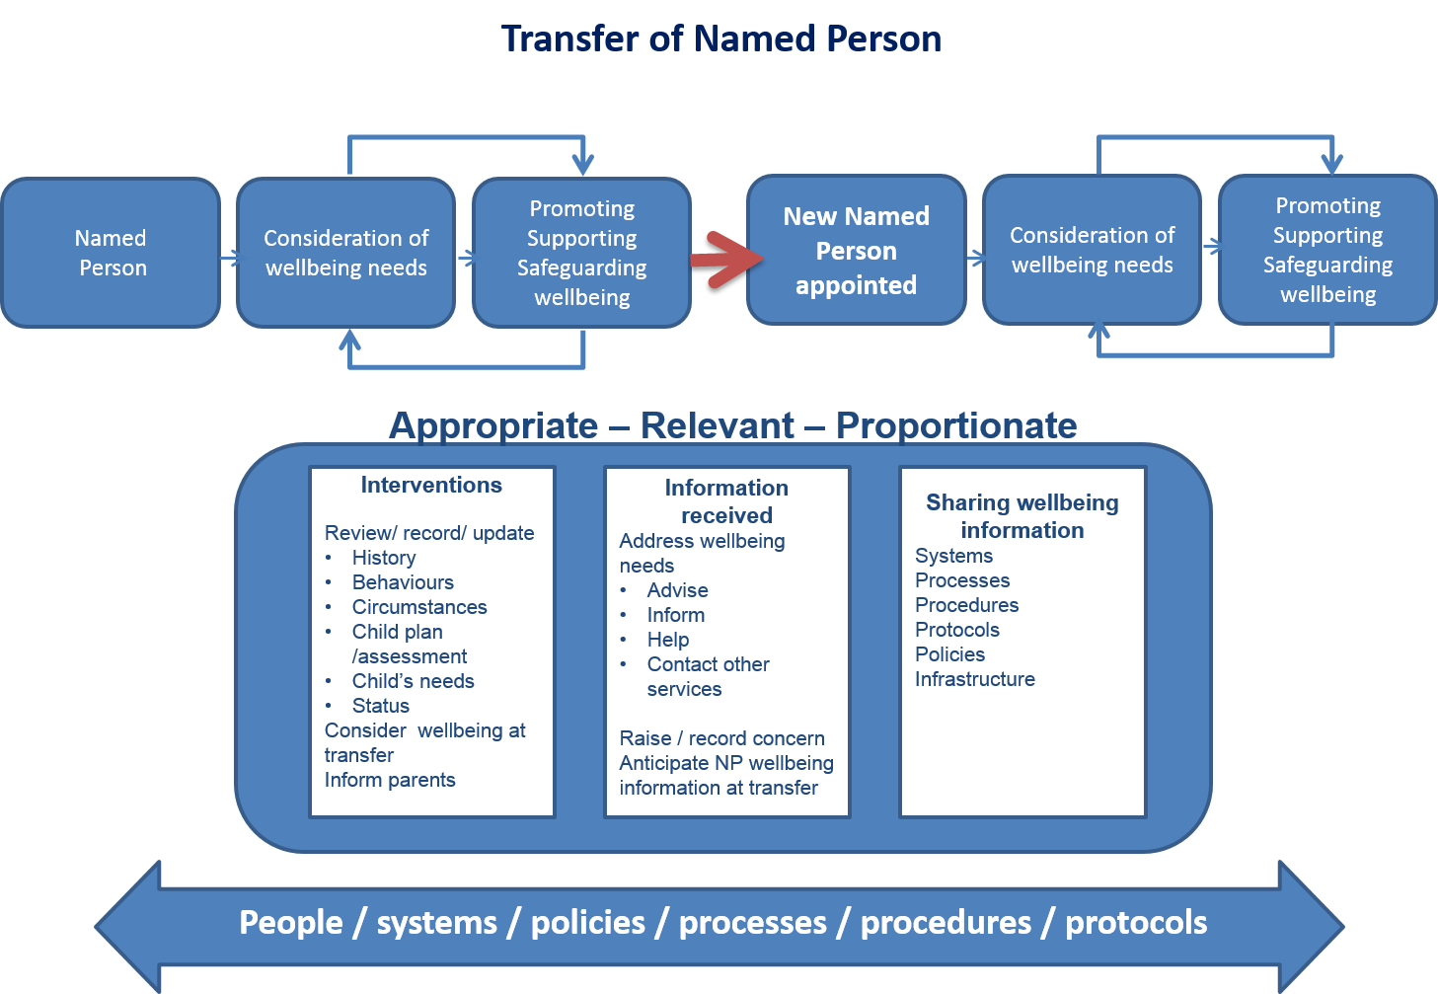

Touchpoint Checklist 4

The following checklist will support the transformational change required for compliance with Parts 4, 5 and 18 of the Children and Young People (Scotland) Act 2014.

Ref | Activity | Readiness Assessment | Y/N
4.1 | Named Person identifies when a child is approaching age of school entry | 4.1.1 Are there systems and processes in place to identify when a child is approaching age of school entry?
4.2 | The Named Person reviews wellbeing information available prior to arranging contact with child/parent(s). | 4.2.1 Do you have a protocol, policy or procedure for reviewing the wellbeing information of a child and are all staff trained in the use of this? This protocol may include questionnaires to parents and seeking information from partners (e.g. the nursery)
4.3 | Where possible the Named Person meets with the child and parent to discuss wellbeing of the child in order to update latest information. | 4.3.1 Do you have a protocol, policy or procedure for discussing and updating wellbeing information prior to transfer of Named Person functions and are all staff trained in the use of this? This should include recording the views of the child and parents.
4.4 | The Named Person discusses with the child and parents what information they believe should be shared with the incoming Named Person Service provider. | 4.4.1 Do you have a process for considering and recording the views of the child and parents in relation to what information should be shared, including sensitive information in relation to the child, parents and any other individual.  4.4.2 Do you have guidance on processes to consider when a child or parent disagrees with the decision of a Named Person to share specific information?
4.5 | The Named Person identifies what wellbeing information they will share with the incoming Named Person service provider ensuring that all information shared is relevant and proportionate. | 4.5.1 Do you have an agreed process for deciding and recording what information is relevant and proportionate to share with the incoming Named Person service provider?  4.5.2 Do you have secure systems and processes in place to for retaining and archiving details of information shared, not shared and reasoning?
4.6 | The Named Person informs parent and child that their Named Person will change and that as a result information may be shared with the incoming Named Person service provider. | 4.6.1 Do you have a protocol, policy or procedure and guidance on how to inform the child and parent of what wellbeing information is being shared with the incoming Named Person service provider? This should include guidance on the management of sharing of sensitive information in relation to the child, parents, and any other individual?  4.6.2 Do you have guidance on processes for staff to consider when due to the risk to the child it is not advisable to make the parent aware of information that may be shared?  4.6.3 Do you have guidance on processes to consider when a child or parent disagrees with the decision of a Named Person to share specific information?  4.6.4 Do you have information available to children and parents on how they may challenge decisions to share specific information?
4.7 | The Named Person identifies what wellbeing information they intend to share with the incoming Named Person ensuring that all information shared is relevant and proportionate. | 4.7.1 Do you have an agreed process for deciding and recording what information is relevant and proportionate to share with the incoming Named Person service provider?  4.7.2 Do you have secure systems and processes in place to for retaining and archiving details of information shared, not shared and reasoning?
4.8 | The Named Person identifies who the incoming Named Person service provider is and where possible identifies the incoming Named Person. | 4.8.1 Do you have processes in place to identify who the incoming Named Person service provider will be and where possible to identify the incoming Named Person?
4.9 | The Named Person provides the incoming Named Person service provider with the name and address of the child and parents and also any information that is likely to be relevant and ought to be shared to support the exercising of their functions in providing a Named Person service. | 4.9.1 Do you have systems and processes to transfer personal and sensitive information from the outgoing Named Person to the incoming Named Person?
4.10 | The incoming Named Person service provider receives information from the outgoing Named Person Service provider. | 4.10.1 Do you have processes in place to identify children who you anticipate you will be providing a Named Person service?  4.10.2 Do you have processes in place to identify Named Persons for all children to whom you will be providing a Named Person service?  4.10.3 Do you have processes in place to receive and securely store wellbeing information shared with you from an outgoing Named Person service?
4.11 | The incoming Named Person service advises the child and parent of who the incoming Named Person is and information about the role of the Named Person. | 4.11.1 Do you have processes in place to inform the child and parents who the incoming Named Person is, how their functions are generally exercised and arrangements for contacting them?
4.12 | Information shared must be stored securely and any sharing of information requires a decision. | 4.12.1 Do you have appropriate system access controls in place to ensure that access to information is appropriately and securely managed and a when a decision to share has been made? (This is particularly important where the Named Person uses the same system to store information particular to their role and others use parts of the same system for operational purposes, such as a patient management system or the SEEMiS Education system.)
4.13 | A Named Person is made available as required. | 4.13.1 Do your policies, procedures, protocols, systems and processes ensure that a Named Person service is available to children and families including taking into consideration planned and unplanned variations in operational services:  - Leave;  - Sickness; and  - The Named Person not now in the position that was fulfilling the functions.
4.14 | Staff are aware that the principles of the Data Protection Act 1998 apply to all Personal Data or Sensitive Personal Data that is shared under this Act. | 4.14.1 Your organisation has clear  guidance  - that Information shared and who it is shared with must be relevant and proportionate to the purpose  - that there is a need to ensure, on a case-by-case basis, that the information they are considering sharing is likely to be relevant to the Named Person function.  Personal data must be:  - fairly and lawfully processed;  - processed for specified lawful purposes;  - adequate, relevant and not excessive;  - accurate and where appropriate, up to date;  - kept no longer than is necessary;  - processed in accordance with the individual’s rights;  - secure; and  - only transferred outside the European Economic Area with adequate protection.

Version Control
1.2

Children and Young People Touchpoint Programme

20/04/15
Touchpoint 5

Named Person (Education)

This Touchpoint is number 5 in a series of 12 designed to assist areas as they prepare to implement Parts 4, 5 and 18 of the Children and Young People (Scotland) Act 2014.

The Touchpoints are generic by design and will need to be further developed in line with local practice and process. They are designed to be used by Strategic and Operational Managers tasked with the implementation of the Children and Young People (Scotland) Act 2014 and will assist them in preparing specific guidance for practitioners.

The Children and Young People (Scotland) Act 2014 legislates for the implementation of Getting It Right For Every Child through Parts 4 (Named Person), 5 (Child’s Plan) and 18 (Wellbeing). Specific duties and responsibilities will follow with commencement in August 2016. These duties include:

- A Named Person made available to every child 0 -18 years (and beyond if still in school);
- A legal requirement to share information with the Named Person as appropriate; and
- A single system for assessment and planning through a Child’s Plan.

Compliance with the legislation can only be achieved through significant transformational change supported by systems, practice and culture change.

Touchpoint Process 5

Named Person is Education

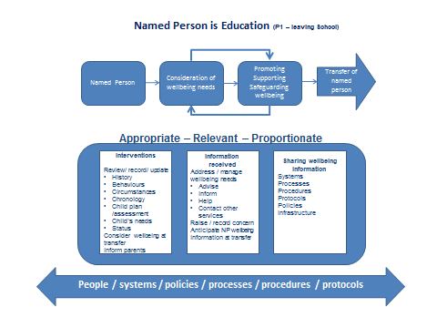

Touchpoint Checklist 5

The following checklist will support the transformational change required for compliance with Parts 4, 5 and 18 of the Children and Young People (Scotland) Act 2014.

Ref | Activity | Readiness Assessment | Yes / No
5.1 | All appropriate/ relevant and proportionate wellbeing information has been received from Health | 5.1.1 Do you have an agreed process/ procedure with the health Named Person service for receiving child wellbeing information?  5.1.2 Does your (local authority) website accurately reflect the arrangements for making the Named Person available for all children up to 18, or beyond if still in school, for whom you have a responsibility?  5.1.3 Do you have processes in place to ensure that the child and the child’s parents are informed who their Named Person is?  5.1.4 Do your systems for the above include the arrangements for children who will be home educated?
5.2 | Child wellbeing information from health services should be stored safely and securely within your systems. | 5.2.1 Do you have systems and processes in place to ensure only appropriate/ and restricted access to child wellbeing information such as:  - System access controls;  - Adding and removing access; and  - Audit and monitor?
5.3 | Throughout a child’s life at school, staff should use the GIRFEC National Practice Model when assessing a child’s wellbeing. | 5.3.1 Are all staff comfortable/ trained to use the GIRFEC National Practice Model?  5.3.2 Are your systems able to record wellbeing indicators?  5.3.3 Have you agreed how chronologies and child plans will be developed and managed?
5.4 | Using the GIRFEC National Practice Model a wellbeing concern:  - Is identified; and/ or  - Additional support is required.  (A wellbeing concern can be identified by anyone who has contact with a child.) | 5.4.1 Do you have an agreed process for raising and receiving wellbeing concerns?  5.4.2 Do you have agreed processes in place for seeking assistance from education services and other partners? How will disagreements be resolved?  5.4.3 Have you agreed how you will record wellbeing concerns on your system?  5.4.4 Do you have arrangements in place to provide the Named Person functions if the usual Named Person is absent such as on holiday/ sick/ position is vacant?  5.4.5 Do you have a staged intervention process/ policy/ procedure in place to ensure wellbeing concerns are identified and proportionately managed?
5.5 | No wellbeing concerns found during assessments/ progress/ reviews.  The outcome is recorded on the system as no wellbeing concerns. | 5.5.1 Do your systems use the GIRFEC National Practice Model to record the outcome – no wellbeing concern following assessment/ progress review?
5.6 | Using the GIRFEC National Practice Model you record the detail of your wellbeing concern. | 5.6.1 Do your systems use the GIRFEC National Practice Model to record your wellbeing concern?
5.7 | The Named Person should review all wellbeing information held and make an assessment using the GIRFEC National Practice Model .  The 5 practitioner’s questions are used to decide on further action.  Immediate action is taken if the assessment process indicates a child protection concern. | 5.7.1 Does Named Person have appropriate access to retrieve child’s wellbeing record?  5.7.2 Is the Named Person trained and supported to carry out appropriate assessment processes?  5.7.3 Is there a clear process in place to support the Named Person to recognise and raise a child protection concern?
5.8 | Through assessment of all relevant/ appropriate and proportionate information the named person decides:  i) No additional support required (go to 5.9 ); or  ii) Additional internal support for the child is required (go to 5.10).  The Named Person records the decision on the system. | 5.8.1 Is the appropriate involvement of the child and parents embedded in practice, and are there systems in place to show that regard has been given to their views?  5.8.2 Do your systems and processes include the views of the child or young person, and the child’s or young person’s parents?  5.8.3 Does your system enable recording of:  - Wellbeing assessment and needs; and  - Additional support (targeted intervention)?  5.8.4 Do you have systems and processes in place to enable the sharing/ receiving of wellbeing information for the purpose of assessment?
5.9 | The Named Person decides no additional support is required.  The decision is recorded on the system. | 5.9.1 Do your systems and processes enable the recording of notes and actions from discussion?
5.10 | The Named Person may discuss single agency support with other appropriate professionals.  The Named Person may share relevant/ appropriate/ proportionate information with other professionals prior to meeting.  The planning meeting discussions should consider:  - Wellbeing assessment;  - Additional wellbeing support requirements (targeted intervention);  - Date for review; and  - Parents/child or young person are involved. | 5.10.1 Do you have an agreed framework of professional support for the Named Person?  5.10.2 Are processes and guidance on information sharing in line with legislative requirements?  5.10.3. Are the views of the child and the child’s parents, as appropriate, sought as part of the decision making process on information sharing?
5.11 | The outcome is recorded on the system such as:  - Additional wellbeing support agreed (targeted intervention);  - Date for review; and  - Parents/ child or young person are involved. | 5.11.1 Do you have systems and processes to record  - Additional wellbeing support requirements (targeted interventions);  - Notes and actions from discussion (joint or single agency);  - Date for review; and  - Parents/ child or young person are involved?
5.12 | The Named Person prepares or considers preparing a Child’s Plan. | 5.12.1 Do you have a business process/ plan to manage times when the normal named person is not available which include how wellbeing assessments/ concerns should be managed?
5.13 | A Named Person is made available as required. | 5.13.1 Do your policies, procedures, protocols, systems and processes ensure that a Named Person service is always available to children and families including taking into consideration planned and unplanned variations in operational services:  - Leave;  - Sickness; and  - The Named Person not now in the position that was fulfilling the functions?

Version Control
1.3

Children and Young People Touchpoint Programme

20/04/15
Touchpoint 6

Transition of Named Person service for school age child at change of education arrangements

This Touchpoint is number 6 in a series of 12 designed to assist areas as they prepare to implement Parts 4, 5 and 18 of the Children and Young People (Scotland) Act 2014.

The Touchpoints are generic by design and will need to be further developed in line with local practice and process. They are designed to be used by Strategic and Operational Managers tasked with the implementation of the Children and Young People (Scotland) Act 2014 and will assist them in preparing specific guidance for practitioners.

The Children and Young People (Scotland) Act 2014 legislates for the implementation of Getting It Right For Every Child through Parts 4 (Named Person), 5 (Child’s Plan) and 18 (Wellbeing). Specific duties and responsibilities will follow with commencement in August 2016. These duties include:

- A Named Person made available to every child 0 -18 years (and beyond if still in school);
- A legal requirement to share information with the Named Person as appropriate; and
- A single system for assessment and planning through a Child’s Plan.

Compliance with the legislation can only be achieved through significant transformational change supported by systems, practice and culture change.

Touchpoint Process 6

Transition of Named Person or Named Person Service for school age child at change of education arrangements. This includes transfer between a public school and an independent school, transfer to a public school outwith the LA of residence. (Excludes home educated and other exceptions such as Gypsy Travellers)

Touchpoint Checklist

The following checklist will support the transformational change required for compliance with Parts 4, 5 and 18 of the Children and Young People (Scotland) Act 2014.

Ref | Activity | Readiness Assessment | Y/N
6.1 | Parents advise the Named Person of an intended change of school. | 6.1.1 Do you have an agreed process for Named Persons to manage and record:  - Children who will transfer to an independent school;  - Children who will transfer from an independent school to a local authority school; and  - Children who will transfer to a public school out with their residential local authority?  6.1.2 Where a child resides in Scotland but is going to be attending a school out with Scotland do you have a procedures and policies in place to:  - Identify an appropriate Named Person for the child within the Local Authority; and  - Establish appropriate lines of communication with the child’s new school should they agree to share wellbeing concerns with the child’s Named Person (this is not a legal requirement)?
6.2 | The Named Person collates pupil records where only routine information will be shared with receiving school/ the new Named Person. | 6.2.2 Do you have an agreed process for transferring routine records and archiving material?
6.3 | The Named Person identifies what wellbeing information is held and decides what wellbeing information is appropriate, relevant and proportionate to share. | 6.3.1 Do you have an agreed process for deciding and recording what information is appropriate, relevant and proportionate to share?  6.3.2 Do you have secure systems and processes in place for retaining and archiving information which is not to be shared?
6.4 | Only information that is appropriate, proportionate and relevant to the functions of the Named Person should be shared. | 6.4.1 Do you have a policy, guidance and suitable training that will support staff in determining what information ought to be shared?
6.5 | The Named Person discusses the transfer of information with the child/ young person and where appropriate their parents, as far as practicable, and has regard to their views. | 6.5.1 Do you have a process for considering the views of the child/ young person, and the parents as appropriate at the point of transfer?  6.5.2 Do you have guidance available to assist in situations where the child/ parent disagrees with a decision made by the Named Person to share information?  6.5.3 Do you have guidance/ advice available to children and parents on such matters?
6.6 | The Named Person records agreed transition process where appropriate and wellbeing requirements as part of school transfer processes. | 6.6.1 Where appropriate, do you have an agreed policy/ process/ procedure for discussing/ agreeing transition process and any wellbeing requirements?
6.7 | The new Named Person receives child wellbeing information. | 6.7.1 Do you have processes in place to receive and securely store wellbeing information from an outgoing Named Person?
6.8 | The incoming Named Person advises the child, young person and parents of the new Named Person arrangements. | 6.8.1 Do you have processes in place to inform child, young person and parents who is the new Named Person?
6.9 | Wellbeing information shared must be stored securely and no one other than the Named Person can view it, unless a decision has been made to further share. | 6.9.1 Do you have appropriate system access controls in place to ensure only appropriate access to a child’s wellbeing information?
6.10 | A Named Person is made available as required. | 6.10.1 Do your policies, procedures, protocols, systems and processes ensure that a Named Person service is always available to children and families including taking into consideration planned and unplanned variations in operational services:  - Activity out with normal working hours of Named Person;  - Leave;  - Sickness; and  - The Named Person not now in the position that was fulfilling the functions?
6.11 | Where there is a Child’s Plan in place, the Named Person or Lead Professional will make arrangements to review the plan, consulting where practicable the child, child’s parents (if appropriate) and the partners to the Plan.  Based on the review the Named Person (or Lead Professional), decides whether the current Plan should continue, be amended or come to an end.  The outcome of the review is recorded. | 6.11.1 Do you have clear procedures for reviewing a Child’s Plan prior to transfer of Named Person responsibilities?

Version Control
1.3

Children and Young People Touchpoint Programme

20/04/15
Touchpoint 7

Transition of Named Person or Named Person service when the child leaves school prior to 18th birthday

This Touchpoint is number 7 in a series of 12 designed to assist areas as they prepare to implement Parts 4, 5 and 18 of the Children and Young People (Scotland) Act 2014.

The Touchpoints are generic by design and will need to be further developed in line with local practice and process. They are designed to be used by Strategic and Operational Managers tasked with the implementation of the Children and Young People (Scotland) Act 2014 and will assist them in preparing specific guidance for practitioners.

The Children and Young People (Scotland) Act 2014 legislates for the implementation of Getting It Right For Every Child through Parts 4 (Named Person), 5 (Child’s Plan) and 18 (Wellbeing). Specific duties and responsibilities will follow with commencement in August 2016. These duties include:

- A Named Person made available to every child 0 -18 years (and beyond if still in school);
- A legal requirement to share information with the Named Person as appropriate; and
- A single system for assessment and planning through a Child’s Plan.

Compliance with the legislation can only be achieved through significant transformational change supported by systems, practice and culture change.

Transition of Named Person or Named Person Service when child leaves school prior to 18th Birthday (includes transition from school within a residential Local Authority, from school outwith the residential Local Authority and from Independent School).

Touchpoint Checklist

The following checklist will support the transformational change required for compliance with Parts 4, 5 and 18 of the Children and Young People (Scotland) Act 2014

Ref | Activity | Readiness Assessment | Y/N
7.1 | The child makes the decision to leave school before 18th birthday. | 7.1.1 Do you have process to record that pupil is leaving school?  h
7.2 | The Named Person advises the child (and, if appropriate, the parents) that there will be a change of Named Person, or Named Person service, and how to contact as part of the leaver’s protocol. | 7.2.1 Do you have processes in place to inform children/ parents of transfer of the Named Person responsibility at school leaving date, if before 18th birthday?
7.3 | The Named Person reviews wellbeing information held within their system and decides what information should be shared with the incoming Named Person service, or the new Named Person. | 7.3.1 Do you have guidance for the Named Persons on what information should be shared?  7.3.2 Can information which is not shared be archived for future reference where required?  7.3.3 How will disagreements be resolved?  7.3.4 Where child attends an independent school, or public school in a Local Authority area which is not the area in which they reside, are there protocols in place to receive/transfer information about change of the Named Person responsibility, and to manage transfer of records and wellbeing information?
7.4 | As far as practicable the Named Person discusses the sharing of information with the child, and if appropriate in line with good practice, the child’s parents. | 7.4.1 Are there standard procedures in place to discuss transfer of information at this transition, with the child, and if appropriate in line with good practice, the child’s parents?  7.4.2 How will disagreements be resolved?
7.5 | Information is shared with the new Named Person, or incoming Named Person service, in a timely manner. | 7.5.1 Can appropriate wellbeing information be shared securely?
7.6 | Where there is a Child’s Plan in place, the Named Person or Lead Professional will make arrangements to review the plan, consulting where practicable the child, child’s parents (if appropriate) and the partners to the Plan.  . | 7.6.1 Do you have clear procedures for reviewing a Child’s Plan prior to transfer of the Named Person responsibilities?  7.6.2 Do you have arrangements in place for the Named Person to manage a Child’s Plan for a child who has left school?  7.6.3 Are there protocols to support the link between the Named Person and the Lead Professional where the child has left school?
7.7 | Based on the review the Named Person and/or Lead Professional in consultation with Plan partners decides whether the current plan should continue, be amended or come to an end. | 7.7.1 Are there protocols to support the link between the Named Person and the Lead Professional where the child has left school?  7.7.2 How will disagreements be resolved?
7.8 | The outcome of the review is recorded. | 7.8.1 Do you have a system in place to record information and decisions where a child has left school?
7.9 | The incoming Named Person, or Named Person service, informs the child and parents of the arrangements in place to make available the Named Person service.  . | 7.9.1 Do you have arrangements in place to make Named Person service available post school until 18th birthday?  7.9.2 Do you have a system in place to allow information on the availability of the Named Person service post school up until the 18th birthday to be communicated to the child, and the child’s parents?  7.9.3 .Do you have a system in place to enable a child who moves into the Local Authority area after leaving school, know how to access the Named Person up until their 18th birthday?
7.10 | The arrangements for the Named Person service post-school are made known to other services. | 7.10.1 Are these arrangements widely known and understood within relevant Council services, partner agencies and by the community?  7.10.2 Are these clearly set out and published?
7.11 | A Named Person is made available as required. | 7.11.1 Do your policies, procedures, protocols, systems and processes ensure that a Named Person service is always available to children and families including taking into consideration planned and unplanned variations in operational services:  - Activity out with normal working hours of Named Person;  - Leave;  - Sickness; and  - The Named Person not now in the position that was fulfilling the functions?

Version Control
1.3

Children and Young People Touchpoint Programme

20/04/15
Touchpoint 8

Transition of Named Person service for children of Gypsies/ Travellers

This Touchpoint is number 8 in a series of 12 designed to assist areas as they prepare to implement Parts 4, 5 and 18 of the Children and Young People (Scotland) Act 2014.

The Touchpoints are generic by design and will need to be further developed in line with local practice and process. They are designed to be used by Strategic and Operational Managers tasked with the implementation of the Children and Young People (Scotland) Act 2014 and will assist them in preparing specific guidance for practitioners.

The Children and Young People (Scotland) Act 2014 legislates for the implementation of Getting It Right For Every Child through Parts 4 (Named Person), 5 (Child’s Plan) and 18 (Wellbeing). Specific duties and responsibilities will follow with commencement in August 2016. These duties include:

- A Named Person made available to every child 0 -18 years (and beyond if still in school);
- A legal requirement to share information with the Named Person as appropriate; and
- A single system for assessment and planning through a Child’s Plan.

Compliance with the legislation can only be achieved through significant transformational change supported by systems, practice and culture change.

Touchpoint Process 8

Transition of Named Person service for children of Gypsy/ Travellers.

Touchpoint Checklist

The following checklist will support the transformational change required for compliance with Parts 4, 5 and 18 of the Children and Young People (Scotland) Act 2014.

Ref | Activity | Readiness Assessment | Y/N
8.1 | The Named Person service is in place for children of Gypsy/ Traveller communities:  - From birth to 5; and  - Of school age. | 8.1.1 Do you have an agreed process for making available Named Person service of children of Gypsy/ Traveller communities pre-school/ in school/ receiving education services/ not accessing education services?
8.2 | Notification that a child of a Gypsy/ Traveller family is leaving the area (or has left the area) takes place. | 8.2.1 Do you have clear procedures in place to identify when Gypsy/ Traveller children –pre-school/ in school/ receiving education services/ or not accessing education services leave the area?
8.3 | Where practicable, the Named Person ascertains when/ if the child will return to the area. | 8.3.1 Do you have an established practice and procedure which would allow the Named Person to ascertain if the family will return to the area after a specified time?  For example, via relationship with the family, outreach service, support from other services, electronic alert?
8.4 | Where the Named Person ascertains that the child will return to the area, the child’s status as ‘travelling’ is recorded and wellbeing information is retained. There is no transfer of the Named Person service. | 8.4.1 Do you have a process for retaining wellbeing information and recording child’s status while temporarily travelling?
8.5 | When the child returns to the area, the Named Person records that the child has resumed residence in the area and updates the wellbeing information as appropriate. | 8.5.1 Do you have a system to identify when a Gypsy/ Traveller child returns to the area?  8.5.2 Do you have a system to support the Named Person to record the child’s return and update the wellbeing information as appropriate?
8.6 | Where it is not possible for the Named Person to ascertain where the child has travelled to, or when or if they will return, the Named Person service retains any wellbeing information until contacted by an incoming Named Person service, or the child returns to the area. | 8.6.1 Do you have a system for noting when a child has moved without information about the incoming Named Person service?  8.6.2 Do you have a system for retaining wellbeing information for children who have left the area in these circumstances?
8.7 | Where the Named Person service is contacted by an incoming Named Person service, the Named Person reviews the wellbeing information and decides what should be shared with the new Named Person service. | 8.7.1 Are the arrangements for making available the Named Person service to Gypsy/ Traveller children publically accessible, and available on enquiry from other areas?
8.8 | Only information that is appropriate/ proportionate/ relevant to the functions of the Named Person should be shared. | 8.8.1 Do you have policy, guidance and suitable training to support staff in determining what information ought to be shared?
8.9 | The Named Person discusses the transfer of information with the child/ young person and where appropriate the child’s parents, as far as practicable, and has regard to their views. | 8.9.1 Do you have a process for considering the views of the child/ young person, and the parents as appropriate at the point of transfer?  8.9.2 Do you have guidance available to assist in situations where the child/ parent disagrees with a decision made by the Named Person to share information?  8.9.3 Do you have guidance/ advice available to children and parents on such matters?
8.10 | The Named Person records agreed transition process where appropriate and wellbeing requirements as part of transfer processes. | 8.10.1 Where appropriate, do you have an agreed policy/ process/ procedure for discussing/ agreeing transition process and any wellbeing requirements?
8.11 | The New Named Person service receives child wellbeing information. | 8.11.1 Do you have processes in place to receive and securely store wellbeing information from an outgoing Named Person service?
8.12 | The incoming Named Person service advises the child, young person and parents of the new Named Person arrangements. | 8.12.1 Do you have processes in place to inform child, young person and parents who is the new Named Person?
8.13 | Wellbeing information shared must be stored securely and no one other than the Named Person can view it, unless a decision has been made to further share. | 8.13.1 Do you have appropriate system access controls in place to ensure only appropriate access to a child’s wellbeing information?
8.14 | Where there is a Child’s Plan in place at point of transfer, the Named Person, or Lead Professional, will arrange a review of the plan as appropriate and prepare for transfer of the Plan to the incoming Named Person service. | 8.14.1 Do your transfer procedures include processes to review and transfer the Child’s Plan?
8.14 | The Named Person will include the child, and as appropriate, the child’s parents, in the review and transfer of the Child’s Plan where this is practicable. | Do you have processes in place to include, as far as practicable, the child and as appropriate, the child’s parents in the review and transfer of the Child’s Plan?
8.15 | A Named Person is made available as required. | 8.15.1 Do your policies, procedures, protocols, systems and processes ensure that a Named Person service is always available to children and families including taking into consideration planned and unplanned variations in operational services:  - Activity out with normal working hours of Named Person;  - Leave;  - Sickness; and  - The Named Person not now in the position that was fulfilling the functions?

Version Control
1.3

Children and Young People Touchpoint Programme

20/04/15
Touchpoint 10

Change Manager - Implementation

To be read with Touchpoint 11

This Touchpoint is number 10 in a series of 12 designed to assist areas as they prepare to implement Parts 4, 5 and 18 of the Children and Young People (Scotland) Act 2014.

The Touchpoints are generic by design and will need to be further developed in line with local practice and process. They are designed to be used by Strategic and Operational Managers tasked with the implementation of the Children and Young People (Scotland) Act 2014 and will assist them in preparing specific guidance for practitioners.

The Children and Young People (Scotland) Act 2014 legislates for the implementation of Getting It Right For Every Child through Parts 4 (Named Person), 5 (Child’s Plan) and 18 (Wellbeing). Specific duties and responsibilities will follow with commencement in August 2016. These duties include:

- A Named Person made available to every child 0 -18 years (and beyond if still in school);
- A legal requirement to share information with the Named Person as appropriate; and
- A single system for assessment and planning through a Child’s Plan.

Compliance with the legislation can only be achieved through significant transformational change supported by systems, practice and culture change.

Touchpoint Process 10

Change Manager Implementation

Touchpoint Checklist

The following checklist will support the transformational change required for compliance with Parts 4, 5 and 18 of the Children and Young People (Scotland) Act 2014.

Ref | Activity | Readiness Assessment | Y/N
10.1 | The wellbeing of a child or young person should be assessed by reference to the extent to which the child or young person is or, as the case may be, would be— .  Safe,  Healthy,  Achieving,  Nurtured,  Active,  Respected,  Responsible, and  Included | 10.1.1 The concept of wellbeing is understood by all within the organisation.  10.1.2 The culture of the organisation promotes a focus on the wellbeing of children regardless of the client base.  10.1.3 The National Practice Model is used to assess wellbeing in all planning processes for individual children.
10.2 | All children aged 0 to 18yrs will have a Named Person service made available. The Named Person’s function is to promote, support or safeguard the wellbeing of the child or young person  (i) advising, informing or supporting the child or young person, or a parent of the child or young person, .  (ii) helping the child or young person, or a parent of the child or young person, to access a service or support, or .  (iii) discussing, or raising, a matter about the child or young person with a service provider or relevant authority, when there is an identified risk that is likely to have an adverse impact on the child’s wellbeing. | 10.2.1 Your organisation has identified designated roles, which meet the requirements of the Act, within universal services which will perform the Named Person role.  10.2.2 Named Persons are aware of their role and statutory functions.  10.2.3 Where there is an identified training need this has been addressed.  10.2.4 There is a management structure and network of support established for Named Persons  10.2.5 Named Persons are supported with training, systems and processes appropriate to their functions and to the sensitive personal data they are likely to handle at times.
10.3 | Children who leave school prior to their 18th birthday will have a Named Person made available. | 10.3.1 You have identified which specific role in your organisation will carry out this function.
10.4 | Gypsies/ Travellers will have a Named Person | 10.4.1 You have identified which specific role in your organisation will carry out this function.
10.5 | Home educated children will have a Named Person. | 10.5.1 You have identified which specific role in your organisation will carry out this function.
10.6 | A Named Person service provider has a duty to communicate how:  - The operation of the Named Person function is generally exercised;  - The general arrangements for contacting Named Persons; and  - How the service provider generally exercises its function.  They must also provide the child or young person and their parents with information about the arrangements for contacting the Named Person:  - As soon as is reasonably practicable after it becomes the Named Person service provider; and  - As soon as reasonably practicable if there is any change in the arrangements. | 10.6.1 You have an effective communications strategy to meet these requirements.
10.7 | Public Bodies listed in schedule 2 of the Act have a duty under section 26 of the Act to share information that is likely to be relevant to the Named Person’s function with a child’s Named Person. (This will usually be information about a likely risk to a child’s wellbeing). | 10.7.1 Schedule 2 bodies likely to be involved in regular information sharing activity with your organisation have been identified.  10.7.2 There is appropriate governance in place to support the proportionate sharing of information between relevant partners.  10.7.3 Data Sharing Agreements are in place with partners covering such sharing.  10.7.4 All staff are aware of this duty and how to raise a concern with a child’s Named Person.  10.7.5 There are processes established to enable the secure and timely sharing of information with a child’s Named Person.
10.8 | The duty under section 26 of the Act includes those contracted or commissioned to perform a function on behalf of the public body. | 10.8.1 Contracts and agreements with voluntary and private sector providers reflect this.  10.8.2 There is appropriate training available to those performing a function on behalf of your organisation.
10.9 | A child’s Named Person must further share information with an appropriate body on schedule 2 when they are of the opinion that it is necessary in respect of their functions. (This is where the Named Person is of the opinion that the public body can assist in addressing the child’s wellbeing need or can provide advice or assistance to to the child or parents.) | 9.9.1 There are secure processes in place to allow the onward sharing of information by the Named Person.
9.10 | At points of transition an outgoing Named Person Service will share relevant information as appropriate with the incoming Named Person Service. | 9.10.1 There are clear processes in place to manage information sharing for all transitions.
9.11 | A Child’s Plan will be used to manage the wellbeing needs of any child who requires an intervention not normally provided through universal services (a targeted intervention). | 9.11.1 The impact of this change has been scoped and is being actively managed.  9.11.2 All relevant staff are aware of the change and suitably trained in both a single planning process and the use of the National Practice Model to assess wellbeing.
9.12 | There will be a minimum data set, which sets out the minimum requirement (as appropriate to the child’s needs) within all Child’s Plans. | 9.12.1 The minimum data set has been considered and is reflected in all Child’s Plan documentation.
9.13 | No other plan will be used to manage the needs of a child up to 18yrs when a targeted intervention is required. | 9.13.1 The impact of this has been assessed in relation to all interventions including but not restricted to looked-after children, child protection, youth justice, vulnerable adults under 18yrs, young offenders in custody, young carers and children with disability.
9.14 | Public Bodies as listed on schedule 3 of the Act have a duty to provide information or assistance to the body managing the Plan. | 9.14.1 Processes are in place to enable the secure sharing of information with the managing authority. Protocols are in place regarding assistance. Escalation and conflict resolution models are in place where assistance is disputed.

Version Control
1.3

Children and Young People Touchpoint Programme

20/04/15
Touchpoint 11

Strategic Management Implementation

To be read with Touchpoint 10

This Touchpoint is number 11 in a series of 12 designed to assist areas as they prepare to implement Parts 4, 5 and 18 of the Children and Young People (Scotland) Act 2014.

The Touchpoints are generic by design and will need to be further developed in line with local practice and process. They are designed to be used by Strategic and Operational Managers tasked with the implementation of the Children and Young People (Scotland) Act 2014 and will assist them in preparing specific guidance for practitioners.

The Children and Young People (Scotland) Act 2014 legislates for the implementation of Getting It Right For Every Child through Parts 4 (Named Person), 5 (Child’s Plan) and 18 (Wellbeing). Specific duties and responsibilities will follow with commencement in August 2016. These duties include:

- A Named Person made available to every child 0 -18 years (and beyond if still in school);
- A legal requirement to share information with the Named Person as appropriate; and
- A single system for assessment and planning through a Child’s Plan.

Compliance with the legislation can only be achieved through significant transformational change supported by systems, practice and culture change.

Touchpoint Process 11

Strategic Management Implementation

Touchpoint Checklist

The following checklist will support the transformational change required for compliance with Parts 4, 5 and 18 of the Children and Young People (Scotland) Act 2014.

Ref | Activity | Readiness Assessment | Y/N
11.1 | There is a vision of your transformed organisation post commencement of the Children and Young People (Scotland) Act 2014. | 11.1.1 Is the programme of change reflected in current policy and organisational environment such as Business Delivery plan?  11.1.2 Have you defined success criteria for your implementation of GIRFEC and compliance with the Act?
11.2 | The change strategy been agreed by the sponsoring group (Executive Management). | 11.2.1 Do you have an established governance framework that is fit for purpose such as a Programme/ Project Board?  11.2.2 Do you have an agreed change plan, which will deliver compliance with the relevant sections of the Act and commencement dates?  11.2.3 Is the change plan owned by a member of the Executive team?  11.2.4 Have you agreed key roles and responsibilities for the programme within current corporate priorities?  11.2.5 Are senior managers aware and supportive of the change to process/ procedures and working practices?
11.3 | The required skills and capabilities for this programme are available, they take account of the organisation’s current commitments and capacity to deliver. | 11.3.1 Do you have a dedicated Business Change resource available within your organisation?  11.3.2 Is your IT department aware of this programme?  11.3.3 Are they aware of the impact it may have on delivery schedules?
11.4 | There is a framework for managing issues and risk to this programme. | 11.4.1 Do you have a risk and issues register which is actively used?  11.4.2 Have you identified key risks and actions/ activities to manage them?  11.4.3 Do you have an agreed escalation route when issues/ risks are identified?
11.5 | Key stakeholders have been identified. | 11.5.5 Have you identified all of your key stakeholders (internal/ external)?  11.5.6 Do you know how you will assess their support and commitment to the programme?
11.6 | A Communication Strategy has been agreed. | 11.6.1 Are you familiar with the various communication channels available to you?  11.6.2 Have you identified your different stakeholder groups such as groups you need to inform / directly engage with?  11.6.3 Do you have a Communications Plan to facilitate communication which is timely, consistent and coordinated and delivers the key messages to specified audiences?  11.6.4 Do you have a nominated communications lead to plan and manage the communications of all key messages?

Version Control
1.4

Children and Young People Touchpoint Programme

20/04/15
Touchpoint 12

Schedule 2 bodies – raising a wellbeing concern with the Named Person

This Touchpoint is number 12 in a series of 12 designed to assist areas as they prepare to implement Parts 4, 5 and 18 of the Children and Young People (Scotland) Act 2014.

The Touchpoints are generic by design and will need to be further developed in line with local practice and process. They are designed to be used by Strategic and Operational Managers tasked with the implementation of the Children and Young People (Scotland) Act 2014 and will assist them in preparing specific guidance for practitioners.

The Children and Young People (Scotland) Act 2014 legislates for the implementation of key elements of the Getting It Right For Every Child approach through parts 4 (Named Person), 5 (Child’s Plan) and 18 (Wellbeing). Specific duties and responsibilities will follow with commencement planned for 1 August 2016. These duties include:-

- A Named Person to be made available to every child 0-18 years (and beyond if still in school)
- A legal requirement to share information with the Named Person as appropriate.
- A single system for assessment and planning through a Child’s Plan

Compliance with the legislation can only be achieved through continuing transformational change supported by systems, practice and culture change.

Touchpoint Process 12

A wellbeing concern is identified that ought to be shared with a child’s Named Person

Touchpoint Checklist 12

The following checklist will support the transformational change required for compliance with parts 4, 5 and 18 of the Children and Young People (Scotland) Act 2014.
Flow  Ref | Activity | Readiness Assessment | Y/N
12.1 | Public Bodies listed in schedule 2 of the Children and Young People (Scotland) Act 2014, have a duty under section 26 of the Act to share information with a child’s Named Person if it is likely to be relevant to the Named Person’s functions. (In most cases this will be when they become aware of a matter that is likely to present a risk to a child’s wellbeing.) | 12.1.1 Staff in Schedule 2 bodies are aware of the role of the Named Person and the duty to share appropriate and proportionate information.  12.1.2 Policies and guidance exist advising staff of the correct procedures to follow when raising a wellbeing concern about a child or young person when their wellbeing is likely to be at risk of being adversely affected.  12.1.3 There is clear guidance for all staff that they must consider wellbeing and report circumstances where a child’s wellbeing is likely to be at risk  12.1.4 There is a clear understanding that where staff suspect a child to be at risk of significant harm child protection procedures must be followed.  12.1.5 There is a clear understanding that where staff suspect that a child aged 16 or 17 or a young person aged 18 to be at risk of significant harm that adult protection procedures need to be considered.
12.2 | Public bodies put in place training and guidance to ensure that the concept of wellbeing is understood by all within the organisation. | 12.2.1 Wellbeing training and awareness has been delivered to all staff.  12.2.2 All staff have access to guidance and management support to carry out this aspect of their role.
12.3 | Named Person Service Providers, for all client groups have been identified. | 12.3.1 There is appropriate governance such as Data Sharing Agreements and Information Sharing Protocols in place to support the proportionate sharing of information between relevant partners.  12.3.2 Data Sharing Agreements are in place with partners covering such sharing.  12.3.3 Contracts and agreements with voluntary and private sector providers reflect this.
12.4 | Staff are aware of their duty to share information and the processes for doing so. | 12.4.1 Your organisation has a clear process for raising wellbeing concerns including:  - What circumstances may trigger the sharing of information, particularly where it is a concern  - How information to be shared is identified and concerns raised  - How this will be processed within your organisation  - How your organisation will pass the relevant information to the Named Person  - The requirement to protect personal information and process it fairly and securely in line with existing legal duties, such as the Data Protection Act 1998
12.5 | Staff are aware that in deciding whether they ought to share information, they are required to carry out certain steps | 12.5.1 Your organisation has clear guidance that information that is likely to be relevant to the functions of a child’s Named Person (to promote, support and safeguard a child’s wellbeing) should be shared if it:  - would not prejudice the conduct of any criminal investigation or the prosecution of any offence.  and that in deciding whether to share it staff must:  - where practicable have regard to the views of the child and in doing so take account of the child’s age and maturity. (It is important to remember that having regard to the child’s view does not mean having to comply with the child’s wishes. It is for the service provider to decide if information ought to be shared.)  - consider that information ought to be provided only if the likely benefit to the wellbeing of the child or young person of sharing the information outweighs any likely adverse effect on that wellbeing arising from not sharing the information.
12.6 | Staff are aware that in cases where they have a duty of confidentiality they may share information under the terms of this Act, provided the information sharing requirements of the Act have been followed. | 12.6.1 The duty of confidentiality is clearly understood within your organisation.  12.6.2 Staff are aware that when sharing such information with the Named Person that they must inform them that it is shared in breach of the duty of confidentiality
12.7 | Staff are aware of the right of each individual to privacy | 12.7.1 Your organisation has guidance that advises staff that when a child has sufficient capacity to make a decision, then it is important to respect the child’s privacy and not disclose to the parent any information that the child would wish to be kept in confidence.
 | Staff are aware that the principles of the Data Protection Act 1998 apply to all Personal Data or Sensitive Personal Data that is shared under this Act. | 12.7.2 Your organisation has clear guidance  - that Information shared and who it is shared with must be relevant and proportionate to the purpose  - that there is a need to ensure, on a case-by-case basis, that the information they are considering sharing is likely to be relevant to the Named Person function.  Personal data must be:  - fairly and lawfully processed;  - processed for specified lawful purposes;  - adequate, relevant and not excessive;  - accurate and where appropriate, up to date;  - kept no longer than is necessary;  - processed in accordance with the individual’s rights;  - secure; and  - only transferred outside the European Economic Area with adequate protection.

