The Scottish Child Abuse Inquiry
Thursday 29th September 2016 – pre briefing

Introduction

The Scottish Child Abuse Inquiry commenced on 1st October 2015. The Inquiry will raise public awareness of the abuse of children in care and provide public acknowledgement of the suffering of children. It is due to report to Scottish Government Ministers within 4 years with recommendations to improve the laws, policies and practices in Scotland. The Inquiry is one part of the Scottish Human Rights Commission (SHRC) InterAction Action Plan on Historic Abuse.

In October 2015, The Inquiry Chair wrote to all organisations which are likely to be relevant to the Inquiry to request that immediate steps were taken to preserve records which may be sought by the Inquiry at a later date. This could include adult records as they may contain disclosures of childhood abuse.

Social Work Scotland, in partnership with Chief Social Work Officers, SOLAR, SOLACE, ADES, and COSLA have arranged this seminar to support local authorities in discharging their statutory duties to the Inquiry and consider:

- Arrangements for support to victims
- Managing allegations
- Managing records and requests for information
- Requests to give evidence
- Support to staff
- Managing media and messages to staff
- Insurance, claims and financial liability

Arrangements for support to victims

The Inquiry has a specially trained Witness Support team who will provide advice and assistance through all stages of the Inquiry. The Inquiry has regular access to the advice of clinical psychologists and other professionals with expertise in trauma.

As part of the action to address historic child abuse, the Scottish Government has set up a survivor support fund. This will provide a core support service for survivors of in care childhood abuse. It has opened already for priority cases and is due to be launched for all other applications.
The National Confidential Forum (NCF), was put in place in 2014 to enable survivors to share their care experiences. A revised engagement plan is being out in place to address the low uptake and awareness of the NCF.
There exists a national In Care Survivors Service Scotland which is a partnership led by Open Secret. This is a trauma informed counselling and advocacy and support service for adults who suffered childhood abuse in care and their families.
Considerations
- Local arrangements to raise awareness of the national supports?
- Identify local services which are best placed to provide support to victims who come to the attention of services?

Managing allegations

At the point of receiving an allegation, most organisations are unable to apologise for any distress or harm as this can be used as an admission of guilt and potentially void insurance arrangements. This makes it more difficult for organisations to engage with victims on a compassionate basis.
The passage of the Apologies (Scotland) Act 2016, has received Royal Assent but not yet been brought into force. The Act will make an apology inadmissible as evidence of liability in most civil proceedings and may support public bodies in their initial approach to survivors where abuse is alleged to have taken place.
It is not known at present whether victim reports of abuse will increase as the Inquiry gains momentum however previous cases in the media have generated increased police enquiries. The Scottish Government intends to lift the three-year time bar on civil action in cases of historical childhood abuse (dating back from September 1964) which may encourage further victims to come forward.
Considerations:
- Local arrangements for managing allegations – whether there is a single point of contact, clear pathway, links to specialist police officers etc?

Managing records and requests for information

The Inquiry can compel public bodies or private organisations to produce particular documents. Except where Legal Professional Privilege or some other legal bar to disclosure to the Inquiry is asserted, all documents must be provided to the Inquiry in an unredacted form ie no parts of the text should be censored for confidentiality reasons prior to presenting to the Inquiry. The Inquiry Protocol on Anonymity and Other Protective Measures and Protocol on Core Participant Status are the key Inquiry documents which relate to information and redaction. The Inquiry will manage redactions and other information constraints on a case by case basis through Restriction Orders. Those individuals or groups who are granted Core Participant status may have access to information and evidence not publicly available.
Considerations
- Local arrangements to furnish the Inquiry with requested information timeously. Would this necessitate the review of current records management arrangements?
- Consideration of a single point of contact?
- Discussion with legal services and the Inquiry team to agree provision of records and secure transfer?

Requests to give evidence

It isn’t yet clear what requests will be made with respect to witness testimony. From the sector, there are at least two feasible possibilities:
- Requests for expert witness testimony (most likely to be academics and/or senior or retired managers) – to provide overview information with respect to guidance, legislation, the “practice of social work”.
- Requests for specific testimony (likely to be past and present staff at all levels) – related to specific areas of practice, institutions, people, situations etc.

Considerations
- Support to those giving evidence – practically how an Inquiry works, support on the day, from where (if required) they could access legal advice?
- Whether access to records is necessary/ possible to assist in preparation – in addition to case files, whether there is a historical library of policies and procedures?

Support to staff

There are a number of ways in which staff may be affected during the Inquiry, for example:
- As previously noted, they may be called upon to give evidence;
- They may themselves have been a victim/ survivor of abuse (and may/ may not disclose this);
- They may be identified as a perpetrator or as having contributed to/ let abuse happen (NB this could also have criminal and for current staff disciplinary implications); or
- They may be working in a particular service which comes under scrutiny/ becomes subject to negative media scrutiny.

As the potential effects on individual staff members are extremely varied, different approaches to support are likely to be required.

Considerations
- Are there general discussions which should take place with human resources regarding possible emotional support routes for staff?
- For those giving evidence, would identifying a lead to coordinate support be useful?
- Are there general discussions which should take place with unions regarding support and possible legal advice for current and past staff where they are identified as being complicit in abuse?

Managing media and messages

As the Inquiry gathers pace, it is likely that the media portrayal will focus more on the individual testimony and learning coming from the process. In addition, it is likely that the SHRC InterAction Action Plan Review Group will propose to the Scottish Government that oversight of the whole InterAction Plan be placed with the Scottish Parliament and that Ministers be asked to report twice a year on progress.

There is an opportunity with the increased media scrutiny to highlight examples of positive practice. However, given the nature of the issue it is likely that survivor’s stories, many of whom may have experienced horrific abuse, will dominate the media.

Considerations
- Are there early messages locally and as a professional body we should be giving out?
- As a professional body, what are the key messages of acknowledgement and support of survivors?
- Where issues of concern emerge, what arrangements do we need in place to manage the local and professional responses?
- Locally, where a service or staff member (and we need to assume also senior managers) is criticised, what plans need to be in place to address this and maintain public confidence?
- Locally and as a professional body, how the positive examples of practice are highlighted and celebrated to support current practice and those children and their families who are currently receiving support?

Insurance, claims and financial liability
The Scottish Government intends to lift the three-year time bar on civil action in cases of historical childhood abuse (dating back from September 1964) in line with the InterAction Action Plan accountability actions. This means that those previously prevented from taking forward a civil case may in future choose to do so. This is of particular importance for those survivors who for whatever reason have been unable to seek justice through the criminal courts.
In addition, there is also the possibility that in preparation for the Inquiry, public institutions may identify records previously thought lost which could pave the way for further criminal or civil prosecutions.
Considerations
- What local arrangements are in place for interaction with survivors coming forward and to address claims?
- Whether current insurance arrangements are likely to cover historic claims or whether further financial arrangements will be necessary?

A joint approach:
The seminar will hear from those involved in similar processes, the current Inquiry and those preparing for the current Inquiry. This will then be followed by round table discussions to explore those points covered in this brief. This brief will be reviewed based on the conclusions of these presentations and conversations and circulated to assist with members planning and preparation.
Background
Historic Abuse
Scotland is one of only a few countries to develop and implement a dedicated support strategy for survivors of historic abuse in any setting. For over 10 years Survivor Scotland has delivered services to many survivors.
In 2010, the Scottish Human Rights Commission was funded to develop a Human Rights framework as part of work to seek remedies for historical child abuse in Scotland. This is known as the InterAction Process. The InterAction process was completed in 2014 and an InterAction Plan was produced. The Scottish Government has made a commitment to carry out its ‘InterAction’ Plan (an overview of the plan is attached as Appendix 1).
The InterAction Review Group was established in May 2012 to oversee the Scottish Human Rights Commission InterAction on Historic Abuse of Children in Care. Its membership included survivors of abuse, representatives of provider organisations, Scottish Government, CELCIS , SW Scotlland and the Scottish Human Rights Commission. The Review Group facilitated collaboration across stakeholders in order that the InterAction could take place in an atmosphere of respect, dignity and support. Following the final meeting of the InterAction in October 2014, a revised remit was produced. The group continues to facilitate engagement with stakeholders in relation to fulfilling the commitments of the InterAction Action Plan and providing progress information to the Scottish National Action Plan for Human Rights (SNAP) Action Group on Justice and Safety.

The National Confidential Forum (NCF) was set up in 2014 as part of the Victims and Witnesses (Scotland) Act 2014 and forms part of the Plan’s acknowledgement measures.
The NCF has been holding hearings since January 2015. People who spent time in institutional care as children have been invited to come forward and share their experiences, both good and bad. What people say at the NCF hearings will form an important record about children in care in Scotland in the past and will also inform future learning.
Rachel Happer has recently been appointed as the Head of the NCF. A revised engagement plan is being produced to address concerns that there is a low awareness and has been a low uptake of the NCF. By August 2016, approximately 83 hearings had taken place.
Other action taken by the Scottish Government in relation to the Plan includes:
- The setting up of a dedicated support fund for survivors of abuse placed in care by the state to enable survivors to identify their own personal goals and access the right support to achieve them. £13.5 million is to be allocated over the next five years to develop a dedicated in care support service. The fund is now open for priority cases and due to formally launch for all other applications.
- An intention to lift the three-year time bar on civil action in cases of historical childhood abuse (dating back from September 1964). A draft Limitation (Childhood Abuse) (Scotland) Bill to that effect was published by the Scottish Government on 14 March 2016. Further review of the terminology is underway to ensure that there are no unintended consequences from this action.
- The passage of the Apologies (Scotland) Act 2016, which has received Royal Assent but not yet been brought into force. The Act will make an apology inadmissible as evidence of liability in most civil proceedings, with the aim of encouraging public bodies and others to issue such apologies where wrongdoing is alleged, without having to await the outcome of the court process.
As part of the InterAction process, CELCIS were also commissioned in 2014 to undertake A Review of Developments in Services for Children in Care in Scotland.
Key issues:
- There have been significant developments in practice, although most of the focus has been on residential rather than foster care (most children looked after away from home are in kinship or foster care);
- We still do not collate on a national basis information regarding allegations of abuse of children looked after away from home;
- Improved systems are in place for recruitment however having systems in place will not on its own protect children; and
- There is a need to systematically engage with and publish views of children looked after away from home regarding their care experiences.

The Scottish Child Abuse Inquiry
The Public Inquiry into Historical Child Abuse in Scotland forms part of the Plan’s accountability measures.
On 17/12/14 Angela Constance, Cabinet Secretary for Education and Lifelong Learning, announced that a Public Inquiry would be undertaken into the historic abuse of children and that a consultation process would take place involving survivors and others in relation to the terms of reference and the appointment of a suitable Chair.
The Inquiry is being held under the Inquiries Act 2005 (“the Act”) and is a Scottish Inquiry in terms of section 1(2)(b) and section 28 of the Act. Panel members, along with the Chair, form the Inquiry Panel in terms of the Act. The Inquiry can compel public bodies or private organisations to produce particular documents. It also has the power to summon people who were involved, such as a person providing care, to give evidence. People who make statements to a statutory inquiry are protected from some court actions, such as defamation. An Inquiry is not designed to rule on anyone’s civil or criminal liability and has no power to do this. It may be that liability can be inferred from facts that come out of the inquiry, or from recommendations it makes.
On 28/5/15 the draft terms of reference for the Inquiry were announced and Susan O’Brien QC was appointed as the Inquiry Chair.
The purpose of the Inquiry is to;
- To investigate the nature and extent of abuse of children whilst in care in Scotland, during the relevant time frame.
- To consider the extent to which institutions and bodies with legal responsibility for the care of children failed in their duty to protect children in care in Scotland (or children whose care was arranged in Scotland) from abuse, and in particular to identify any systemic failures in fulfilling that duty.
- To create a national public record and commentary on abuse of children in care in Scotland during the relevant time frame.
- To examine how abuse affected and still affects these victims in the long term, and how in turn it affects their families.
- The Inquiry is to cover that period which is within living memory of any person who suffered such abuse, up until such date as the Chair may determine, and in any event not beyond 17 December 2014.
- To consider the extent to which failures by state or non-state institutions (including the courts) to protect children in care in Scotland from abuse have been addressed by changes to practice, policy or legislation, up until such date as the Chair may determine.
- To consider whether further changes in practice, policy or legislation are necessary in order to protect children in care in Scotland from such abuse in future.
- Within 4 years (or such other period as Ministers may provide) of the date of its establishment, to report to the Scottish Ministers on the above matters, and to make recommendations.
For the purpose of this Inquiry, “Children in Care” includes children under 18yrs in institutional residential care such as children’s homes (including residential care provided by faith based groups); secure care units including List D schools; Borstals; Young Offenders’ Institutions; places provided for Boarded Out children in the Highlands and Islands; state, private and independent Boarding Schools, including state funded school hostels; healthcare establishments providing long term care; and any similar establishments intended to provide children with long term residential care. The term also includes children in foster care.
The term does not include: children living with their natural families; children living with members of their natural families, children living with adoptive families, children using sports and leisure clubs or attending faith based organisations on a day to day basis; hospitals and similar treatment centres attended on a short term basis; nursery and day-care; short term respite care for vulnerable children; schools, whether public or private, which did not have boarding facilities; police cells and similar holding centres which were intended to provide care temporarily or for the short term; or 16 and 17 year old children in the armed forces and accommodated by the relevant service.
“Abuse” for the purpose of this Inquiry is to be taken to mean primarily physical abuse and sexual abuse, with associated psychological and emotional abuse. The Inquiry will be entitled to consider other forms of abuse at its discretion, including medical experimentation, spiritual abuse, unacceptable practices (such as deprivation of contact with siblings) and neglect, but these matters do not require to be examined individually or in isolation.
On 1/7/15, Susan O’Brien, QC commenced in her role as Inquiry Chair. She subsequently appointed as panel members Glen Houston, Northern Ireland Chief Executive of the Regulation and Quality Improvement Authority and Michael Lamb, Professor of Psychology at the University of Cambridge.
On 4/7/16, Ms O’Brien announced her resignation as the Inquiry Chair. In her resignation letter, she detailed concerns in relation to her contact with the Scottish Government. Professor Michael Lamb had days earlier resigned on 27/6/26 due to these concerns. The Scottish Government Education Secretary, John Swinney, subsequently met with survivor groups on 7/7/16 in relation to their concerns surrounding the Inquiry and their lack of confidence in the process.
On 27/7/16, Lady Anne Smith, a senior judge and head of Scottish Tribunals was appointed as the new Chair of the Inquiry. Lady Smith was previously the Chair of the Scottish Partnership on Domestic Abuse and previously chaired the Advocates Family Law Group and the Advocates Professional Negligence Groups.
The rest of the senior Inquiry team remains unchanged at this time and the remaining panel member Glen Houston has indicated his intention to remain in the post. The Inquiry team have been continuing to meet with survivors to hear their evidence. Two survivor groups – INCAS (In Care Abuse Survivors) and FGBA (Former Boys and Girls Abused of Quarriers Homes) have applied and received core participant status in the Inquiry. Core participants are expected to have a significant role in the Inquiry and will obtain access to evidence and documents which may not be available to the public.
In response to the concerns regarding delays in progressing the Interaction Plan and changes to the Inquiry, a proposal is likely to be put forward to the Scottish Government by the SHRC InterAction Action Plan Review Group to propose that oversight of the InterAction Plan be placed with the Scottish Parliament and that Ministers be asked to report twice a year on progress.
The Inquiry is in the process of drafting Protocols for handling the documents it will recover and retain for its work. In 2015 the Inquiry Chair wrote to all organisations which she believed were likely to be relevant to the Inquiry to ask that they take immediate steps to preserve records which may be sought by the Inquiry at a later date. The Inquiry intends to begin issuing requests for documents in the coming months.
The Scottish Government has recently written to key public bodies, agencies etc to advise that a government team has been established to consider and plan for the impact of the Inquiry in a ‘core participant’ sense. The focus for the team will include:
- directing searches of records
- liaising with agencies, public bodies, third sector organisations and others on the proposed approach of the Scottish Government
- consideration of policy implications

In addition, as part of the work of this group, the Scottish Government is offering to provide advice and/or assistance to organisations in relation to planning and preparation.
Police Scotland and the Crown Prosecution and the Procurator Fiscal Service have put in place single points of co-ordination and contact for the purposes of the Inquiry.

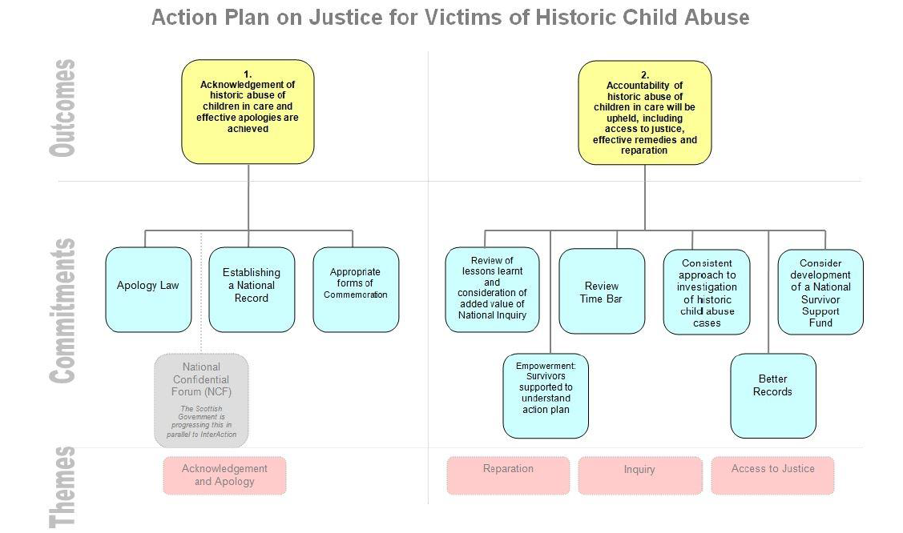

https://www.childabuseinquiry.scot/
http://www.shrcinteraction.org/Portals/23/Action-Plan-on-Historic-Abuse-of-Children-in-Care-Nov-2013.pdf
http://www.survivorscotland.org.uk/current-future-priorities/in-care-survivor-support-fund-service/
http://www.nationalconfidentialforum.org.uk/
http://www.incaresurvivors.org.uk/index.php?option=com_content&view=article&id=55&Itemid=73
https://www.childabuseinquiry.scot/key-documents/protocol-anonymity-and-protective-measures/
https://www.childabuseinquiry.scot/key-documents/protocol-core-participant-status/
http://www.shrcinteraction.org/Portals/23/Protecting_and_Safeguarding_Children_in_Care_v3.pdf

