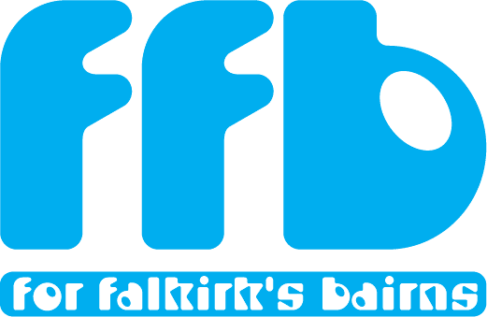
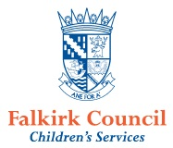
Falkirk Pupil Equity Funding – Guidance Note for Partners/ External Agencies

The Pupil Equity Fund is designed to enable Head teachers and schools to reduce the poverty related attainment gap. The funding will reach schools in every local authority area in Scotland and will be distributed on the basis of the numbers of pupils in P1-S3 known to be eligible and registered for free school meals.

Falkirk has asked partners to share what they can offer to schools to enable Head teachers to meet the identified needs within their communities that will help close the gap.

In order to keep a strategic overview of support being offered, and to co-ordinate demand for support, the Service and School Improvement Team will work alongside partners and external agencies to facilitate engagement with schools in relation to closing the attainment gap.

- Head teachers/ Schools/ Clusters should not be approached directly by partners/ external agencies.

- Partners with existing service level agreements with Falkirk Council will be asked to demonstrate how they can deliver any additional resource beyond that implied by their current service level agreement.

- Agencies with no existing service level agreement will be asked how any proposed services/ resources would help reduce the poverty related attainment gap.

- Partners should contact the Service and School Improvement Managers Rhona Jay and Alex Black who will arrange a time for partners/ external agencies to share proposed offers of support with the team. rhona.jay@falkirk.gov.uk alex.black@falkirk.gov.uk

If you require further information on Pupil Equity Funding, please see the Scottish Government website.

