Individual Core Resource Packs
As part of our preparation for the first phase of the re-opening of schools in August, we will need to consider how we minimise the sharing of resources amongst groups of children.
The provision of Individual packs for each child will help to reduce the need for large amounts of shared resources to be cleaned.
Due to the likely need for a blended model of in-school and in-home learning, it will be necessary to provide children with packs for school and home. Each school should therefore order the resources required to provide each child with:
- A core resource pack to be used in-school at Early, First or Second Level.
- A home learning resource pack for in-home learning which should stay at home and not be brought into school.
It is important that all pupils in Falkirk have access to a ‘basic kit’ of materials both in-school and at home. Illustrations for each of the CfE levels are given below.
Schools will want to add to this basic kit with materials and resources that support aspects of the curriculum in your school.
As we receive further guidance from Scottish Government, we will issue advice on classroom management and organisation including: physical distancing; cleaning of resources; set-up and resources of classroom for play-based learning; other primary stages.

Budget and Ordering
We have made available a small additional budget for the purchasing of any additional resources you may require in order to provide these individual learning packs for pupils. Schools will already have a notional commitment of budget each year for the provision of such materials, however, it is accepted that quantities will be greater under current circumstances.
Therefore, the central budget should only be applied when:
- Existing stocks has been allocated in the first instance. This budget is not aimed at replenishing stockpiles, although it is acceptable to keep a reasonable stock of consumables for replacing materials in home learning packs.
- You have committed the same level of budget towards the purchase of these resources as you would do normally.

Use emergency COVID-19 fund code 204000 - 4999

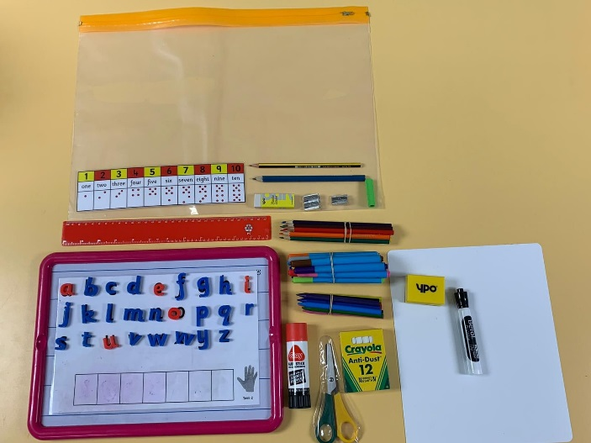
Early Level

Early Level
- Number Line  - Magnetic Board and letters  - Pencils - thick or triangular  - Rubber  - Sharpeners (correct size for pencil.  - Colouring in pencils/crayons/pen | - Whiteboard, pen and duster  - Ruler - 30cm  - Scissors (consider left-handed option)  - Pritt Stick  - Chalk  - Pencil grip (if needed)

First Level
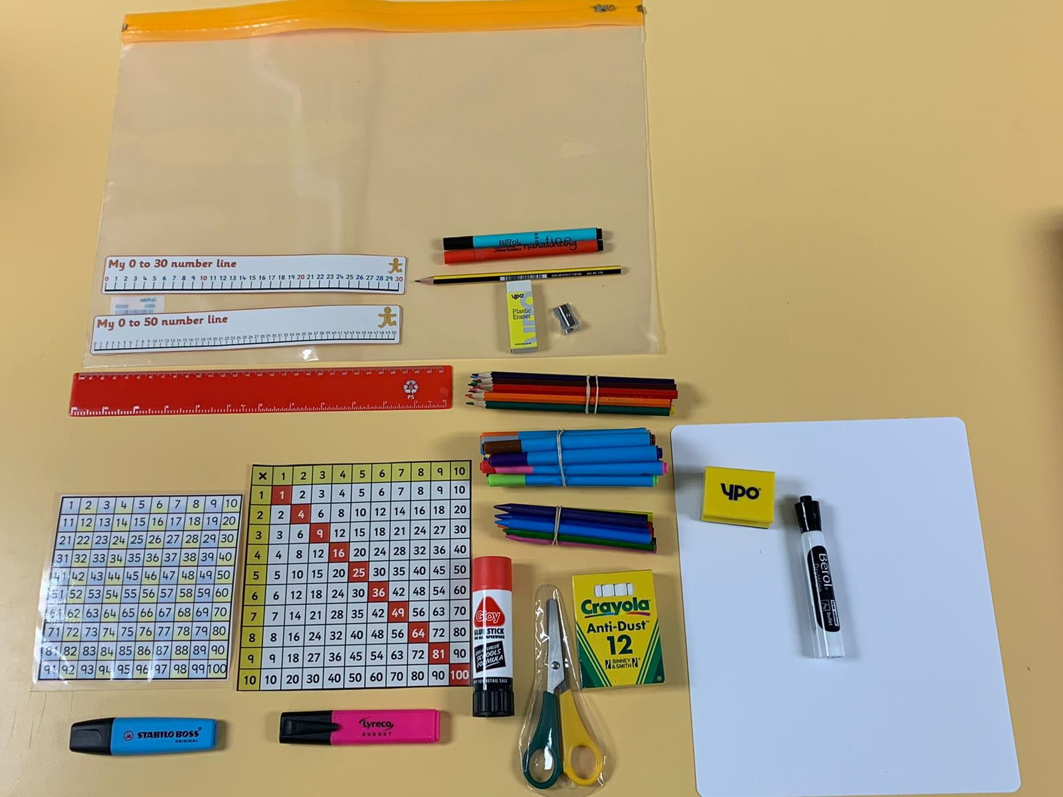
First Level
- Number Line (0-30 or 0-50)  - 100 square  - Multiplication Square  - Pencil  - Rubber  - Sharpener  - Colouring in pencils/pens/crayons | - Whiteboard, pen and duster  - Handwriting pen  - Scissors (consider left-handed option)  - Pritt Stick  - Highlighter  - 30cm Ruler  - Chalk

Second Level
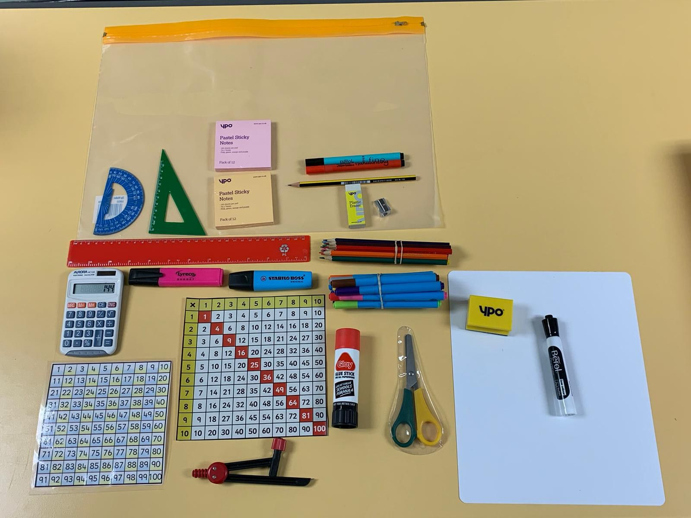
Second Level
- Number Square  - Hundred Square  - Multiplication Square  - Calculator  - Angles protractor  - Pencil  - Pen- Drawing  - Rubber  - Sharpener  - Colouring pens/pencils | - Whiteboard, pen and duster  - 30cm ruler  - Compass  - Scissors (consider left handed option)  - Chalk  - Pritt Stick  - Highlighter  - Post it notes

Home Learning Pack
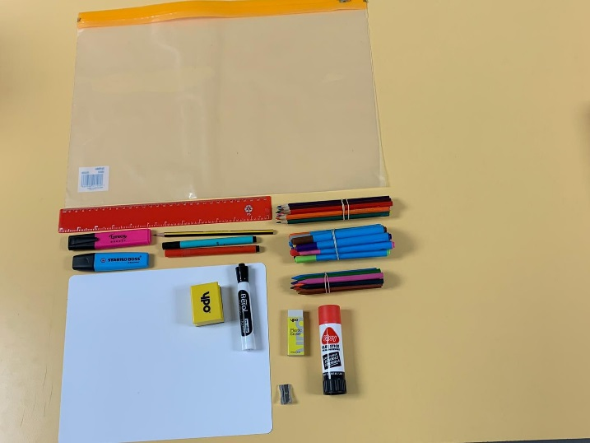

Home Learning
- Pencil  - Rubber  - Sharpener  - Colouring in pencils/pens/crayons  - 30cm ruler | - Whiteboard, pen and duster.  - Handwriting pen  - Pritt Stick  - Highlighter

Other resources to consider
- Clip Board
- Tray (Pupil)
- Zip Wallets (A4/A3)
- Box (under desk)
- Reading Bag
- Fidget Toy

