Introduction
We know that Covid-19 can be spread:
- Directly: from close contact with an infected person (within 2 metres)
- Indirectly: by touching a surface, object or the hand of an infected person that has been contaminated with respiratory secretions and then touching own mouth, nose or eyes.

Latest advice from Health Protection Scotland states.
“Under most circumstances, the amount of infectious virus on any contaminated surfaces is likely to have decreased significantly by 72 hours”.

To mitigate potential spread of the virus, all establishments should:
- Promote good hand hygiene regularly.
- Ensure there are adequate facilities for hand hygiene.
- Ensure staff and pupils socially distance using 2m guidance.
- Ensure good ventilation in all rooms.
- Increase cleaning frequency of surfaces in classrooms.

Practical support
It is inevitable that, as a consequence of Covid-19, there will be changes to how children experience their learning in school.
The health and safety of all staff, children and families is of the utmost importance at this time.
Protocols will need to be adapted for each establishment taking account of the layout of the building and school roll.
It is likely that there will be a need for regular review of all protocols throughout the coming months and adjustments may have to be made as we are informed by further advice and our own experience. These adjustments should be communicated clearly to staff, children and families where appropriate.
Each establishment may want to consider how to give the children as much responsibility as possible for cleaning their own resources and adhering to guidelines. This will, of course, be age and stage appropriate.

Guidelines for set-up of learning spaces
Health Protection Scotland Guidance advice on limiting potential spread requires:
- Regular decontamination of frequently touched environmental and equipment surfaces will help to reduce the risk of infection.
- Removal of any hard to clean surfaces from the environment.

Therefore, it is important that all learning spaces are as clutter free as possible.
- Work surfaces, desks and units should be clear and any resources which are not being used in the classroom for the foreseeable future should be stored safely away so that they are not accessed by the children. This will mean it is easier for adults and children to regularly decontaminate surfaces by using wipes or a spray.
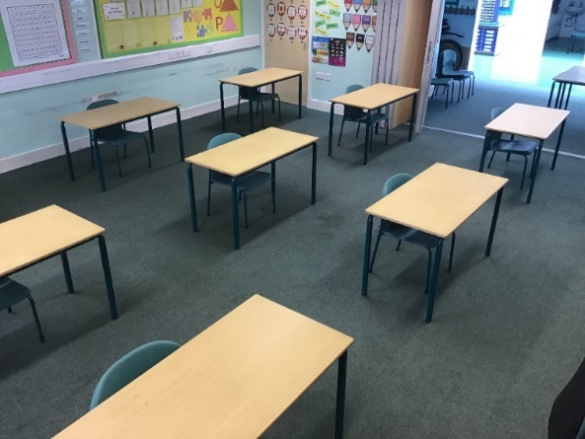
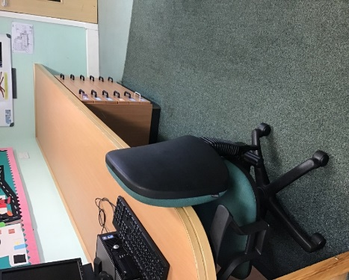

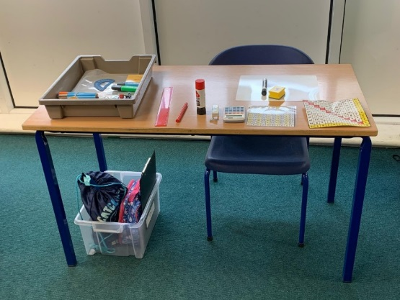

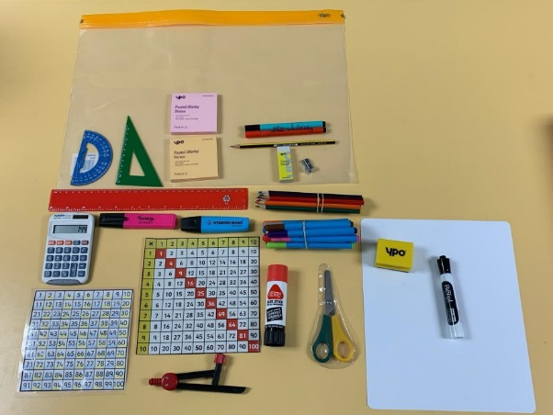
- Children should not share resources. They should have their own Zip Lock bag of basic resources which will minimise the risk of spreading the virus. This should include all the resources they will need for any given day. This should also include any jotters that the child will use. All resources to be stored within reach of the child, including jackets.

- Cloakrooms should not be used.

Resources which cannot be cleaned thoroughly e.g. textbooks:
For key resources which cannot be kept in Zip Lock bags e.g. textbooks, there should be a system in place to limit the possibility of spreading the virus.
Textbooks could be numbered so that each numbered textbook corresponds to a child. This would mean that a textbook could be used one day by a child and then have the plastic cover wiped to be used the next day by the same child.

Resources which cannot be cleaned thoroughly shared across cohorts:
Resources such as textbooks which cannot be cleaned thoroughly may be shared across cohorts if a period of 72 hours has elapsed since last use. For example,
It may be helpful to assign numbered resources to children in both cohorts to further reduce risk. In the example below textbook 1 would only be used by John in cohort 1 and Anna in cohort 2, with 72 hours between uses.
Cohort 1 Monday and Tuesday |  |  | Cohort 2 Thursday and Friday
Textbook 1 | John |  | Textbook 1 | Anna
Textbook 2 | Sarah |  | Textbook 2 | Ella
Textbook 3 | Andrew |  | Textbook 3 | James
Textbook 4 | Emily |  | Textbook 4 | Alex
Textbook 5 etc. | Harry |  | Textbook 5 | Sophie

Sharing resources between different groups across the week

Example for textbook 1 used by John in Group 1 and Anna in Group 2
Available for use
Should not be used
Cleaning/Weekend

Mon  Gp 1 | Tue  Gp 1 | Wed  Clean | Thu  Gp 2 | Fri  Gp 2 | Sat | Sun | Mon  Gp 1 | Tue  Gp 1 | Wed  Clean | Thu  Gp 2 | Fri  Gp 2

Textbook 1 first used by John in Cohort 1 on Monday. | Textbook 1 available for use by Anna in Cohort 2. | Textbook 1 available for use once more by John in Cohort 1

The approach to this will vary in each setting, however, the principle of allowing 72 hours before a different child uses a resource which cannot be cleaned thoroughly, such as a textbook, should be applied.

Marking Jotters
Self-assessment and self-correction strategies should be employed where possible. If it is necessary to physically mark jotters, staff should be aware of the possibility of cross contamination.
Marking could be done in school, wearing gloves with all surfaces wiped afterwards and possibly using hand sanitiser between each jotter.
Jotters should not be taken home to be marked.

Resources which can be cleaned thoroughly
If resources other than books can be cleaned thoroughly e.g. wooden/plastic resources, then it will be possible for resources to be used by a different cohort without the need for the 72 quarantine.

ICT Resources
If the children are working on a PC in a class or Computer Suite, a member of staff and/or the child should wipe down each computer keyboard and work area before and after each use.
Only one child should use an iPad at any given time and iPads should be cleaned before and after use by the child/adult and then at the end of a session by a member of staff.
Only one child to use the interactive whiteboard at any given time and cleaned after use. The whiteboard should also be cleaned regularly as with all surfaces in the class.

