Falkirk Council – Planning for Outdoor Learning and Play
The following resource list provides ideas and options for increasing capacity to deliver learning outdoors in school/ELC grounds. It covers the basic considerations:
clothing, shelter, handwashing and toilets.
There is also a section for basic equipment for going off-site, and a list of additional resources to consider.
NB: There are other suppliers for many of the items listed – the links are mainly to companies already on Integra or have been assessed as best value for a specific product.
Clothing
 | Supplier | Item Number | Description | Price  (inc. VAT)
Adult Waterproofs
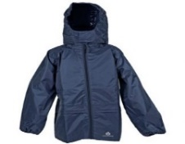 | Muddy Faces | DRY 5002 | Lightweight, waterproof jacket  Sizes S-XXL | £14.00
 | Cosy Direct | 5161 |  | £14.39
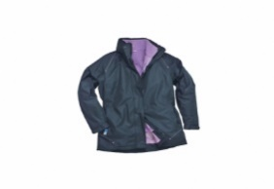 | Lion Safety | C/CW571 | Ladies 3 in one jacket | £52.74
 | Lion Safety | C/CW570 | Gents 3 in 1  Jacket | £52.74
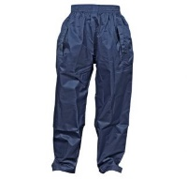 | Muddy Faces | DRY5001 | Waterproof over trousers  S -XXL | £10.00
 | Lion Safety | C/FW3 | Flex Waterproof Overtrousers | £28.43
Children’s Waterproofs
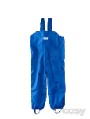 | Cosy Direct | 23354 | Age 3-4 | £14.95
 | Cosy Direct | 23355 | Age 4-5 | £14.95
 | Muddy Faces | CLCHI80 | Age 3 - 5 | £16.00
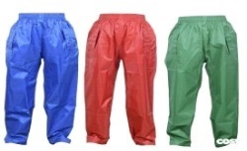 | Cosy Direct | 47216 | Age 3-4 | £7.29
 | Cosy Direct | 47215 | Age 5-6 | £7.29
 | Muddy Faces | DRY3001 | Age 2  Age 3-4  Age 5-6 | £7.95
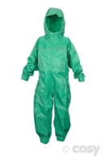 | Cosy Direct | 35294 | Age 3-4 | £12.95
 | Cosy Direct | 47230 | Age 5-6 | £12.95
 | Muddy Faces | DRY3003 | Age 2  Age 3-4  Age 5-6 | £14.95
Additional clothing - Children
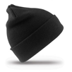 | Muddy Faces | CLCHI02 | Woolly Ski Hat  One Size | £1.99
 | Amazon |  | Sun protection hat | £4.12
 | Muddy Faces | CLCHI16 | Sun protection hat  One size | £4.59
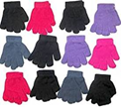 | Cosy Direct | 5195 | Fit all Gloves  3 pairs | £2.59
 | Amazon | Children’s  Magic  Gloves | Pack of 12 | £5.97
Additional clothing - Adult
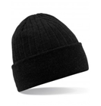 | Muddy Faces | CLADU39 | Thinsulate Beanie | £4.79
 | Lion Safety | C/CA15 | Black, Navy & Yellow | £4.80
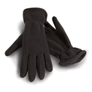 | Muddy Faces | CLADU12 | Sm, Med, Large | £2.99
 | Muddy Faces | HGH22 | Highlander Fleece | £7.99
Wellies
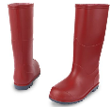 | Muddy Puddles |  | Classic wellies in a range of colours and sizes | £10.80

On-site shelter
 | Supplier | Item Number | Description | Price  (inc. VAT)
Tarpaulins
Tarpaulins are the simplest type of shelter and can be used in a wide range of ways and environments. Depending on where/how the tarps are to be used rope/clips/pegs will be required to secure them.
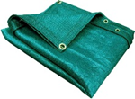 | Cosy Direct | 34244 | Medium green tarpaulin, 2.4 x 1.8m | £1.26
 | Cosy Direct | 34245 | Large green tarpaulin, 5.4 x 1.8m | £8.49
 | Cosy Direct | 555 | Giant green tarpaulin 7 x 5.4m | £19.19
 | Greenman Bushcraft |  | A more robust long lasting tarp 4x4m includes guy lines and pegs | £47.95
 | Greenman Bushcraft |  | A more robust long lasting tarp 4.5m x 3m includes guy lines and pegs | £44.95
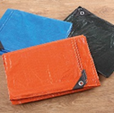 | tts | EYO4498 | Waterproof Tarpaulins 3pk | £33.54
Small group shelters/storage
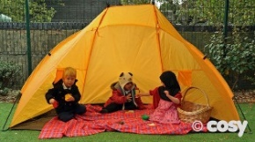 | Cosy Direct | 25086 | Quick Put Up Shelter - instant shelter or used in the garden as a cheap den or shade, early years. W2m x H1.15m | £16.19
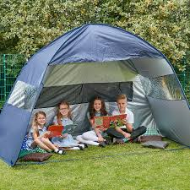 | tts | FU10092 | Pop Up Outdoor Canopy | £119.94
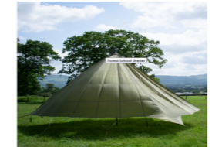 | DAS Outdoors |  | Forest School Shelter, internal area of 28m2, assembly required | £150.00
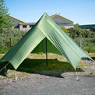 | DAS Outdoors |  | Small group shelter | £135
Gazebos
Gazebos fold out and are quick to erect. They work well on a solid surface like tarmac but if pegs are not an option to secure it to the ground the legs would need weighted down.
house of tents
A wide range of gazebos available in a range of sizes and colours with options for 2 or 4 side walls. Some examples below
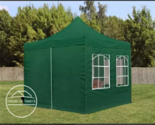 | 3m x 3m option |  | LOGIline 3 x 3m PES popup gazebo, economy steel, 30mm, sidewalls with window | £229.99
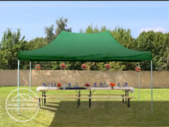 | 3m x 4.5m option |  | LOGIline 3 x 4.5m PES Pop up Gazebo, steel 30mm, economy, green | £219.99
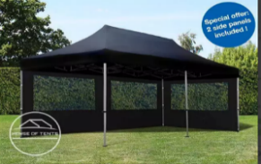 | 3m x 6m option |  | ALUline 3 x 6m, Pop up Gazebo economy, aluminium 32mm, black | £349.99
Dome shelters
Easy to erect and ideal for grass
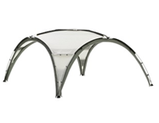 | Garden4less |  | Coleman Event Dome can  add walls and groundsheet  15ft | £164.99
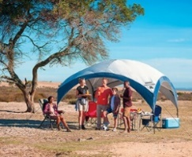 | Garden4less |  | Coleman FastPitch Event Shelter XL .Can be constructed in less than 5 minutes | £189.99
Inflatable option
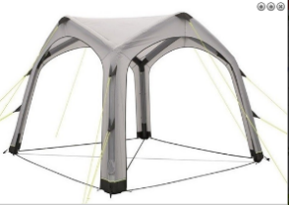 | World Of Camping | 9566 | Outwell Vale Air Shelter  Air pump included, Includes a handy storage/carry bag, Fire retardant | £299.99
Large tents
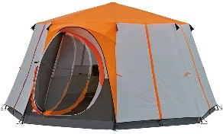 | Amazon |  | Coleman Tent Octagon, 6 to 8 Man Festival Dome Tent, Waterproof Family Camping Tent with Sewn-in Groundsheet | £223.45
Fixed Shelters
There are many options to consider for fixed shelters within grounds. The options below are just two examples.
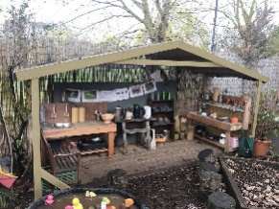 | Cosy Direct | 48389 | Bayonne Big Barn, open sides, covered play area, suitable early years | £390.00
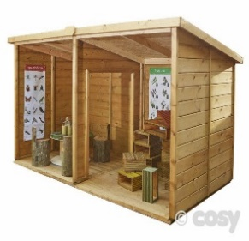 | Cosy Direct | 30442 | Super Shelter Side by Side, double den, H1.6m x W3m x D1.6m Self assembly. | £946.80
Den building /Shelter accessories
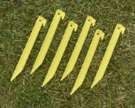 | Cosy Direct | 49446 | Easy to spot tent pegs (6) | £1.91
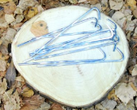 | Muddy Faces | PAR113 | Steel tent pegs (10 pk) | £1.79
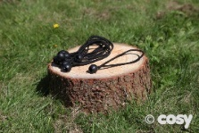 | Cosy Direct | 30062 | Ball bungees (10pk) for use with tarps | £2.99
 | Cosy Direct | 50009 | Elasticatic shock cord ties (25pk) for use with tarps | £7.19
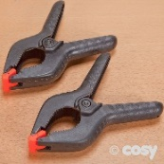 | Cosy Direct | 567 | Giant Pegs (5pk) | £5.99
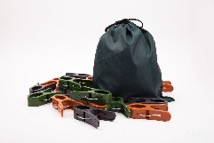 | Cosy Direct | 36726 | Large Camo Pegs | £13.10
 | Cosy Direct | 430 | Sisal Rope 10m | £4.79
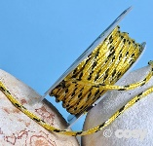 | Cosy Direct | 20955 | Braided Polyrope 15m | £2.40
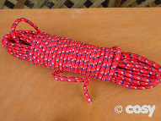 | Cosy Direct | 25108 | Strong Braided Rope 30m | £5.87
 | Cosy Direct | 4348 | Big Thick Rope 5m or 10m | £26.99
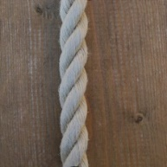 | Muddy Faces |  | Hempex rope in various widths and lengths  (6mm, 10mm, 18mm, 24mm. Each available in 10m or 30m lengths) | £3.99 - £15.99
 | Greenman Bushcraft |  | Polypropylene Outdoor Rope 30m x 6mm | £7.95
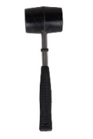 | Greenman Bushcraft |  | Rubber Mallet | £2.95
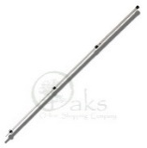 | Greenman Bushcraft |  | Telescopic Tarp Pole | £22.95

On-site handwashing
 | Supplier | Description/Price
 | Forest School | - Heats up to 40C in 3 hours  - Ideal as a hand wash station  - 20L Capacity  - Solar heated  £7.95
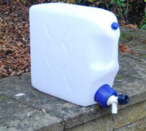 | Muddy Faces | - 25l container with tap  £20.39
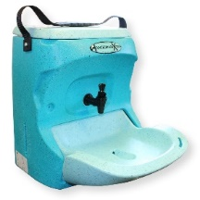 | Teal Wash | The Handeman Xtra Portable provides hot water without the need for a power supply or plumbing. It uses pre-heated hot water and provides a minimum of fifteen 12 second hand washes per filling  £156+vat
 | Teal Wash | - Easy to use  - Robust and easy to clean.  - Portable and no need for electricity or plumbing  - Especially designed with smaller hands in mind  £318+vat
 | IMC Mobile Handwashing Unit  Contact supplier direct.  Simon Dann @ CCES UK simon.dann@ccesuk.com | - No plumbing required  - Just fill, plug in and go (needs power supply)  - Provides 85 hand washes - 10 litres per fill.  - Internal waste collection - no need for drainage.  - Foot-activated, infrared-operated tap, no need for hand contact.  - Large wheels make hand wash station quick and easy to move.  - easy to wipe clean  £427.68 incl VAT

On-site toilet facilities
 | Supplier | Description/Price
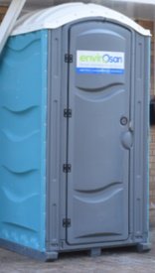 | Envirosan | Standard portable toilet  £25 per week + VAT (includes weekly service by Service Engineer)  1 x Delivery: £40  1 x Collection: £40  Deposit: £300 (Refundable @ end of Hire)  Minimum Hire: 2 weeks (this includes transport)
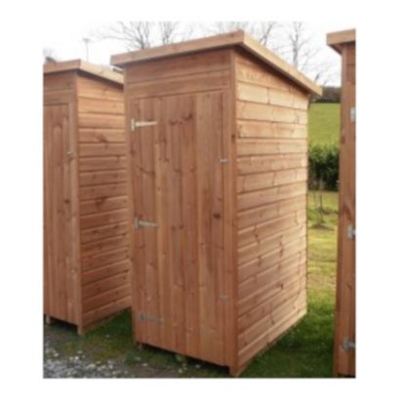 | Muddy Faces | Small Eco Loo Compost Toilet  £1,800 (inc VAT)
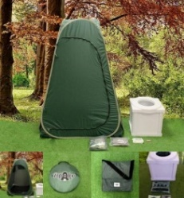 | Popaloo | Full kit including tent, toilet, carry case and accessories (seat cover, wipes etc)  £124.95  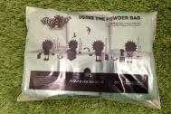  10 Powder bags  £14.95  50 Powder Bags  £47.95
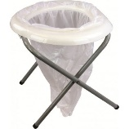 | Muddy Faces | Portable Toilet with steel legs  Includes 6 replacement bags  Max Load 90kg /14st  £17.99
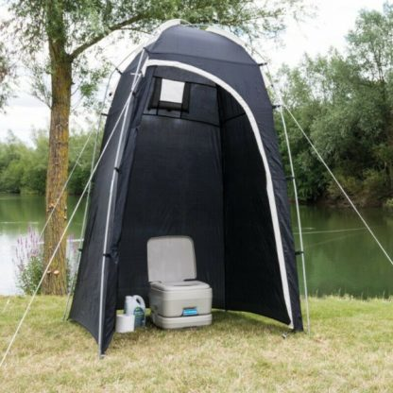 | Muddy Faces | Easy to erect toilet tent with roll back door and ventilation. Tent only.  £35.99 (inc VAT)
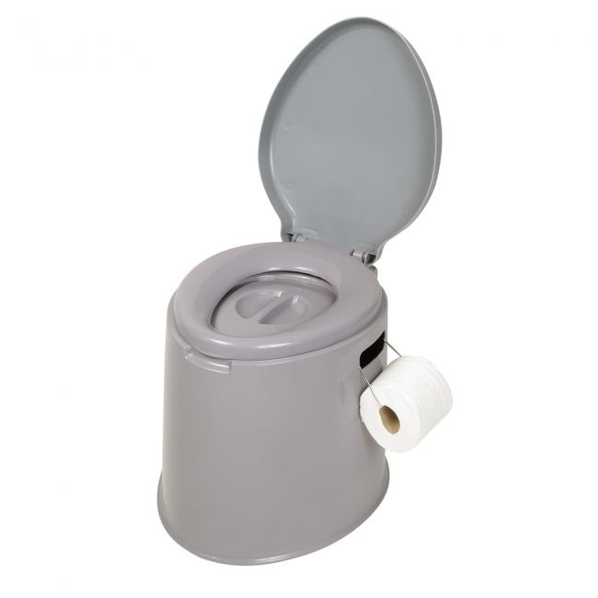 | Winfields outdoors | Kampa Dometic King Khazi Portable Toilet  Seat Height 41cm  £24.99
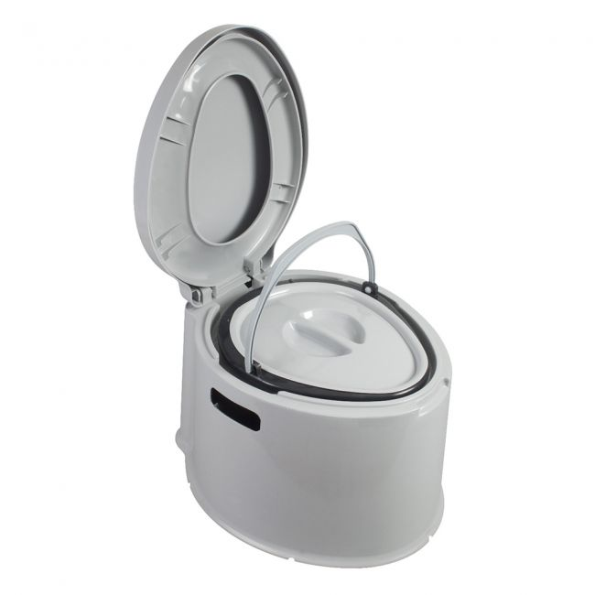 | Winfields Outdoors | Kampa Dometic Khazi Portable Toilet  Seat Height 34cm  £19.99

Going Off-site
 | Supplier | Item Number | Description |  | Price
Transport
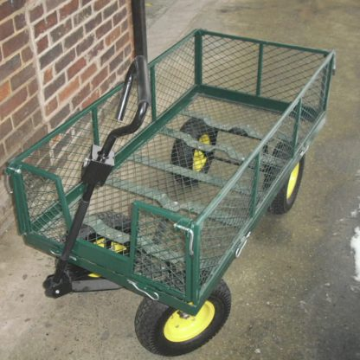 | Muddy Faces | OPTRA38 | Steel framed garden cart with pneumatic wheels that is suitable for loads up to 300kg. |  | £155.99
Toilet facilities
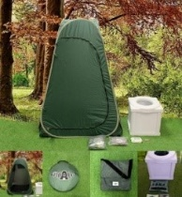 | Popaloo |  |  | Full kit including tent, toilet, carry case and accessories (seat cover, wipes etc) | £124.95
Handwashing
 | Forest School |  | - Heats up to 40C in 3 hours  - 20L Capacity  - Solar heated |  | £7.95
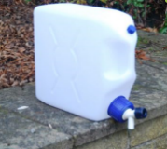 | Muddy Faces |  | 25l container with tap |  | £20.39
Shelter
 | Greenman Bushcraft |  | A more robust long lasting tarp 4x4m includes guy lines and pegs |  | £47.95
 | Cosy Direct | 25108 | Strong Braided Rope 30m |  | £5.87
Depending on the site to be used different shelter options may be more appropriate. For example in open spaces pop up shelters may be better.
First Aid
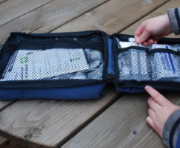 | Muddy Faces | HSFIR03 | First aid kit designed for leaders working in the outdoors |  | £22.79
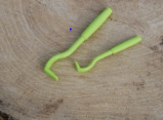 | Muddy Faces | OTOM01 | Tick twister – to help with safe removal of ticks |  | £5.99
You will also need to take:
- Instant ice packs
- Liquid handsoap
- Paper towels
- Hand wipes
- Anti bacterial wipes
- Rubbish bags
- Disposable Gloves
General Outdoor Resources
The following list provides ideas for additional resources that are useful outdoors
- Walkie talkies
- Sit mats
- Clip boards
- Magnifying glasses
- Containers for collecting items eg minibeasts
- Scissors
- Small world figures
- Clay
- Rope
- String
- Torches

