Falkirk Council Children’s Services:
Managing Blended Learning - Using Digital Technology Guidance Paper 1

The Coronavirus (COVID-19): re-opening schools guide states that ‘Digital and at home learning will be a key component to the return to a blended model of education’, Scottish Government (May 2020)

- Council staff and management in schools are currently planning for the return of pupils in August. There are many considerations including how to ensure continuity of learning.
- Unlike the current distance learning situation, a blended model of learning can be planned for by teachers to optimise learning.
- Teachers need to consider what learning requires to take place face to face with pupils. “Blended learning ...provides stronger support for students who struggle to stay on track without some face-to-face support (Christensen Institute, Blended Learning Universe). As such, it may hold the key to helping us mitigate some of the challenges we faced during school closures while leveraging the power of face-to-face learning” (Reinhard and Bown-Anderson, May 2020).

Professor John Hattie in a Webinar on 10 June 2020 on move to blended/hybrid model building on digital distance learning reinforces the ‘importance of capturing our experiences during this shared moment in time in order to "Build Back Better". Reflect, learn and weave the best of the new with the best of the old. Know Thy Impact’.
- When teachers are planning work that should take place in the classroom they should consider using pedagogical strategies that take advantage of the fact that pupils are together e.g. cooperative learning and the fact that the teacher is present to support children when they are struggling to move their learning on.
- Learning at home should consist of instruction or straightforward follow up activities.
- The role of digital is key in the home learning phase of the blended learning model.
- Teachers using technology are still able to support those pupils who are working online through e.g. assignment feedback and interact with them e.g. through Team Posts. This is the blended element of the model.

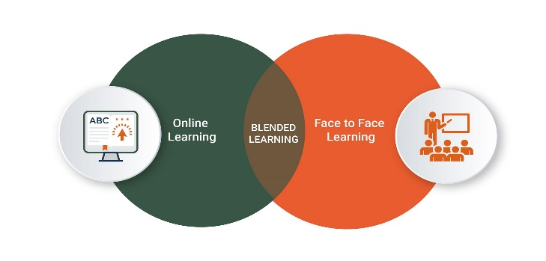

Source: https://www.creatrixcampus.com/blog/understanding-blended-learning

The West Partnership document advises that:
- Blended learning that uses virtual learning environments can use online discussion activities, both asynchronously and synchronously, to develop a sense of community outside of the classroom.
- Use of platforms already familiar to learners are likely to minimise barriers to engagement.
- It is also worth remembering that many learners will be accessing content on portable devices such as tablets and smart phones. Therefore, apps and platforms which function well on small screens may be more advantageous.
- It is important that teachers remain highly visible to their children and young people.
Bowness, J., Morrison, E., Stuart, J. & Green, S., (June 2020)

The hybrid model must embrace digital to amplify, accelerate and connect learners and learning, Reinhart, and Bown-Anderson (May, 2020)
Blended Lesson examples from Falkirk Teachers
https://tinyurl.com/yd9pcqnk
For support in using Digital Technology check out DigiLearnFalk in Microsoft Teams in Glow

Bibliography and Useful Links

https://www.gov.scot/publications/coronavirus-covid-19-re-opening-schools-guide/pages/digital/

https://connect-design-learn.org/2020/05/28/reimagining-the-school-experience/

https://blogs.glowscotland.org.uk/glowblogs/public/westpartnership/uploads/sites/7660/2020/06/12105221/Effective-Blended-Learning-series-part2.pdf
https://educationendowmentfoundation.org.uk/evidence-summaries/evidence-reviews/distance-learning-rapid-evidence-assessment/
https://www.newamerica.org/education-policy/reports/pandemic-planning-for-distance-learning-scenarios-and-considerations-for-prek12-education-leaders/

