World War One – update from Education Scotland
No.1, August 2015

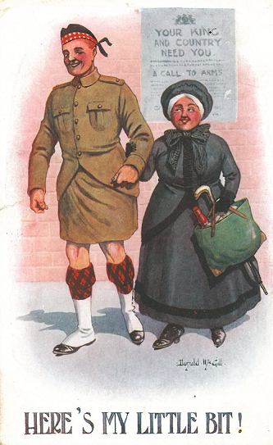

A summary of recent developments around the WW1 theme which may offer educational benefit:

Education Scotland’s WW1 site for teachers and educators has gone live, with further material to come over the next months.
http://www.educationscotland.gov.uk/worldwarone/

Our WW1 blog has news pieces about centenary activities, projects, resources, etc
https://blogs.glowscotland.org.uk/glowblogs/WorldWarOne/

Education Scotland will be hosting a WW1 ‘Sharing Practice’ event for primary and secondary teachers, on Monday 5th October, at a Glasgow city centre hotel. The day will include presentations, workshops, and sessions to discuss differing approaches to learning and teaching and the range of resources in use by practitioners. Key organisations will also be on hand to highlight the resources and opportunities they make available to teachers; these include Commonwealth War Graves Commission, National Museums, National Library, National Records, and Historic Scotland.
Contact Nick Morgan for details. Nicholas.morgan@educationscotland.gsi.gov.uk

Scottish Government’s WW1 Commemoration Panel now has its own website at
http://www.ww100scotland.com/ and a presence on Facebook.

Stirling University is running a Secondary school pupils writing competition, focused on the Gallipoli experience. The University is also offering creative writing workshops for young people to help get them engaged with the competition.
http://www.stir.ac.uk/arts-humanities/about/literature-languages/english-studies/gallipoli/

At the Scottish Learning Festival at SECC, on Thursday 24th September, Middleton Park school from Aberdeen will present a seminar titled “World War One whole school context: a collaborative approach”.
http://www.educationscotland.gov.uk/slf/slf2015/programme.asp

The Army’s “Soldiers to Schools” (S2S) initiative enables Secondary schools to request military assistance to support teaching activities in the classroom. Soldiers who undertake this work have been specially trained, and can help students to learn more about the British Army of 1914-18 and compare it with contemporary service.
Contact Major Paul Crosbie for details. 0131-310-3752

