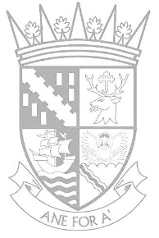
Falkirk Council
Education Services

Falkirk Learning for Sustainability Showcase
Camelon Education Centre
4 June 2015
4.00pm – 5.30pm

Name of School:
Contact Name:

Mobile Tel Number:

No of Staff Attending:

Are you bringing pupils: Yes No

If yes – please give number of pupils

Please give a brief description of what you plan to do

Will need access to an electrical socket: Yes No

(Please bring your own extension lead)

Are there any communication or access needs:

Please return completed form by Monday 25 May, 2015 to:
Fiona Dyson
Education Services
Camelon Education Services
Abercrombie Street
Camelon
Falkirk
FK2 4HA
e.mail ssi.admin@falkirk.gov.uk

N:\Curriculum Support\Learning for Sustainability\Global Citizenship(new)\Falkirk LfS Showcase\Application form.docx

