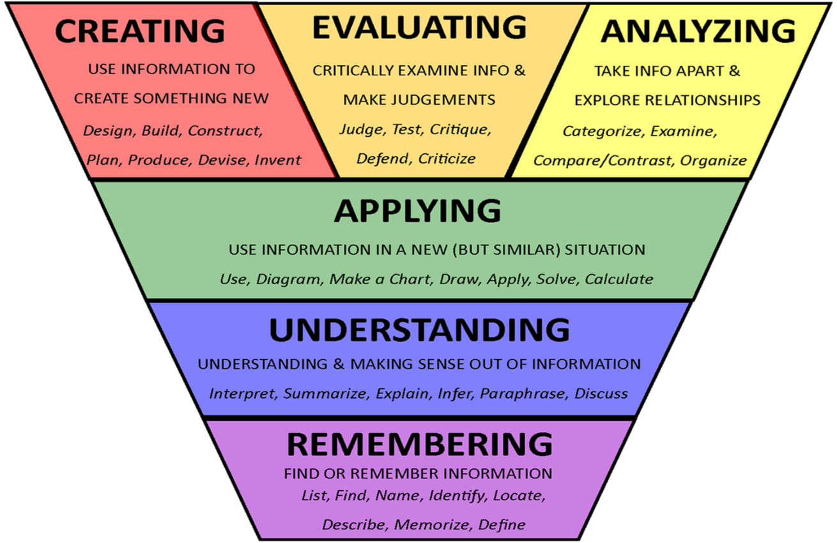

**Understanding**

**Applying**

Class:

Level:

Session:

Term:

Curricular area:

**Analyzing**

**Evaluating**

**Creating**

**Remembering**