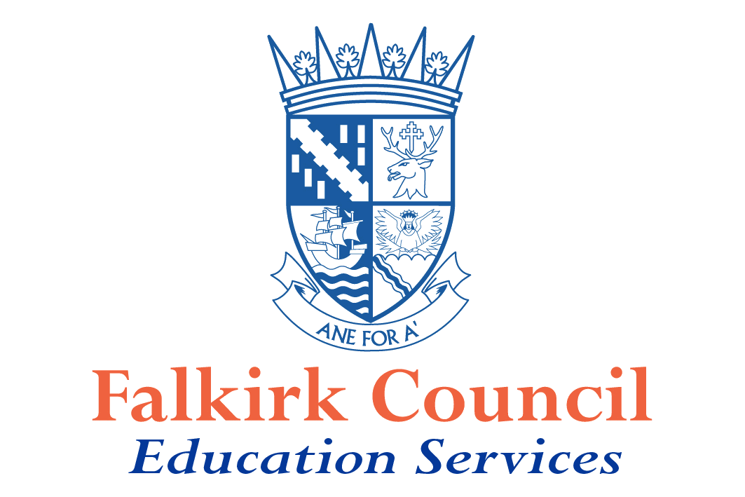

Falkirk Council

Curriculum for Excellence

Assessment in the broad, general education

Guidance 2013 - 2016

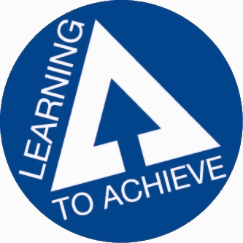
Introduction

The guidance in this document should be read in the context of Learning to Achieve and all of the documents in the Building the Curriculum 5 series.

Falkirk Council's approach to the implementation of Curriculum for Excellence has been an evolutionary one. We have sought to build the capacity of our teachers through a range of professional learning opportunities such as Tapestry Teacher Learning Communities, Co-operative Learning Academies, and certification with Harvard Graduate School in Teaching and Leading for Understanding.

We are committed to supporting establishments to research and trial a range of assessment, moderation and reporting processes which better inform parents and learners about their progress and next steps in learning. We recognise that establishments across the Authority have already begun to adapt their practices and our aim is to build on emerging practice.

Learning to Achieve, Falkirk’s strategy for raising attainment, affords Headteachers the opportunity to work with their staff, parents and learners to develop innovative, creative learning environments.

The guidance contained in this document is designed to support Headteachers and teachers as they collaboratively implement those aspects of Learning to Achieve, specifically linked to assessment, reporting and profiling.

This guidance will support establishments through the next 3 year planning cycle and will be reviewed in 2015 to take account of the on-going developments within Curriculum for Excellence and the associated assessment processes.

Nigel Fletcher

Head of Educational Support and Improvement

Assessment

“Assessment will be an integral part of learning and teaching, helping to provide an emerging
picture of a young person’s learning and achievements as he or she develops across the four
capacities. Up to the end of S3, assessment by teachers will be the main means of assessing
each young person’s achievements. Assessment should be planned and used in ways which
reflect the principles for curriculum design.”

Building the Curriculum 3

Assessment, reporting and profiling all draw on the process of reflection by learners and dialogue with learners about their achievements, progress and next steps in learning.

Each learner’s progress and achievements

Wide range of information
and evidence

Reporting
to
Parents

Learner reflection
and dialogue

Recognising achievement

Profile

Planning for Assessment of progress and achievement

Teachers have always assessed learners' progress. Assessment is essential for:

- Identifying learners' strengths and achievements
- Monitoring progress and informing next steps for the learner and for the teacher including providing advice and guidance as to future studies and potential attainment levels
- Providing evidence for reporting to and working with parents and other partners
- Engaging learners in their own learning 2
Learners' progress can be assessed in relation to the development of:

- Knowledge and understanding
- Skills
- Personal attributes and capabilities
- Attitudes to learning

Approaches to assessment need to be fair and inclusive allowing each learner the best possible chance of success by being able to demonstrate how well he / she is progressing and what he / she has achieved. All learners need to be fully involved in assessment processes in ways that reflect their individual capabilities and needs. Careful consideration will have to be given to developing appropriate fair and inclusive approaches for learners with complex additional support needs.

The five ‘Assessment for Learning ‘strategies provide teachers with a process for assessing learners' progress through every day learning activities. Teachers will use this information along with specific assessment tasks or summative tests to judge learners' progress.

The principles and practice papers provide guidance on significant features of learning in each of the curriculum areas. When designing learning experiences teachers should consider how they offer opportunities for breadth, challenge and application.

Expectations

Teachers will:
- consider assessment when they are planning learning experiences; assessment has to be integrated with the learning and teaching process.

- Consult the principles and practice papers associated with each curriculum areas; these identify for teachers the key skills developed through the Experiences and Outcomes

- Use the NAR planning flow chart to support their planning

- ensure that assessment approaches are fair and inclusive

- Consider key questions:
  - What are pupils learning? ( Learning Intentions)
  - Why is it important that they learn this? (Relevance)
  - How can this learning be applied elsewhere? ( Transferability/ application/ breadth)
  - Will the planned learning experiences generate evidence that allows me to make a judgement on ‘how well’ and ‘how much’ they have learned? (Success criteria / application/ breadth/ challenge)
- How can learners be involved in determining how they can best demonstrate their learning?

Gathering evidence

Teachers gather evidence of learning and progress in a variety of ways including:

- Observation | - Discussion
- Peer assessment | - Questioning
- Self assessment | - Written tests
- Evaluation of performances or artefacts | - Presentations

In reaching professional judgements about learners' progress and in preparing for reporting to parents teachers should take account of the range of evidence available.

Evidence should be drawn from what learners can say, write, make and do and should be directly linked to the learning intentions and success criteria identified for the learning experience. Teachers will make judgements on the balance of activities which require learners to say, write, make and do across learning programmes. This balance will reflect the focus of the learning intentions and success criteria identified at the planning stage and will vary across different learning programmes.

Evidence should be drawn from learning experiences which have provided opportunities for breadth, challenge and application.
About progression - Assessing progress and achievement - Learning, teaching and assessment
Through reflection and dialogue learners and teachers will select what best reflects the 'latest and best' examples of learning and achievement. Learners’ input to this process will increase as they mature.

As approaches to recording, monitoring and tracking are developed they should be manageable and practicable within day-to-day learning and teaching and should be focussed on significant features of performance.

There is no requirement for teachers to record and retain evidence of every small step in learning. Much evidence will be contained in learners' jotters and / or folders (paper or electronic).

Expectations

Teachers will:

- link assessment evidence to learning intentions and success criteria
- record learners’ progress in respect of ‘how much’ and ‘how well’ they have learned.
- use a carefully planned blend of approaches to the kinds of evidence used

- base their judgements on a range of evidence of what learners can say, write, make and do
- discuss with learners their progress and their self-assessment
- provide regular planned opportunities for the learner to reflect on his / her learning and achievements

4

Moderation

The key purpose of moderation is to develop consistency of understanding and application of standards.

Moderation is a process which is applied to; planning; learning and teaching; evidence.

Current arrangements reflect clearly that moderation is every teacher’s business. Practices such as such as; collaborative planning; staff reviewing progress in learning; agreed assessment activities; agreed marking schemes all contribute to the moderation process.

These processes will be further developed as teachers are provided with regular opportunities to come together to discuss and agree standards. These opportunities will be most effective when they are built into the school calendar and in-service days.

In order to meet the national expectations of teachers in respect of assessment, teachers need to develop an understanding of national standards and then apply those standards consistently in their classrooms.

As teachers work together to develop their understanding of national standards, using the NAR, principles and practice papers, and professional learning resources, they will develop confidence in applying the standards to their own planning for learning and teaching and assessment. They will be able to work together to sample and check learners’ work to ensure consistency in the application of these standards.

Moderation allows teachers to compare their judgements, and if necessary, to modify their approach. The process involves teachers in reviewing evidence of learning and reaching agreement on the quality, based on the evidence gathered.

Establishments should have in place arrangements which allow time for professional dialogue within, and across, stages/departments/faculties and cluster networks.

Expectations

Headteachers will ensure that:

- teachers understand the purposes and processes connected with moderation
- time for moderation is built into working time agreements; in-service days
- teachers are aware of their responsibility to work collaboratively with colleagues within their own establishment and across establishments
- teachers have opportunities to engage with school; cluster and authority level moderation processes
Teachers will:
- ensure that they have a sound understanding of the principles and practice papers
- work collaboratively with colleagues to share standards within and across establishments
- provide exemplification of planning and evidence of learners’ work to support moderation processes
5
Reporting

Reporting is the process through which parents are informed about their children's strengths, progress, achievements and next steps in learning, any specific support needs and how they can help support learning.

Reporting should support and improve learning by:

- providing clear, positive and constructive feedback on learning and progress
- providing an agreed agenda for discussion to support next steps in learning
- promoting parental engagement in their child’s learning
- creating opportunities for learners to have a more central role in assessment and reporting e.g. through dialogue with their teachers to set and evaluate targets for their next steps in learning and selecting their ‘latest and best’ exemplification

It is essential that parents and learners understand these key purposes of reporting. It is incumbent on Headteachers to work collaboratively with parents, teachers and learners to ensure the purposes of reporting are clearly understood.

Reporting to parents should focus on the key areas of:

- Health and Well-being
- Literacy
- Numeracy
- Skills across learning
- Attendance
- Additional Support
- How parents can support learning

Reporting to parents in the 21st Century is developing as an interactive process and now comprises a range of activities such as children presenting their learning to parents, parent consultation meetings,
on-going discussion and written reports.

6
Expectations
Headteachers will;
- ensure that parents will receive regularly, information about their children’s strengths, progress and achievements, are informed about any gaps in their children’s progress, about next steps in learning, about any specific support needs and about ways they can help support learning.

- develop interactive reporting processes in consultation with parents and learners. These processes will reflect local needs and will encourage dialogue between teacher, learner and parent.

- will consult with parents, teachers and learners to determine the processes best suited to their local context.

- will evaluate the impact of their reporting processes on improving learning.

Teachers will:

- provide planned opportunities for the learner to reflect on his / her learning and achievements

- provide qualitative information which reflects’ how much’ and’ how well’ each child has achieved.

- Will evaluate a range of evidence produced a period of time to inform their judgements about learners’ progress

7
Profiling

The profiling process is designed to promote the learners’ understanding of the value of reflecting on their own achievements, the importance of their participation in the process and the benefits of being able to explain their achievements to others. Profiling builds on the skills learners have begun to develop in Early Years through their contribution to the recording of the Learning Journey.

A profile is a record of the learner’s best achievements to date. It emphasises strengths and does not identify detailed points for development. This latter information would be contained within the school’s reporting processes. The design of the final profile will vary from school to school. It is important to note the importance of the profiling processes required to reach the end product. Learners will, with appropriate support, contribute to the profiles required at P7 and S3.

The purpose of a profile is to:

• provide the learner with a reflective summary statement of achievement
• publicly recognise progress in learning and achievement
• challenge, motivate and support all children and young people to achieve their best
• build learners’ skills and ability to reflect on their learning
• support and inform transition

The profile should include the following areas as a minimum:

• information on progress and achievement across learning
• information on progress and achievement in literacy, numeracy and health and well-being
• a learner's statement which outlines his / her latest and best achievements in and/or out of school
• a record of awards as appropriate
• an opportunity for a parental comment
The profile will be supported by a range of evidence (electronic or otherwise) gathered by learners.

The profiling process builds on activities which engage learners in reflection and discussion about their learning. The quality and on-going nature of the discussions will be critical in ensuring learners engage effectively with the process. Through regular dialogue about learning, learners are supported in reflecting on their learning and articulating the knowledge and skills they have gained to others.

Approaches to recognising achievement should promote learners’ ownership and engagement as this supports them to understand what they have learned and recognise their achievements for themselves. Opportunities for personal achievement should be an integral component of the planned curriculum. In planning these, staff should take account of the principles of curriculum design.

Staff should encourage learners to participate in a wide range of opportunities ensuring breadth of achievement and that they develop a range of skills for learning, life and work building on their interests, strengths and aspirations. Staff should target children and young people at risk of missing out by aiming to address any inequalities of access to opportunities.

8
Expectations

Headteachers will:

- ensure that teachers, learners and parents have opportunities to develop a shared understanding of achievement
- develop a culture of on-going reflection and dialogue for all learners 3-18, within which profiling processes can be sited
- ensure that processes build on prior experience / learning
- ensure opportunities for every learner in P7 and S3 to be involved in a profiling process that allows them to produce a ‘profile’ which recognises their achievements.
- establish effective systems which capture a wide range of relevant learner experiences
- ensure that profiling processes are fair and inclusive
- ensure that the focus is on the process and not the product

Teachers will:

- design processes that meet the needs of all learners
- ensure that learners are at the heart of these processes
- ensure that there are regular planned opportunities for the learner to reflect on his / her learning and achievements
- encourage learners to consider their achievements in terms of skills for work, life and learning

The key difference between reporting and profiling is that reporting is teacher led and profiling is learner led.

9
Standardised Assessment

We recognise the need to have a range of reliable, robust data on the progress of our learners. To this end we have adopted standardised assessment procedures using University of Durham’s Centre for Evaluation and Monitoring (CEM) assessments, based on a three-year contract, to be reviewed thereafter.

These standardised, computer-adaptive assessments are used by all primary schools at P1, 3, 5 and 7, and in secondary schools at S2 to provide ‘value added’ information on pupil progress initially over the three- year period of the CEM contract.

CEM provide assessments which are computer-generated and adaptive. This ensures that learners are tested to the limit of their ability but are not demotivated by spending time unnecessarily attempting questions which are beyond their capabilities. Results are returned to the school usually within 48 hours and are easily accessed electronically.

The P1 assessments are administered twice in the session, viz. at the beginning and end of the session thus enabling ‘value added’ to be identified for each pupil and class. Test results are measured against overall performance of P1 pupils in Scotland. P1 (PIPs) tests assess literacy, numeracy, and phonics as well as attitudes to learning.

P3, 5 and 7 tests (InCAS) assess Developed Ability, Reading, Mathematics and Mental Maths. Results yield useful data on a range of aspects of each of these elements which inform next steps in learning and teaching. Pupils are tested in the final term of the session and their performance is measured against the performance of pupils of the same age across the United Kingdom.

S2 assessments (SoSCA) assess aspects of reading, mathematics and science as well as attitudes to science. Again, these are administered towards the end of the session.
Results yield useful data on current performance and likely future performance in S4. Currently, predictions are given for Standard Grade but CEM are developing predictions for performance in New National Qualifications.

Schools have been issued with detailed advice in administering the tests, on how to interpret the data and on how to use the data when speaking to parents.

Some schools have purchased additional CEM test packages to enable them to assess pupils in P2, 4 and 6 to enable them to undertake additional analysis of the extent of added value.

10

Appendix 1
Reviewing the 5 formative assessment strategies in lessons and their impact on the involvement of learners
Progressively embedding pedagogies of engagement
Clarifying and sharing learning intentions and criteria for success | Learners know there are learning intentions for each lesson/piece of work  Learners know what they have to do and understand what they are trying to learn  Learners can assess their progress in relation to the learning intentions | Learners have a clear understanding of the relevance of what they are trying to learn.  Learners are aware of features of what makes a good piece of learning using success criteria. | Learners are clear about the success criteria and can, with support, use these to judge the quality of their own work and identify how best to improve it.  Learners can, with support, contribute to determining the success criteria. | Learners value the employment of learning intentions for all learning.  Learners routinely determine and use their own success criteria to improve their learning based on their own personal learning targets.
Engineering effective classroom discussion, questions and learning tasks that elicit evidence of learning | In whole class discussions learners listen to others and actively participate.  Learners feel confident to raise questions  Learners are confident to talk about what makes their work good | Learners effectively participate in whole class response systems.  Learners’ feel confident to take risks by sharing their ideas or constructively challenging the ideas of others. | Learners are able to differentiate between types of questions to encourage thinking to provide appropriate evidence of learning | Learners responses are typically extended and demonstrate high level thinking.  Learners are able to support their views with appropriate evidence or argument
Providing feedback that moves learners forward | Learners receive oral feedback whilst the learning is happening. | Learners can identify strengths and weaknesses in their work and act appropriately following feedback to make improvements | Learners understand ways of bridging the gap between what they can do and need to do to progress their learning. | Learners value feedback on learning from teacher or peers and consciously use it to advance their thinking and identify the next steps for their learning in relation to their level
Activating students as owners of their own learning | Learners relate their learning to previous lessons.  Learners understand why their learning is relevant to them  Learners know the level they are learning at and what it contains | Learners recognise how their current learning builds upon earlier learning.  Learners are confident to talk about what makes a good piece of work good and how it can be improved | Learners can relate their learning to past, present and future learning in a subject and can relate this learning to other curricular areas and life skills  Learners understand their own preferred way of learning. | Learners understand how their learning relates to the key concepts and skills they are developing.  Learners can differentiate which learning is relevant to help them to progress.
Activating students as instructional resources for one another | Learners can work appropriately with others  Learners are confident to try new activities and speak in a familiar group.  Learners are confident to discuss others work against learning intentions | In paired or group discussions learners contribute effectively.  Learners can keep discussion on task and relate to the learning intentions and success criteria. | In whole class, group or paired discussions learners develop their thinking and learn from each other.  Learners are confident to explain their understanding or mistakes in others work. | Learners initiate and lead discussions in groups or whole class.  Learners collaborate in group work and are self determined and governed by agreed learning outcomes
11
Appendix 2

Breadth, challenge and application

It is recognised that well-designed learning experiences with clearly defined learning intentions and success criteria will generate the evidence required to determine learner progress.

When designing learning experiences teachers should consider:

- Which of the key features outlined in the principles and practice papers are the focus for the design of this learning experience?
- What combination of Experiences and Outcomes contribute to this learning experience?
- How difficult are the tasks?
- Are there opportunities for individualised tasks / activities to provide differentiated levels of challenge?
- What are the opportunities to apply previously learned skills and knowledge to these tasks?
- Are there opportunities for pupils to undertake open-ended tasks?
- How are the pupils supported from routine tasks / operations into more open ended / problem solving type activities?
- What opportunities are there for collaborative activities?
- What opportunities are there for application of knowledge/ skills in an unfamiliar context?
- Are there opportunities to make links across learning / interdisciplinary?
- Are there opportunities for learners to use Higher Order Thinking Skills?

Appendix 3

Bloom’s Revised Taxonomy

Remembering
Understanding
Applying
Analysing
Evaluating

Listen
Show tell
Give examples
Explain
Discuss
Apply
Use change
Demonstrate
Group contrast
Match
Compare
Compare
Assess
Judge
Decide
Compare

Plan modify
Adapt
Creating

Combine

Argue classify

Construct

Answer

Find
Copy

13

Appendix 4

Reporting to parents

- Traditional school reports – interim, progress, final
- Meet the teacher events
- Parents’ Evenings
- Performances
- Blogs, wikis.
- Folios of learners’ work
- Learners’ presentations
- Open days
- Parents’ information events / workshops

14
Appendix 5: Template for a report for customisation

The template below illustrates one way of reflecting the key areas for reporting

Learner’s name: Teacher’s name:

Date:

An attendance print out from SEEMIS could be attached to this to reflect attendance and punctuality.

Health and Wellbeing
- Strengths

- Next steps in learning

Literacy
- Strengths

- Next steps in learning

Numeracy
- Strengths

- Next steps in learning

Achievements
Skills and attitudes across learning
- Strengths

- Next steps in learning

Additional Support
How you can help your child

15
NAR ( National Assessment Resource) Flowchart

16

Throughout this document any reference to parents includes carers
Throughout this document any reference to teachers includes all adults who contribute to the assessment of learners’ progress 1
Detailed in Appendix 1 3
Detailed in Appendix 3 12

