Activity 2 - Progression 1 Key Strengths – fractions, decimal fractions and percentages
First level P4 | Second level P7 | Third level S2
Finding a fraction of an amount given a pictorial representation and within a structured question | Finding a fraction of an amount within a simple word problem ( unitary fraction) | Carrying out “stepped-out” ratio and proportion questions
Cross out half of these shapes  Answer: __________ stars | There are 51 pupils in Primary 7 at Beach Primary School.  $\frac{1}{3}$ of them can swim.  How many of the Primary 7 pupils can swim?  Answer: ____________ pupils | 2 bags of flour will make 5 loaves of bread.  How many bags of flour would be needed to make 35 loaves of bread?  Answer: ____________ bags
Key Strengths - measurement
Counting whole square centimetres to find area of simple shapes | Find the perimeter of a simple 2D shape | Finding the perimeter of a 2D shape
Are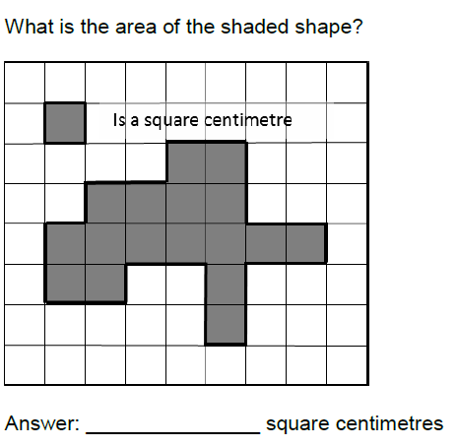as for | 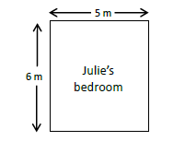  What is the perimeter of Julie’s bedroom?  Answer _________m | Allan made a square picture frame at school.  What is the perimeter of the frame?  Answer _________mm
Activity 2 - Progression 2a Areas for improvement – fractions, decimal fractions and percentages
First level P4 | Second level P7 | Third level S2
Finding a fraction of an amount by applying my knowledge of division | Skills in carrying out decimal fraction calculations | Carrying out calculations with a wide range of fractions decimal fractions and percentages.
A baker drops a box of 15 eggs.  $\frac{1}{3}$ of the eggs break.  How many of the eggs break?  Answer: ___________ | 45.5 ÷ 5  Answer: ___________ | 4 3.0  Answer: ___________
At each stage (P4/P7/S2), what are the significant aspects of learning that would allow learners to confidently answer these questions?

At P7 pupils need to be able to:

At P4 pupils need to be able to:

At S2 pupils need to be able to:

Between P4 and P7 pupils need to develop knowledge and skills in:

Between P4 and P7 pupils need to develop knowledge and skills in:

Activity 2 – Progression 2b Areas for improvement – measurement
First level P4 | Second level P7 | Third level S2
Finding the area of shapes with half centimetres | Understanding of how to find the area of a simple 2D shape | Understanding of area of 2D shape or volume of a simple 3D object
Donald draws a triangle on a grid.  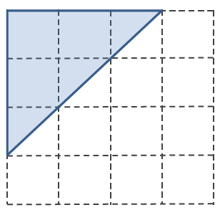  What is the area of the triangle?  Each square = 1 square centimetre.  Answer: _________________ cm² | What is the area of this square?  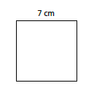  Answer _________ cm² | Calculate the area of this right-angled triangle.  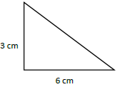  Answer _________ cm²
At each stage (P4/P7/S2), what are the significant aspects of learning that would allow learners to confidently answer these questions?

At P4 pupils need to be able to:

At P7 pupils need to be able to:

At S2 pupils need to be able to:

Between P4 and P7 pupils need to develop knowledge and skills in:

Between P4 and P7 pupils need to develop knowledge and skills in:

Activity 2 - Progression 3 How do you plan to improve learners’ skills?

For example: cross-curricular learning, whole school approaches, linking learning, tracking numeracy across learning, applying learning at the appropriate level in other curriculum areas
Fractions, decimal fractions and percentages

Measurement

