Specialist Services Resource Group (SSRG)

The Specialist Services Resource Group (SSRG) is a multiagency resource allocation group which considers Requests for Assistance for Mariner Support Service and Barnardo’s Cluaran Service. The Group provides a coordinated approach to considering the needs of children and young people at a high stage of intervention that use authority wide specialist resources.

This Group meets on a monthly basis and considers Requests for Assistance for children and young people with a range of significant needs. The Intensive Family Support Service (IFSS) are represented on the Group, and may also be considered as an appropriate support. Due to the nature of IFSS and its need to provide emergency support, Requests for Assistance are still taken through the IFSS current referral route. Crisis Requests can be made to Cluaran Service when there is a crisis in a child or young person’s life.

The Specialist Services Resource Group Multi Agency Membership
Children’s Services Manager, Cluaran Secondary Pupil Support Manager
Headteacher, Mariner Support Services IFSS Manager
Secondary Headteacher Representative Team Manager, Social Work Services
Educational Psychologist Additional Support for Learning Officer

Process for Requesting Assistance

- Each Request for Assistance should be made following a Team around the Child meeting. In most circumstances the request should be made on a multi-agency basis by the Named Person or the Lead Professional. It is important that the meeting discusses the relevant referral criteria - see pages 3 & 4. All Requests for Assistance should be explained to the child or young person and their family.

- All requests to be completed using Application Form (PDF), Forms 1a, Form 4 - Child’s Plan, Form 6 - minutes of a Team around the Child Meeting. This should provide sufficient information for the Group to make informed decisions and contain evidence of:

- A Multiagency Assessment
- Team around the Child involvement and nominated Lead Professional
- Clear identification of the strengths and risks and analysis of the needs of the young person
- Previous Interventions

Requests for Assistance should be emailed to Cluaran using the secure email address:FV-UHB.BarnardosCLUARANServiceFalkirk@nhs.net

All paperwork to be submitted at least 5 working days in advance of the SSRG meeting, see submission dates below. This will give sufficient time for the group to receive and read all the relevant information in time for the meeting.

Advice and consultation Please contact either Service at any point, by phone or email, for information regarding a request for assistance. Both Services welcome
on-going communications and partnership from all agencies.

Feedback from the SSRG meeting
A summary of the decisions made at the SSRG meeting for each young person will be emailed securely to both the Named Person and Lead Professional within 7 days of the meeting by the minute taker (Cluaran Secretary).
SSRG Dates for 2018

SUBMISSION DATE FOR PAPERWORK  Deadline 12:00pm | DATE OF SSRG MEETING
Thursday 18 January 2018 | Thursday 25 January 2018
Thursday 15 February 2018 | Thursday 22 February 2018
Thursday 8 March 2018 | Thursday 15 March 2018
Thursday 19 April 2018 | Thursday 26 April 2018
Thursday 24 May 2018 | Thursday 31 May 2018
Thursday 14 June 2018 | Thursday 21 June 2018
Thursday 19 July 2018 | Thursday 26 July 2018
Thursday 23 August 2018 | Thursday 30 August 2018
Thursday 20 September 2018 | Thursday 27 September 2018
Thursday 18 October 2018 | Thursday 25 October 2018
Thursday 22 November 2018 | Thursday 29 November 2018
Thursday 13 December 2018 | Thursday 20 December 2018

Cluaran Crisis Referral
The majority of requests to Cluaran should be made on a planned basis. However, a Crisis Referral may be made directly to Cluaran when there is situation where a child or young person may be accommodated within 5 days unless additional supports are put in place. The Lead Professional or Named Person should contact the Cluaran Management Team to discuss whether or not such a request would be appropriate and meet the Service’s Criteria. If the request is agreed the appropriate Child’s Plan Forms should be provided and Cluaran would aim to allocate a worker within 48 hours.

The requests made at a time of crisis will be placed on the agenda for the next SSRG meeting.

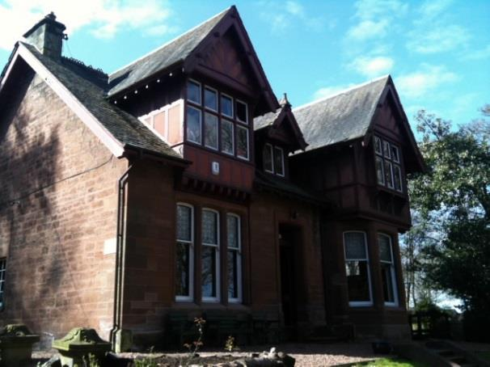
Barnardo’s Cluaran Service

01342 632903

Watling Lodge

Tamfourhill Road

Falkirk

FK1 4RE
Cluaran secure email address:
FV-UHB.BarnardosCLUARANServiceFalkirk@nhs.net

Each young person, where a Request for Assistance is made to Cluaran, should be aged between 11-16 and meet one or more of the essential criteria:

- Young people at risk of being looked after away from home.
- Young people at risk of being placed in residential school or in a residential unit out with the Falkirk area as a result of combined education and foster placement difficulties.
- Young people who have been in residential school or secure accommodation and require an integrated package of support to return to Falkirk Council area.

Our aim, in partnership with Falkirk Council Education and Social Work Services, is to ensure as many young people as possible remain with their own families, schools and communities wherever safe and appropriate.

Cluaran offers:

- Individual support packages that are designed to meet the needs of the young person in a variety of ways:-

Social Emotional Educational Behavioural

- Family Work – bringing families together to facilitate change and support.
- Support through transitions. Cluaran can start work in primary 7 to support transition between primary school and secondary school, leaving school/16+ transition, change in school placement/care placement or changes in family circumstances.
- Group Work - helping young people to learn from each other
- Outdoor, Informal Education and Alternative Curriculum – providing new ways of learning for young people.
- Support for Parents/Carers – Parent Network, direct support and opportunities to meet with other parents.
- Education support - helping young person within their Education Placement to enable them to achieve their full potential.
- Vocational Programme - exploring options for the future.
- Volunteer Befrienders - supporting young people by providing a positive adult relationship.
- Flexible support - Offering flexible support for young people, families and carers and responding to changes in circumstances.
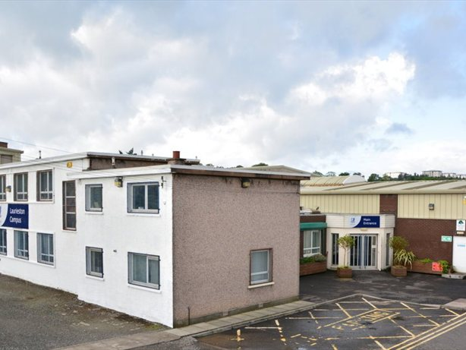
Mariner Support Service
Bog Road
Laurieston
Falkirk
FK2 9PB
01324 501090

The Mariner Support Service is an integral part of the Additional Support Needs provision of Falkirk Council. The Service provides a flexible and holistic approach to meeting the needs of children and young people experiencing a range of social, emotional and behavioural needs. The Multi-disciplinary Team consists of the Head Teacher, Depute Head Teachers, Teachers, Community Learning and Development Workers, Family Support Workers, SfLAs and administrative staff. The Team provide an Outreach Service to promote inclusion and sustain inclusive practices through service activities that aim to develop and enhance the skills of both children and staff operating in a range of systems and contexts.

Intensive support for transition is offered for a small number of young people to complement Falkirk Council’s arrangements for transition already in place. This is to help to ensure that times of transition and change in education for all children accessing the Mariner Support Service are as smooth as possible.

Off-site placements are available at The Focus School for young people experiencing significant SEBN. Here they experience environments which allow them to continue with an education following a broad and innovative curriculum which takes into account their past experiences, is responsive to their emotional and educational needs and maximises their achievements. The aim is always to enable young people to gain the skills required to make a successful transition into full time mainstream education or a post 16 positive destination.

There is an expectation that all young people accessing specialist provision will retain a mainstream element in their individualised programmes. Full time alternative educational provision will be only normally be considered for the last 18 months of statutory education.

Essential Criteria

The young person will:

- Be aged between 11-16 years old.
- Will have been assessed as having significant social, emotional and behavioural needs
- Require support from Social Care and/or health partners (CAMHS)
- Require access to 1-1/small group teaching to access curriculum
- Require specialist environment to support behaviour management
- Require supervision to ensure safety of self/others
- Require significant support to interact appropriately with adults/peers
- Require support with family relationships
- May require support for offending behaviour and/or substance abuse

