|  |
| --- |
| **Welcome to**  **Inclusion and Wellbeing Service 3-18**  **Mariner Support Service**  **2017-2018** |
| **Children's Services crest** |
|  |
| |  |  |  | | --- | --- | --- | | Inclusion and Wellbeing Service  Oxgang School and Support Service (P1-P7)  c/o Moray Primary School  Moray Place  Grangemouth  FK3 9DL  01324 501311 | Inclusion and Wellbeing Service  Mariner Support Service (11-16years of age)  Laurieston Campus  Bog Road  Falkirk  FK2 9PB  01324 501090 | Children’s Services  Sealock House  2 Inchyra Road.  Grangemouth.  FK3 9XB.  01324 506600 | |
|  |
|  |

**Contents**

|  |  |
| --- | --- |
| **Welcome** | **Page 2** |
| **Vision Statement** | **Page 3** |
| **Staffing** | **Page 3** |
| **The School Week** | **Page** **4** |
| **Travel** | **Page 4** |
| **Planning for Learning** | **Page 5** |
| **Positive Relationships and Experiences** | **Page 6** |
| **Meeting the Additional Support Needs of Children** | **Page 7** |
|  |  |

|  |
| --- |
| **Welcome** |

We would like to extend the warmest of welcomes to you. It is important to us that you feel comfortable during your time with Mariner Support Service. We want you and your family to feel that you are able to come in or contact us at any time. We value the contribution that young people, parents, carers, and family can make to our community, therefore, we encourage you to join, plan and lead in many aspects of Mariner Support Service.

We appreciate that you may be feeling anxious as you begin working with us. There will be planning meetings arranged to support transition times and also to plan for any other areas where support is required. Most of the information that you require should be discussed and shared at the meetings. You will also have opportunities to visit Mariner Support Service and meet the staff before the transition begins. If there are any questions that arise out with meetings or visits then please contact any member of the team at any time.

|  |
| --- |
| **Vision Statement** |

Vision:

The service is committed to being reflective and responsive to meet the changing needs of the children and young people in Falkirk Council. Our aim is to become a centre of excellence, working with all our partners to plan for and achieve positive outcomes for all of our children, young people and their families.



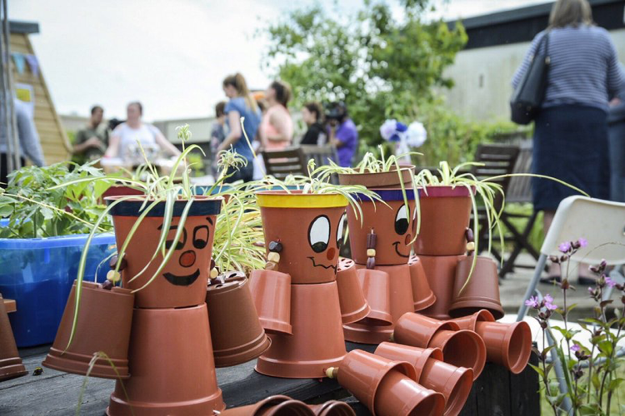

|  |
| --- |
| **Staffing** |

Across Inclusion and Wellbeing Service there are a range of staff which include Clerical, Early Years Officers, Support for Learning Assistants, Inclusion Workers, Family Support Workers, Community Learning and Development Workers, Teachers and a Leadership Team.



The team located within Mariner Support Service include:

* Clerical
* Support for Learning Assistants
* Teachers
* Specialist Family Support Workers
* CLD
* Depute Head Teachers
* Head Teacher

|  |
| --- |
| **The School Week** |

The length of the school day differs slightly from the mainstream school day which means that on a Friday children finish at 12.40pm.

An overview of the school week is:

|  |  |  |
| --- | --- | --- |
| Day | Start | End |
| Monday | 9.00am | 3.15pm |
| Tuesday | 9.00am | 3.15pm |
| Wednesday | 9.00am | 3.15pm |
| Thursday | 9.00am | 3.15pm |
| Friday | 9.00am | 12.40pm |

|  |
| --- |
| **Travel** |

Travel costs and travel arrangements are met by the local authority. We encourage children and young people to self-transport where possible.

Buses:

A bus pass will be given out to those who are able to transport themselves.

Taxi:

A taxi can be arranged to transport, along with other children, to and from Mariner Support Service. Taxis may collect children between 8.00am and 8.45am depending on distance and the amount of other children needing collected. The taxi will drop off daily home at the end of the school day. Taxis will only collect and drop off at one agreed address.

Parents:

As an alternative we offer parental contracts for parents who are able to transport their child to and from school. A mileage allowance is paid for up to 4 trips per day and is claimed back monthly.

|  |
| --- |
| **Planning for Learning at Mariner Support Service** |

We spend time working with all learners on many subjects and activities. In Mariner Support Service we offer the following:

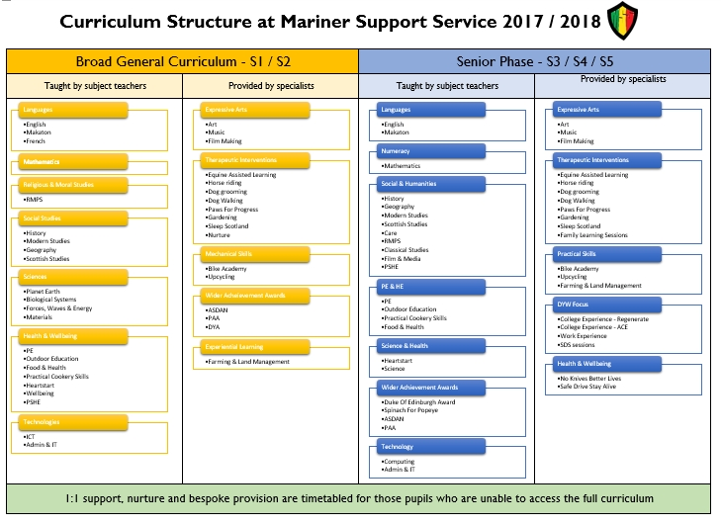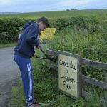

Additionally, there are a number of wider experiences we have in place. We run a Bike Academy where young people learn skills to repair and maintain bikes. We have outdoor education where we undertake activities such as climbing, kayaking, mountain biking, and walking. Also we have opportunities to work on small farms, learn and undertake up-cycling, use RDA for equine therapies and stable work, engage with Tartan Warrior training for fitness and many more activities.

|  |
| --- |
| **Positive Relationships and Experiences** |

Across Inclusion and Wellbeing Service we pride ourselves in meeting the needs of everyone through building positive relationships.

Within Mariner Support Service we ensure this happens through:

* Regular Pupil Council where young people take the lead in improving Mariner Support Service
* Ensuring that all children are listened to and have the opportunity to contribute to decisions made about them
* Regular parent ‘Keeping it Real’ sessions so that parents can be part of the learning experience for their children, contribute to the service community, and be active leaders in developing the service
* Celebration of success events where achievement in the widest sense is recognised for all children
* Christmas and Summer fairs to share the amazing work across our community

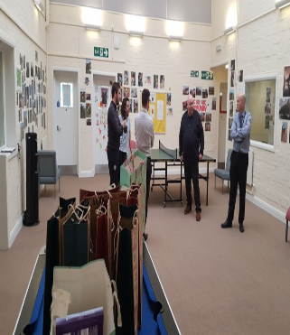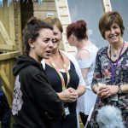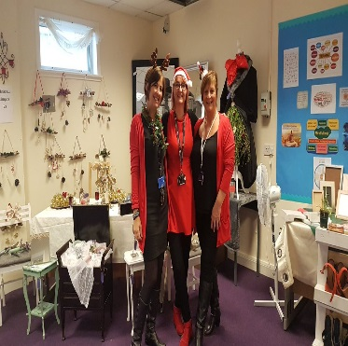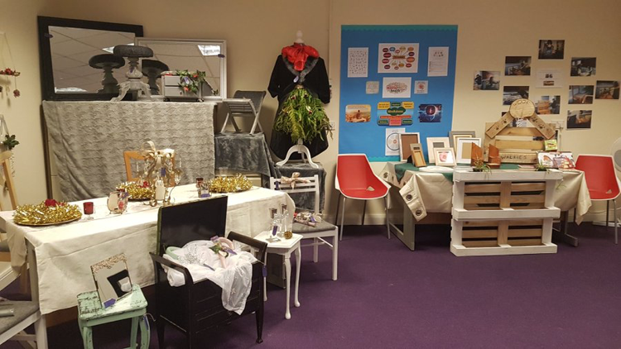

|  |
| --- |
| **Meeting the Additional Support Needs of Children** |

Getting it Right for Every Child (GIRFEC) lies at the heart of the Inclusion and Wellbeing Service. Across the service there is an expectation that all staff understand, engage, and commit to the principles that underpin GIRFEC. There will be a Named Person for all children and young people - somebody that people can go to any time they need help or want to speak to someone.

The Team Around the Child (TAC) will work to identify the needs and strengths. The TAC includes children, young people, parents, carers and professionals. Together we create a plan showing how services will work together to meet needs. One of the team will take on the role of ‘Lead Professional’.  This person has the responsibility of making sure everyone works effectively to meet the targets in the plan.

