SESSION 6 – USING HIGHER ORDER SKILLS TAXONOMIES AS PART OF TEACHING FOR DEEP LEARNING

Pre-Task for Prior Learning | None
Share impact of teacher actions from previous session. |  | 10
Reflective Questions | What are higher order skills?  What is Bloom’s taxonomy? What role does it play in Curriculum for Excellence?  Which skills are essential learning for 21st century pupils? Why?  Which HOS are integrated into my teaching?  Which HOS skills do I use most? Why might this be?
Learning Intentions | We are developing knowledge and understanding of the higher order skills. | 5
Success Criteria | In order to support teaching for understanding, I can:  - Increase my knowledge of the higher order skills  - Understand how these skills can be organised using taxonomies  - Identify and evaluate an example of these skills within my practice
Session Content | Whole group task:  Use Round Robin, Team Relay or chosen method to gather and record existing understanding of HOS as notes and words on a flip chart sheet.  Carousel or share whole group responses to these records – record any questions the group has.  View Kier Bloomer video 6.1– discuss which aspects the group already had understanding of and also which of their questions have been answered.  Individual task:  Study Hand out 1 – Bloom’s and HOS taxonomies.  Pair task:  Use Bloom’s triangle activity to assign tasks to HOS.  Group task:  Use Hand out 2 –  - What would emerging and advanced examples of this look like? How much do I integrate Higher Order Skills into my practice?  - Use as focus for paired interview of random partner to respond to: Which HOS have you used in recent lessons? How did it go? | 10  2  2  10  8  8
Teacher Action Plan |  | 5
Teacher Actions | Individuals record their own progress and define next steps. Monitor the extent of their use of HOS and note which are used and which ones recur most often. Use the Excellence group taxonomy at the bottom of handout 1.

HANDOUT 1 – THE TAXONOMIES
CESA7 (online) School Improvement Services At http://www.cesa7.org/schoolimprove/index.asp (09.07.12)

Anderson And Krathwohl’s 2001 Update Of Benjamin Bloom’s Cognitive Taxonomy 1956 and resulting Skills Path in Action

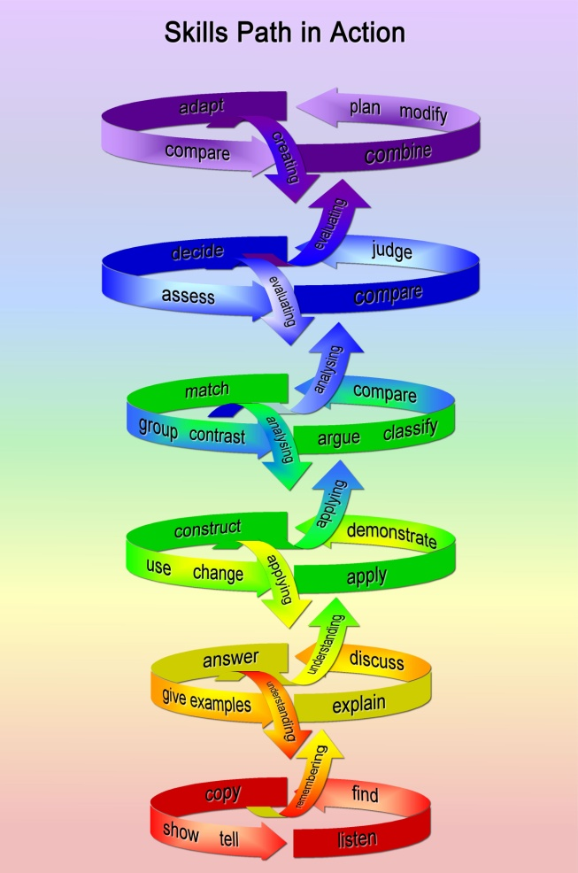
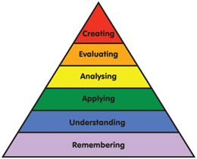

Changes in emphasis
•The revised taxonomy is a more authentic tool for curriculum planning, instructional delivery and assessment.
•The revision is aimed at a broader audience. Bloom's Taxonomy was traditionally viewed as a tool best applied in the earlier years of schooling (i.e. primary years). The revised taxonomy is more universal and easily applicable at secondary and even tertiary levels.
•The revision emphasizes explanation and description of subcategories. For example, sub-categories at the Remembering level of the taxonomy include :
- Recognizing / Identifying - Locating knowledge in memory that is consistent with presented material.
- Recalling / Retrieving / Naming – Retrieving relevant knowledge from long-term memory.
Judy Sargent, Ph.D.
CESA 7 School Improvement Services

Higher Order Skills Excellence Group – Cognitive Taxonomy 2011

CREATION
SYSTEMS THINKING
EVALUATION
SYNTHESIS
ANALYSIS
APPLICATION
UNDERSTANDING
KNOWLEDGE, INFORMATION

HANDOUT 2 – TO WHAT EXTENT DO I INTEGRATE HIGHER ORDER SKILLS INTO MY PRACTICE?
Note examples of what you think would be emerging and advanced practice.
EMERGING | ADVANCED

Where am I? Each person put initials into appropriate box.
1 | 2 | 3 | 4 | 5 | 6 | EXPLAIN WHY

